Algebra 1
Unit 5Lesson 10CC BY NC 2024 Illustrative Mathematics®
Unit 5, Lesson 10

Domain and Range (Part 1)
- Let’s find all possible inputs and outputs for a function.
Algebra 1
Unit 5Lesson 10CC BY NC 2024 Illustrative Mathematics®

10.1Number of Barks
The total number of times a dog has barked is a function of the time, in seconds, after its owner tied its leash to a post and left. Less than 3 minutes after he left, the owner returned, untied the leash, and walked away with the dog.
- Could each value be an input of the function? Be prepared to explain your reasoning.
- 15
- $84\frac{1}{2}$
- 300
- Could each value be an output of the function? Be prepared to explain your reasoning.
- 15
- $84\frac{1}{2}$
- 300
Algebra 1
Unit 5Lesson 10CC BY NC 2024 Illustrative Mathematics®

10.2Card Sort: Possible or Impossible?
Your teacher will give you a set of cards that each contain a number. Decide whether each number is a possible input for the functions described here. Sort the cards into two groups—possible inputs and impossible inputs. Record your sorting decisions.
- The area of a square, in square centimeters, is a function of its side length, $s$, in centimeters. The equation $A\left(s\right)=s^{2}$ defines this function.
  - Possible inputs:
  - Impossible inputs:
- A tennis camp charges $40 per student for a full-day camp. The camp runs only if at least 5 students sign up, and it limits the enrollment to 16 campers a day. The amount of revenue, in dollars, that the tennis camp collects is a function of the number of students that enroll.
- The equation $R\left(n\right)=40n$ defines this function.
  - Possible inputs:
  - Impossible inputs:
- The relationship between temperature in degrees Celsius and the temperature in kelvin can be represented by a function $k$. The equation $k\left(c\right)=c+273.15$ defines this function, where $c$ is the temperature in degrees Celsius and $k\left(c\right)$ is the temperature in kelvin.
  - Possible inputs:
  - Impossible inputs:
Algebra 1
Unit 5Lesson 10CC BY NC 2024 Illustrative Mathematics®

10.3What about the Outputs?
In an earlier activity, you saw a function representing the area of a square (function $A$) and another representing the revenue of a tennis camp (function $R$). Refer to the descriptions of those functions to answer these questions.
- Here is a graph that represents function $A$, defined by $A\left(s\right)=s^{2}$, where $s$ is the side length of the square in centimeters.
- 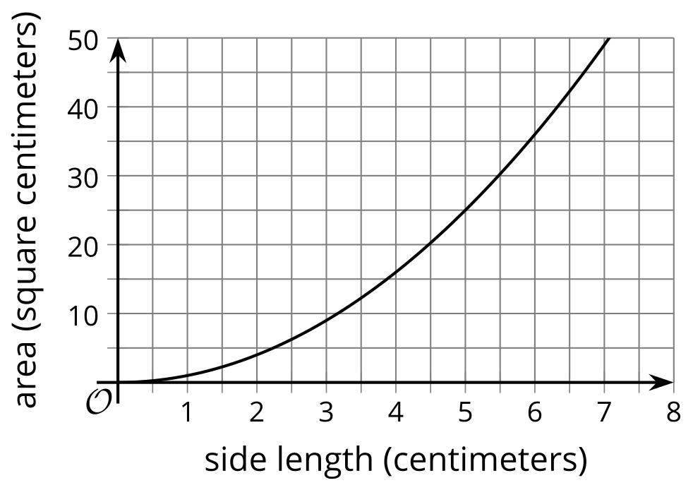
  - Name three possible input-output pairs of this function.
  - Earlier we described the set of all possible input values of $A$ as “any number greater than or equal to 0.” How would you describe the set of all possible output values of $A$?
- Function $R$ is defined by $R\left(n\right)=40n$, where $n$ is the number of campers.
  - Is 20 a possible output value in this situation? What about 100? Explain your reasoning.
  - Here are two graphs that relate number of students and camp revenue in dollars. Which graph could represent function $R$? Explain why the other one could not represent the function.
  - 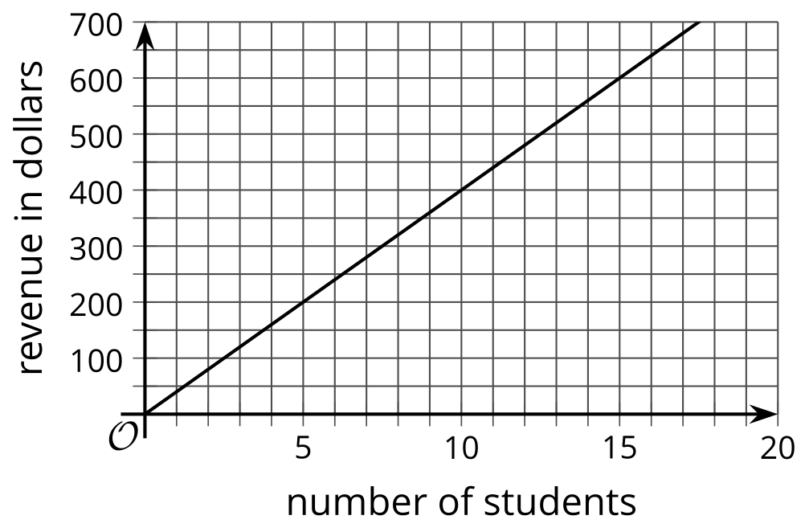
  - 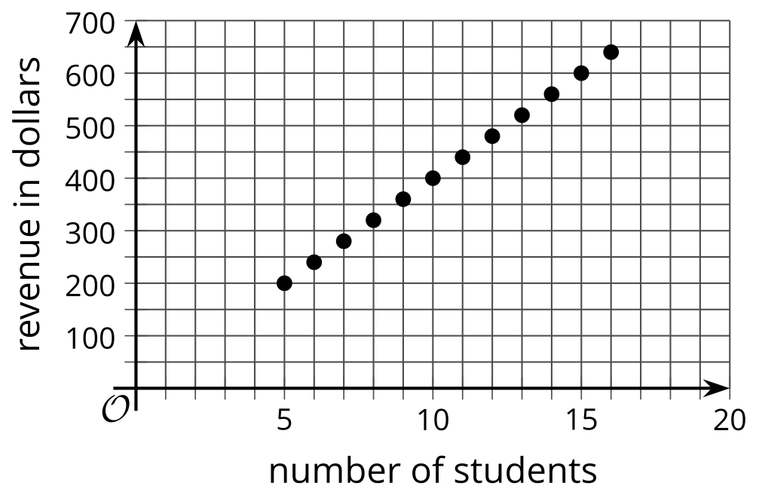
  - Describe the set of all possible output values of $R$.

Are you ready for more?
If the camp wishes to collect at least $500 from the participants, how many students can they have? Explain how this information is shown on the graph.
Algebra 1
Unit 5Lesson 10CC BY NC 2024 Illustrative Mathematics®

10.4What Could Be the Trouble?
Consider the function $f\left(x\right)=\frac{6}{x−2}$.
To find out the sets of possible input and output values of the function, Clare created a table and evaluated $f$ at some values of $x$. Along the way, she ran into some trouble.
- Find $f\left(x\right)$ for each $x$-value Clare listed. Describe what Clare’s trouble might be.
- $x$ | - -10 | - 0 | - $\frac{1}{2}$ | - 2 | - 8
- $f\left(x\right)$
- Use graphing technology to graph function $f$. What do you notice about the graph?
- Use a calculator to compute the value you and Clare had trouble computing. What do you notice about the computation?
- How would you describe the domain of function $f$?

Are you ready for more?
Why do you think the graph of function $f$ looks the way it does? Why are there two parts that split at $x=2$, with one curving down as it approaches $x=2$ from the left and the other curving up as it approaches $x=2$ from the right?
Evaluate function $f$ at different $x$-values that approach 2 but are not exactly 2, such as 1.8, 1.9, 1.95, 1.999, 2.2, 2.1, 2.05, and 2.001. What do you notice about the values of $f\left(x\right)$ as the $x$-values get closer and closer to 2?

Lesson 10 Summary
The domain of a function is the set of all possible input values. Depending on the situation represented, a function may take all numbers as its input or only a limited set of numbers.
- Function $A$ gives the area of a square, in square centimeters, as a function of its side length, $s$, in centimeters.
  - The input of $A$ can be 0 or any positive number, such as 4, 7.5, or $\frac{19}{3}$. It cannot include negative numbers because lengths cannot be negative.
  - The domain of $A$ includes 0 and all positive numbers (or $s≥0$).
- Function $q$ gives the number of buses needed for a school field trip as a function of the number of people, $n$, going on the trip.
  - The input of $q$ can be 0 or positive whole numbers because a negative or fractional number of people doesn’t make sense.
  - The domain of $q$ includes 0 and all positive whole numbers. If the number of people at a school is 120, then the domain is limited to all non-negative whole numbers up to 120 (or $0≤n≤120$).
- Function $v$ gives the total number of visitors to a theme park as a function of days, $d$, since a new attraction opened to the public.
  - The input of $v$ can be positive or negative. A positive input means days since the attraction opened, and a negative input means days before the attraction opened.
  - The input can also be whole numbers or fractional. The statement $v\left(17.5\right)$ refers to 17.5 days after the attraction opened.
  - The domain of $v$ includes all numbers. If the theme park had opened exactly one year before the new attraction opened, then the domain would be all numbers greater than -365 (or $d≥\text{-}365$).
The range of a function is the set of all possible output values. Once we know the domain of a function, we can determine the range that makes sense in the situation.
- The output of function $A$ is the area of a square in square centimeters, which cannot be negative but can be 0 or greater, not limited to whole numbers. The range of $A$ is 0 and all positive numbers.
- The output of $q$ is the number of buses, which can only be 0 or positive whole numbers. If there are 120 people at the school, however, and if each bus could seat 30 people, then only up to 4 buses are needed. The range that makes sense in this situation would be any whole number that is at least 0 and at most 4.
- The output of function $v$ is the number of visitors, which cannot be fractional or negative. The range of $v$, therefore, includes 0 and all positive whole numbers.

