Lesson 16: Arrange Objects Into Arrays
- Let’s make some arrays.

Warm-up: Notice and Wonder: Eggs
What do you notice? What do you wonder?
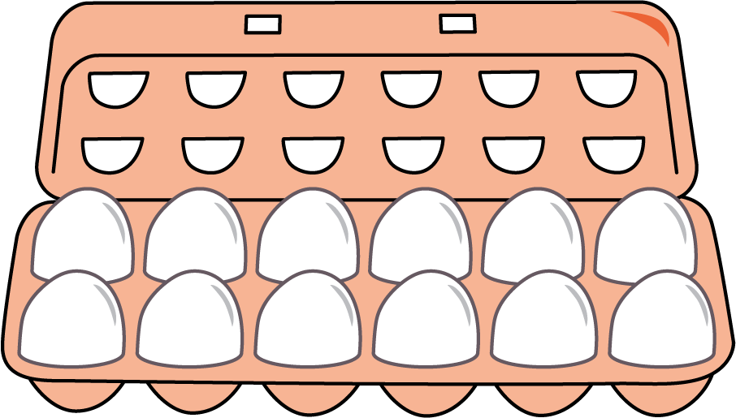

16.1: Compare Equal Groups and Arrays
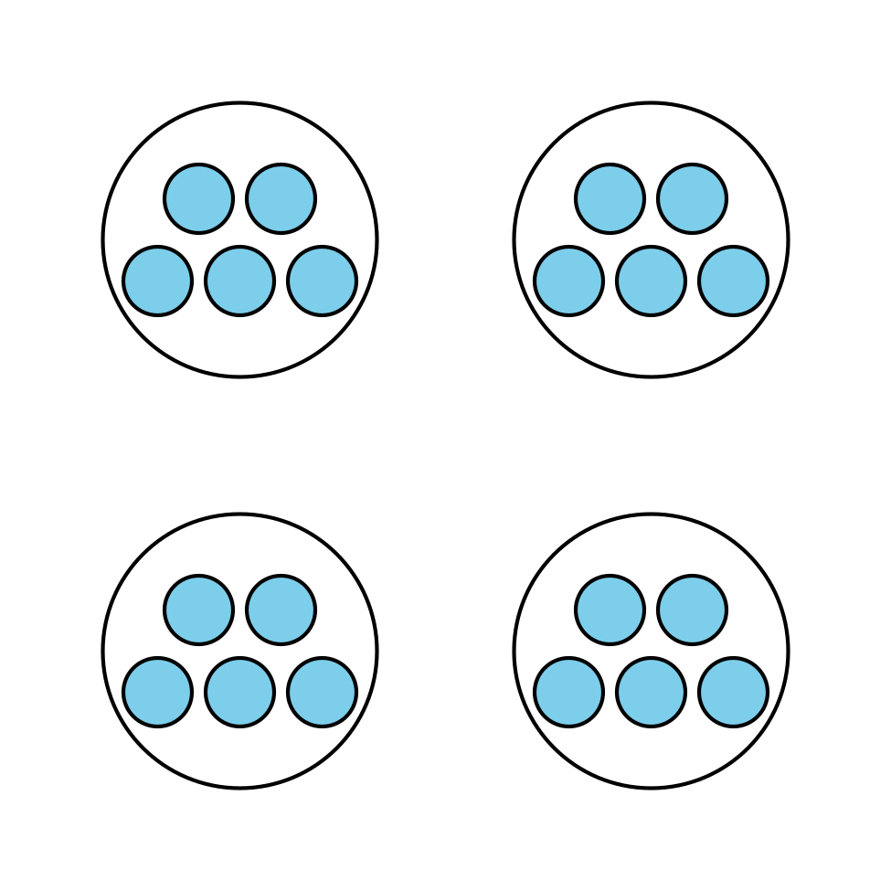

- How does arranging the dots into an array affect how you see the number?
- Noah says he sees equal groups in the drawing with 4 circles and 5 dots in each circle, but says there are no equal groups in the array. Do you agree with Noah? Explain your reasoning.

16.2: Arrange Into Arrays
- Use cubes to make 6 groups of 5.
  - Arrange them into an array.
  - Explain or show how the array is related to equal groups.
- Count out 20 cubes.
  - Arrange them into as many arrays as you can.
  - Explain or show how each array is related to equal groups.
- Count out 24 cubes.
  - Arrange them into as many arrays as you can.
  - Explain or show how each array is related to equal groups.
© CC BY 2021 Illustrative Mathematics®

