Unit 2 Lesson 17: Using Equations for Lines

1 Missing center (Warm up)

Student Task Statement
A dilation with scale factor 2 sends $A$ to $B$. Where is the center of the dilation?
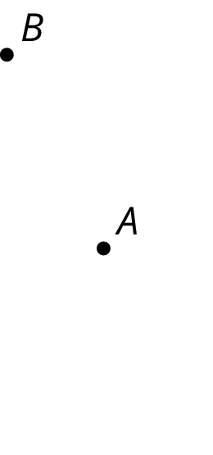

2 Writing Relationships from Two Points

Student Task Statement
Here is a line.
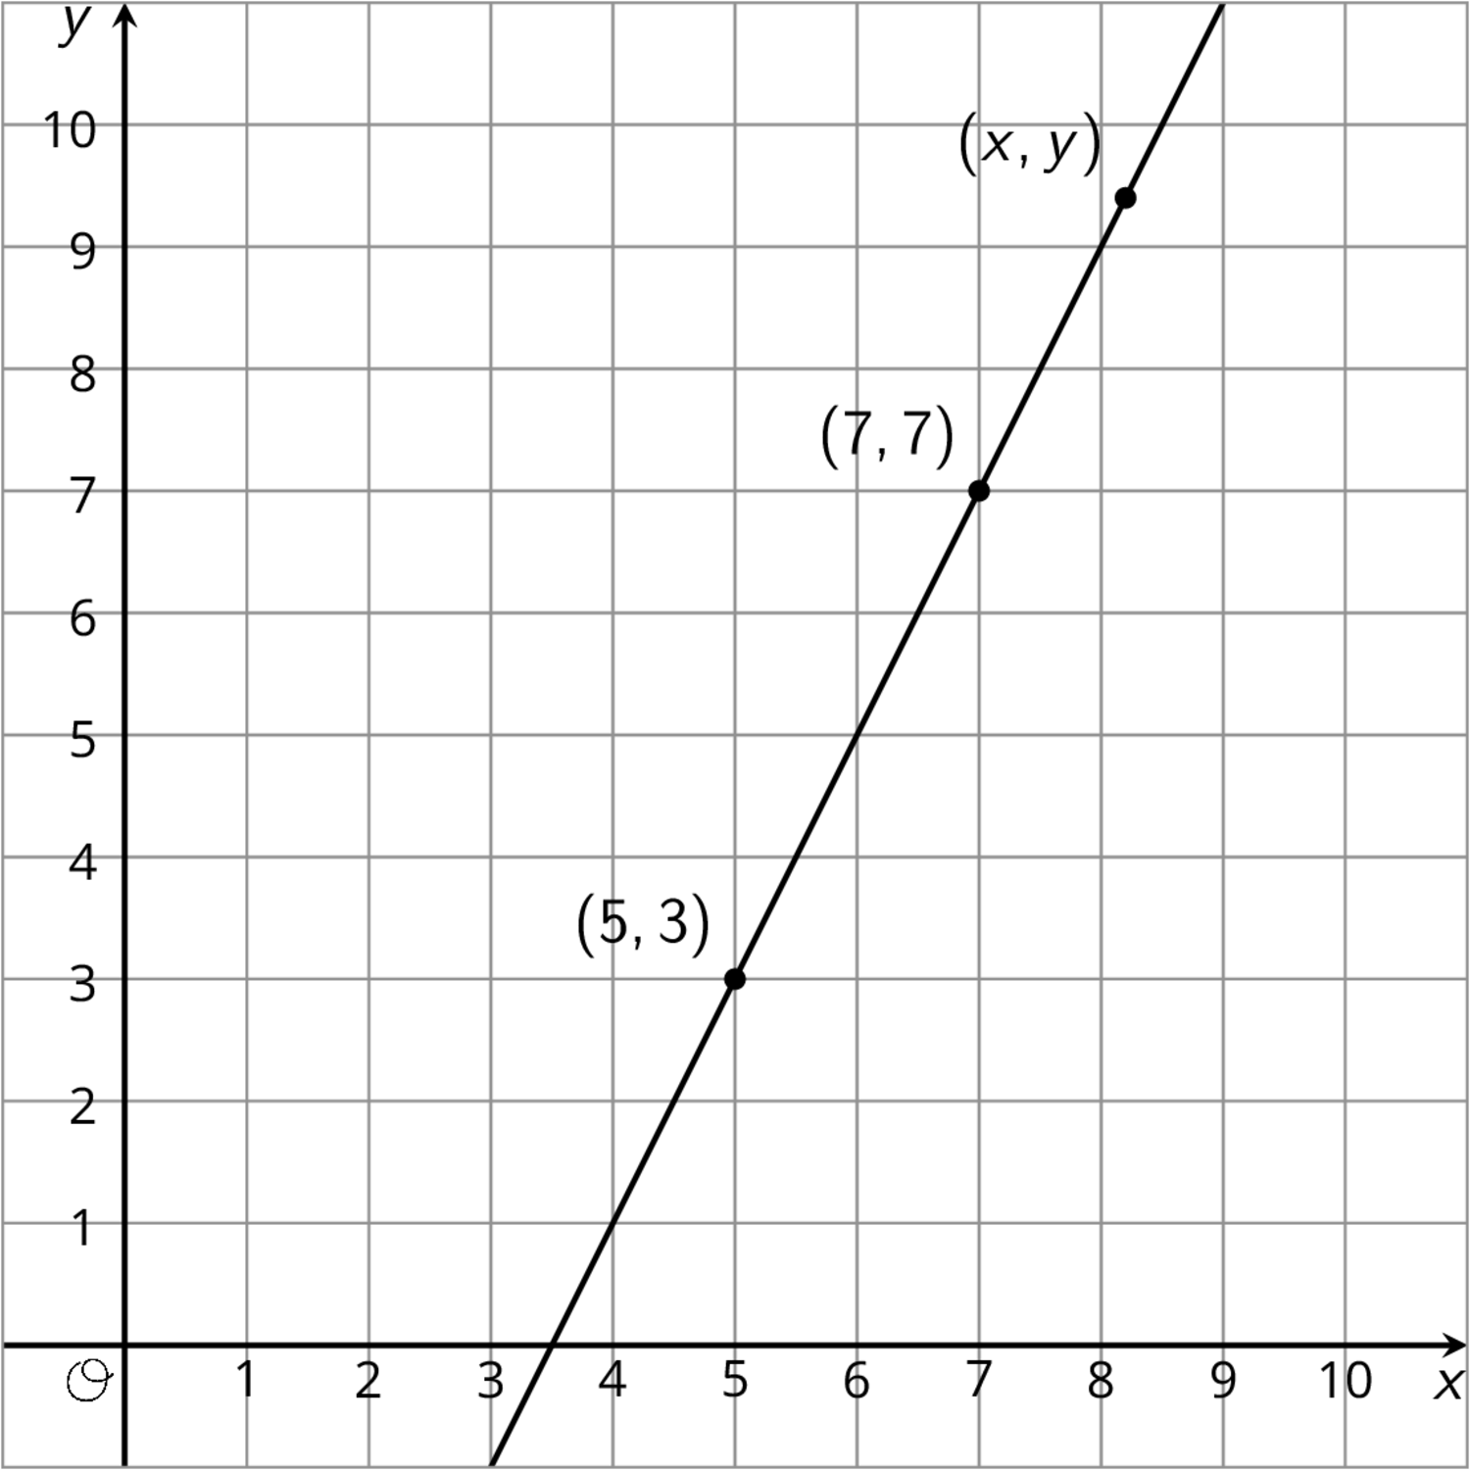
- Using what you know about similar triangles, find an equation for the line in the diagram.
- What is the slope of this line? Does it appear in your equation?
- Is $\left(9,11\right)$ also on the line? How do you know?
- Is $\left(100,193\right)$ also on the line?

3 Dilations and Slope Triangles

Student Task Statement
Here is triangle $ABC$.
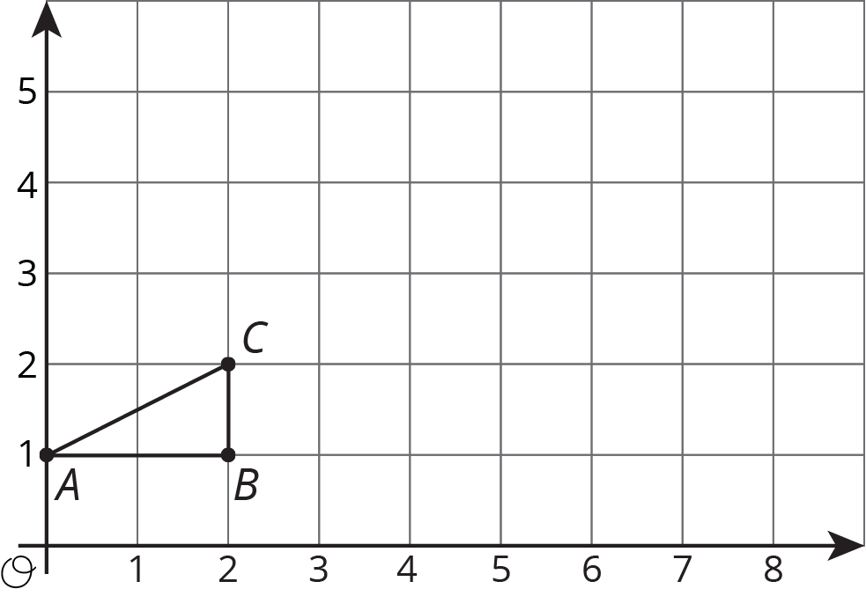
- Draw the dilation of triangle $ABC$ with center $\left(0,1\right)$ and scale factor 2.
- Draw the dilation of triangle $ABC$ with center $\left(0,1\right)$ and scale factor 2.5.
- Where is $C$ mapped by the dilation with center $\left(0,1\right)$ and scale factor $s$?
- For which scale factor does the dilation with center $\left(0,1\right)$ send $C$ to $\left(9,5.5\right)$? Explain how you know.

Images for Activity Synthesis
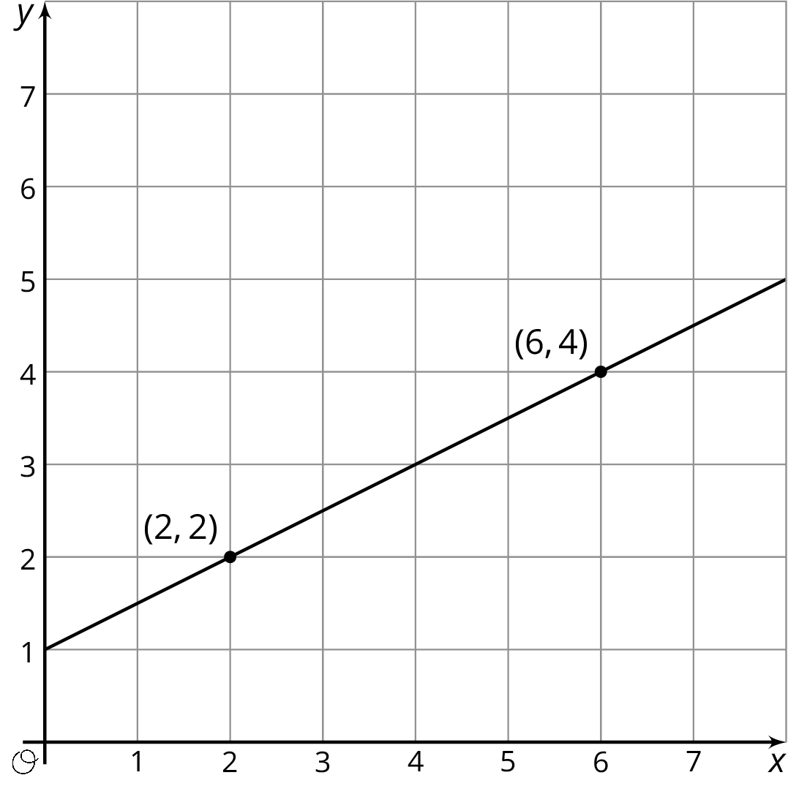
© CC BY Open Up Resources. Adaptations CC BY IM.

