Grade 6
Unit 3Lesson 4CC BY NC Illustrative Mathematics, based on IM 6–8 Math, CC BY Open Up Resources.
Unit 3, Lesson 4

Comparing Speeds and Prices
Let’s compare some speeds and some prices.
Grade 6
Unit 3Lesson 4CC BY NC Illustrative Mathematics, based on IM 6–8 Math, CC BY Open Up Resources.

4.1Treadmill Workouts
Some students did treadmill workouts.
- Tyler ran 4,200 meters in 30 minutes.
- Kiran ran 6,300 meters in $\frac{1}{2}$ hour.
- Mai ran 6.3 kilometers in 45 minutes.
Grade 6
Unit 3Lesson 4CC BY NC Illustrative Mathematics, based on IM 6–8 Math, CC BY Open Up Resources.

4.2More Treadmills
Some students did treadmill workouts, each one running at a constant speed. Answer the questions about their workouts. Explain or show your reasoning.
- Tyler ran 4,200 meters in 30 minutes.
- Kiran ran 6,300 meters in $\frac{1}{2}$ hour.
- Mai ran 6.3 kilometers in 45 minutes.
- What is the same about the workouts done by:
  - Tyler and Kiran?
  - Kiran and Mai?
  - Mai and Tyler?
- At what rate did each of them run?
- How far did Mai run in her first 30 minutes on the treadmill?

Are you ready for more?
Tyler and Kiran each started running at a constant speed at the same time. Tyler ran 4,200 meters in 30 minutes and Kiran ran 6,300 meters in $\frac{1}{2}$ hour. Eventually, Kiran ran 1 kilometer more than Tyler. How much time did it take for this to happen?
Grade 6
Unit 3Lesson 4CC BY NC Illustrative Mathematics, based on IM 6–8 Math, CC BY Open Up Resources.

4.3The Best Deal on Beans
Four different stores posted ads about special sales on 15-oz cans of baked beans.
- Which store is offering the best deal? Explain your reasoning.
- Store A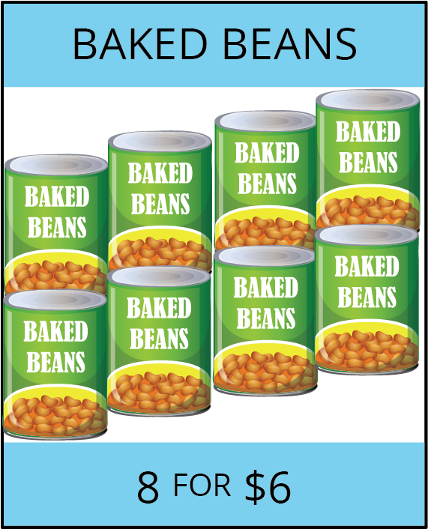
- Store B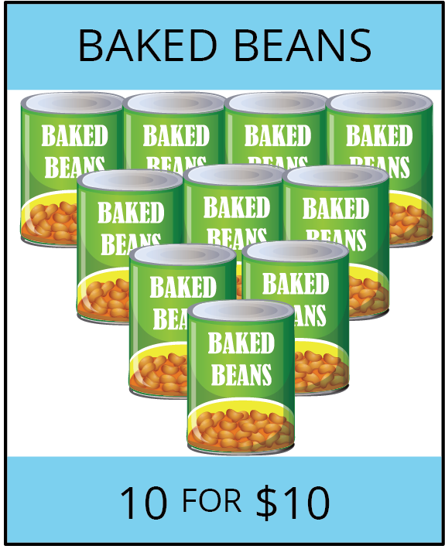
- Store C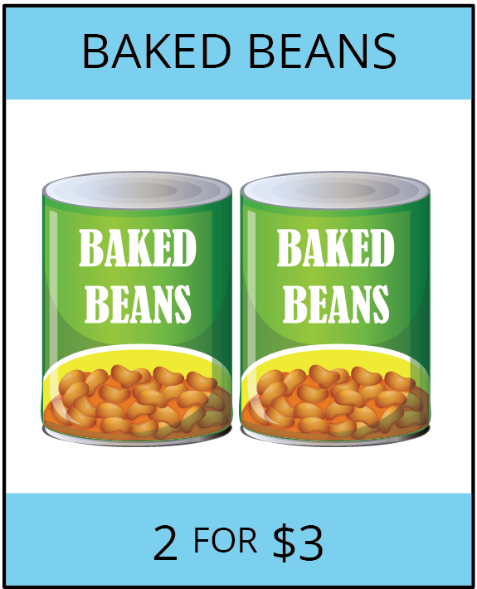
- Store D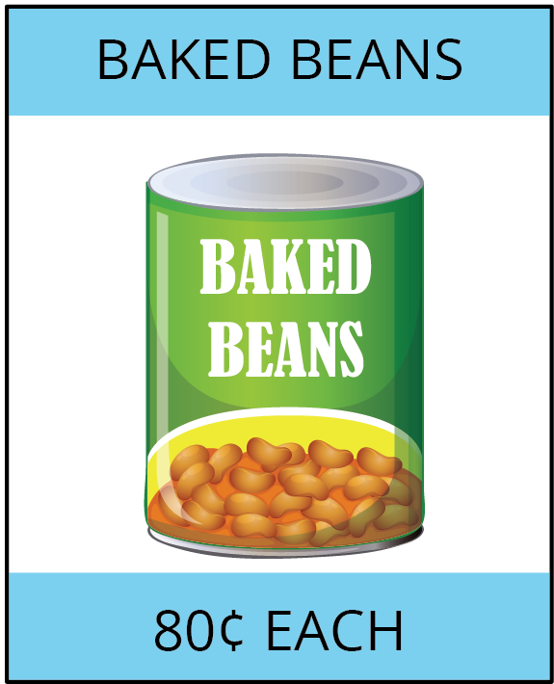
- Store D is also selling 28-oz cans of baked beans for $1.40 each. How does that price compare to the other prices?

Lesson 4 Summary
Diego ran 3 kilometers in 20 minutes. Andre ran 2,550 meters in 17 minutes. Who ran faster? Since neither their distances nor their times are the same, we have two possible strategies:
- Find the time each person took to travel the same distance. The person who traveled that distance in less time is faster.
- Find the distance each person traveled in the same time. The person who traveled a longer distance in the same amount of time is faster.
It is often helpful to compare distances traveled in 1 unit of time (1 minute, for example), which means finding the speed, such as meters per minute.
Let’s compare Diego and Andre’s speeds in meters per minute.
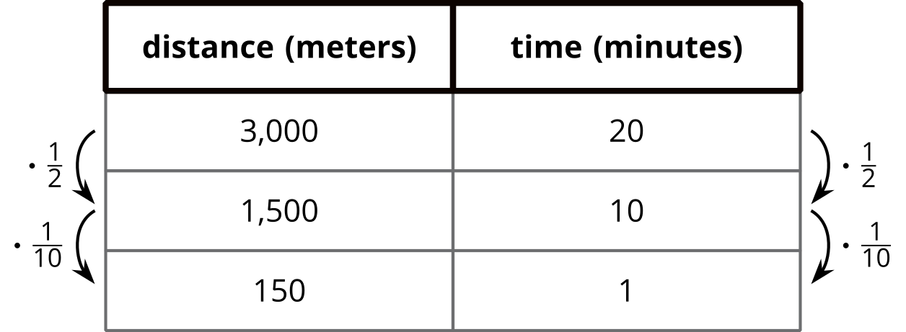
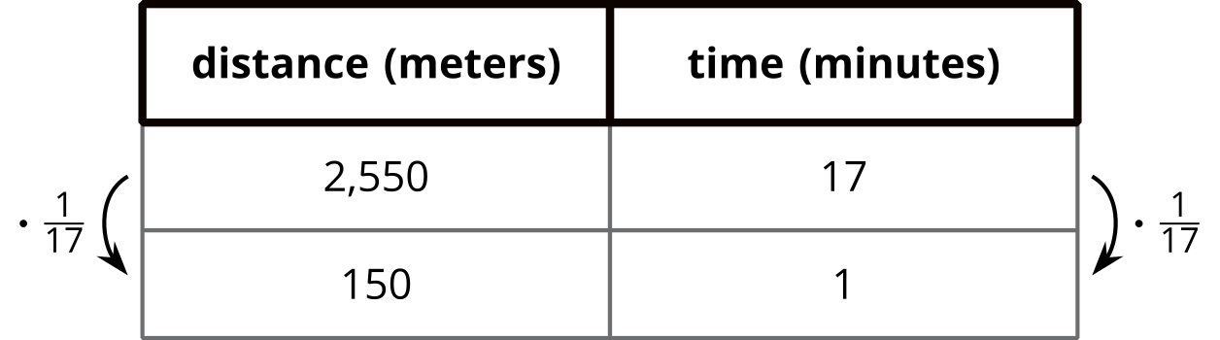
Both Diego and Andre ran 150 meters per minute, so they ran at the same speed.
Finding ratios that tell us how much of quantity $A$ per 1 unit of quantity $B$ is an efficient way to compare rates in different situations. Here are some familiar examples:
- Car speeds in miles per hour.
- Fruit and vegetable prices in dollars per pound.

