Grade 2
Unit 6CC BY NC 2024 Illustrative Mathematics®

Unit 6 Family Support Materials

Geometry, Time, and Money
In this unit, students reason with shapes and their attributes, and partition shapes into equal pieces. This work helps to build a foundation for fractions. Students also solve story problems involving money, using their understanding of fourths, quarters, and skip-counting by 5 to tell time.

Section A: Attributes of Shapes
In this section, students extend their understanding of geometry from previous grades to identify and draw triangles, quadrilaterals, pentagons, and hexagons. Students learn to count the sides to determine the name of a shape and come to see that any shape has the same number of corners as the number of sides. For example, students are familiar with the hexagon shape from the frequent use of pattern blocks in previous grades. They expand their understanding to realize that hexagons include any shape with six sides and six corners, and that the shape may look different from the pattern block they worked with in the past.
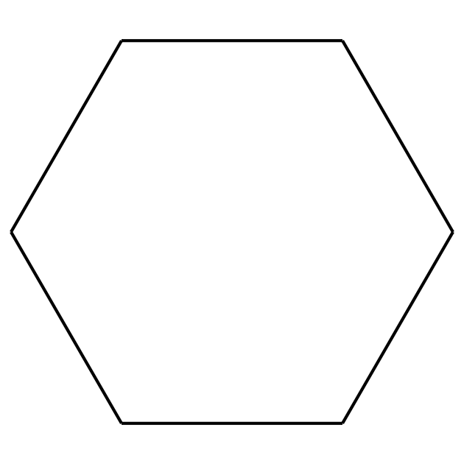
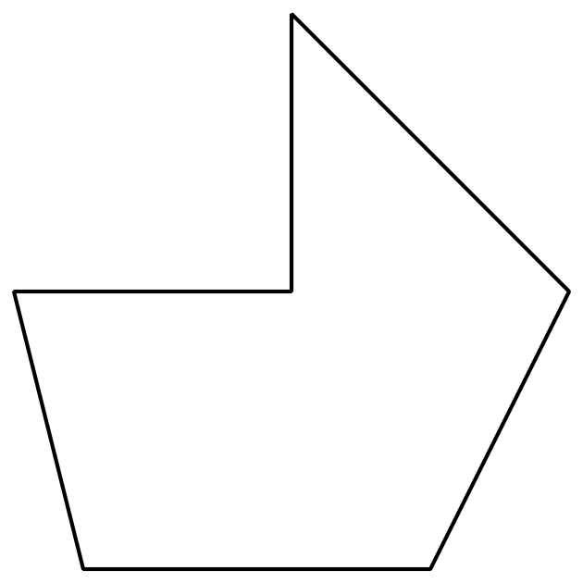
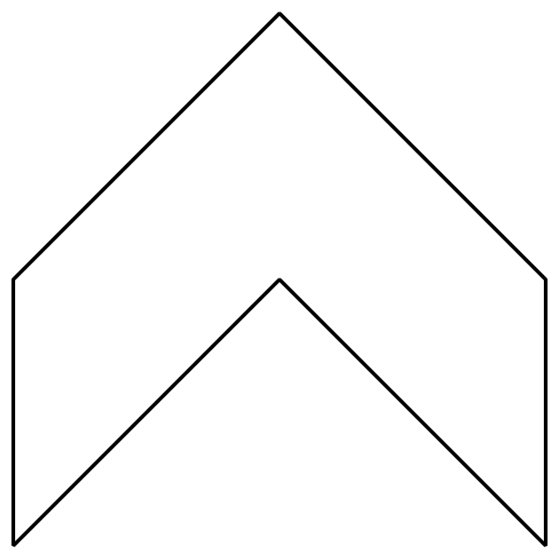
At the end of the section, students use their understanding of two-dimensional (flat) shapes to identify three-dimensional (solid) shapes. They recognize that two-dimensional shapes make up the faces of solid shapes, and use the names of two-dimensional shapes to describe solid shapes. For example, students learn to describe a cube as a solid shape that has 6 equal-size square faces.

Section B: Halves, Thirds, and Fourths
In this section, students learn that shapes can be partitioned into 2, 3, or 4 equal pieces called halves, thirds, and fourths or quarters, respectively. In grade 1, students partitioned shapes into 2 and 4 equal pieces, and described each piece as “a half” and “a fourth” or “a quarter,” respectively. In this section, students add the term “thirds” to their vocabulary.
After analyzing examples and non-examples, students identify equal pieces, and partition rectangles into halves, thirds, and fourths. Shapes are partitioned in different ways to build an understanding that equal pieces of identical wholes do not need to be the same shape. They learn that if the wholes are divided into the same number of equal pieces, the names of the pieces are the same. The example in the image shows a square partitioned into fourths, first using smaller triangles, and then using smaller squares. Students also learn that 2 halves, 3 thirds, and 4 fourths each make up 1 whole.
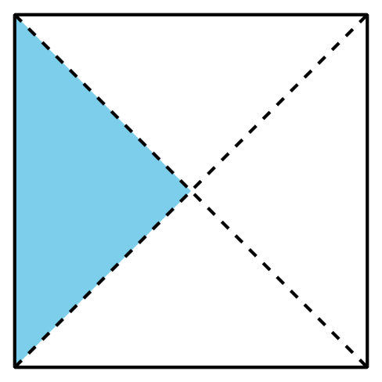
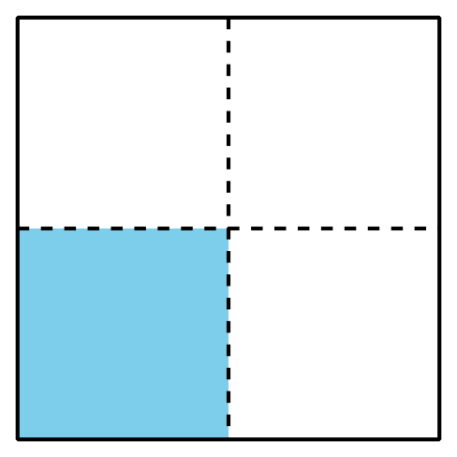

Section C: Time on the Clock
This section continues the focus on the language of fractions as students use their understanding of fourths and quarters to tell time. In this section, students first make a connection between the analog clock and circles partitioned into fourths to tell time, using “half past,” “quarter past,” and “quarter till.”
Students recognize that the hour hand on an analog clock moves toward the next hour as time passes, and they skip-count by 5 to tell time in 5-minute intervals. They represent time on analog clocks by drawing the hour and minute hands and by writing the time numerically.
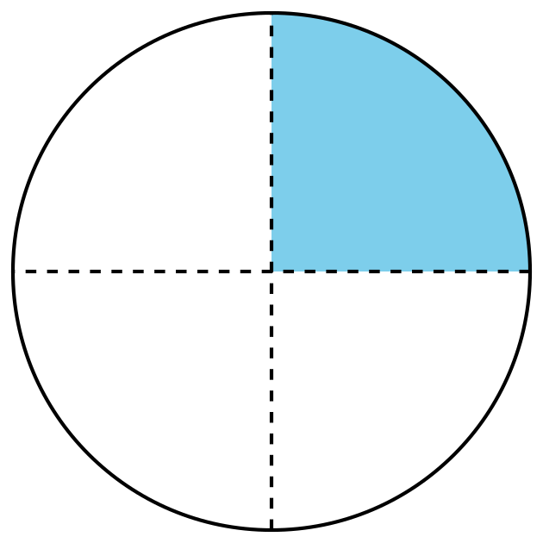
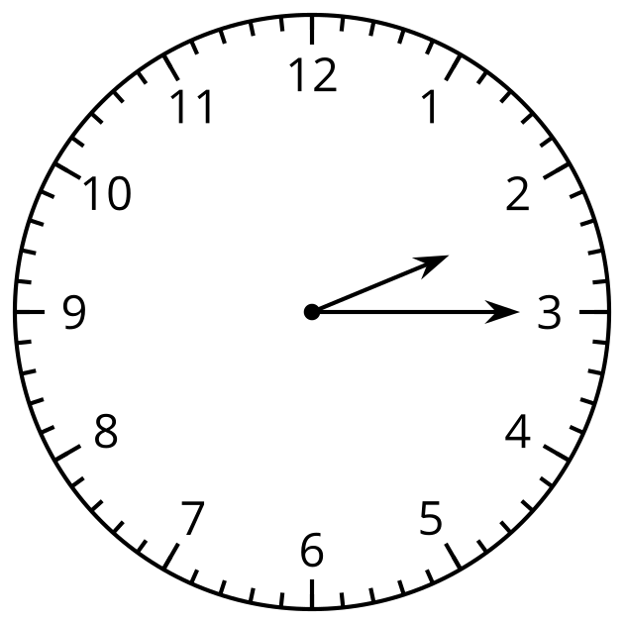
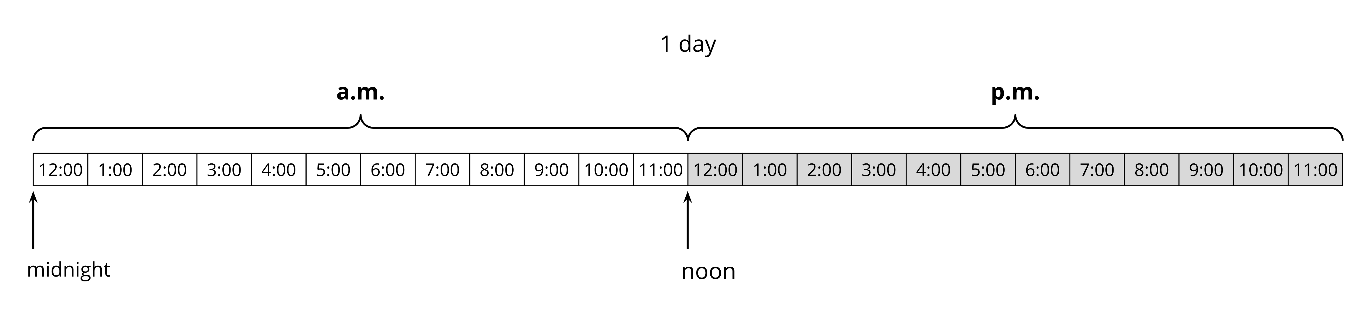
Students learn that each hour comes around twice a day on a 12-hour clock and is labeled with “a.m.” and “p.m.” to distinguish between times of day. Toward the end of this section, students relate a.m. and p.m. times to their daily activities.

Section D: The Value of Money
In this section, students continue to develop fluency with addition and subtraction within 100, through the context of money. They identify coins, such as quarters, dimes, nickels, and pennies, and find the total values of different coin combinations. They learn that 1 dollar has the same value as 100 cents and solve problems involving dollars and cents.

Try it at home!
Near the end of the unit, ask your second grader to complete these tasks:
- Find different shapes around the house. (Bonus points for finding non-traditional shapes!)
- Tell time on an analog clock.
- Determine the value of a coin combination.
Questions that may be helpful as they work:
- How did you know it was a (shape name)?
- How did you determine the time?
- What kind of coin is this? How much is it worth?
- How did you figure out the total value of the coin combination?
Solution:
Answers may vary.
Sample response:
- I knew it was a square because it has 4 equal sides.
- I know that it is 5:15 because I saw that the hour hand is slightly past 5 and the minute hand is pointing toward 3.
- This is a penny. It is worth 1 cent.
- I know that the total is 52 cents because 1 quarter is 25 cents, 2 dimes is 20 cents, 1 nickel is 5 cents, and 2 pennies are 2 cents. $25+20+5+2=52$

