Grade 2
Unit 6Lesson 12CC BY NC 2024 Illustrative Mathematics®
Unit 6, Lesson 12

Count by 5 to Tell Time
- Let’s tell time.
Grade 2
Unit 6Lesson 12CC BY NC 2024 Illustrative Mathematics®

Warm-up Notice and Wonder: Number Line and Clock
What do you notice? What do you wonder?
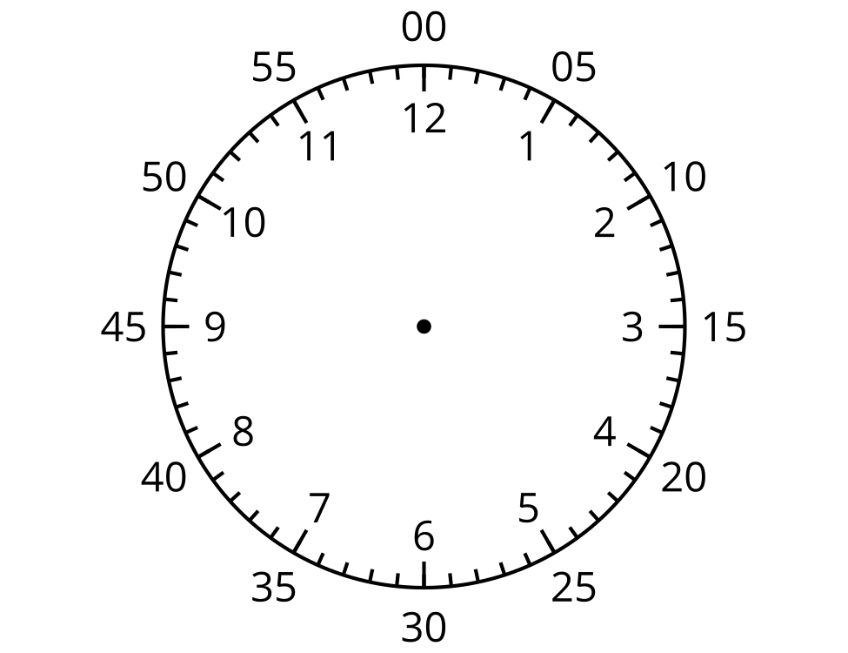
Grade 2
Unit 6Lesson 12CC BY NC 2024 Illustrative Mathematics®

Activity 1 Count by 5 on the Clock
- Discuss 2 ways to read the time on this clock.
- 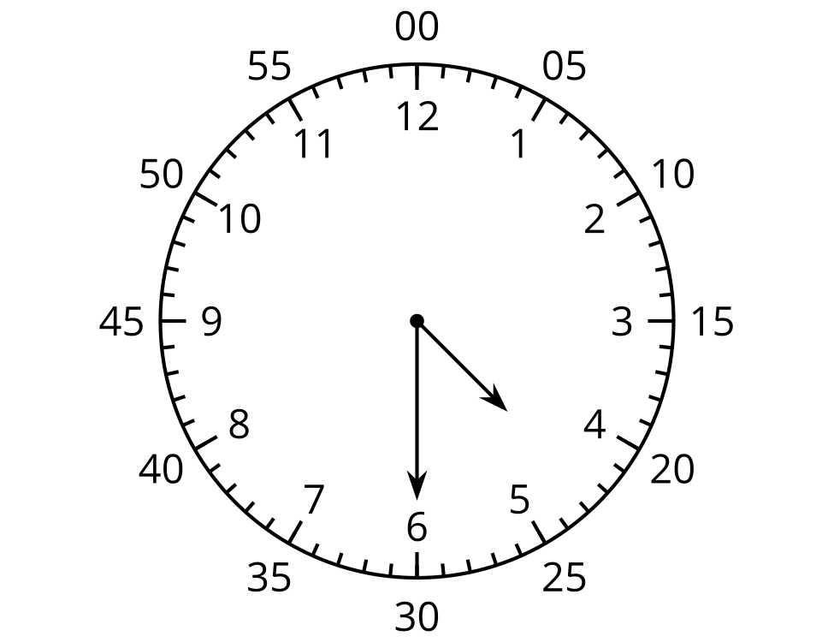
- What time does this clock show?
- 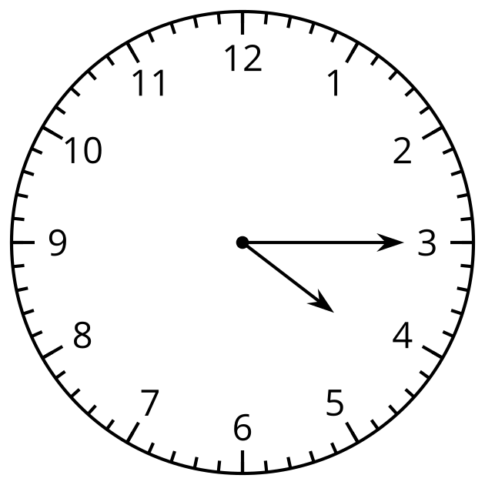
- Read the time on each clock card with your partner. Put the clocks in order, based on the times they show.
Grade 2
Unit 6Lesson 12CC BY NC 2024 Illustrative Mathematics®

Activity 2 Write the Time
Write the time shown on each clock.

- 

 