Grade 2
Unit 6Lesson 14CC BY NC 2024 Illustrative Mathematics®
Unit 6, Lesson 14

Center Day 3
- Let’s notice shapes in books, and practice adding and subtracting.
Grade 2
Unit 6Lesson 14CC BY NC 2024 Illustrative Mathematics®

Warm-up Number Talk: Adding Up to 4 Two-digit Numbers
Find the value of each expression mentally.
- $10+15+20+10$
- $5+30+20$
- $15+20+30$
- $25+15+5+15$
Grade 2
Unit 6Lesson 14CC BY NC 2024 Illustrative Mathematics®

Activity 2 Centers: Choice Time
Choose a center.
Capture Squares
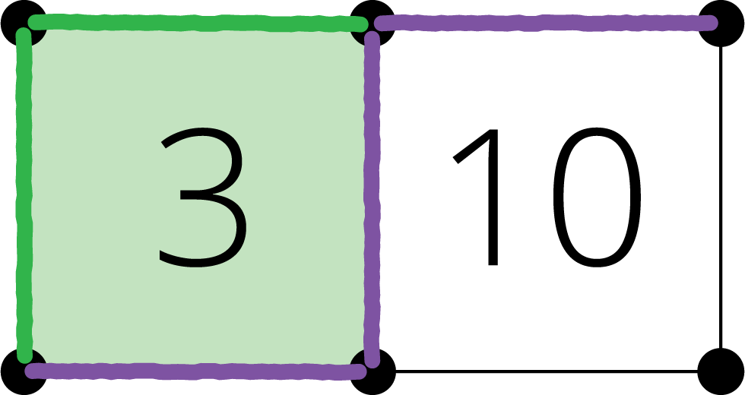
Number Puzzles
Unable to process <img src="/tikz_files/237761.svg">Failed: rsvg-convert --format png --dpi-x 300 --dpi-y 300 /app/tmp/svgtopng-1786381145.948329.svg --output /app/tmp/svgtopng-1786381145.948329.png Backtrace: /app/app/services/script/runner.rb:34:in `block in run_cmd' <internal:kernel>:90:in `tap' /app/app/services/script/runner.rb:32:in `run_cmd' /app/app/services/script/svg_to_png.rb:27:in `convert_svg_to_png' /app/app/services/script/svg_to_png.rb:17:in `to_png' /app/vendor/bundle/ruby/3.3.0/gems/embeddable_content-1.1.0/app/services/embeddable_content/images/image_downloader.rb:37:in `png_rendered_from_svg' /app/vendor/bundle/ruby/3.3.0/gems/embeddable_content-1.1.0/app/services/embeddable_content/images/image_downloader.rb:33:in `raw_image_data' /app/vendor/bundle/ruby/3.3.0/gems/embeddable_content-1.1.0/app/services/embeddable_content/images/image_downloader.rb:13:in `block in save' <internal:kernel>:90:in `tap' /app/vendor/bundle/ruby/3.3.0/gems/embeddable_content-1.1.0/app/services/embeddable_content/images/image_downloader.rb:13:in `save'
Picture Books


