Grade 2
Unit 7Lesson 18CC BY NC 2024 Illustrative Mathematics®
Unit 7, Lesson 18

Center Day 3
- Let’s add and subtract 3-digit numbers.
Grade 2
Unit 7Lesson 18CC BY NC 2024 Illustrative Mathematics®

Warm-up Number Talk: Simplify It
Find the value of each expression mentally.
- $34−9$
- $434−99$
- $367−98$
- $635−298$
Grade 2
Unit 7Lesson 18CC BY NC 2024 Illustrative Mathematics®

Activity 2More Target Numbers and Choice Time
Choose a center.
Target Numbers
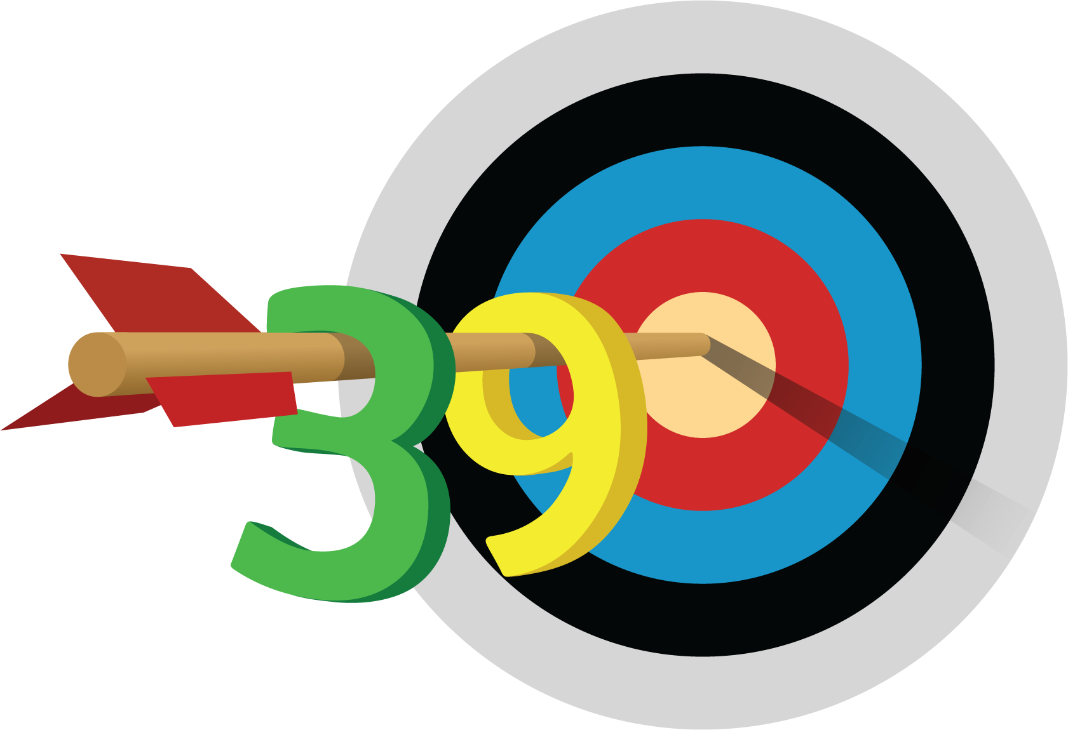
Five in a Row: Addition and Subtraction
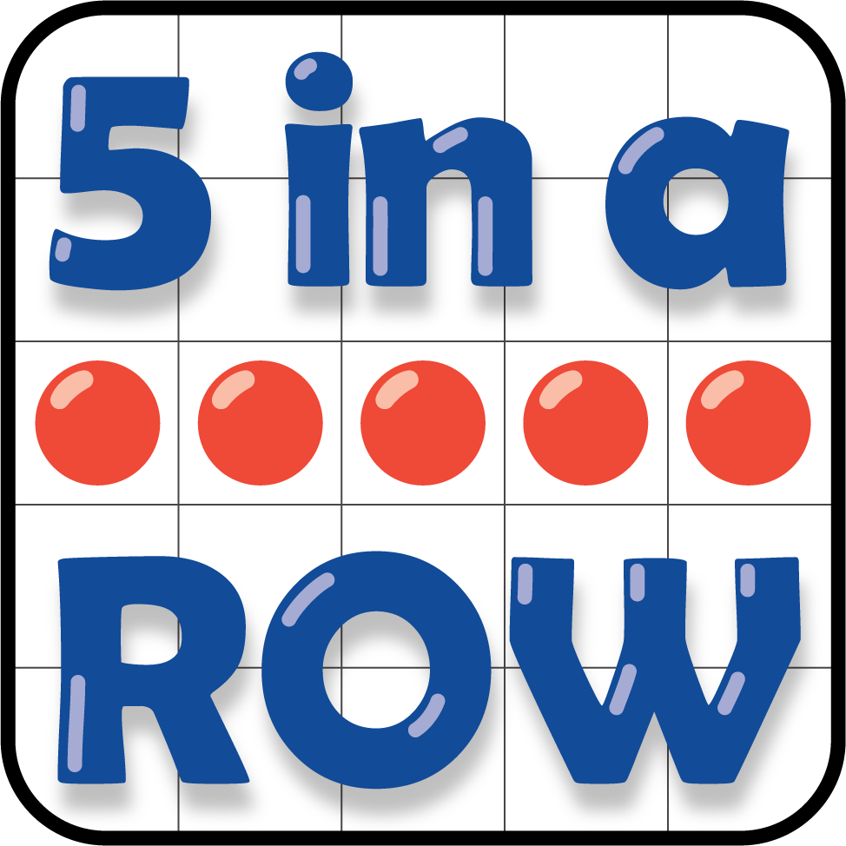
How Close?
