Unit 2 Lesson 9: End Behavior (Part 2)

1 It’s a Cover Up (Warm up)

Student Task Statement
Match each of the graphs to the polynomial equation it represents. For the graph without a matching equation, write down what must be true about the polynomial equation.

A
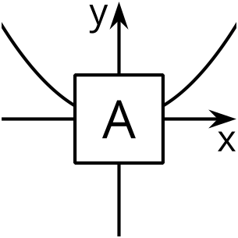

B
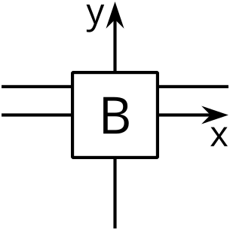

C
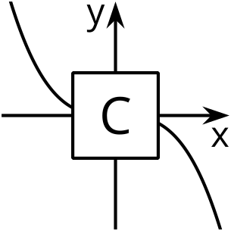

D
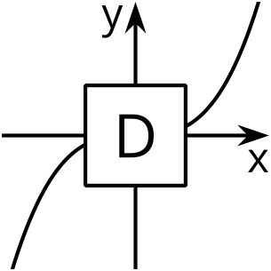
- $y=x\left(x+3\right)\left(2−x\right)$
- $y=1−3x+5x^{4}$
- $y=5\left(x+3\right)−5x$

2 The Case of Unexpected End Behavior

Student Task Statement
- Write an equation for a polynomial with the following properties: it has even degree, it has at least 2 terms, and, as the inputs get larger and larger in either the negative or positive directions, the outputs get larger and larger in the negative direction.
- Pause here so your teacher can review your work.
- Write an equation for a polynomial with the following properties: it has odd degree, it has at least 2 terms, as the inputs get larger and larger in the negative direction the outputs get larger and larger in the positive direction, and as the inputs get larger and larger in the positive direction, the outputs get larger and larger in the negative direction.

3 Which is Greater?

Student Task Statement
$M$ and $N$ are each functions of $x$ defined by $M\left(x\right)=\text{-}x^{3}−2x+8$ and $N\left(x\right)=\text{-}20x^{2}+3x+8$.
- Describe the end behavior of $M$ and $N$.
- For $x>0$, which function do you think has greater values? Be prepared to share your reasoning with the class.
© CC BY 2019 by Illustrative Mathematics®

