Lesson 1: Unidades estándar de medida

Standards Alignments
Building On | 1.MD.A.2
Addressing | 2.MD.A
Building Towards | 2.MD.A.1, 2.MD.A.2

Teacher-facing Learning Goals
- Measure by iterating same-size length units.

Student-facing Learning Goals
- Midamos longitud.

Lesson Purpose
The purpose of this lesson is for students to measure by iterating same-size length units and identify the need for standard units of measurement.
In grade 1, students learned how to measure length by laying multiple copies of a shorter object end to end without gaps or overlaps. In this lesson, students use these measuring skills to measure the length of objects by iterating with straws and centimeter cubes. In the first activity, students use different length units when measuring the same objects and see that this leads to different measurements. In the second activity, all students use the same length unit (centimeter cubes) and see they all find the same measurement. In the lesson synthesis, students are introduced to the centimeter as the length of a centimeter cube. Students will use the centimeter as a length unit in future lessons.
Give students access to centimeter cubes during the cool-down.

Access for:

Students with Disabilities
- Representation (Activity 2)

Instructional Routines
MLR8 Discussion Supports (Activity 1), What Do You Know About _____? (Warm-up)

Materials to Gather
- Centimeter cubes: Activity 2
- Connecting cubes: Activity 2
- Straws: Activity 1
- String: Activity 1

Lesson Timeline
Warm-up | 10 min
Activity 1 | 15 min
Activity 2 | 20 min
Lesson Synthesis | 10 min
Cool-down | 5 min

Teacher Reflection Question
In grade 1, students measured by iterating same-size length units. How did students demonstrate their understanding and skill with measurement in this lesson? What can you do in future lessons to build on these strengths?

Cool-down
(to be completed at the end of the lesson) 5min
Mide un rectángulo

Standards Alignments
Addressing | 2.MD.A

Student-facing Task Statement
- ¿Qué tan largo es el rectángulo?
Usa cubos de un centímetro para medir.
- 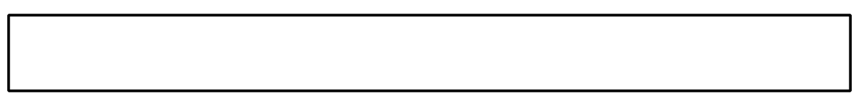
- ____________ cubos de un centímetro
- Clare obtuvo 6 cuando midió el mismo rectángulo.
¿Por qué puede ser diferente su medida?

Student Responses
- 11 centimeter cubes
- Sample response: Clare’s measurement might be different because she probably used a different kind of cube to measure.

