Lesson 26 Practice Problems
- The organizers of a conference needs to prepare at least 200 notepads for the event and have a budget of $160 for the notepads. A store sells notepads in packages of 24 and packages of 6.
- This system of inequalities represent these constraints: $\left\{\begin{matrix}24x+6y≥200 \\ 16x+5.40y≤160\end{matrix}\right.$
  - Explain what the second inequality in the system tells us about the situation.
  - Here are incomplete graphs of the inequalities in the system, showing only the boundary lines of the solution regions.
  - Which graph represents the boundary line of the second inequality?
  - 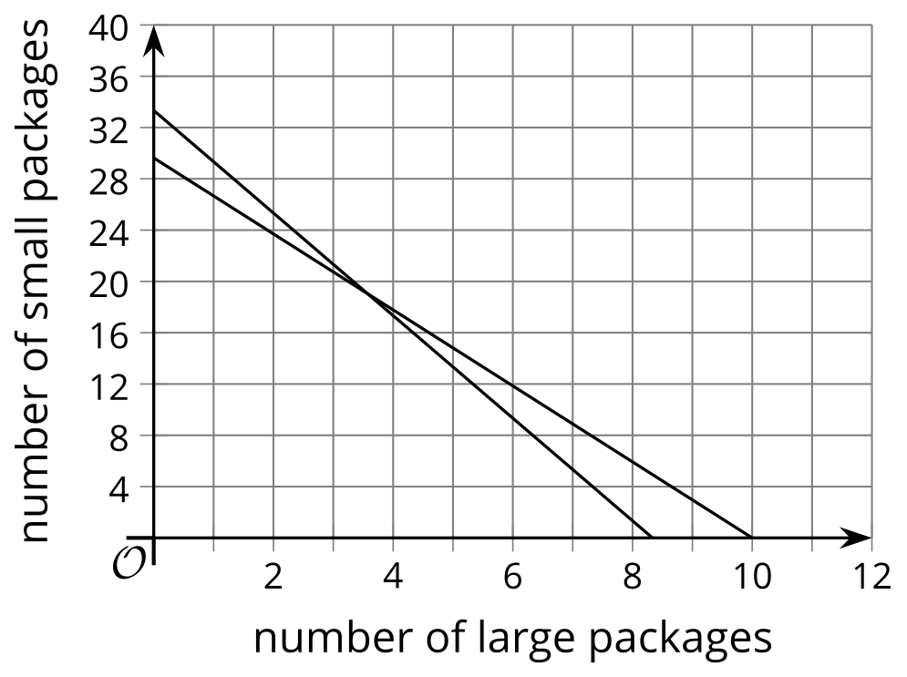
  - Complete the graphs to show the solution set to the system of inequalities.
  - Find a possible combination of large and small packages of notepads the organizer could order.
- (From Unit 2, Lesson 25.)
- A certain stylist charges $15 for a haircut and $30 for hair coloring. A haircut takes on average 30 minutes, while coloring takes 2 hours. The stylist works up to 8 hours in a day, and she needs to make a minimum of $150 a day to pay for her expenses.
  - Create a system of inequalities that describes the constraints in this situation. Be sure to specify what each variable represents.
  - Graph the inequalities and show the solution set.
  - 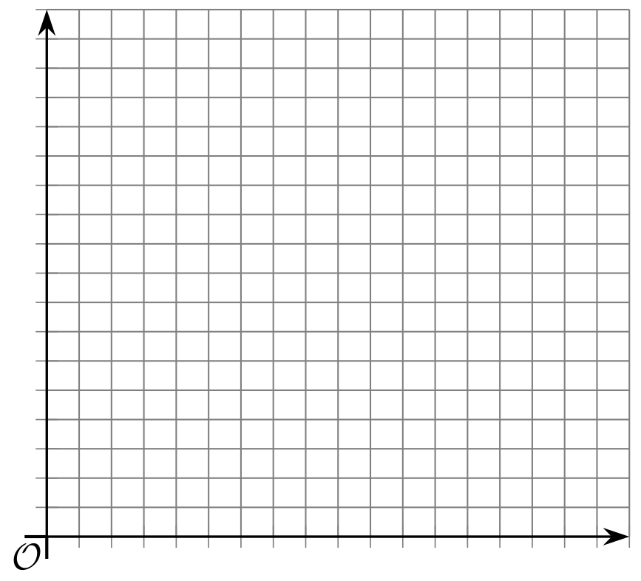
  - Identify a point that represents a combination of haircuts and and hair-coloring jobs that meets the stylist’s requirements.
  - Identify a point that is a solution to the system of inequalities but is not possible or not likely in the situation. Explain why this solution is impossible or unlikely.
- (From Unit 2, Lesson 25.)
- Choose the graph that shows the solution to this system: $\left\{\begin{matrix}y>3x+2 \\ \text{-}4x+3y≤12\end{matrix}\right.$
  - 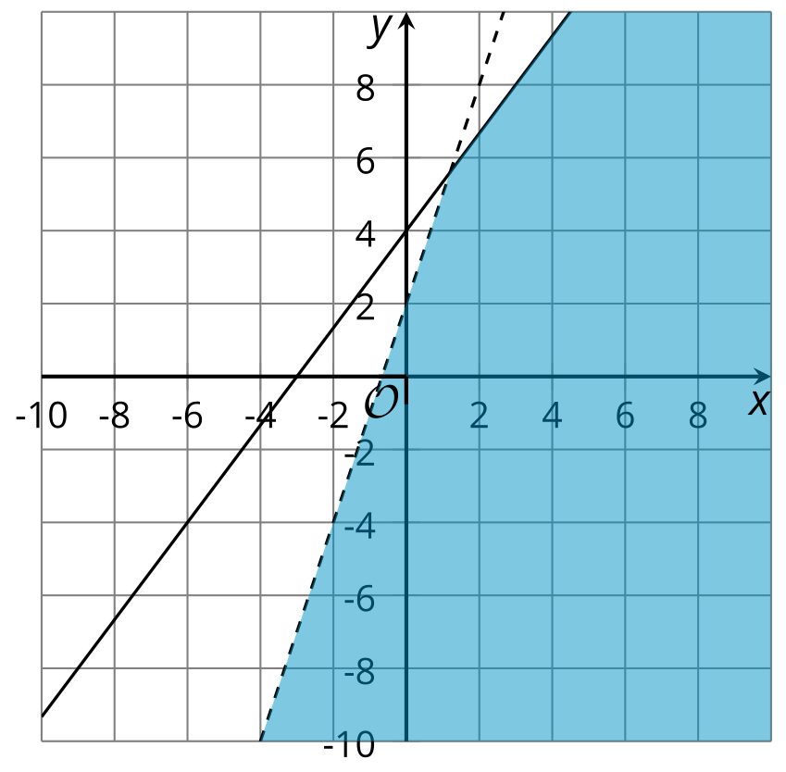
  - 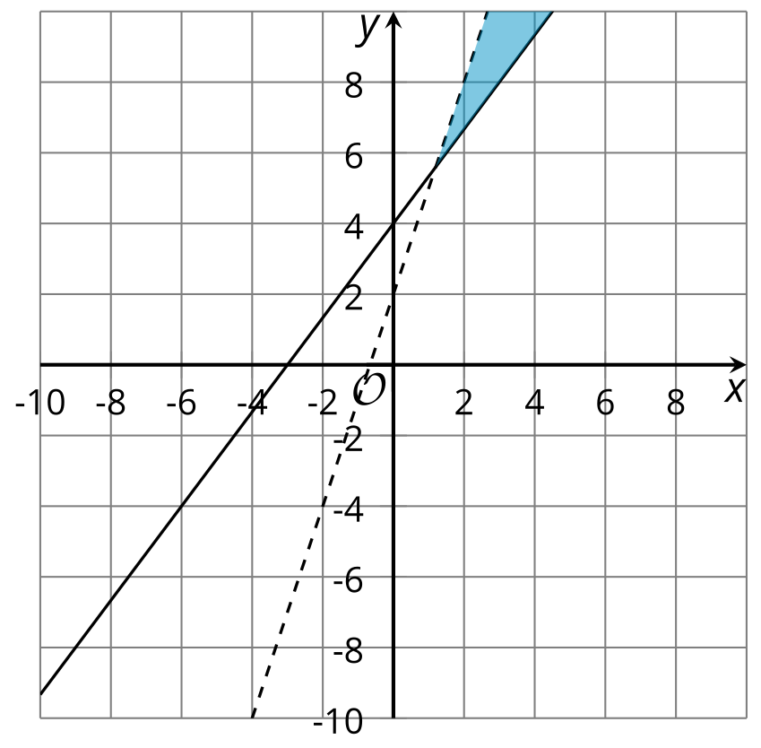
  - 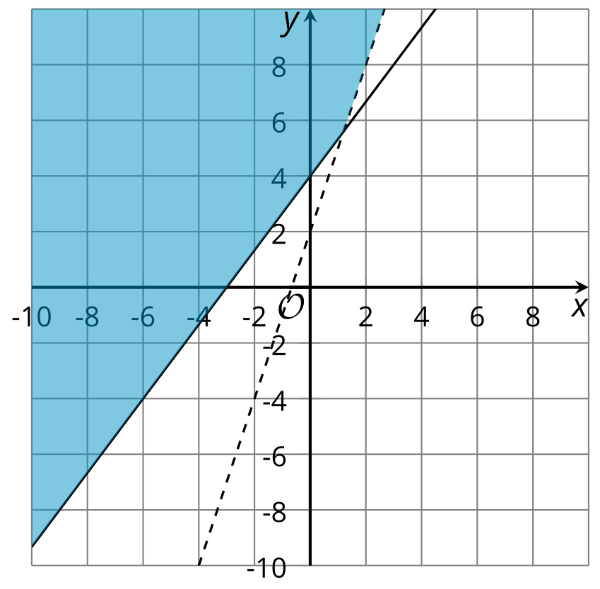
  - 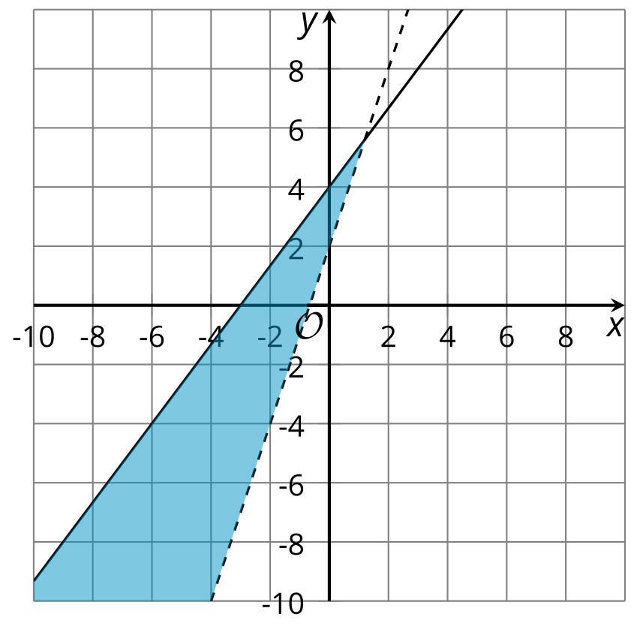
- (From Unit 2, Lesson 24.)
- Match each inequality to the graph of its solution.
  - 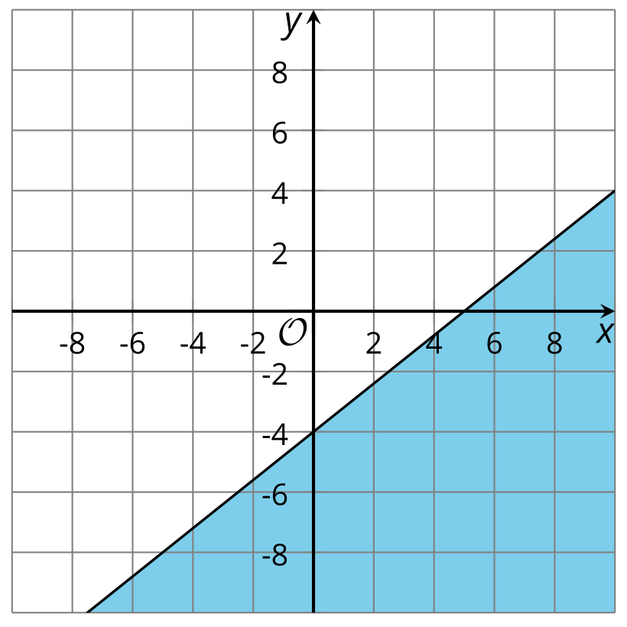
  - 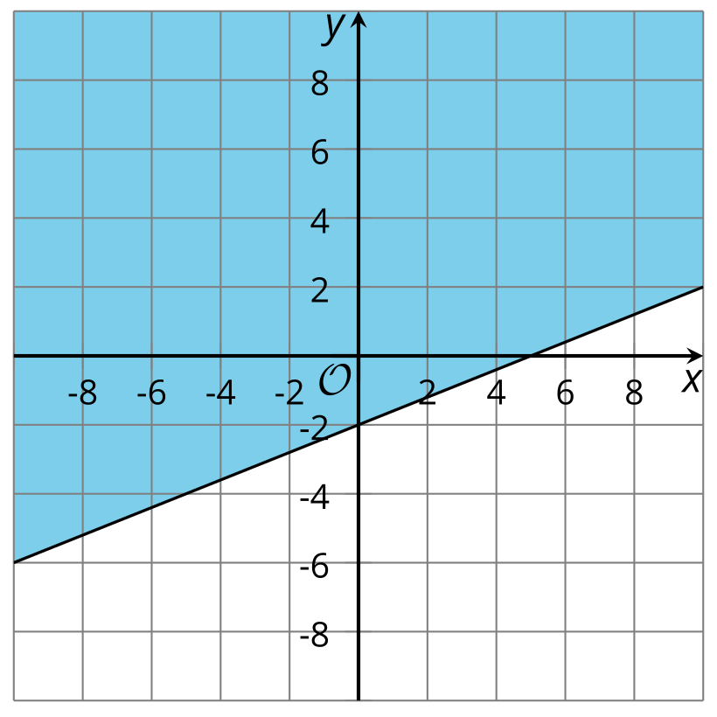
  - 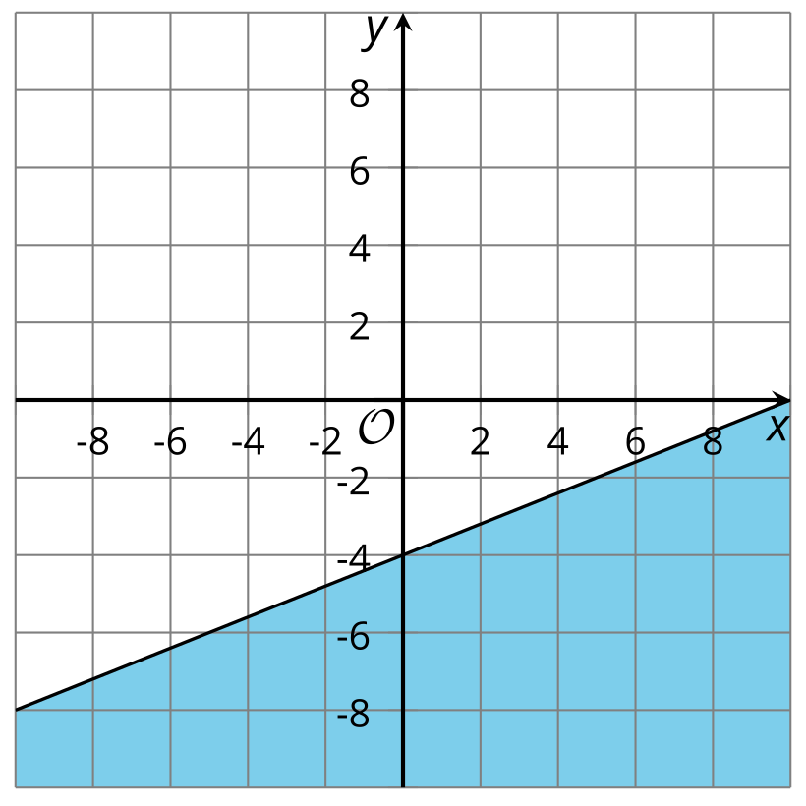
  - 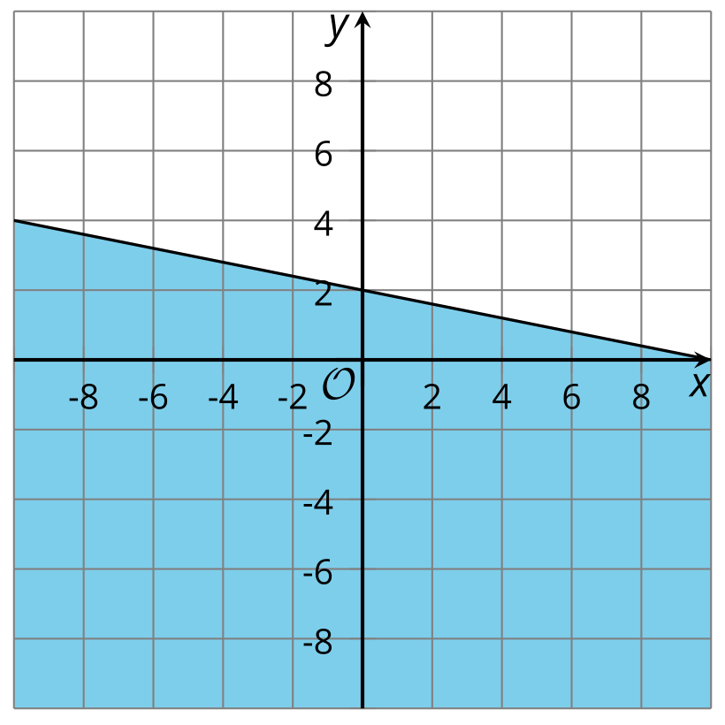
  - 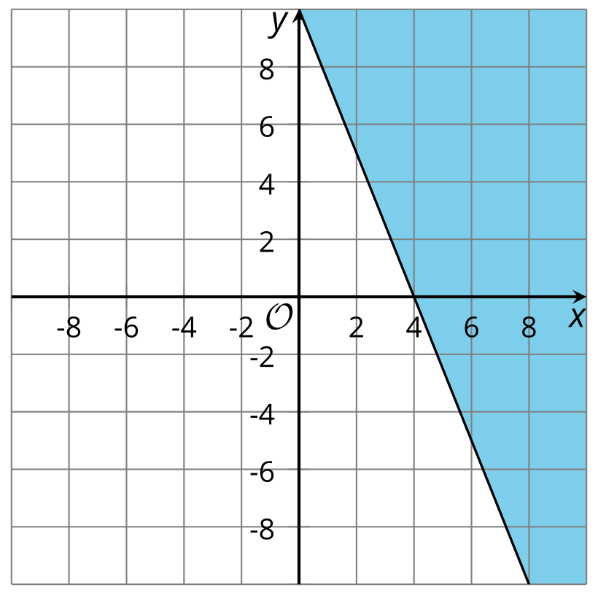
  - $2x−5y≥20$
  - $5x+2y≥20$
  - $4x−10y≤20$
  - $4x−5y≥20$
  - $2x+10y≤20$
- (From Unit 2, Lesson 23.)
© CC BY 2019 by Illustrative Mathematics®

