Grade 6
Unit 2Lesson 12CC BY NC Illustrative Mathematics, based on IM 6–8 Math, CC BY Open Up Resources.
Unit 2, Lesson 12

Navigating a Table of Equivalent Ratios
Let’s use a table of equivalent ratios like a pro.
Grade 6
Unit 2Lesson 12CC BY NC Illustrative Mathematics, based on IM 6–8 Math, CC BY Open Up Resources.

12.1Math Talk: Multiplying by a Unit Fraction
Find the value of each product mentally.
- $\frac{1}{3}⋅21$
- $\frac{1}{6}⋅21$
- $\left(5.6\right)⋅\frac{1}{8}$
- $\frac{1}{4}⋅\left(5.6\right)$
Grade 6
Unit 2Lesson 12CC BY NC Illustrative Mathematics, based on IM 6–8 Math, CC BY Open Up Resources.

12.2Comparing Taco Prices
number of tacos | price in dollars
Use the table to help you solve these problems. Explain or show your reasoning.
- Noah bought 4 tacos and paid $6. At this rate, how many tacos could he buy for $15?
- Jada’s family bought 50 tacos for a party and paid $72. Were Jada’s tacos the same price as Noah’s tacos?
Grade 6
Unit 2Lesson 12CC BY NC Illustrative Mathematics, based on IM 6–8 Math, CC BY Open Up Resources.

12.3Hourly Wages
Lin is paid $90 for 5 hours of work. She used the table to calculate how much she would be paid at this rate for 8 hours of work.
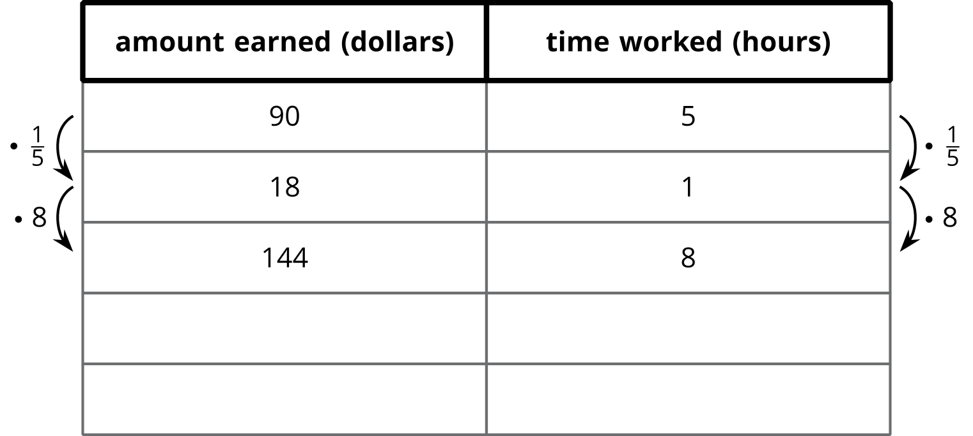
- What is the meaning of the 18 that appears in the table?
- Why was the number $\frac{1}{5}$ used as a multiplier?
- Explain how Lin used this table to solve the problem.
- At this rate, how much would Lin be paid for 3 hours of work? For 2.1 hours of work?
Grade 6
Unit 2Lesson 12CC BY NC Illustrative Mathematics, based on IM 6–8 Math, CC BY Open Up Resources.

12.4Memory Card
In 2022, 128 gigabytes (GB) of portable computer memory cost $16.
- Here is a double number line diagram that represents the situation.
- 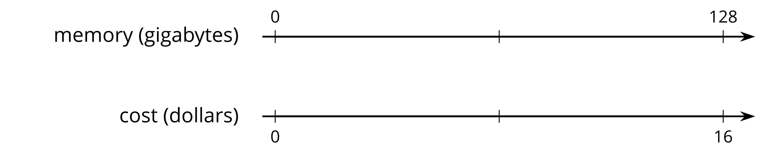
- One set of tick marks has already been drawn to show the result of multiplying 128 and 16 each by $\frac{1}{2}$. Label the amount of memory and the cost for these tick marks.
- Next, keep multiplying by $\frac{1}{2}$ and drawing and labeling new tick marks, until you can no longer clearly label each new tick mark with a number.
- Here is a table that represents the situation. Find the cost of 1 gigabyte. You can use as many rows as you need.
- memory (gigabytes) | - cost (dollars)
- 128 | - 16
- 
- Did you prefer the double number line or the table for solving this problem? Why?

Are you ready for more?
Here is another question about finding half of something repeatedly. A question like this was originally posed by Zeno of Elea, a Greek philosopher who lived around 490–430 BCE.
Suppose you stand in the middle of the classroom and move toward the door to exit. Every time you make a move toward the door, you travel only half the distance between you and the door.
- Can you reach the door and get out? Make a prediction and be prepared to explain your reasoning.
- Compare your prediction with those of your classmates. Do you all agree one way or the other? If it seems helpful, consider using objects to demonstrate your thinking.
- Going halfway toward a destination is one of Zeno’s paradoxes. A paradox is a situation that both cannot be true and must be true at the same time. How would you explain that it is both possible and impossible to get out of the room?

Lesson 12 Summary
Finding a row containing a “1” is often a good way to work with tables of equivalent ratios. For example, the price for 4 lbs of granola is $5. At that rate, what would be the price for 62 lbs of granola?
Here are tables showing two different approaches to solving this problem. Both of these approaches are correct. However, one approach is more efficient.
- Less efficient
- 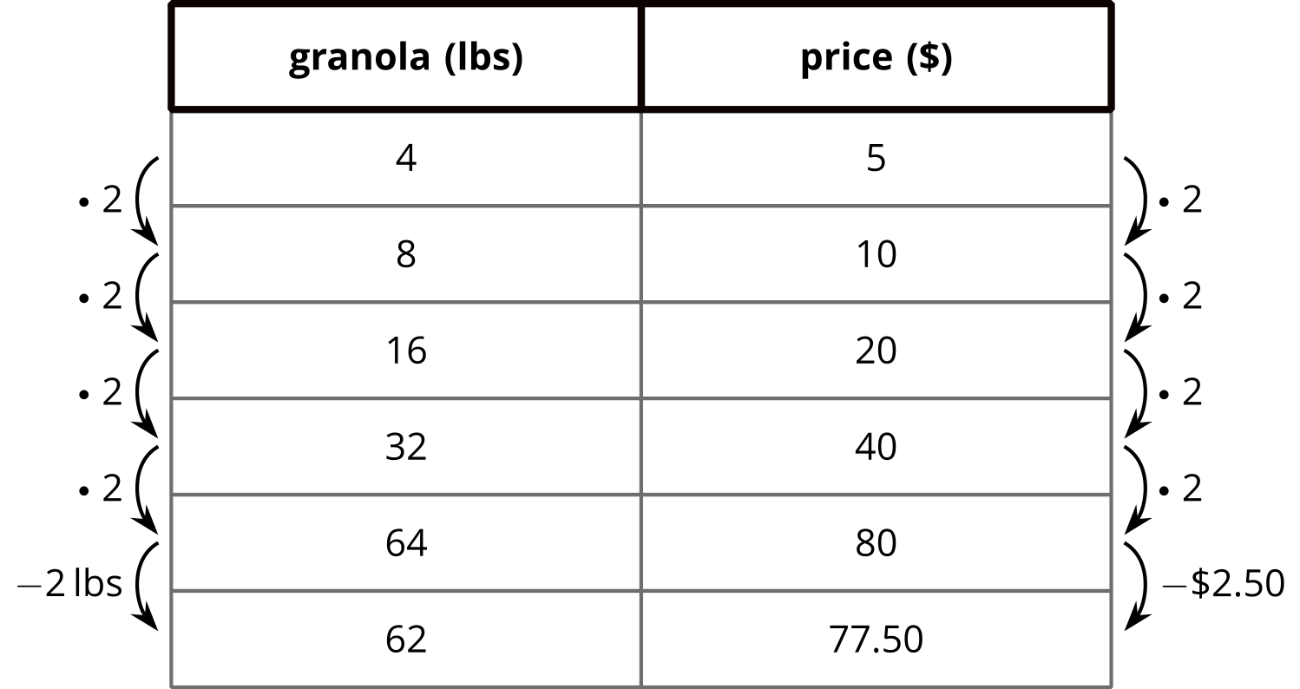
- More efficient
- 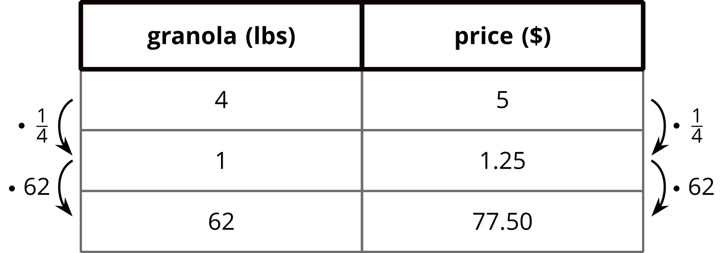
Notice how the more efficient approach starts by finding the price for 1 lb of granola.
Remember that dividing by a whole number is the same as multiplying by a unit fraction. In this example, we can divide by 4 or multiply by $\frac{1}{4}$ to find the unit price.

