Grade 6
Unit 3Lesson 7CC BY NC Illustrative Mathematics, based on IM 6–8 Math, CC BY Open Up Resources.
Unit 3, Lesson 7

More Rate Comparisons
Let's use unit rates like a pro.
Grade 6
Unit 3Lesson 7CC BY NC Illustrative Mathematics, based on IM 6–8 Math, CC BY Open Up Resources.

7.1An Incomplete Pack
You enter a store to buy a 4-pack of drinks. You find that the drink is nearly sold out and the last pack on the shelf has only 3 bottles.
A pack of 4 bottles costs $3.16. The clerk offers to sell the incomplete pack for $2.25.
Would you take the deal?
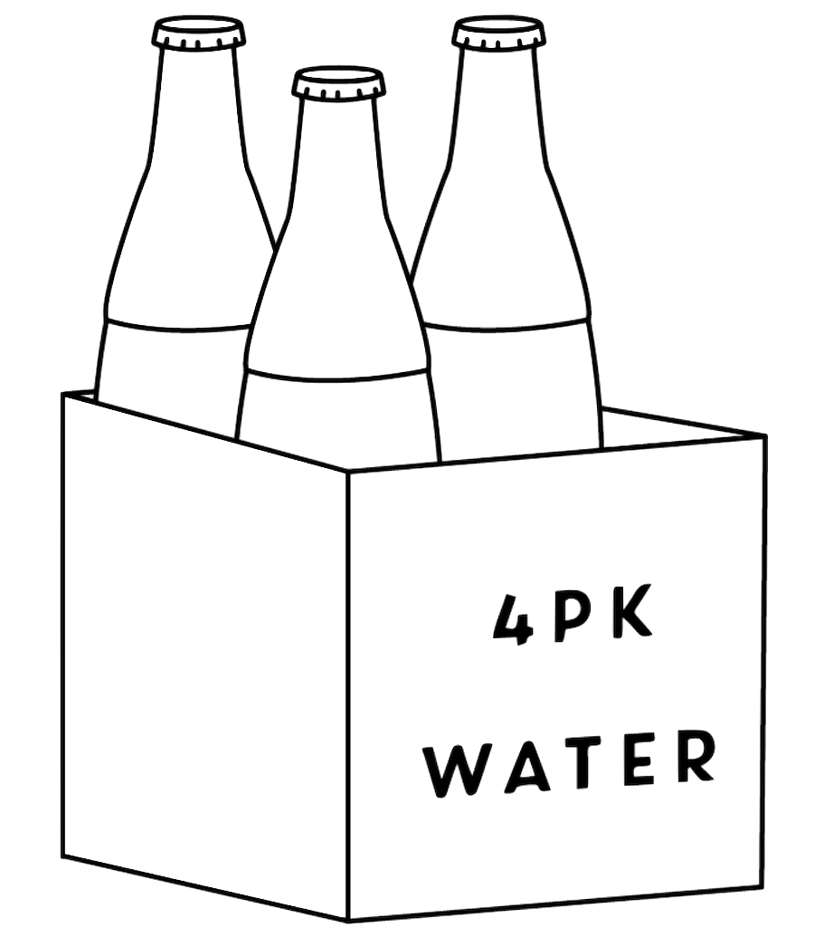
Grade 6
Unit 3Lesson 7CC BY NC Illustrative Mathematics, based on IM 6–8 Math, CC BY Open Up Resources.

7.2Card Sort: Is it a Deal?
Your teacher will give you a set of cards showing different offers.
- Find Card A, and work with your partner to decide whether the offer on Card A is a good deal. Explain or show your reasoning.
- Next, split Cards B–E so that you and your partner each have two.
  - Decide individually if your two cards are good deals. Be prepared to explain your reasoning.
  - For each of your cards, tell your partner whether you think it is a good deal or not, and explain why. Listen to your partner’s explanations for the other cards. If you disagree, explain your thinking.
  - Revise any decisions about your cards based on the feedback from your partner.
- When you and your partner are in agreement about Cards B–E, place all the cards that you think are a good deal in one stack and all the cards that you think are a bad deal in another stack. Be prepared to explain your reasoning.

Are you ready for more?
It’s time to make your own deal!
Read the information on Card F, and then decide what you would charge if you were the clerk. When your teacher signals, trade cards with another group and decide whether or not you would take the other group’s offer.
You may or may not offer a fair deal, but the goal is to set a price so that the other group cannot immediately tell if the deal is a good one.
Grade 6
Unit 3Lesson 7CC BY NC Illustrative Mathematics, based on IM 6–8 Math, CC BY Open Up Resources.

7.3The Fastest of All
Six wild animals sprinted for 1 minute. The table shows how far they ran.
animal | sprint distance
cougar | 1,408 yards
antelope | 1 mile
hare | 49,632 inches
kangaroo | 1,073 meters
ostrich | 1.15 kilometers
coyote | 3,773 feet
Which animal ran the farthest in 1 minute? Order the sprint distances from greatest to least. Show your reasoning.
Here is some conversion information that you may find useful:
1 inch = 2.54 centimeters
1 mile = 1,760 yards
1 mile = 5,280 feet
1 yard = 3 feet
1 foot = 12 inches
1 kilometer = 1,000 meters
1 meter = 100 centimeters

Lesson 7 Summary
Sometimes we can find and use more than one unit rate to solve a problem.
Suppose a small bag of powder detergent holds 16 ounces and is sold for $2. A large bag that holds 2 kilograms is sold for $8. Which is a better deal?
Because the bags are in different units of weight, it helps to make comparisons using the same unit. Here are two different ways:
Compare the price per kilogram:
- The large bag costs $8 for 2 kilograms, so it costs $4 per kilogram ($8÷2=4$).
- The small bag holds 16 ounces or 1 pound of detergent, so it costs $2 per pound. At this rate, the cost is $2⋅\left(2.2\right)$ or $4.40 per kilogram (since there are about 2.2 pounds in 1 kilogram).
The large bag is a better deal, because it costs less money for the same amount of detergent.
Compare the weight of detergent per dollar:
- With the small bag, we get 1 pound of detergent for $2 or 0.5 pound per dollar.
- With the large bag, we get 2 kilograms of detergent for $8 or about 4.4 pounds for $8. This means we get $\left(4.4\right)÷8$, or 0.55, pound per dollar.
The large bag is a better deal, because we get more detergent for the same amount of money.
Another way to solve the problem would be to compare the unit prices of each bag in dollars per ounce. Try it!

