Grade 6
Unit 4CC BY NC Illustrative Mathematics, based on IM 6–8 Math, CC BY Open Up Resources.

Unit 4 Family Support Materials

Dividing Fractions

Section A: Making Sense of Division
This week, your student will be thinking about the meaning of division to prepare to learn about division of fractions. Suppose we have 10 liters of water to divide into equal-size groups. We can think of the division $10÷2$ in two ways, or as the answer to two questions:
- “How many bottles can we fill with 10 liters if each bottle has 2 liters?”
- “How many liters are in each bottle if we divide 10 liters into 2 bottles?”
Here are two diagrams to show the two interpretations of $10÷2$:
A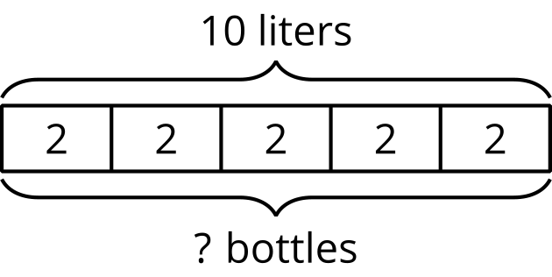
B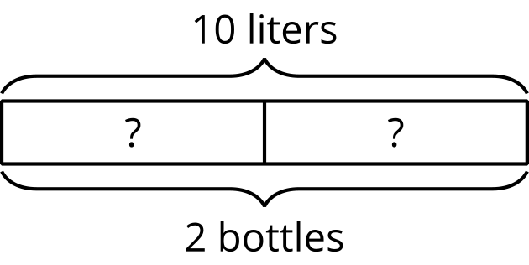
In both cases, the answer to the question is 5, but it could mean either “there are 5 bottles with 2 liters in each” or “there are 5 liters in each of the 2 bottles.”
Here is a task to try with your student:
- Write two different questions we can ask about $15÷6$.
- Estimate the answer: Is it less than 1, equal to 1, or greater than 1? Explain your estimate.
- Find the answer to one of the questions you wrote. It might help to draw a picture.
Solution:
- Sample questions:
  - A ribbon that is 15 inches long is divided into 6 equal sections. How long (in inches) is each section?
  - A ribbon that is 15 inches is divided into 6-inch sections. How many sections are there?
- Greater than 1. Sample reasoning:
  - $12÷6$ is 2, so $15÷6$ must be greater than 2.
  - If we divide 15 into 15 groups ($15÷15$), we get 1. So if we divide 15 into 6, which is a smaller number of groups, the amount in each group must be greater than 1.
- $2\frac{1}{2}$. Sample diagram:
- 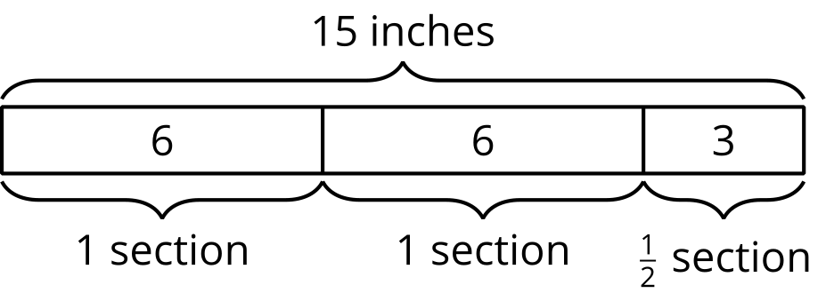

Section B: Meanings of Fraction Division
Earlier, students learned that a division such as $10÷2=?$ can be interpreted as “How many groups of 2 are in 10?” or “How much is in each group if there are 10 in 2 equal-size groups?” They also saw that the relationship between 10, 2, and the unknown number ("?") can also be expressed with multiplication:
$2⋅?=10$
$?⋅2=10$
This week, they use these ideas to divide fractions. For example, $6÷1\frac{1}{2}=?$ can be thought of as “How many groups of $1\frac{1}{2}$ are in 6?” Expressing the question as a multiplication and drawing a diagram can help us find the answer.
$?⋅1\frac{1}{2}=6$
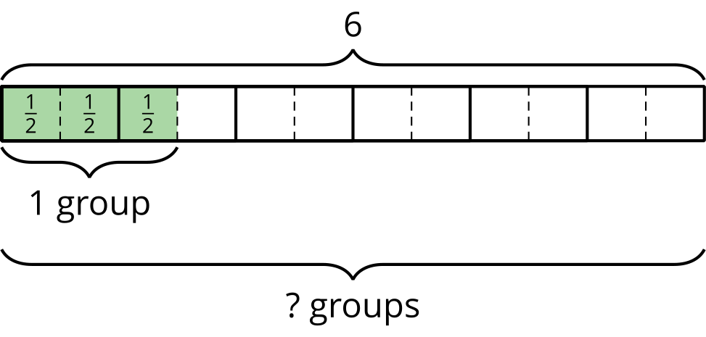
From the diagram we can count that there are 4 groups of $1\frac{1}{2}$ in 6.
We can also think of $6÷1\frac{1}{2}=?$ as “How much is in each group if there are $1\frac{1}{2}$ equal groups in 6?” A diagram can also be useful here.
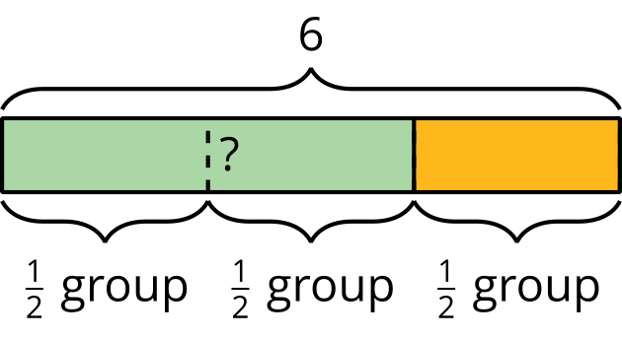
From the diagram we can see that there are three $\frac{1}{2}$ groups in 6. This means there is 2 in each $\frac{1}{2}$ group, or 4 in 1 group.
In both cases, $6÷1\frac{1}{2}=4$, but the 4 can mean different things depending on how the division is interpreted.
Here is a task to try with your student:
- How many groups of $\frac{2}{3}$ are in 5?
  - Write a division equation to represent the question. Use a “?” to represent the unknown amount.
  - Find the answer. Explain or show your reasoning.
- A sack of flour weighs 4 pounds. A grocer is distributing the flour into equal-size bags.
  - Write a question such that $4÷\frac{2}{5}=?$ could represent the situation.
  - Find the answer. Explain or show your reasoning.
Solution:

  - $5÷\frac{2}{3}=?$
  - $7\frac{1}{2}$. Sample reasoning: There are 3 thirds in 1, so there are 15 thirds in 5. That means there are half as many two-thirds, or $\frac{15}{2}$ two-thirds, in 5.

  - 4 pounds of flour are divided equally into bags of $\frac{2}{5}$ pound each. How many bags will there be?
  - 10 bags. Sample reasoning: Break every 1 pound into fifths, and then count how many groups of $\frac{2}{5}$ there are.
  - 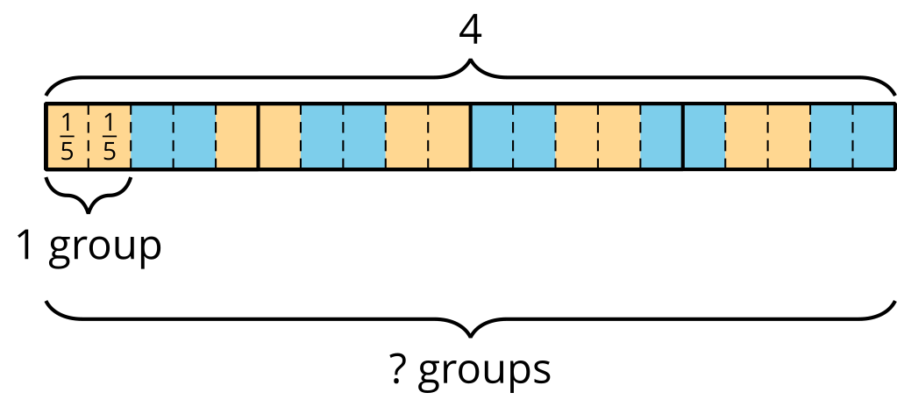

Section C: Algorithm for Fraction Division
Many people have learned that to divide a fraction, we “invert and multiply.” This week, your student will learn why this works by studying a series of division statements and diagrams such as these:
- $2÷\frac{1}{3}=?$ can be viewed as “How many $\frac{1}{3}$s are in 2?”
- 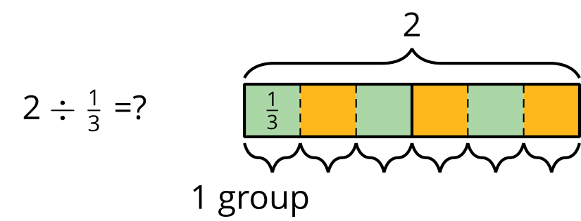
- Because there are 3 thirds in 1, there are $\left(2⋅3\right)$, or 6, thirds in 2. So dividing 2 by $\frac{1}{3}$ has the same outcome as multiplying 2 by 3.
- $2÷\frac{2}{3}=?$ can be viewed as “How many $\frac{2}{3}$s are in 2?”
- 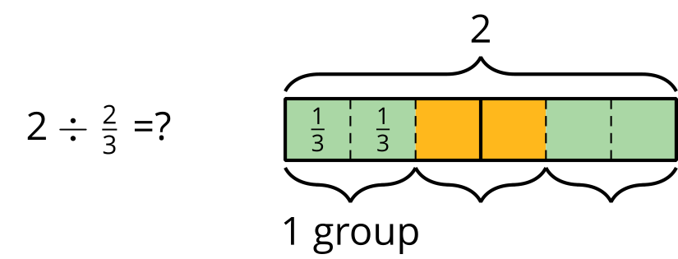
- We already know that there are $\left(2⋅3\right)$, or 6, thirds in 2. To find how many $\frac{2}{3}$s are in 2, we need to combine every 2 of the thirds into a group. Doing this results in half as many groups. So $2÷\frac{2}{3}=\left(2⋅3\right)÷2$, which equals 3.
- $2÷\frac{4}{3}=?$ can be viewed as “How many $\frac{4}{3}$s are in 2?”
- 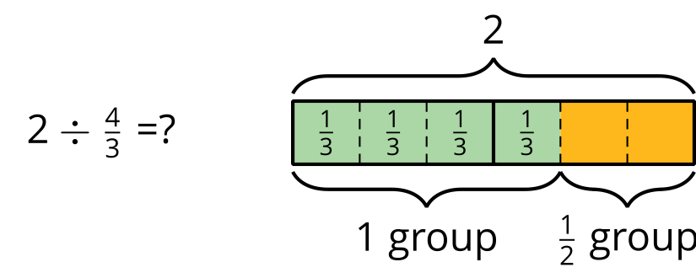
- Again, we know that there are $\left(2⋅3\right)$ thirds in 2. To find how many $\frac{4}{3}$s are in 2, we need to combine every 4 of the thirds into a group. Doing this results in one fourth as many groups. So $2÷\frac{4}{3}=\left(2⋅3\right)÷4$, which equals $1\frac{1}{2}$.
Notice that each division problem above can be answered by multiplying 2 by the denominator of the divisor and then dividing it by the numerator. So $2÷\frac{a}{b}$ can be solved with $2⋅b÷a$, which can also be written as $2⋅\frac{b}{a}$. In other words, dividing 2 by $\frac{a}{b}$ has the same outcome as multiplying 2 by $\frac{b}{a}$. The fraction in the divisor is “inverted” and then multiplied.
Here is a task to try with your student:
- Find each quotient. Show your reasoning.
  - $3÷\frac{1}{7}$
  - $3÷\frac{3}{7}$
  - $3÷\frac{6}{7}$
  - $\frac{3}{7}÷\frac{6}{7}$
- Which has a greater value: $\frac{9}{10}÷\frac{9}{100}$ or $\frac{12}{5}÷\frac{6}{25}$? Explain or show your reasoning.
Solution:

  - 21. Sample reasoning: $3÷\frac{1}{7}=3⋅\frac{7}{1}=21$
  - 7. Sample reasoning: $3÷\frac{3}{7}=3⋅\frac{7}{3}=7$
  - $3\frac{1}{2}$. Sample reasoning: $3÷\frac{6}{7}=3⋅\frac{7}{6}=\frac{7}{2}$. The fraction $\frac{6}{7}$ is two times $\frac{3}{7}$, so there are half as many $\frac{6}{7}$s in 3 as there are $\frac{3}{7}$s.
  - $\frac{1}{2}$. Sample reasoning: $\frac{3}{7}÷\frac{6}{7}=\frac{3}{7}⋅\frac{7}{6}=\frac{3}{6}$
- They have the same value. Both equal 10. $\frac{9}{10}÷\frac{9}{100}=\frac{9}{10}⋅\frac{100}{9}=10$ and $\frac{12}{5}÷\frac{6}{25}=\frac{12}{5}⋅\frac{25}{6}=10$.

Section D: Fractions in Lengths, Areas, and Volumes
Over the next few days, your student will be solving problems that require multiplying and dividing fractions. Some of these problems will be about comparison. For example:
- If Priya ran for $\frac{5}{6}$ hour and Clare ran for $\frac{3}{2}$ hours, what fraction of Clare’s running time was Priya’s running time?
- We can draw a diagram and write a multiplication equation to make sense of the situation.
- 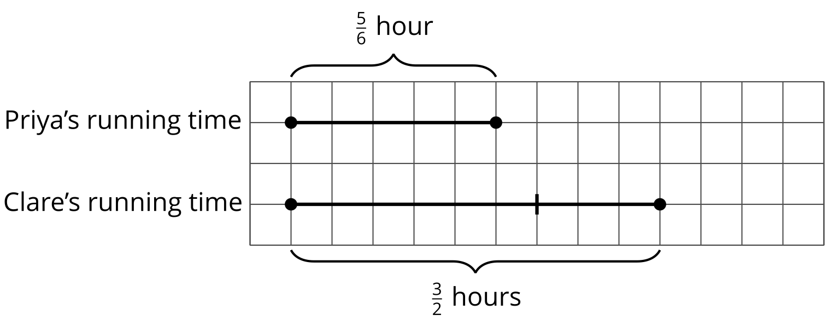
- $\text{(fraction)}⋅\text{(Clare’s time)}=\text{(Priya’s time)}$
- $?⋅\frac{3}{2}=\frac{5}{6}$
- We can find the unknown by dividing. $\frac{5}{6}÷\frac{3}{2}=\frac{5}{6}⋅\frac{2}{3}$, which equals $\frac{10}{18}$. So Priya’s running time was $\frac{10}{18}$, or $\frac{5}{9}$, of Clare’s.
Other problems your students will solve are related to geometry—lengths, areas, and volumes. Here are some examples:
- What is the length of a rectangular room if its width is $2\frac{1}{2}$ meters and its area is $11\frac{1}{4}$ square meters?
- 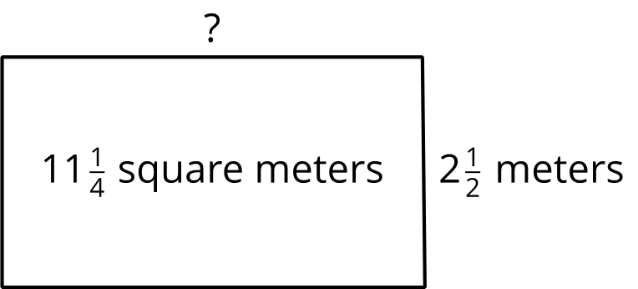
- We know that the area of a rectangle can be found by multiplying its length and width ($?⋅2\frac{1}{2}=11\frac{1}{4}$), so dividing $11\frac{1}{4}÷2\frac{1}{2}$ (or $\frac{45}{4}÷\frac{5}{2}$) will give us the length of the room. $\frac{45}{4}÷\frac{5}{2}=\frac{45}{4}⋅\frac{2}{5}=\frac{9}{2}$. The room is $4\frac{1}{2}$ meters long.
- What is the volume of a box (a rectangular prism) that is $3\frac{1}{2}$ feet by 10 feet by $\frac{1}{4}$ foot?
- We can find the volume by multiplying the edge lengths. $3\frac{1}{2}⋅10⋅\frac{1}{4}=\frac{7}{2}⋅10⋅\frac{1}{4}$, which equals $\frac{70}{8}$. So the volume is $\frac{70}{8}$, or $8\frac{6}{8}$, cubic feet.
Here is a task to try with your student:
- In the first example about Priya's and Clare’s running times, how many times as long as Priya’s running time was Clare’s running time? Show your reasoning.
- The area of a rectangle is $\frac{20}{3}$ square feet. What is its width if its length is $\frac{4}{3}$ feet? Show your reasoning.
Solution:
- $\frac{9}{5}$. Sample reasoning: We can write $?⋅\frac{5}{6}=\frac{3}{2}$ to represent the question “How many times of Priya’s running time was Clare’s running time?” and then solve by dividing: $\frac{3}{2}÷\frac{5}{6}=\frac{3}{2}⋅\frac{6}{5}=\frac{18}{10}$. Clare’s running time was $\frac{18}{10}$, or $\frac{9}{5}$, as long as Priya’s.
- 5 feet. Sample reasoning: $\frac{20}{3}÷\frac{4}{3}=\frac{20}{3}⋅\frac{3}{4}=\frac{20}{4}=5$

