Lesson 1 Practice Problems
- Describe a transformation that gives the graph representing $g$ from the graph representing $f$.

- a.
- 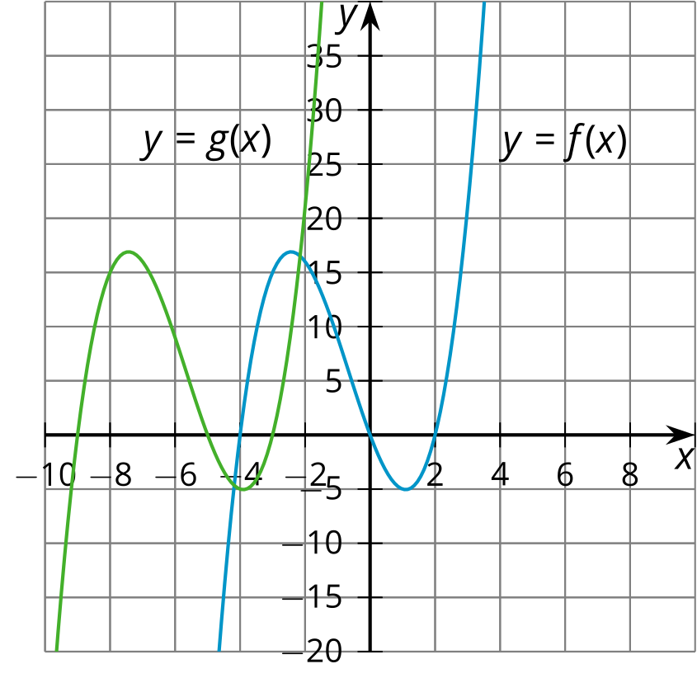

- b.
- 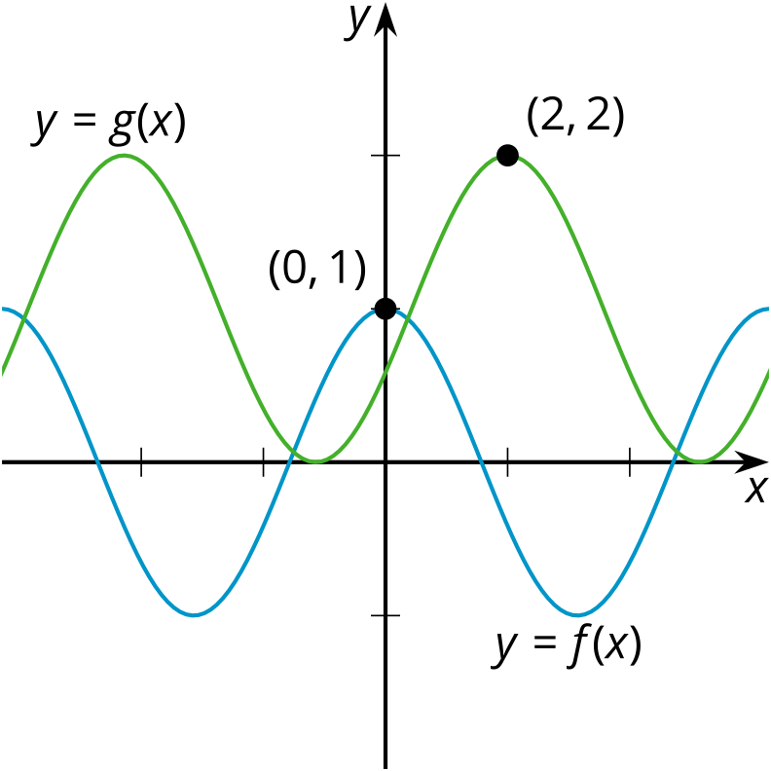

- c.
- 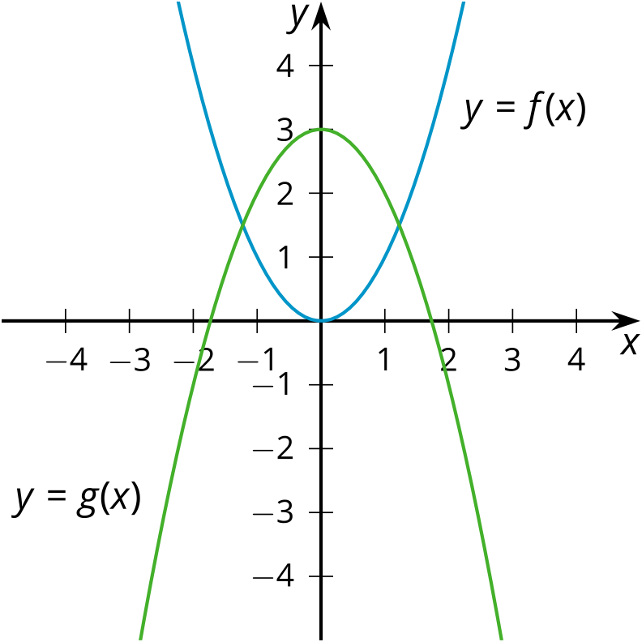

- Describe a way to transform each graph so that it goes through the labeled points.

- a.
- 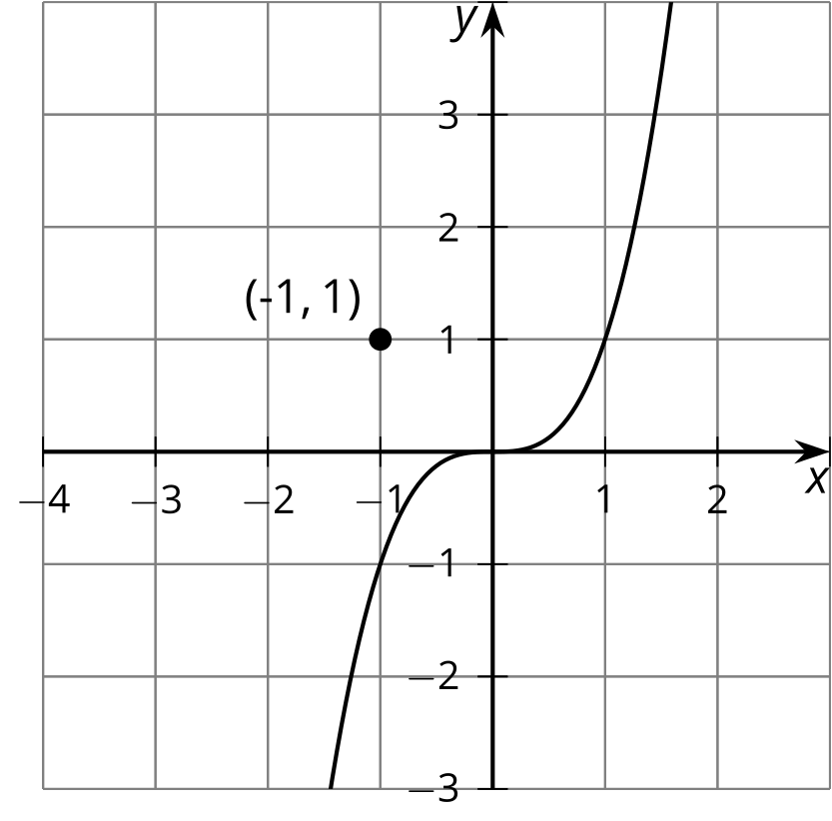

- b.
- 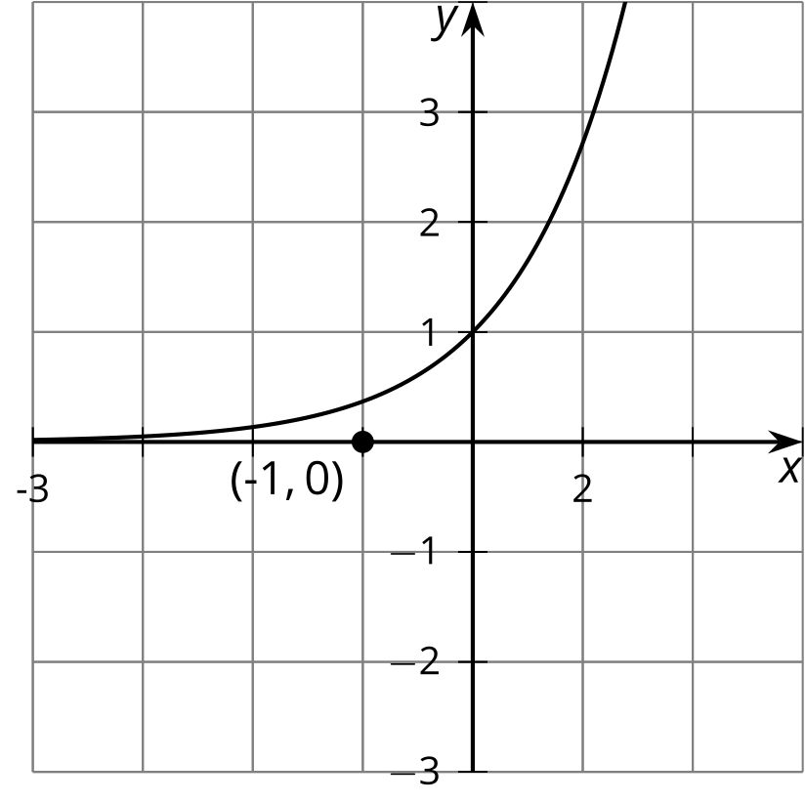

- c.
- 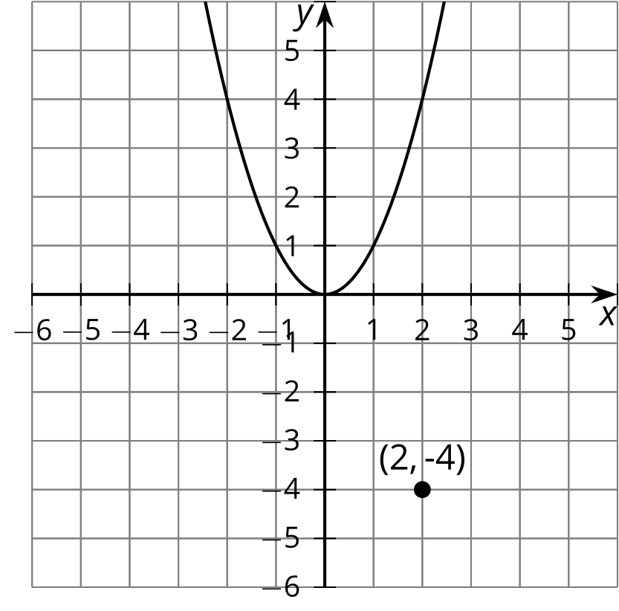

- d.
- 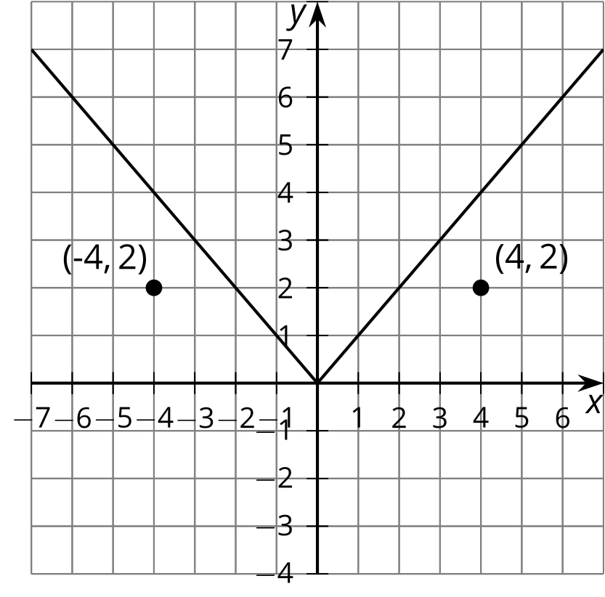
- Describe a way to transform each graph so that it better matches the data.

- a.
- 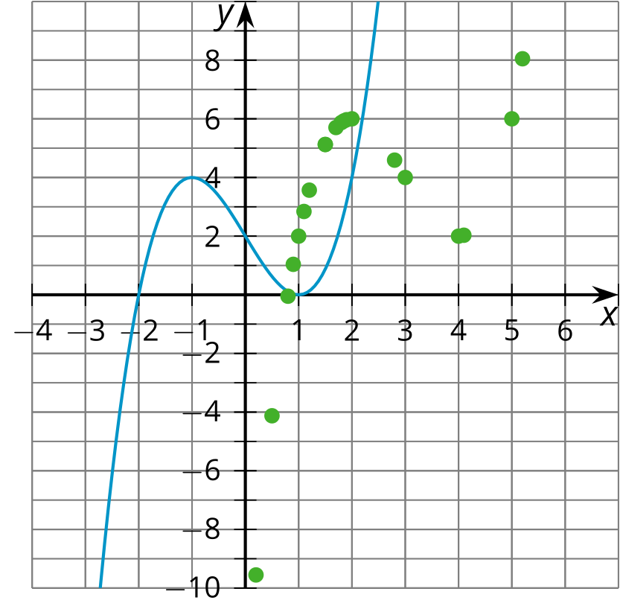

- b.
- 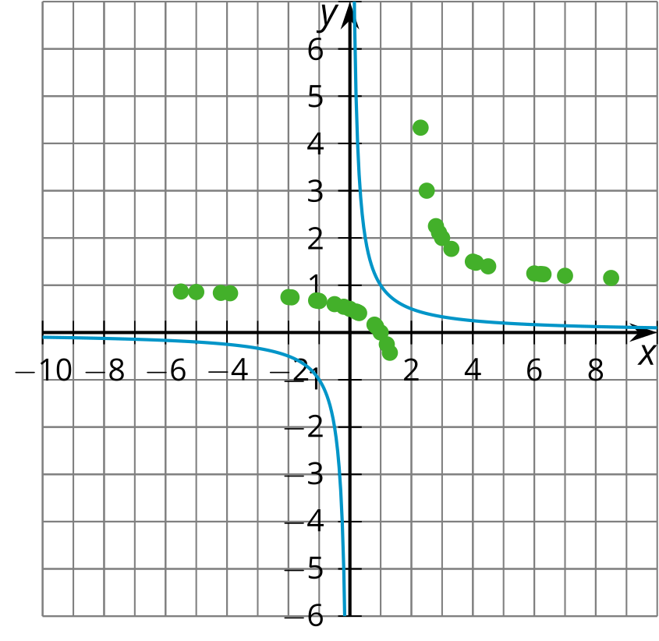

- c.
- 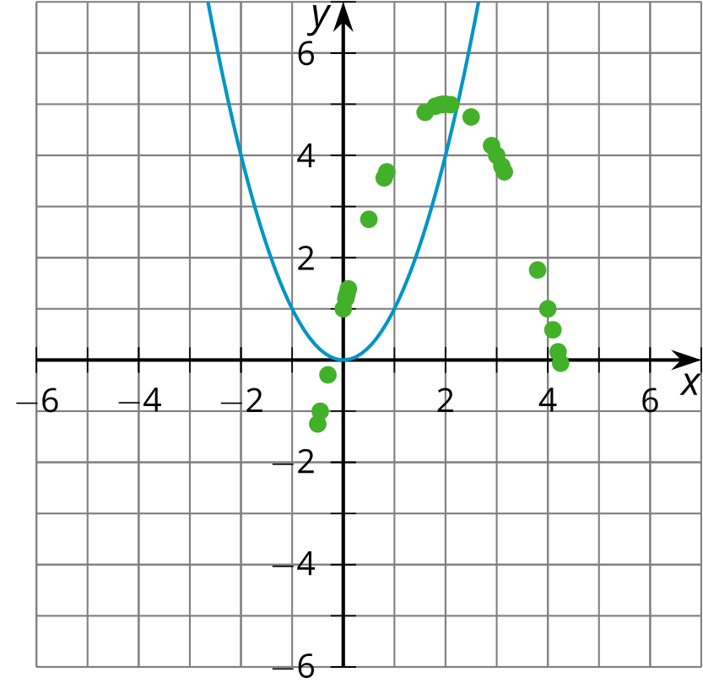

- Does the function $f$ or the function $g$ fit the data better? Explain your reasoning.
- 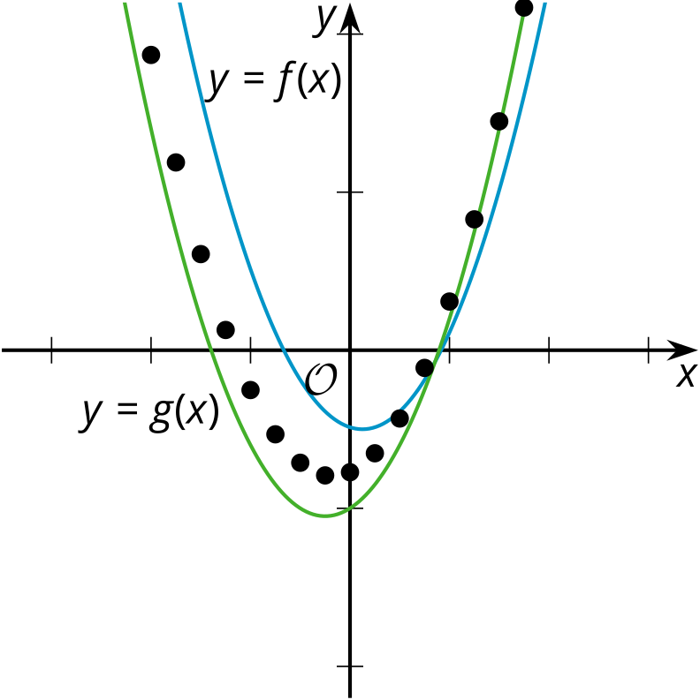
- For the polynomial function $A\left(x\right)=2x^{3}+5x^{2}−28x−15$ we know $\left(x+5\right)$ is a factor. Rewrite $A\left(x\right)$ as a product of linear factors.
- (From Unit 2, Lesson 13.)
© CC BY 2019 by Illustrative Mathematics®

