Algebra 1
Unit 7Lesson 12CC BY NC 2024 Illustrative Mathematics®
Unit 7, Lesson 12

Graphing the Standard Form (Part 1)
- Let’s see how the numbers in expressions like $\text{-}3x^{2}+4$ affect their graph.
Algebra 1
Unit 7Lesson 12CC BY NC 2024 Illustrative Mathematics®

12.1Matching Graphs to Linear Equations
Which graph corresponds to which equation? Explain your reasoning.
- $y=2x+4$
- $y=3−x$
- $y=3x−2$
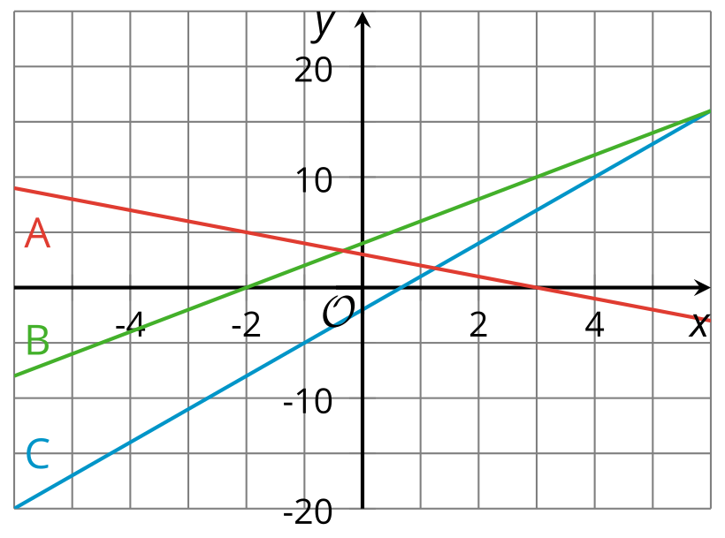
Algebra 1
Unit 7Lesson 12CC BY NC 2024 Illustrative Mathematics®

12.2Quadratic Graphs Galore
Using graphing technology, graph $y=x^{2}$, and then experiment with each of the following changes to the function. Record your observations (include sketches, if helpful).
- Add different constant terms to $x^{2}$ (for example: $x^{2}+5,x^{2}+10$, or $x^{2}−3$)
- Multiply $x^{2}$ by different positive coefficients greater than 1 (for example: $3x^{2}$ or $7.5x^{2}$)
- Multiply $x^{2}$ by different negative coefficients less than or equal to -1 (for example: $\text{-}x^{2}$ or $\text{-}4x^{2}$)
- Multiply $x^{2}$ by different coefficients between -1 and 1 (for example: $\frac{1}{2}x^{2}$ or $\text{-}0.25x^{2}$)

Are you ready for more?
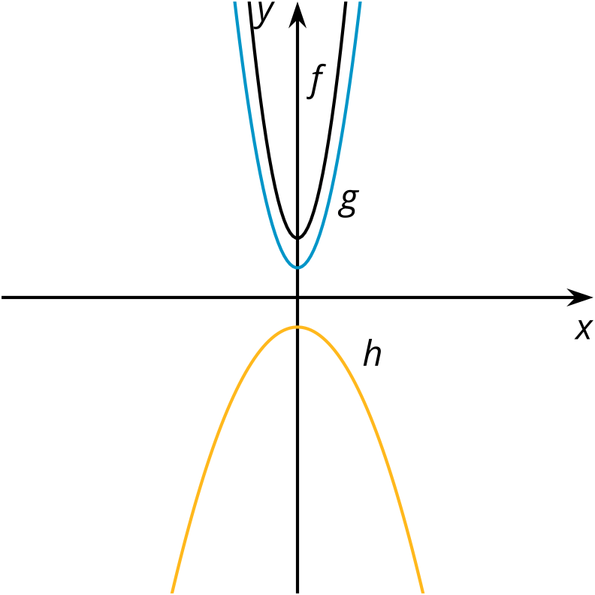
Here are the graphs of three quadratic functions. What can you say about the coefficients of $x^{2}$ in the expressions that define $f$ (at the top), $g$ (in the middle), and $h$ (at the bottom)? Can you find the values of the coefficients? How do they compare?

Algebra 1
Unit 7Lesson 12CC BY NC 2024 Illustrative Mathematics®

12.3What Do These Tables Reveal?

  - Complete the table with values of $x^{2}+10$ and $x^{2}−3$ at different values of $x$.
- $x$ | - -3 | - -2 | - -1 | - 0 | - 1 | - 2 | - 3
- $x^{2}$ | - 9 | - 4 | - 1 | - 0 | - 1 | - 4 | - 9
  - $x^{2}+10$
  - $x^{2}−3$
  - Earlier, you observed the effects on the graph of adding or subtracting a constant term to or from $x^{2}$. Study the values in the table. Use them to explain why the graphs changed the way they did when a constant term was added or subtracted.

  - Complete the table with values of $2x^{2}$, $\frac{1}{2}x^{2}$, and $\text{-}2x^{2}$ at different values of $x$.
- $x$ | - -3 | - -2 | - -1 | - 0 | - 1 | - 2 | - 3
- $x^{2}$ | - 9 | - 4 | - 1 | - 0 | - 1 | - 4 | - 9
  - $2x^{2}$
  - $\frac{1}{2}x^{2}$
  - $\text{-}2x^{2}$
  - You also observed the effects on the graph of multiplying $x^{2}$ by different coefficients. Study the values in the table. Use them to explain why the graphs changed the way they did when $x^{2}$ is multiplied by a number greater than 1, by a negative number less than or equal to -1, and by numbers between -1 and 1.
Algebra 1
Unit 7Lesson 12CC BY NC 2024 Illustrative Mathematics®

12.4Card Sort: Representations of Quadratic Functions
Your teacher will give your group a set of cards. Each card contains a graph or an equation. Sort the cards into sets so that each set contains two equations and a graph that all represent the same quadratic function. Record your matches, and be prepared to explain your reasoning.

Lesson 12 Summary
Remember that the graph representing any quadratic function is a shape called a parabola. People often say that a parabola “opens upward” when the lowest point on the graph is the vertex (where the graph changes direction), and “opens downward” when the highest point on the graph is the vertex. Each coefficient in a quadratic expression written in standard form $ax^{2}+bx+c$ tells us something important about the graph that represents it.
The graph of $y=x^{2}$ is a parabola opening upward with vertex at $\left(0,0\right)$. Adding a constant term 5 gives $y=x^{2}+5$ and raises the graph by 5 units. Subtracting 4 from $x^{2}$ gives $y=x^{2}−4$ and moves the graph 4 units down.
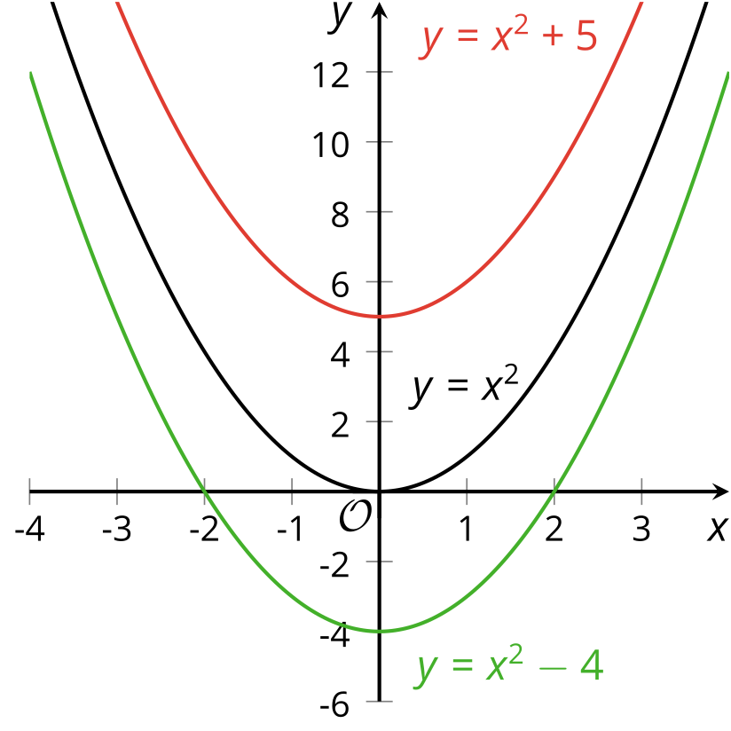
$x$ | -3 | -2 | -1 | 0 | 1 | 2 | 3
$x^{2}$ | 9 | 4 | 1 | 0 | 1 | 4 | 9
$x^{2}+5$ | 14 | 9 | 6 | 5 | 6 | 9 | 14
$x^{2}−4$ | 5 | 0 | -3 | -4 | -3 | 0 | 5
A table of values can help us see that adding 5 to $x^{2}$ increases all the output values of $y=x^{2}$ by 5, which explains why the graph moves up 5 units. Subtracting 4 from $x^{2}$ decreases all the output values of $y=x^{2}$ by 4, which explains why the graph shifts down by 4 units.
In general, the constant term of a quadratic expression in standard form influences the vertical position of the graph. An expression with no constant term (such as $x^{2}$ or $x^{2}+9x$) means that the constant term is 0, so the $y$-intercept of the graph is on the $x$-axis. It’s not shifted up or down relative to the $x$-axis.
The coefficient of the squared term in a quadratic function also tells us something about its graph. The coefficient of the squared term in $y=x^{2}$ is 1. Its graph is a parabola that opens upward.
- Multiplying $x^{2}$ by a number greater than 1 makes the graph steeper, so the parabola is narrower than that representing $x^{2}$.
- Multiplying $x^{2}$ by a number less than 1 but greater than 0 makes the graph less steep, so the parabola is wider than that representing $x^{2}$.
- Multiplying $x^{2}$ by a number less than 0 makes the parabola open downward.
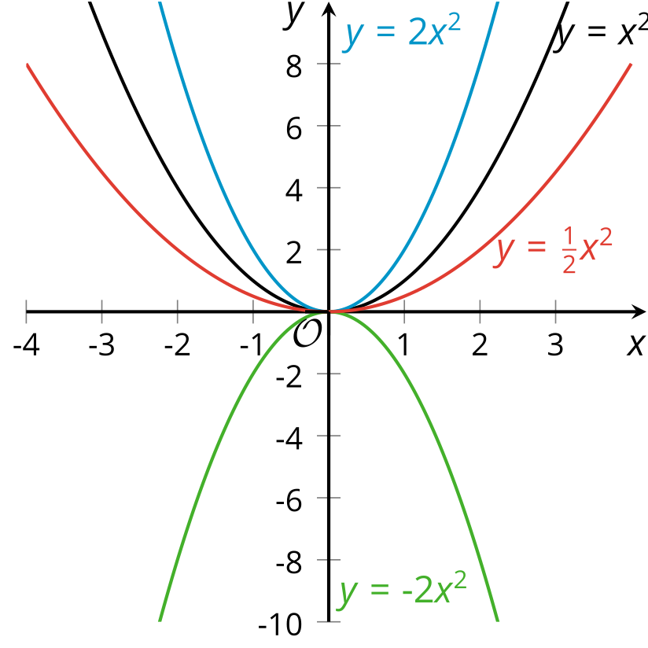
$x$ | -3 | -2 | -1 | 0 | 1 | 2 | 3
$x^{2}$ | 9 | 4 | 1 | 0 | 1 | 4 | 9
$2x^{2}$ | 18 | 8 | 2 | 0 | 2 | 8 | 18
$\text{-}2x^{2}$ | -18 | -8 | -2 | 0 | -2 | -8 | -18
If we compare the output values of $2x^{2}$ and $\text{-}2x^{2}$, we see that they are opposites, which suggests that one graph would be a reflection of the other across the $x$-axis.

