Grade 6
Unit 7Lesson 10CC BY NC Illustrative Mathematics, based on IM 6–8 Math, CC BY Open Up Resources.
Unit 7, Lesson 10

Interpreting Inequalities
Let’s examine what inequalities can tell us.
Grade 6
Unit 7Lesson 10CC BY NC Illustrative Mathematics, based on IM 6–8 Math, CC BY Open Up Resources.

10.1Andre’s Number Line
Andre drew this number line to represent $15<n$.
Do you agree with Andre’s number line? Explain your reasoning.
Grade 6
Unit 7Lesson 10CC BY NC Illustrative Mathematics, based on IM 6–8 Math, CC BY Open Up Resources.

10.2Basketball Game
Noah scored $n$ points in a basketball game.
- What does $15<n$ mean in the context of the basketball game?
- What does $n<25$ mean in the context of the basketball game?
- Draw two number lines to represent the solutions to the two inequalities.
- Name a possible value for $n$ that is a solution to both inequalities.
- Name a possible value for $n$ that is a solution to $15<n$ but not a solution to $n<25$.
- Is -8 a possible value for $n$? Explain your reasoning.
Grade 6
Unit 7Lesson 10CC BY NC Illustrative Mathematics, based on IM 6–8 Math, CC BY Open Up Resources.

10.3Unbalanced Hangers
- Here is a diagram of an unbalanced hanger.
- 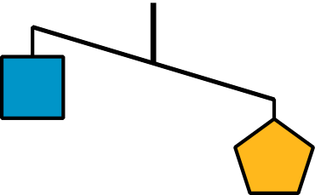
  - Let $p$ be the weight of one pentagon and $s$ be the weight of one square. Write an inequality to represent the relationship of the 2 weights.
  - If the pentagon weighs 8 ounces, write another inequality to describe the situation. What does this inequality mean for this situation?
  - Graph the solutions to this inequality on the number line.
- Here is another diagram of an unbalanced hanger.
- 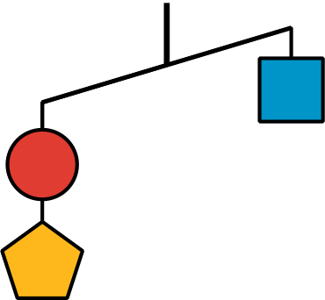
- Andre writes the following inequality, where $c$ represents the weight of one circle: $c+p<s$. Do you agree with his inequality? Explain your reasoning.
- Jada looks at another diagram of an unbalanced hangar and writes the following inequality: $s+c>2t$, where $t$ represents the weight of one triangle. Draw a sketch of the diagram.

Are you ready for more?
Here is a picture of a balanced hanger. It shows that the total weight of the three triangles is the same as the total weight of the four squares.
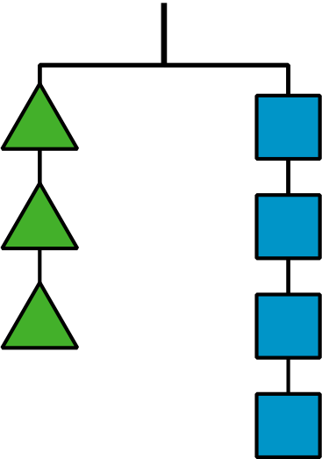
- What does this tell you about the weight of one square when compared to one triangle? Explain how you know.
- Write an equation or an inequality to describe the relationship between the weight of a square and that of a triangle. Let $s$ be the weight of a square and $t$ be the weight of a triangle.

Lesson 10 Summary
An inequality that describes a real-world situation may have number solutions that make the inequality true, but those solutions may not always make sense in real life.
For example:
- A basketball player scored more than 11 points in a game. This can be represented by the inequality $s>11$, where $s$ is the number of points scored. Numbers such as 12, $14\frac{1}{2}$, and 130.25 are all solutions to the inequality because they each make the inequality true.
- $12>11$
- $14\frac{1}{2}>11$
- $130.25>11$
- In a basketball game, however, it is only possible to score a whole number of points, so fractional and decimal scores are not possible. It is also highly unlikely that one person would score more than 130 points in a single game.
- This particular situation limits the solutions.
Here is another example:
- It rained for less than 30 minutes yesterday (but it did rain). This can be represented by the inequality $r<30$, where $r$ represents the number of minutes of rain yesterday. Even though numbers such as $27\frac{3}{4}$ 18.2, and -7 are all less than 30, our solutions are limited to positive numbers since 0 or a negative number of minutes would not make sense in this context.
- To show the upper and lower boundaries, we can write two inequalities:
- $0<r$
- $r<30$
Inequalities can also represent a comparison of two unknown numbers.
- Let’s say we know that a puppy weighs more than a kitten, but we do not know the weight of either animal. We can write either of the following inequalities to represent this: $p>k$ or $k<p$, where $p$ represents the weight of the puppy in pounds, and $k$ represents the weight of the kitten in pounds.

