Unit 4 Lesson 17: Add 0 and 1

WU Notice and Wonder: Add 1 More (Warm up)

Student Task Statement
What do you notice?
What do you wonder?
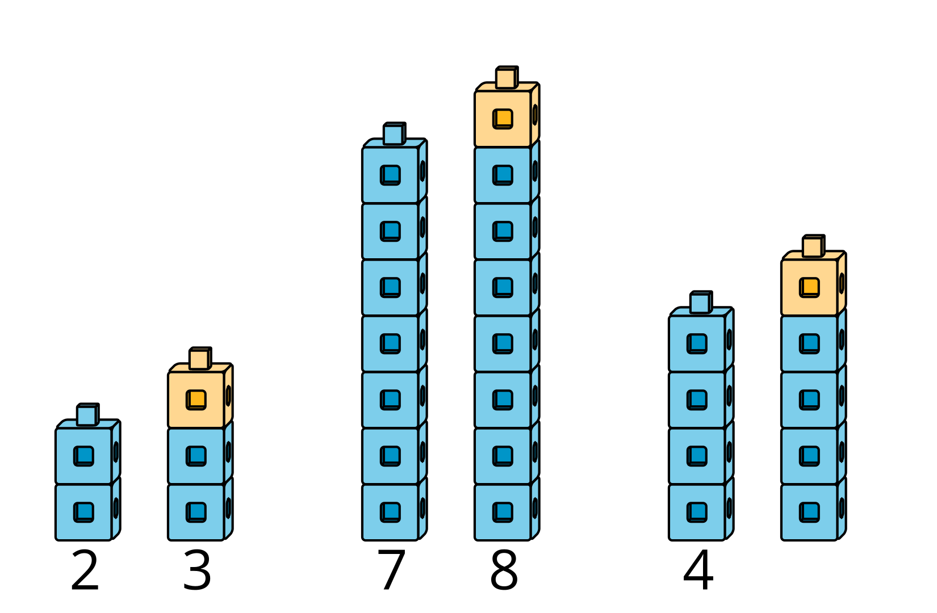

1 Add 0 and 1

Images for Launch
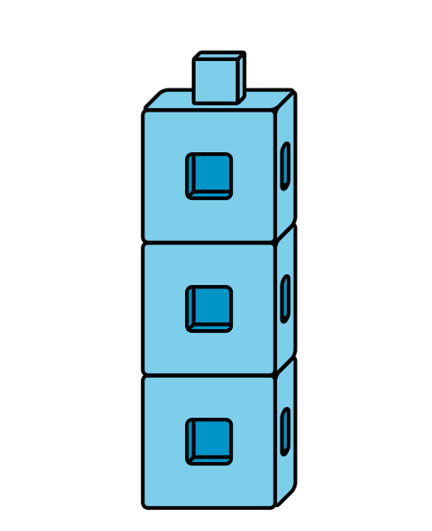

Student Task Statement
$4+\underset{_}{}$
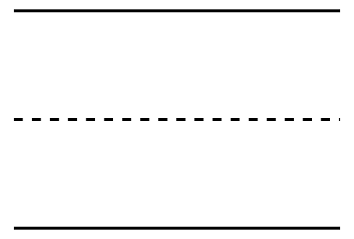
$2+\underset{_}{}$
$8+\underset{_}{}$
$3+\underset{_}{}$
$9+\underset{_}{}$
$1+\underset{_}{}$

2 Notice $+0$ and $+1$ Patterns

Student Task Statement
$4+0$
4

$2+0$
2

$8+0$
8

$3+1$
4

$9+1$
10

$1+1$
2


3 Introduce Find the Value of Expressions, Color the Total or Difference

Student Task Statement
Choose a center.
Find the Value of
Expressions
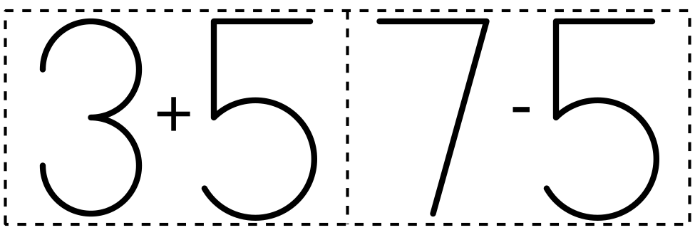
​​​​​​
Roll and Add
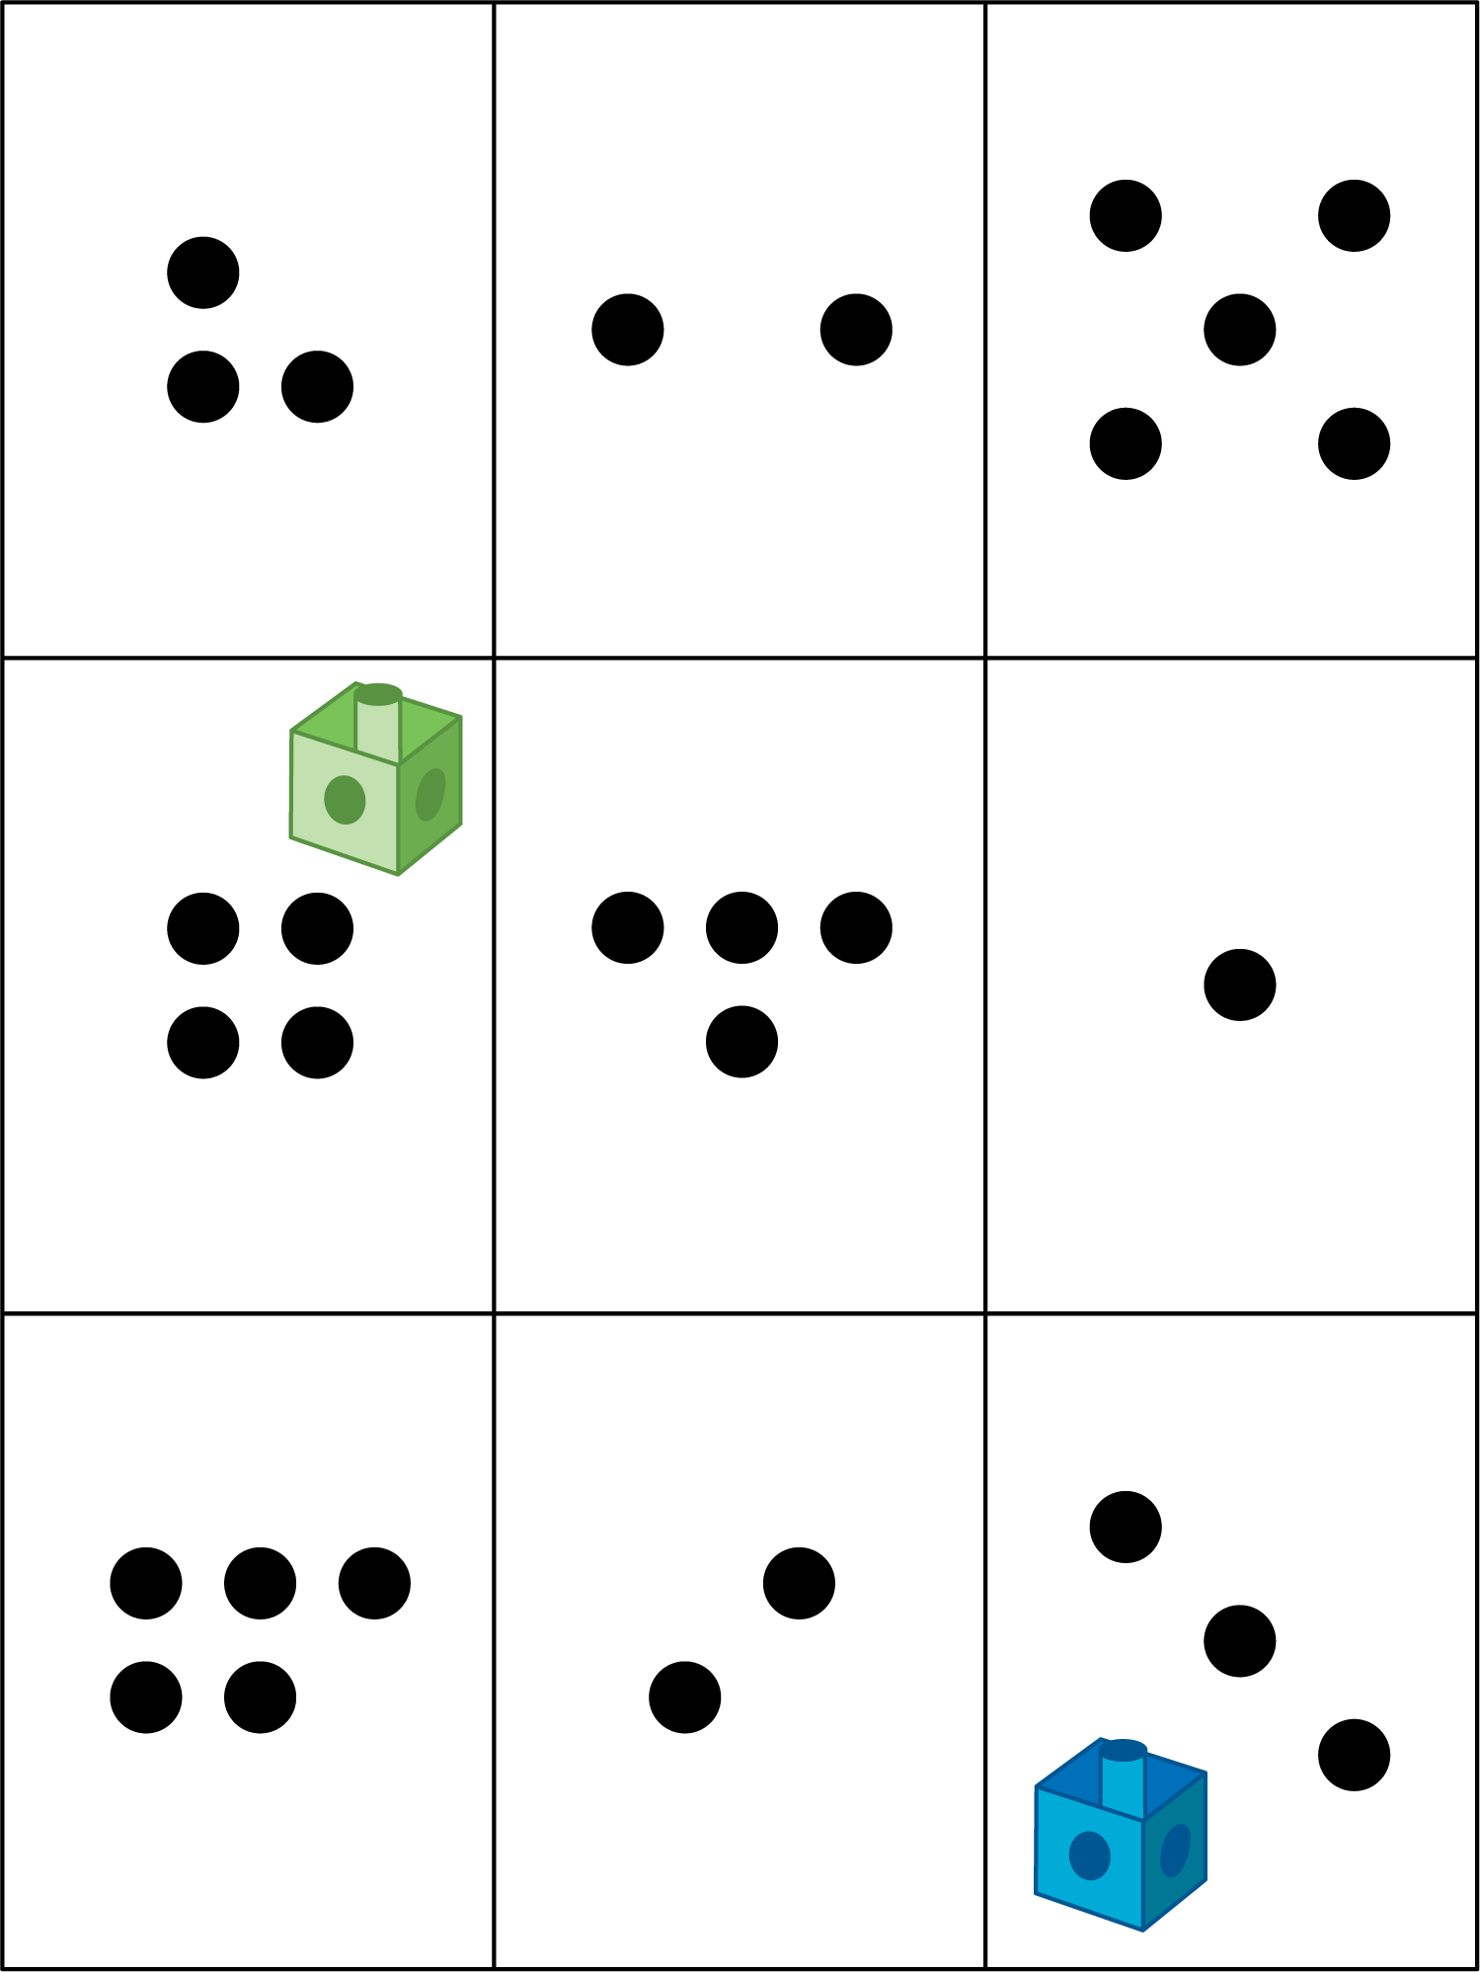
Shake and Spill

Math Stories

Number Race
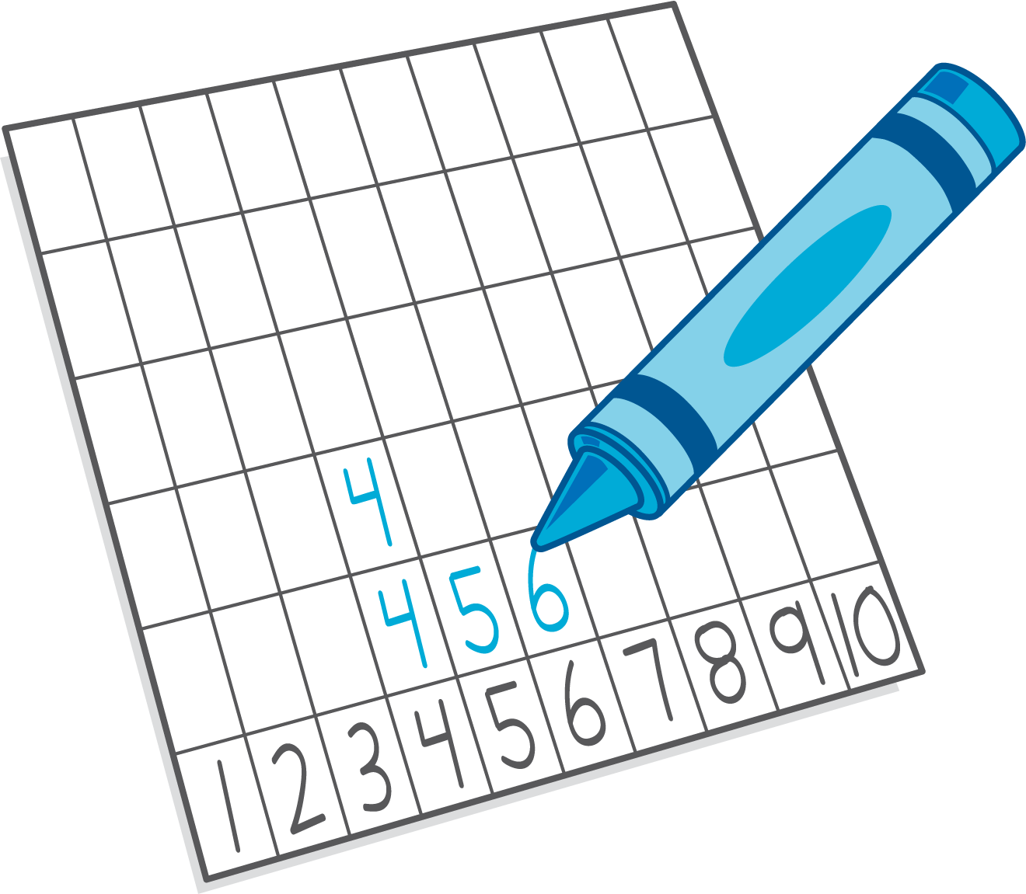

Images for Activity Synthesis

© CC BY 2021 Illustrative Mathematics®

