Lesson 8 Practice Problems
- Here are an unfinished calculation of $\left(0.54\right)⋅\left(3.8\right)$ and a 0.54-by-3.8 rectangle.
- 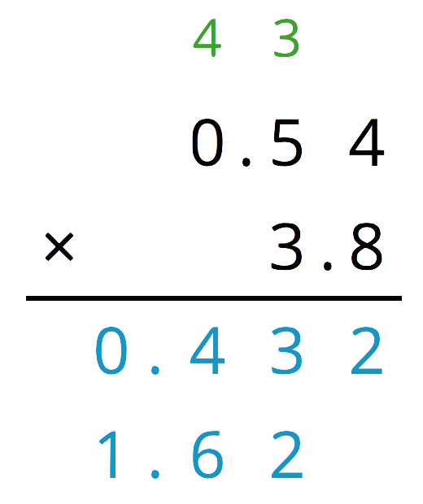
- 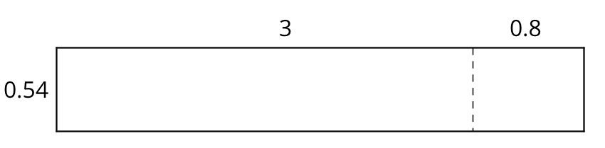
  - Which part of the rectangle has an area of 0.432? Which part of the rectangle has an area of 1.62? Show your reasoning.
  - What is $\left(0.54\right)⋅\left(3.8\right)$?
- Explain how the product of 3 and 65 could be used to find $\left(0.03\right)⋅\left(0.65\right)$.
- Use vertical calculation to find each product.
  - $\left(5.4\right)⋅\left(2.4\right)$
  - $\left(1.67\right)⋅\left(3.5\right)$
- A pound of blueberries costs $3.98 and a pound of clementines costs $2.49. What is the combined cost of 0.6 pound of blueberries and 1.8 pounds of clementines? Round your answer to the nearest cent.
- Complete the calculations so that each shows the correct sum or difference.
- 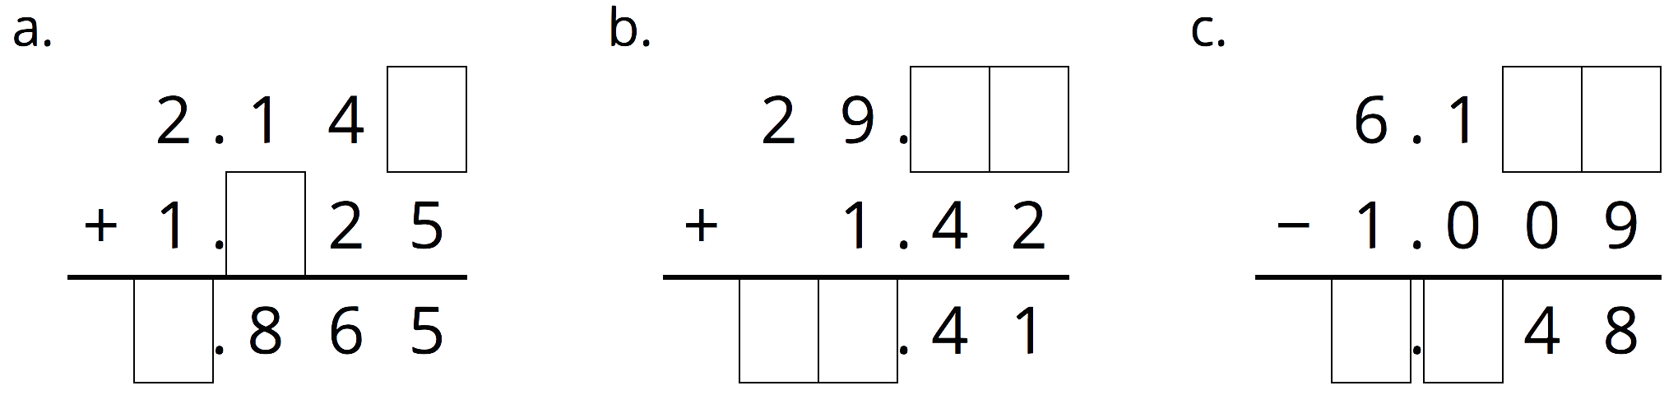
- (From Unit 5, Lesson 3.)
- Which has a greater value: $7.4−0.0022$ or $7.39−0.0012$? Show your reasoning.
- (From Unit 5, Lesson 4.)
- Andre is planting saplings (baby trees). It takes him 30 minutes to plant 3 saplings. If each sapling takes the same amount of time to plant, how long will it take Andre to plant 14 saplings? If you get stuck, consider using the table.
- number of saplings | - time in minutes
- 3 | - 30
- 1
- 14
- (From Unit 2, Lesson 12.)
© CC BY Open Up Resources. Adaptations CC BY IM.

