Grade 2
Unit 8Lesson 5CC BY NC 2024 Illustrative Mathematics®
Unit 8, Lesson 5

Patterns with Even and Odd Numbers
- Let’s look for patterns with even and odd numbers.
Grade 2
Unit 8Lesson 5CC BY NC 2024 Illustrative Mathematics®

Warm-up How Many Do You See: Even or Odd
How many do you see? How do you see them?
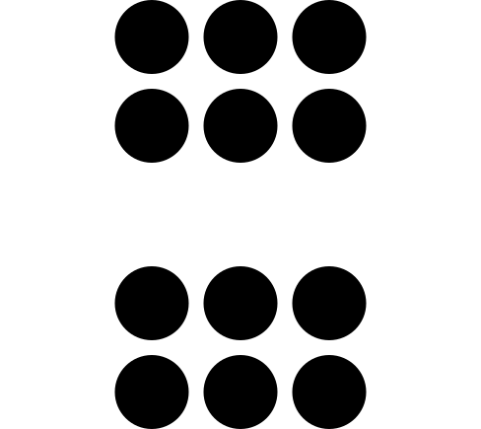
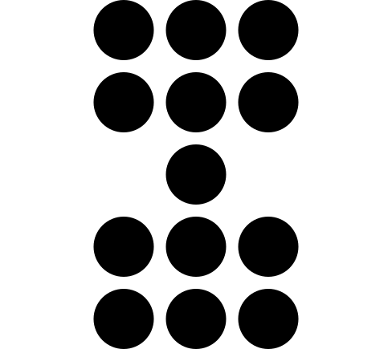
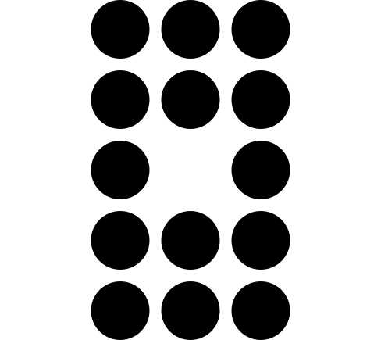
Grade 2
Unit 8Lesson 5CC BY NC 2024 Illustrative Mathematics®

Activity 1 Even and Odd Roundabout
What did you notice? What do you wonder?
Grade 2
Unit 8Lesson 5CC BY NC 2024 Illustrative Mathematics®

Activity 2 Presto Chango
- In the first column of your sheet, record whether each student has an even or odd number of counters. Circle your choice. Show your thinking using drawings, numbers, or words.
- Complete the gray column. Does adding 1 change if the number of counters is even or odd? Show your thinking using drawings, numbers, or words.
- Complete the last column. Does adding 2 change whether the number of counters is even or odd? Show your thinking using drawings, numbers, or words.

