Lesson 23: Usemos una decena para restar

Standards Alignments
Addressing | 1.OA.C.6

Teacher-facing Learning Goals
- Use the unit of a ten to find differences within 20.

Student-facing Learning Goals
- Usemos el 10 para ayudarnos a restar.

Lesson Purpose
The purpose of this lesson is for students to notice how the unit of ten can be used to find differences within 20.
In previous lessons, students subtracted from teen numbers in a way that made sense to them. The purpose of this lesson is to encourage students to use the unit of ten to find differences. In the first activity, students play the same subtraction game they played in the previous lesson, this time using 10-frames to represent their starting number. By using 10-frames, students can visually make sense of how to use 10 in order to take away efficiently. In the second activity, students analyze taking away to make a ten as a method to find the difference between two numbers.
Although many students may use math tools to help them find the difference, they may choose to write equations to represent their thinking. At this point in the year, students are not expected to write equations that match all of their steps, but teachers should always write accurate equations. Student equations may be accurate, like $13−3−3=\boxed{7}$ or $8+2+5=\boxed{15}$ or inaccurate, like $8+2=10+5=\boxed{15}$ or $13−3=10−3=\boxed{7}$.
In addition to writing equations, it may also be helpful to represent how the 10 was used in order to find the difference.

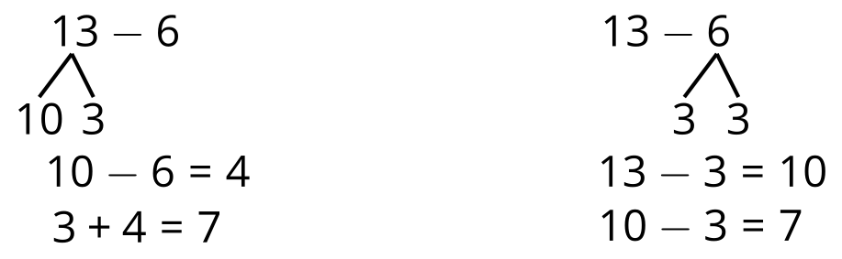

Access for:

Students with Disabilities
- Action and Expression (Activity 1)

English Learners
- MLR8 (Activity 2)

Instructional Routines
Number Talk (Warm-up)

Materials to Gather
- Connecting cubes or two-color counters: Activity 1, Activity 2
- Double 10-frames: Activity 1, Activity 2
- Materials from a previous lesson: Activity 1
- Number cards 0–10: Activity 1

Lesson Timeline
Warm-up | 10 min
Activity 1 | 15 min
Activity 2 | 20 min
Lesson Synthesis | 10 min
Cool-down | 5 min

Teacher Reflection Question
Check-in with your norms and routines. Are they promoting engagement from all of your students? Are there any adjustments you might make so that all students do math tomorrow?

Cool-down
(to be completed at the end of the lesson) 5min
Réstale a 14

Standards Alignments
Addressing | 1.OA.C.6

Student-facing Task Statement
Encuentra el valor de $14−6$.
Muestra cómo pensaste. Usa dibujos, palabras o números.

Student Responses
8. Sample responses:
- I put 14 on my double 10-frame. I took away 4 to get 10 and then another 2 to get 8.
- I took away 6 from the full 10-frame and saw that there were $4+4$ left.

