Lesson 8: Revuelve, saca y cubre

Standards Alignments
Addressing | 1.NBT.A.1, 1.OA.A.1, 1.OA.C.6, 1.OA.D.8
Building Towards | 1.OA.D.8

Teacher-facing Learning Goals
- Relate different equations to the same story problem.
- Solve Put Together/Take Apart, Addend Unknown story problems in a way that makes sense to them.

Student-facing Learning Goals
- Resolvamos un nuevo tipo de problema-historia.

Lesson Purpose
The purpose of this lesson is for students to solve and represent Put Together/Take Apart, Addend Unknown story problems.
Students solve in any way that makes sense to them and write equations to match the problems. This work builds on the work students did with other types of Put Together/Take Apart problems in previous lessons. They extend the familiar game, Shake and Spill. As students play the game in this lesson, they know the total and the number of red counters and need to figure out the number of yellow counters. Students write equations to match the context and explain how the equation relates to the problem. The focus in this lesson is on missing addend addition equations, but students may solve or represent the problems using subtraction. Subtraction equations should be accepted and will be the focus of lessons in the next section. When students recognize that a number in an equation represents a specific quantity they reason abstractly and quantitatively (MP2).

Access for:

Students with Disabilities
- Action and Expression (Activity 1)

English Learners
- MLR8 (Activity 2)

Instructional Routines
Choral Count (Warm-up)

Materials to Gather
- 10-frames: Activity 1, Activity 2
- Cups: Activity 1
- Two-color counters: Activity 1, Activity 2

Materials to Copy
- Shake and Spill Stage 4 and 5 Recording Sheet (G1 and 2), Spanish (groups of 1): Activity 1

Lesson Timeline
Warm-up | 10 min
Activity 1 | 20 min
Activity 2 | 15 min
Lesson Synthesis | 10 min
Cool-down | 5 min

Teacher Reflection Question
Are students trying new methods when they hear others during the discussion? How can you encourage students to try new methods?

Cool-down
(to be completed at the end of the lesson) 5min
Clare juega “Revuelve y saca: Cubre”

Standards Alignments
Addressing | 1.OA.A.1, 1.OA.D.8

Student-facing Task Statement
Clare jugó una ronda de “Revuelve y saca: Cubre”. Usó 9 fichas.
Sus fichas se veían así.

¿Cuántas fichas están debajo del vaso?
Muestra cómo pensaste. Usa dibujos, números o palabras.
Escribe una ecuación que corresponda a las fichas.
Ecuación: ________________________________

Student Responses
$4+\boxed{5}=9$. Sample responses:
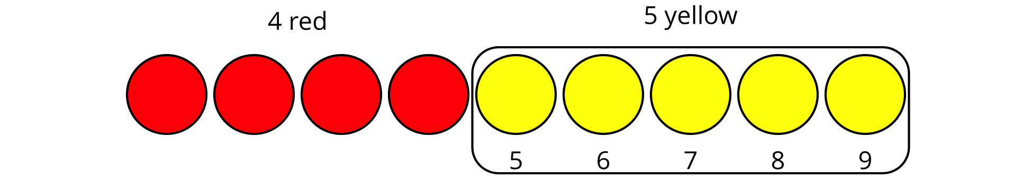
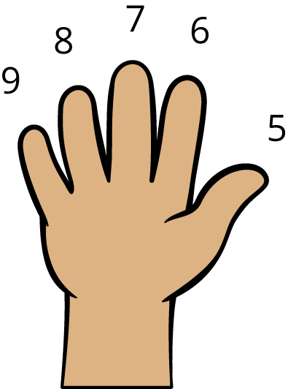
5, 6, 7, 8, 9

