Grade 2
Unit 8Lesson 7CC BY NC 2024 Illustrative Mathematics®
Unit 8, Lesson 7

What Is an Array?
- Let’s learn about arrays.
Grade 2
Unit 8Lesson 7CC BY NC 2024 Illustrative Mathematics®

Warm-upWhich Three Go Together: Counter Collections
Which 3 go together?
A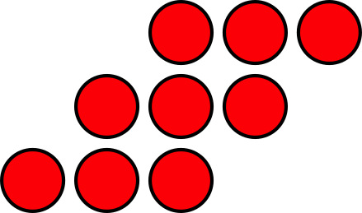
B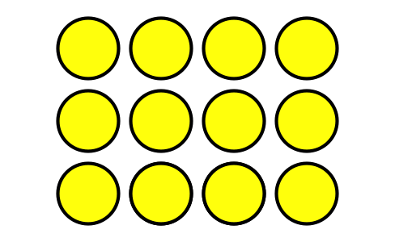
C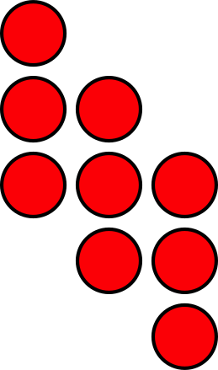
D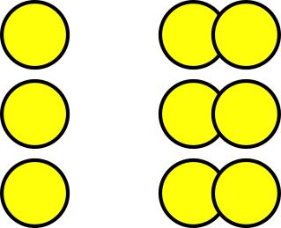
Grade 2
Unit 8Lesson 7CC BY NC 2024 Illustrative Mathematics®

Activity 1 What Is an Array?
Arrange each set of counters into equal-size rows with no leftovers.
- How many counters are there in all? _____
- Show or explain how you arranged them using drawings, numbers, or words.
- How many counters are there in all? _____
- Show or explain how you arranged them using drawings, numbers, or words.
- How many counters are there in all? _____
- Show or explain how you arranged them using drawings, numbers, or words.
Grade 2
Unit 8Lesson 7CC BY NC 2024 Illustrative Mathematics®

Activity 2Rows of Counters

- 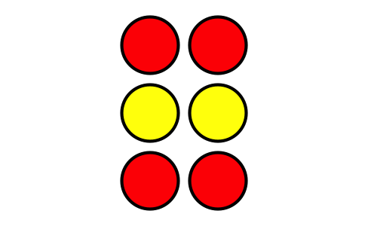
  - How many rows are in this array?
  - How many counters are in each row?
  - How many counters are there in all?

- 
  - How many rows are in this array?
  - How many counters are in each row?
  - How many counters are there in all?
- Use 6 counters. Make 2 rows with the same number in each row. How many counters are in each row?
- Use 20 counters. Make 4 rows with the same number in each row. How many counters are in each row?

