Lesson 3: Is it Odd or Even?

Standards Alignments
Addressing | 2.OA.C.3
Building Towards | 2.OA.C.3

Teacher-facing Learning Goals
- Determine whether representations of groups of objects show an even or odd number of objects.

Student-facing Learning Goals
- Let’s explain why the number of objects in a group is even or odd.

Lesson Purpose
The purpose of this lesson is for students to determine whether representations of groups of objects show an even or odd number of objects.
In a previous lesson, students learned the terms even and odd and saw that if a group has an even number of objects, it can be separated into two equal groups and that each object can be paired with another object.
In this lesson, students justify why a number is even or odd using methods based on making two equal groups, pairing objects, or skip-counting by 2. Some students may begin to justify why a group of objects has an even or odd number of members by using equations with two equal addends to represent even numbers of objects. In the second activity, they interpret addition equations in this way and connect the equations to representations of 2 equal groups (MP2).

Access for:

Students with Disabilities
- Action and Expression (Activity 1)

Instructional Routines
Card Sort (Activity 2), Choral Count (Warm-up), MLR8 Discussion Supports (Activity 2)

Materials to Gather
- Counters: Activity 1
- Crayons: Activity 1

Materials to Copy
- Even and Odd Card Sort (groups of 1): Activity 2

Lesson Timeline
Warm-up | 10 min
Activity 1 | 15 min
Activity 2 | 20 min
Lesson Synthesis | 10 min
Cool-down | 5 min

Teacher Reflection Question
Reflect on whose thinking was heard today. Reflect on whose thinking was not heard but could have enriched the conversations. What prompts or structures might better enable the latter to share their voices and reasoning?

Cool-down
(to be completed at the end of the lesson) 5min
Even or Odd?

Standards Alignments
Addressing | 2.OA.C.3

Student-facing Task Statement
- Is the total number of balloons even or odd? Explain how you know.
- 
- Is the number of dots even or odd? Explain how you know.
- 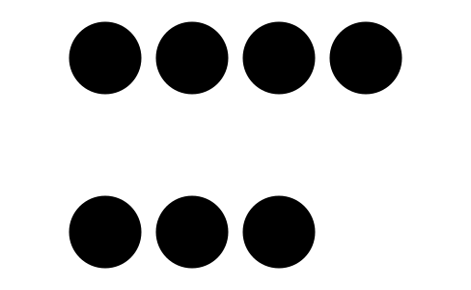

Student Responses
- Even. Sample responses:
  - The number of balloons is even. You can see that both groups are the same.
  - The number of balloons is even. You can pair the balloons that are the same color without any left over.
- Odd. Sample responses:
  - The number of dots is odd. There is one group of 4 on top and another group of 3. You cannot make two equal groups.
  - The number of dots is odd. There are 3 pairs and 1 dot that would be left over.

