Unit 1 Lesson 13: Multiplication Equations

WU Which One Doesn’t Belong: Representations (Warm up)

Student Task Statement
Which one doesn't belong?
A

B
$3×5$
C
$2×5=10$
D
$7+8=15$

1 Multiplication Equation Match

Student Task Statement
Find an equation from the list that can represent each situation, diagram, or drawing. Record the equation. Be prepared to explain your reasoning.
- $3×5=15$
- $4×10=40$
- $2×10=20$
- $10=5×2$
- $30=6×5$
- $4×2=8$
- $16=8×2$
- $4×5=20$
- $50=5×10$
1.
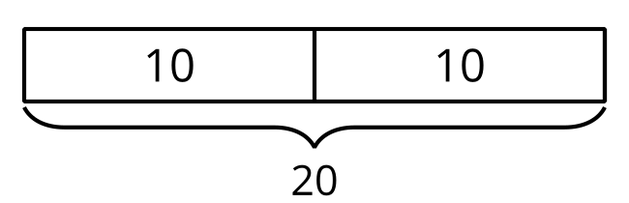
2.
Andre had 5 pairs of socks.
3.
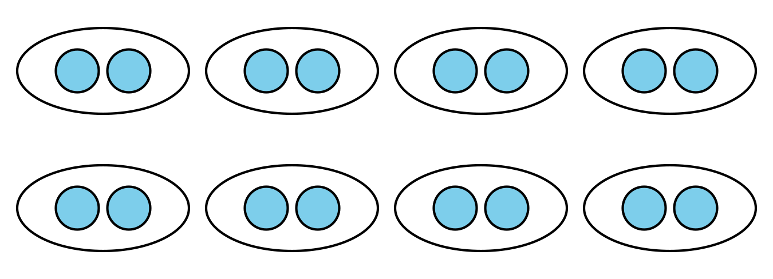
4.
6 hands were on the table. Each hand had 5 fingers.
5.
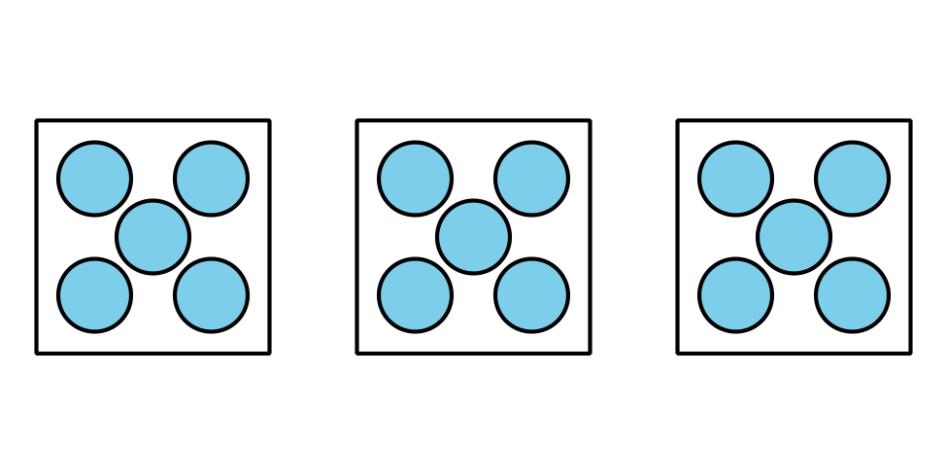
6.
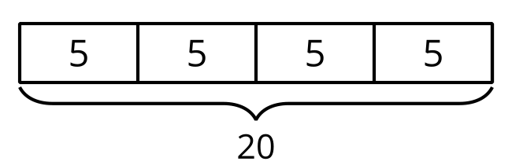
7.
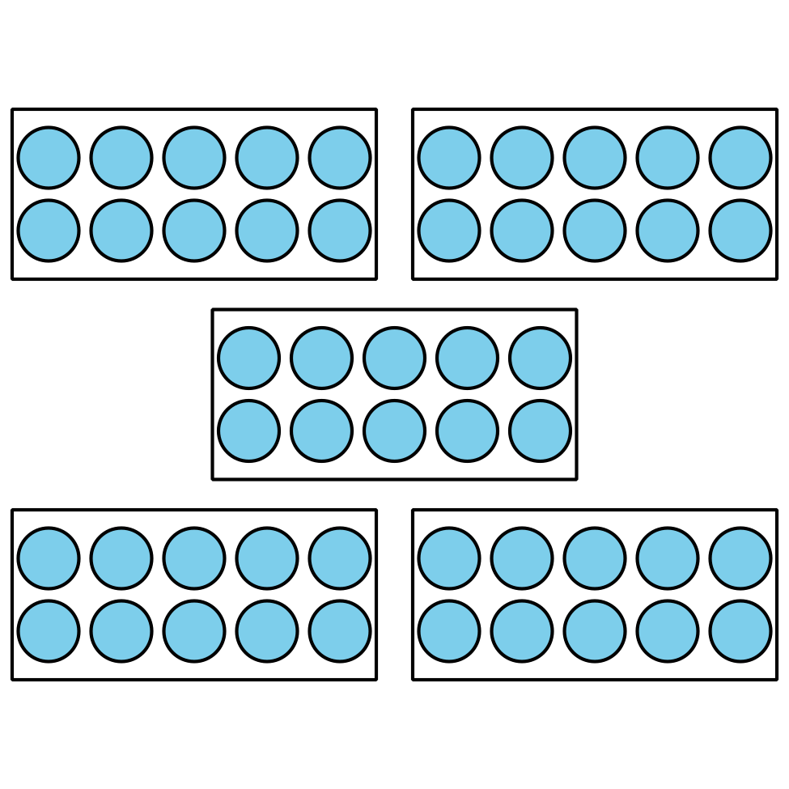
8.
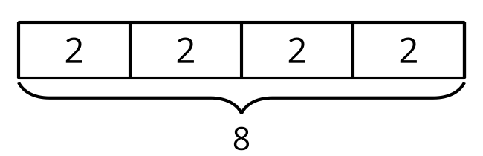
9.
There were 4 boxes of markers. Each box had 10 markers.

2 Write Multiplication Equations

Student Task Statement
Write an equation that represents each situation, drawing, or diagram. Be prepared to explain your reasoning.
- A package has 6 pairs of socks.

- 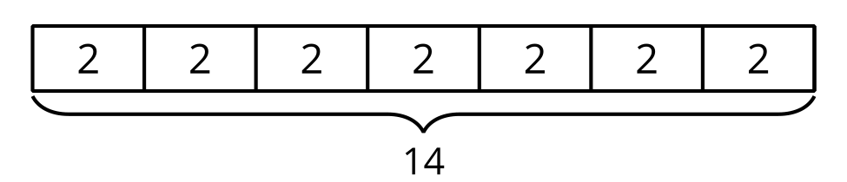
- Diego has 7 sections in his notebook. Each section has 10 pages.

- 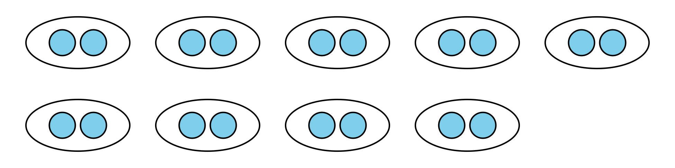

- 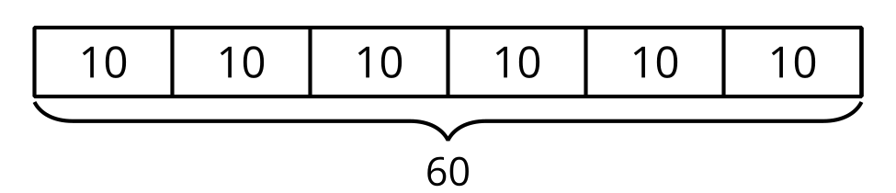
- Elena has 4 bags of oranges. Each bag has 5 oranges in it.

- 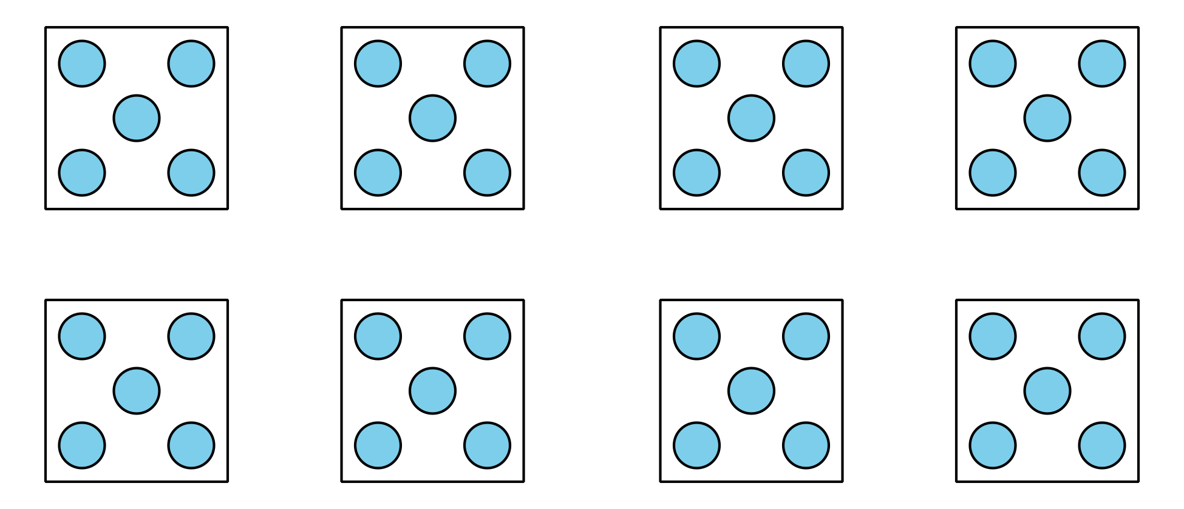
© CC BY 2021 Illustrative Mathematics®

