Algebra 1
Unit 6Lesson 3CC BY NC 2024 Illustrative Mathematics®
Unit 6, Lesson 3

Representing Exponential Growth
Let’s explore exponential growth.
Algebra 1
Unit 6Lesson 3CC BY NC 2024 Illustrative Mathematics®

3.1Math Talk: Exponent Rules
Rewrite each expression as a power of 2.
- $2^{3}⋅2^{4}$
- $2^{5}⋅2$
- $2^{10}÷2^{7}$
- $2^{9}÷2$
Algebra 1
Unit 6Lesson 3CC BY NC 2024 Illustrative Mathematics®

3.2What Does $x^{0}$ Mean?
- Complete the table. Take advantage of any patterns you notice.
- $x$ | - 4 | - 3 | - 2 | - 1 | - 0
- $3^{x}$ | - 81 | - 27
- Here are some equations. Find the solution to each equation using what you know about exponent rules. Be prepared to explain your reasoning.
  - $9^{?}⋅9^{7}=9^{7}$
  - $\frac{9^{12}}{9^{?}}=9^{12}$
- What is the value of $5^{0}$? What about $2^{0}$?

Are you ready for more?
We know, for example, that $\left(2+3\right)+5=2+\left(3+5\right)$ and $2⋅\left(3⋅5\right)=\left(2⋅3\right)⋅5$. The grouping with parentheses does not affect the value of the expression.
Is this true for exponents? That is, are the numbers $2^{\left(3^{5}\right)}$ and ${\left(2^{3}\right)}^{5}$ equal? If not, which is bigger? Which of the two would you choose as the meaning of the expression $2^{3^{5}}$ written without parentheses?
Algebra 1
Unit 6Lesson 3CC BY NC 2024 Illustrative Mathematics®

3.3Multiplying Microbes
- In a biology lab, 500 bacteria reproduce by splitting. Every hour, on the hour, each bacterium splits into two bacteria.
  - Write an expression to show how to find the number of bacteria after each hour listed in the table.
  - Write an equation relating $n$, the number of bacteria, to $t$, the number of hours.
  - Use your equation to find $n$ when $t$ is 0. What does this value of $n$ mean in this situation?
  - When the values of one variable are multiplied by the same value each time the other variable increases by 1, that multiplier is called the growth factor. What is the growth factor in this situation?
- hour | - number of bacteria
- 0 | - 500
- 1
- 2
- 3
- 6
- t
- In a different biology lab, a population of single-cell parasites also reproduces hourly. An equation that gives the number of parasites, $p$, after $t$ hours is $p=100⋅3^{t}.$ Explain what the numbers 100 and 3 mean in this situation.
Algebra 1
Unit 6Lesson 3CC BY NC 2024 Illustrative Mathematics®

3.4Graphing the Microbes
- Refer back to your work in the table of the previous task. Use that information and the given coordinate planes to graph the following:
- a. Graph $\left(t,n\right)$ when $t$ is 0, 1, 2, 3, and 4.
- 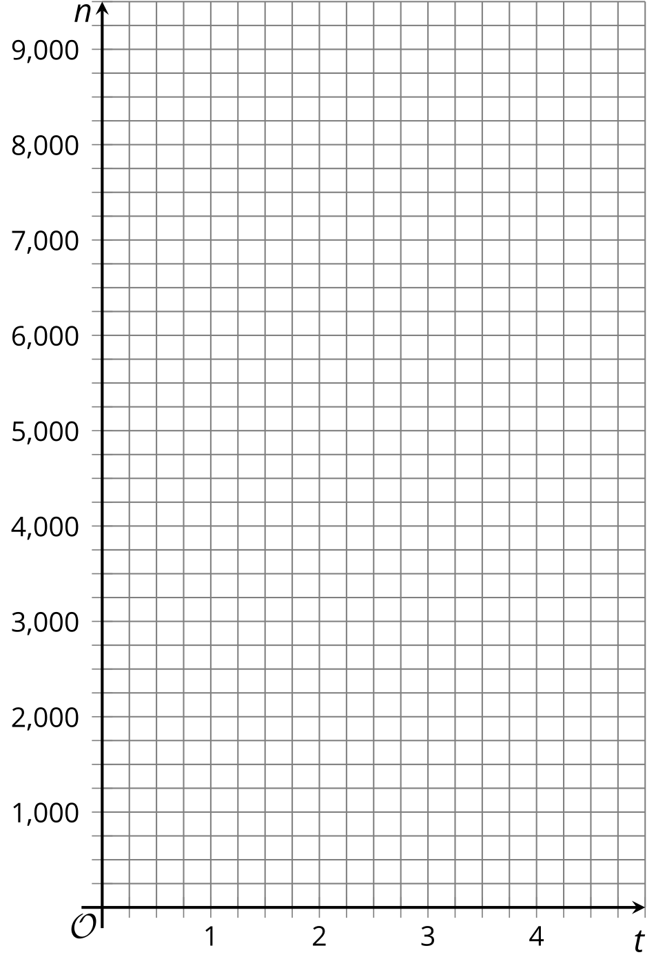
- b. Graph $\left(t,p\right)$ when $t$ is 0, 1, 2, 3, and 4. (If you get stuck, you can create a table.)
- 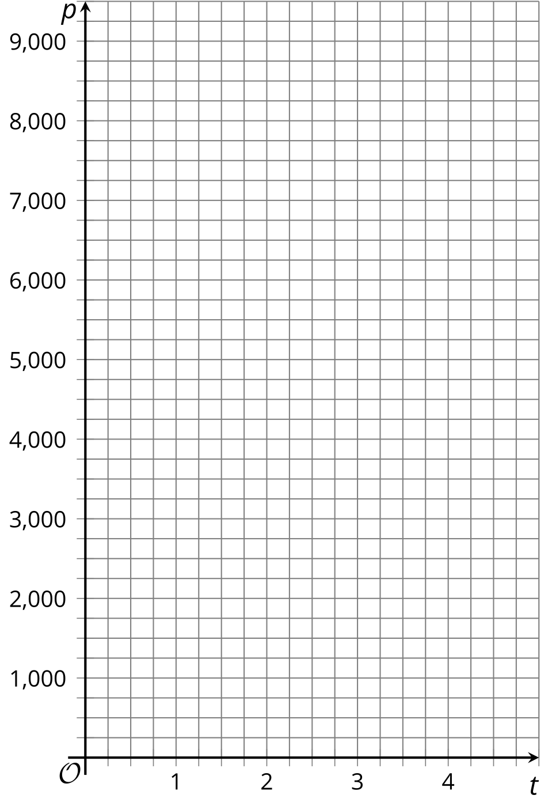
- On the graph of $n$, where can you see each number that appears in the equation?
- On the graph of $p$, where can you see each number that appears in the equation?

Lesson 3 Summary
In relationships where the change is exponential, a quantity is repeatedly multiplied by the same amount. The multiplier is called the growth factor.
Suppose a population of cells starts at 500 and triples every day. The number of cells each day can be calculated as follows:
number of days | number of cells
0 | 500
1 | 1,500 (or $500⋅3$)
2 | 4,500 (or $500⋅3⋅3$, or $500⋅3^{2}$)
3 | 13,500 (or $500⋅3⋅3⋅3$, or $500⋅3^{3}$)
$d$ | $500⋅3^{d}$
We can see that the number of cells ($p$) is changing exponentially, and that $p$ can be found by multiplying 500 by 3 as many times as the number of days ($d$) since the 500 cells were observed. The growth factor is 3. To model this situation, we can write this equation: $p=500⋅3^{d}$.
The equation can be used to find the population on any day, including day 0, when the population was first measured. On day 0, the population is $500⋅3^{0}$. Since $3^{0}=1$, this is $500⋅1$ or 500.
Here is a graph of the daily cell population. The point $\left(0,500\right)$ on the graph means that on day 0, the population starts at 500.
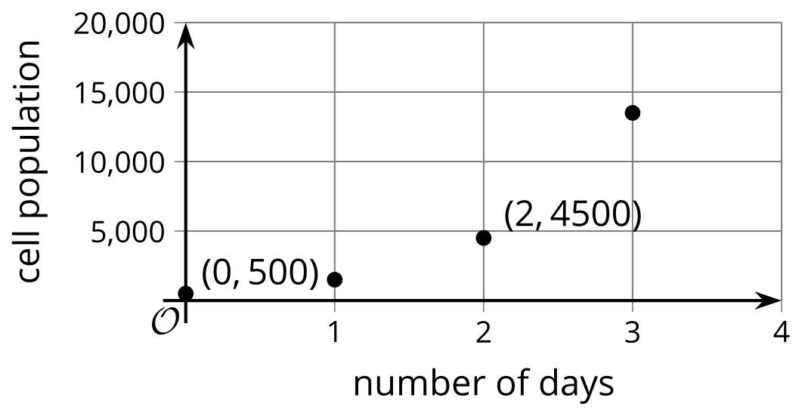
Each point is 3 times higher on the graph than the previous point. $\left(1,1500\right)$ is 3 times higher than $\left(0,500\right)$, and $\left(2,4500\right)$ is 3 times higher than $\left(1,1500\right)$.

