Grade 2
Unit 6Lesson 10CC BY NC 2024 Illustrative Mathematics®
Unit 6, Lesson 10

Center Day 2
- Let’s work with shapes.
Grade 2
Unit 6Lesson 10CC BY NC 2024 Illustrative Mathematics®

Warm-up How Many Do You See: Base-Ten Blocks
How many do you see? How do you see them?
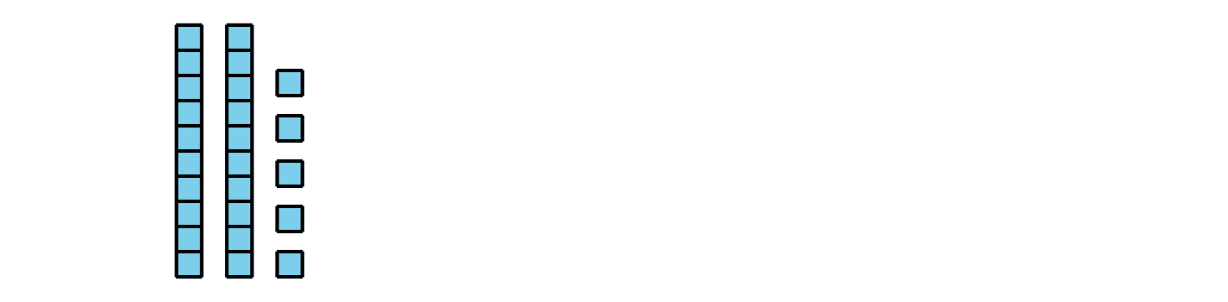
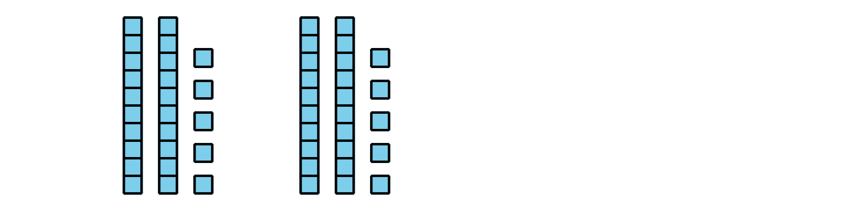
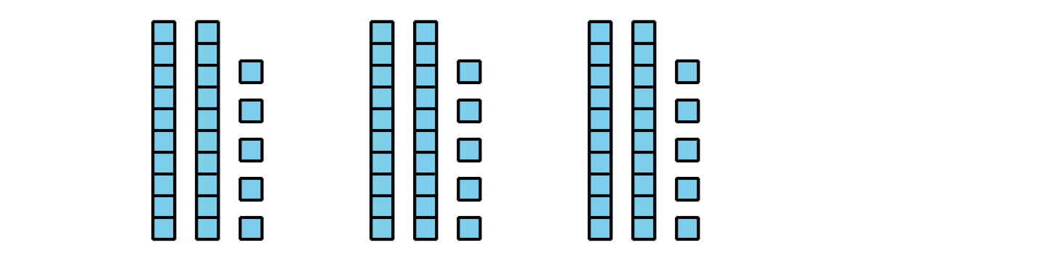
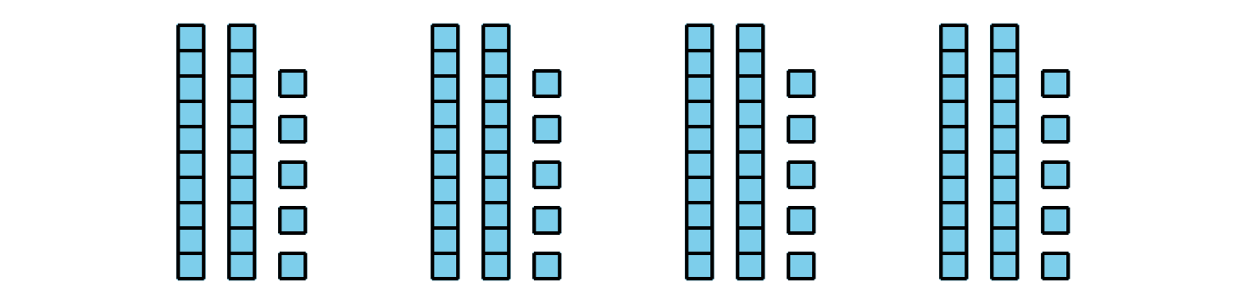
Grade 2
Unit 6Lesson 10CC BY NC 2024 Illustrative Mathematics®

Activity 2 Centers: Choice Time
Choose a center:
How Are They the Same?
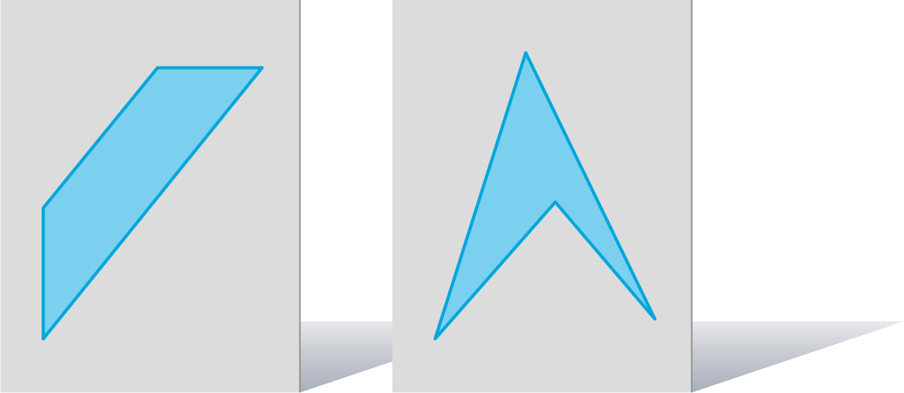
Capture Squares
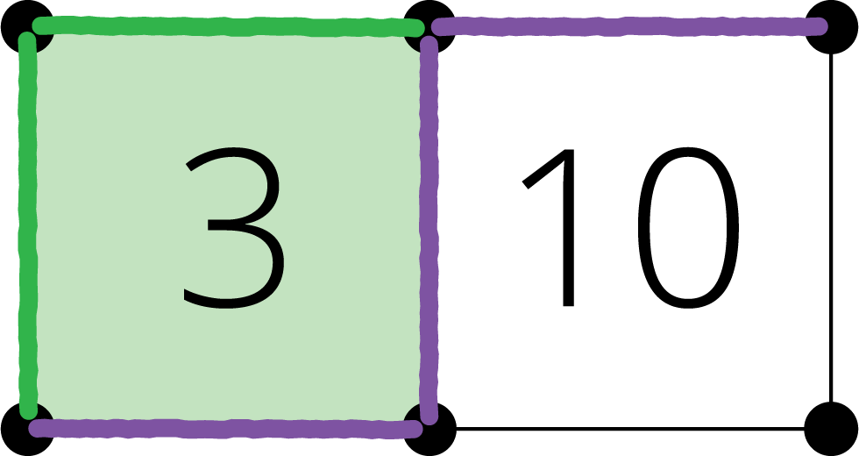
Can You Draw It?
