Grade 6
Unit 8Lesson 8CC BY NC Illustrative Mathematics, based on IM 6–8 Math, CC BY Open Up Resources.
Unit 8, Lesson 8

Describing Distributions on Histograms
Let's describe distributions displayed in histograms.
Grade 6
Unit 8Lesson 8CC BY NC Illustrative Mathematics, based on IM 6–8 Math, CC BY Open Up Resources.

8.1Which Three Go Together: Histograms
Which three go together? Why do they go together?
A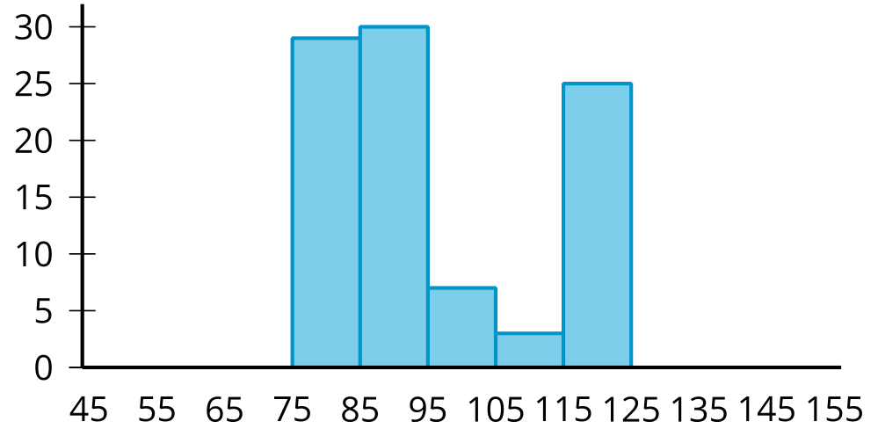
B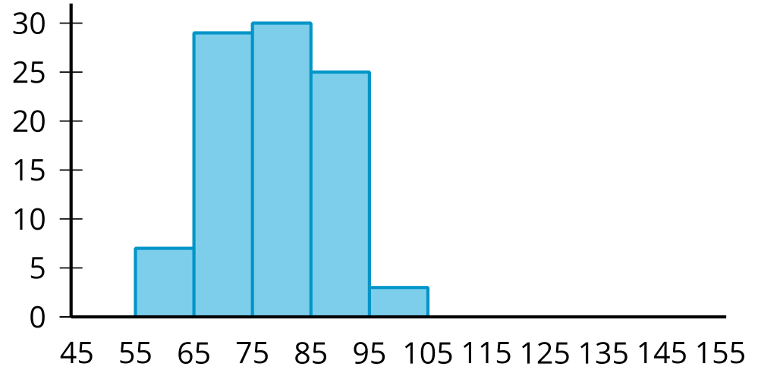
C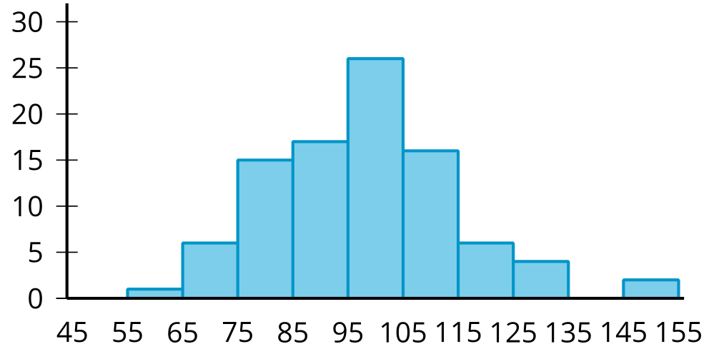
D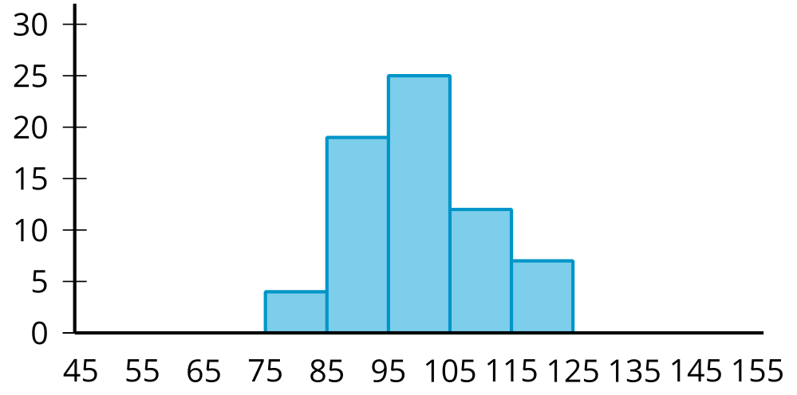
Grade 6
Unit 8Lesson 8CC BY NC Illustrative Mathematics, based on IM 6–8 Math, CC BY Open Up Resources.

8.2Card Sort: Sorting Histograms
Your teacher will give you a set of cards. Each card contains a histogram.
- Sort the histograms into 2 groups based on whether they are approximately symmetrical or not. Be prepared to explain how you know where each card belongs.
- Histograms are also described by how many major peaks they have. Histogram A is an example of a distribution with a single peak that is not symmetrical. Sort the histograms into new categories based on whether they have a single peak or not.
- Some histograms have a gap, a space between two bars where there are no data points. Sort the histograms into new categories based on whether they have one or more gaps or have no gaps.
- Some histograms have a few data points that are unusually far from the center like in Histogram A. Sort the histograms into groups that have this feature.
Grade 6
Unit 8Lesson 8CC BY NC Illustrative Mathematics, based on IM 6–8 Math, CC BY Open Up Resources.

8.3Getting to School
Your teacher will provide you with some data that your class collected the other day.
- Use the data to draw a histogram that shows your class’s travel times.
- 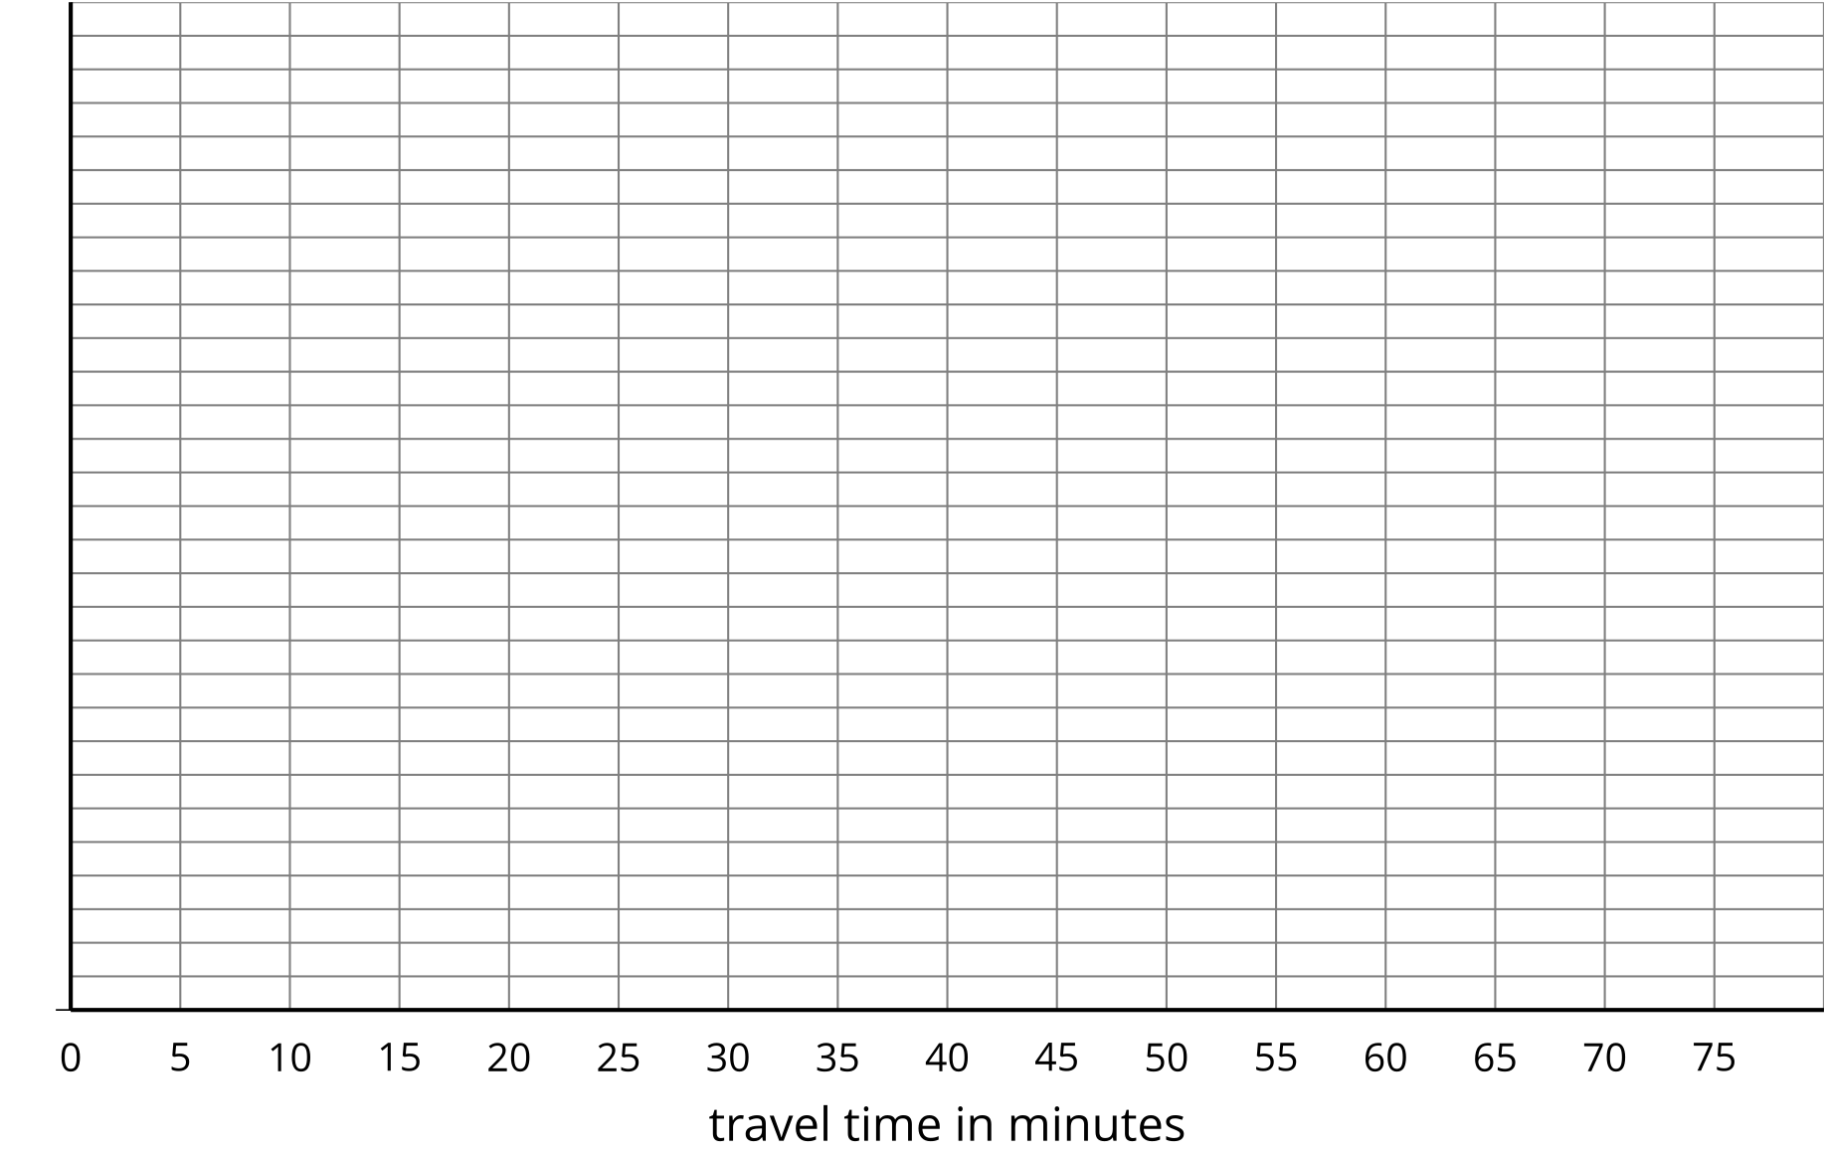
- Describe the distribution of travel times. Comment on the center and spread of the data, as well as the shape and features.
- Use the data on methods of travel to draw a bar graph. Include labels for the horizontal axis.
- 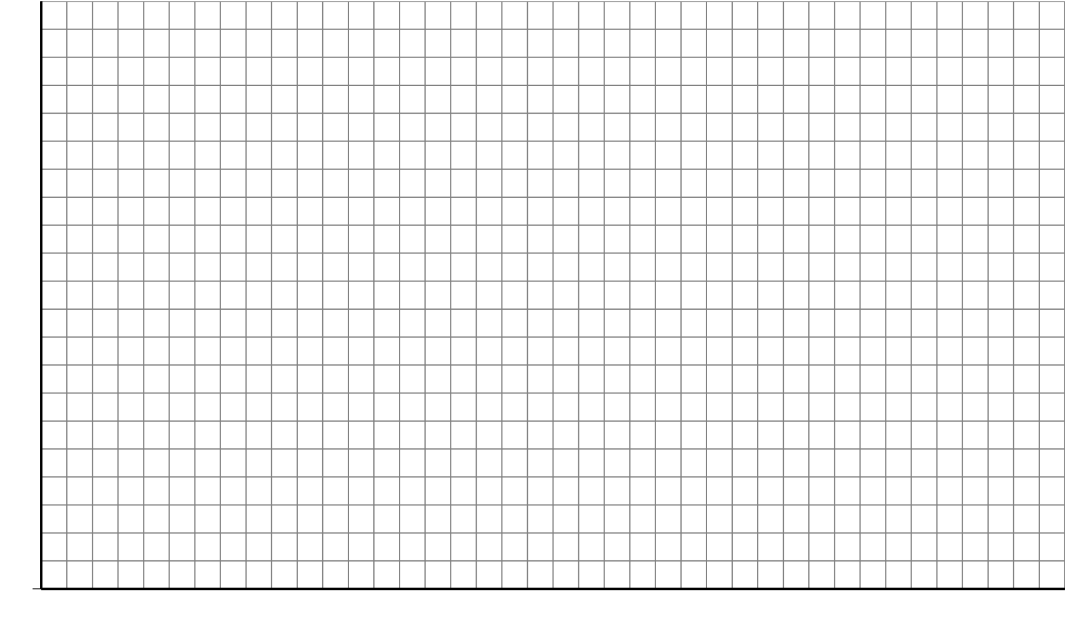
- Describe what you learned about your class’s methods of transportation to school. Comment on any patterns you noticed.
- Compare the histogram and the bar graph that you drew. How are they the same? How are they different?

Are you ready for more?
Use one of these suggestions (or make up your own). Research data to create a histogram. Then, describe the distribution.
- Heights of 30 athletes from multiple sports
- Heights of 30 athletes from the same sport
- High temperatures for each day of the last month in a city you would like to visit
- Prices for all the menu items at a local restaurant

Lesson 8 Summary
We can describe the shape and features of the distribution shown on a histogram. Here are two distributions with very different shapes and features.
A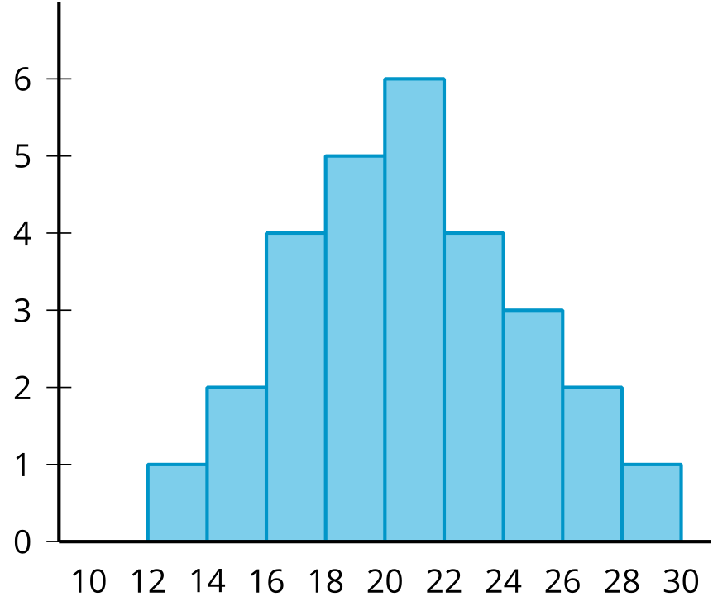
B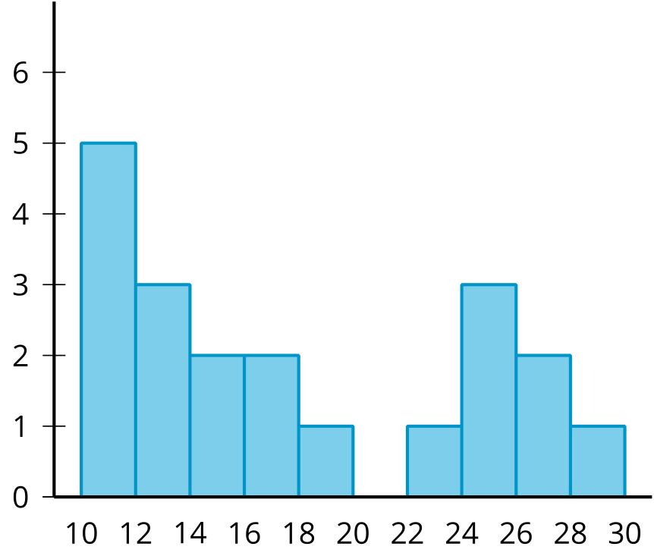
- Histogram A is very symmetrical and has a peak near 21. Histogram B is not symmetrical and has two peaks, one near 11 and one near 25.
- Histogram B has two clusters. A cluster forms when many data points are near a particular value (or a neighborhood of values) on a number line.
- Histogram B also has a gap between the clusters from 20 and 22. A gap shows a location with no data values.
Here is a bar graph showing the breeds of 30 dogs and a histogram for their weights.
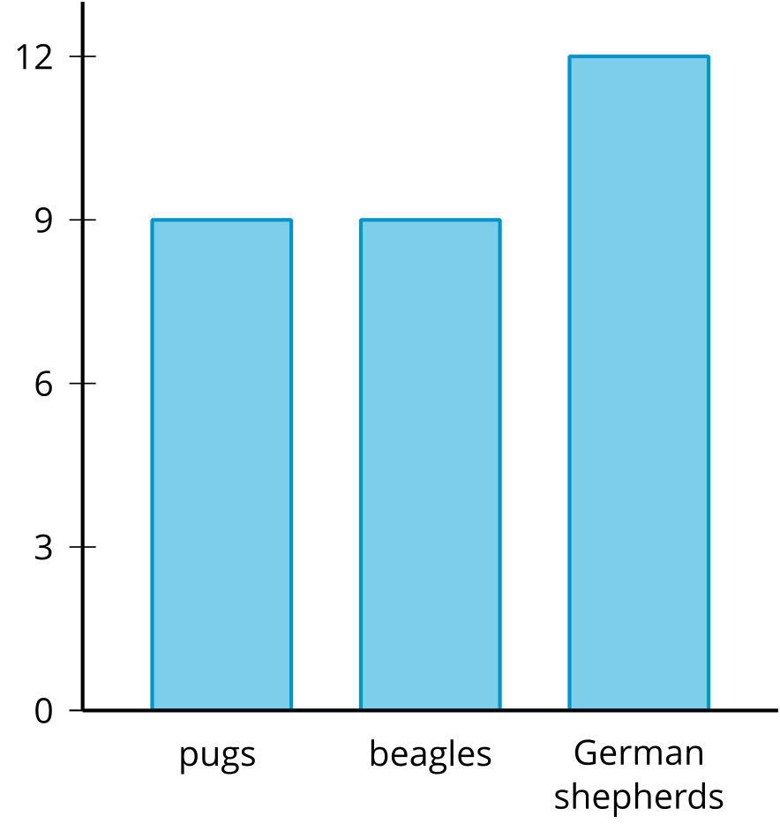
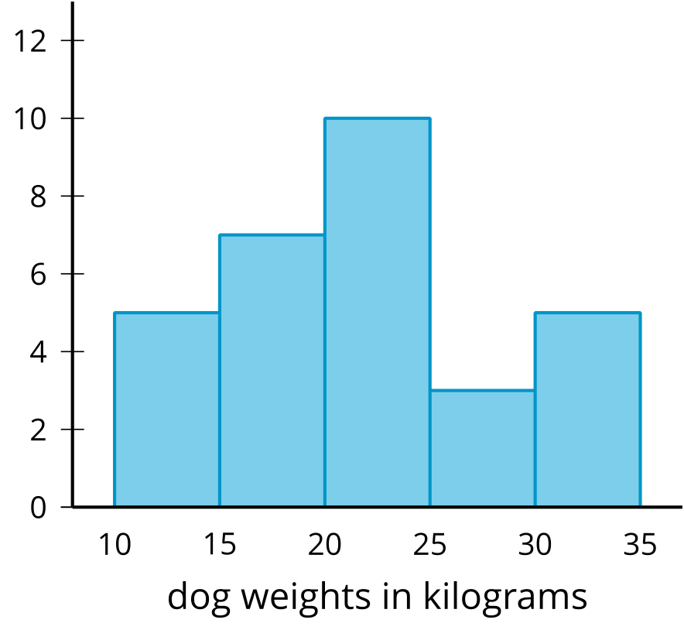
Bar graphs and histograms may look alike, but they have different uses.
- Bar graphs represent categorical data. Histograms represent numerical data.
- Bar graphs have spaces between the bars. Histograms show a space between bars only when no data values are in an interval.
- Bars in a bar graph can be in any order. Histograms must be in numerical order.
- In a bar graph, the number of bars depends on the number of categories. In a histogram, we choose how many bars to use.

