Grade 2
Unit 2Lesson 17CC BY NC 2024 Illustrative Mathematics®
Unit 2, Lesson 17

Our Store’s Inventory
- Let's think about how to run a store.
Grade 2
Unit 2Lesson 17CC BY NC 2024 Illustrative Mathematics®

Warm-upNotice and Wonder: The Shopping Basket
What do you notice? What do you wonder?
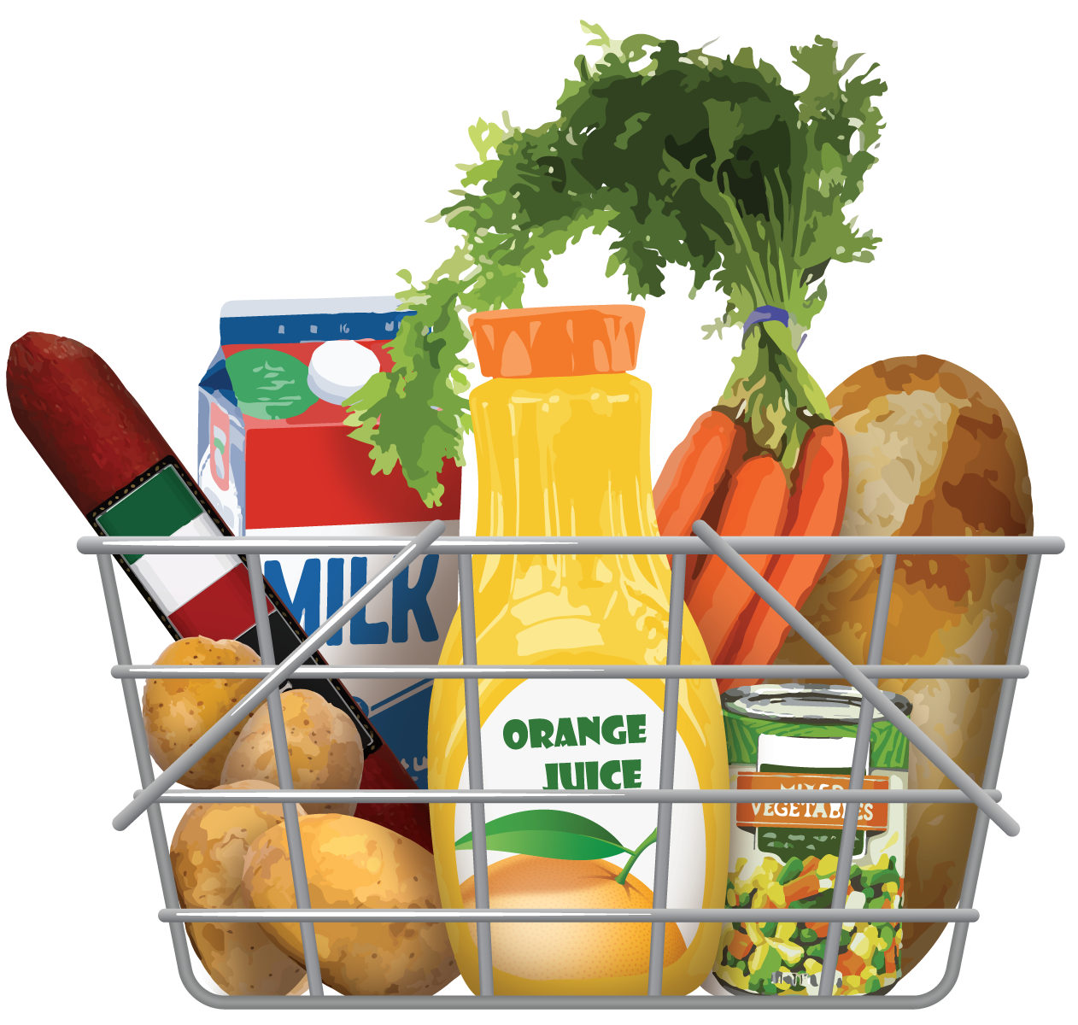
Grade 2
Unit 2Lesson 17CC BY NC 2024 Illustrative Mathematics®

Activity 1100 Items
- Choose 3 items to sell at your store. Write the names of the items in the first row.
- At the beginning of each day, you have:
  - 100 items
  - Fewer than 10 of 1 of the items.
  - More than 10 of the other 2 items.
- Fill in the second row. How much of each item do you start with?
names | item 1: | item 2: | item 3:
amount at the beginning of the day
sales activity
amount at the end of the day
Grade 2
Unit 2Lesson 17CC BY NC 2024 Illustrative Mathematics®

Activity 2Buyers and Sellers
- Take turns rolling a number cube. Each person rolls 3 times. Record each roll.
  - Roll 1: _____________
  - Roll 2: _____________
  - Roll 3: _____________
- Buyers: Create a 1-digit or 2-digit number using the digits you rolled. These numbers represent how many of each item to buy.
- Sellers: Change the total number of items sold on your inventory sheet after a sale. Record the change next to “sales activity.”
Grade 2
Unit 2Lesson 17CC BY NC 2024 Illustrative Mathematics®

Activity 3Sales Reports
- Fill out the inventory sheet with the information from your sales.
 | - item 1 | - item 2 | - item 3 | - total
- starting amount
- number of items sold
- number of items left
- restock amount
- What do you notice about the number of items you sold? What do you notice about the restock amount?

