Algebra 1
Unit 6Lesson 4CC BY NC 2024 Illustrative Mathematics®
Unit 6, Lesson 4

Representing Exponential Decay
Let’s think about how to show and talk about exponential decay.
Algebra 1
Unit 6Lesson 4CC BY NC 2024 Illustrative Mathematics®

4.1Two Other Tables
Use the patterns you notice to complete the tables. Show your reasoning.
Table A
$x$ | 0 | 1 | 2 | 3 | 4 | 25
$y$ | 2.5 | 10 | 17.5 | 25

Table B
$x$ | 0 | 1 | 2 | 3 | 4 | 25
$y$ | 2.5 | 10 | 40 | 160

Algebra 1
Unit 6Lesson 4CC BY NC 2024 Illustrative Mathematics®

4.2The Algae Bloom
In order to control an algae bloom in a lake, scientists introduce some treatment products.
Once the treatment begins, the area covered by algae $A$, in square yards, is given by the equation $A=240⋅{\left(\frac{1}{3}\right)}^{t}$. Time, $t$, is measured in weeks.
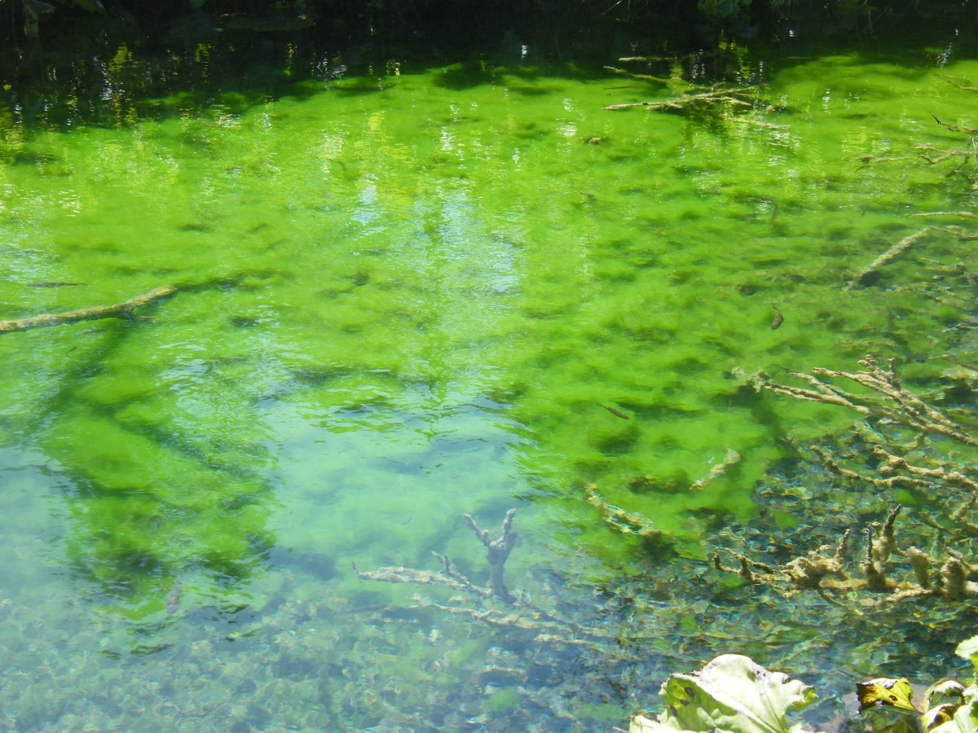
- In the equation, what does the 240 tell us about the algae? What does the $\frac{1}{3}$ tell us?
- Create a graph to represent $A=240⋅{\left(\frac{1}{3}\right)}^{t}$ when $t$ is 0, 1, 2, 3, and 4. Think carefully about how you choose the scale for the axes. If you get stuck, consider creating a table of values.
- 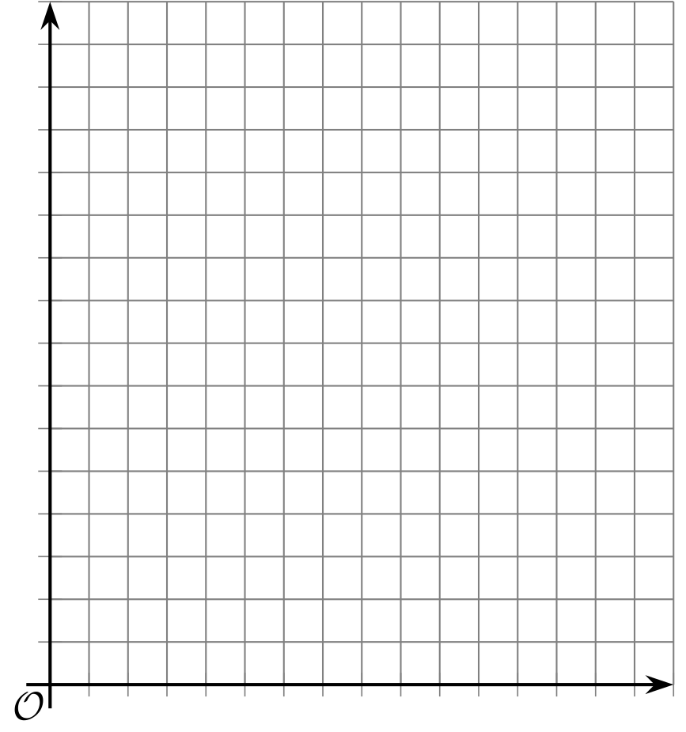
- About how many square yards will the algae cover after 2.5 weeks? Explain your reasoning.

Are you ready for more?
The scientists estimate that to keep the algae bloom from spreading after the treatment concludes, they will need to get the area covered to be under one square foot. How many weeks should they run the treatment in order to achieve this?
Algebra 1
Unit 6Lesson 4CC BY NC 2024 Illustrative Mathematics®

4.3Glow Stick Luminescence
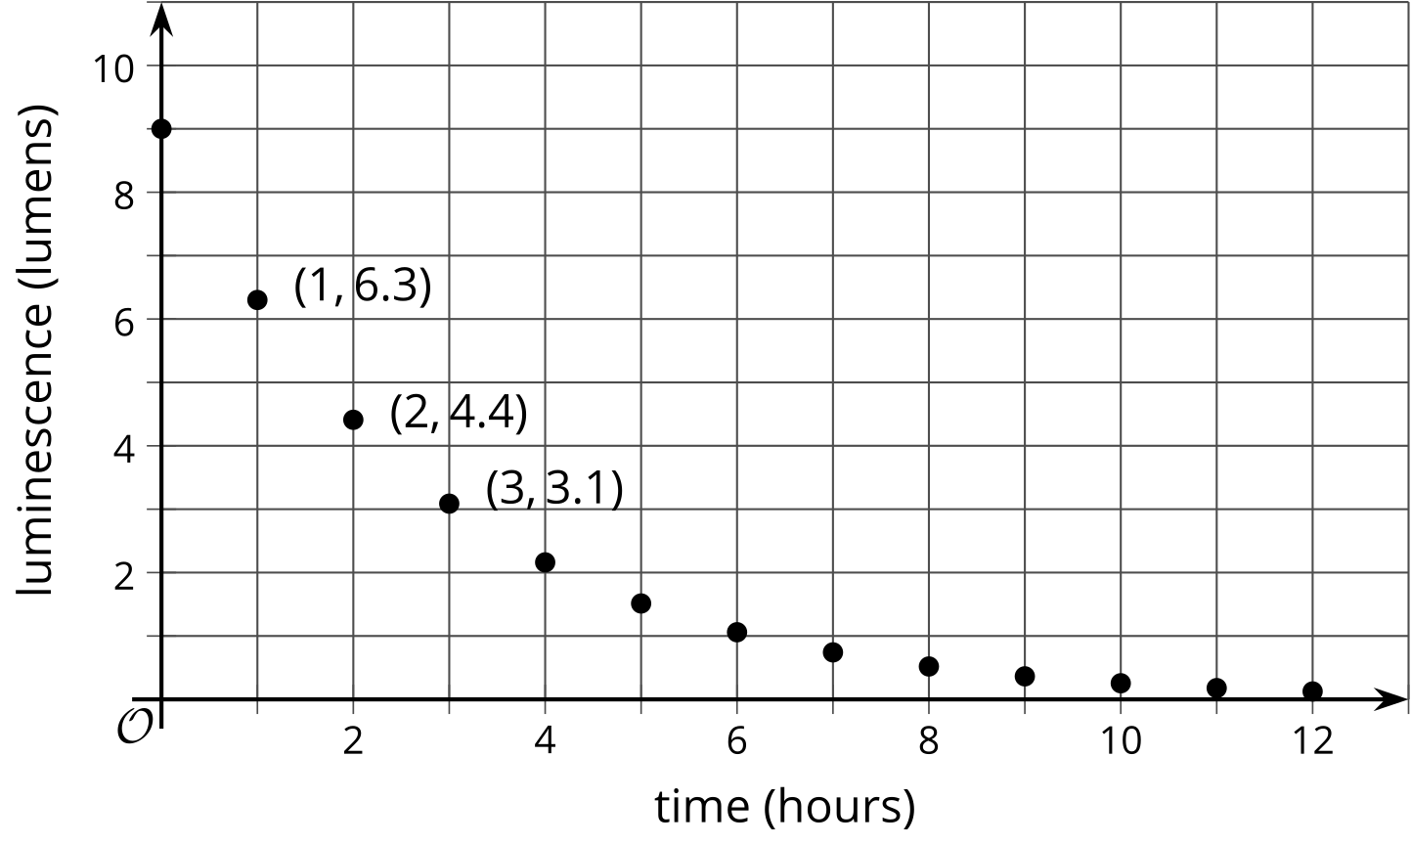
Once a glow stick begins to glow, it can glow for hours. The graph shows the luminescence, in lumens, of a glow stick over time, in hours.
- Scientists have found that glow stick luminescence decreases exponentially. How can you check if the graph supports the scientists’ claim?
- How much less bright is the glow stick after the first hour? What fraction of the original luminescence is that?
- How much less bright is the glow stick after the second hour? What fraction is that of the luminescence 1 hour earlier?
- What fraction of luminescence stays for each hour that passes? Explain your reasoning.
- Complete the table to show the predicted luminescence 4 and 5 hours after beginning to glow.
- glowing time (hours) | - 0 | - 1 | - 2 | - 3 | - 4 | - 5
- luminescence (lumens) | - 9 | - 6.3 | - 4.4 | - 3.1
- Describe how you would find how many lumens the glow stick produces after 10 hours. After $h$ hours?

Lesson 4 Summary
Here is a graph showing the luminescence of a glow-in-the-dark paint, measured in lumens, over a period of time, measured in hours. The luminescence of this glow-in-the-dark paint can be modeled by an exponential function.
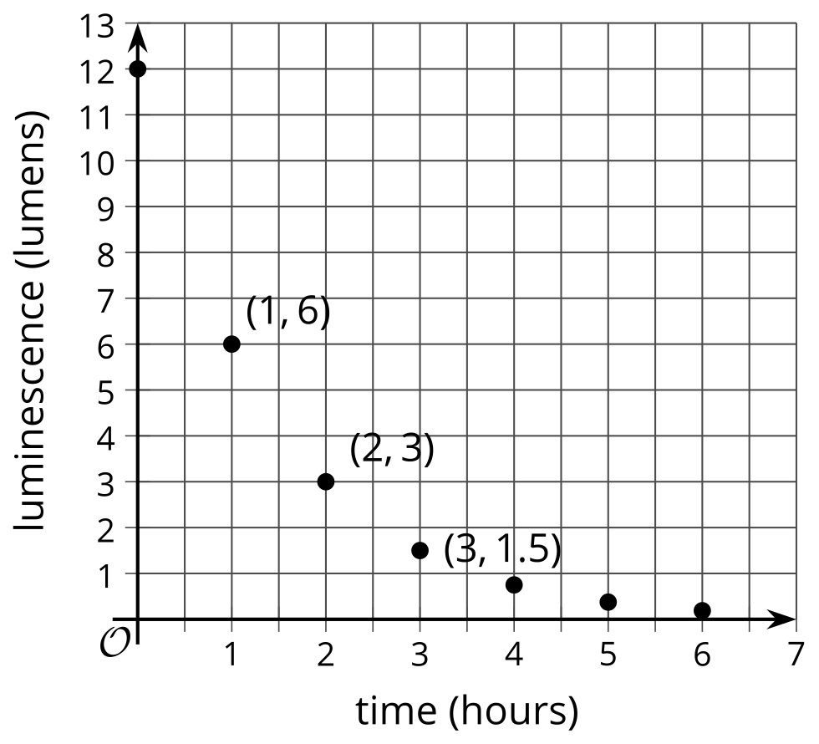
Notice that the amounts are decreasing over time. The graph includes the point $\left(0,12\right)$. This means that when the glow-in-the-dark paint started glowing, its glow measured 12 lumens. The point $\left(1,6\right)$ tells us the glow measured 6 lumens 1 hour later. Between 3 and 4 hours after the glow-in-the-dark paint began to glow, the luminescence fell below 1 lumen.
We can use the graph to find out what fraction of luminescence stays each hour. Notice that $\frac{6}{12}=\frac{1}{2}$ and $\frac{3}{6}=\frac{1}{2}$. As each hour passes, the luminescence that stays is multiplied by a factor of $\frac{1}{2}$.
If $y$ is the luminescence, in lumens, and $t$ is time, in hours, then this situation is modeled by the equation:
$y=12⋅{\left(\frac{1}{2}\right)}^{t}$
We can confirm that the data is changing exponentially because it is multiplied by the same value each time. When the growth factor is between 0 and 1, the quantity being multiplied decreases, the situation is sometimes called “exponential decay,” and the growth factor may be called a “decay factor.”

