Unit 4 Lesson 19: Ways to Divide Larger Numbers

WU True or False: Ones, Tens, Twenties (Warm up)

Student Task Statement
Decide if each statement is true or false. Be prepared to explain your reasoning.
- $4×10=40×1$
- $4×20=4×2×10$
- $8×20=8×2×1$
- $8×20=16×10$

1 Divide with Base-Ten Blocks

Images for Launch
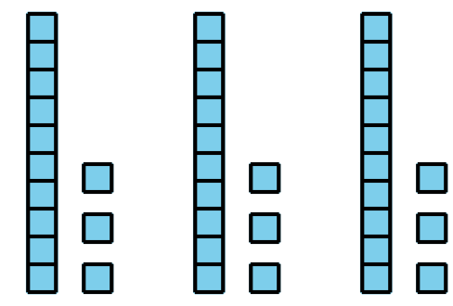

Student Task Statement
- Use base-ten blocks to represent each expression. Then, find its value.
  - $55÷5$
  - $45÷3$
- Find the value of each expression. Use base-ten blocks if you find them helpful.
  - $63÷3$
  - $84÷7$
  - $100÷5$
- 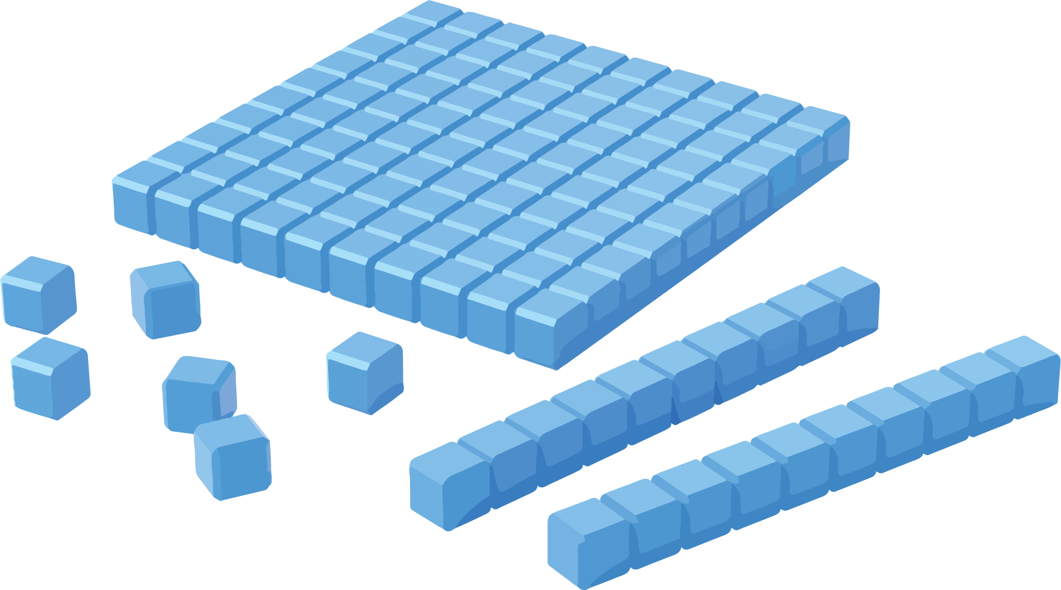

2 Different Ways to Show Division

Student Task Statement
Jada and Han used base-ten blocks to represent $60÷5$.
Here is Jada’s work:
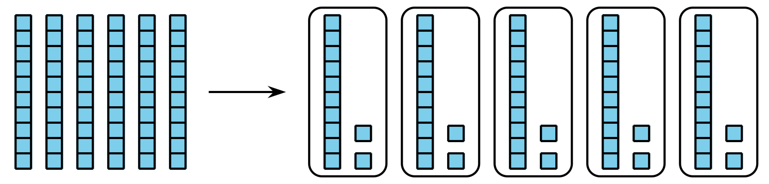
Here’s Han’s work:
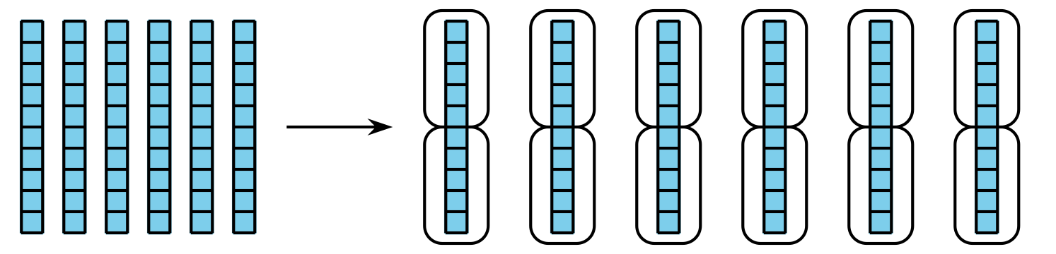
- Make sense of Jada’s and Han’s work.
  - What did they do differently?
  - Where do we see the value of $60÷5$ in each person’s work?
- How would you use base-ten blocks so you could represent these expressions and find their value? Be prepared to explain your reasoning.
  - $64÷4$: Would you make 4 groups or groups of 4?
  - $72÷6$: Would you make 6 groups or groups of 6?
  - $75÷15$: Would you make 15 groups or groups of 15?
© CC BY 2021 Illustrative Mathematics®

