Grade 6
Unit 3Lesson 17CC BY NC Illustrative Mathematics, based on IM 6–8 Math, CC BY Open Up Resources.
Unit 3, Lesson 17

Painting a Room
Let’s see what it takes to paint a room.
Grade 6
Unit 3Lesson 17CC BY NC Illustrative Mathematics, based on IM 6–8 Math, CC BY Open Up Resources.

17.1Getting Ready to Paint
Here are drawings of the four walls of a bedroom.
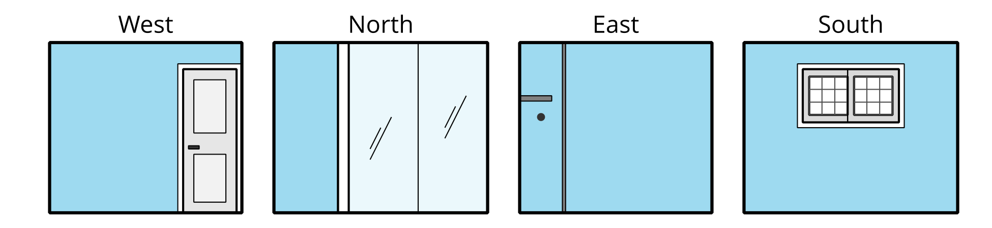
If you are asked to paint all the walls and buy enough paint for the job, what information would you need?
Grade 6
Unit 3Lesson 17CC BY NC Illustrative Mathematics, based on IM 6–8 Math, CC BY Open Up Resources.

17.2All the Walls
Here is the floor plan for the bedroom that needs to be painted.
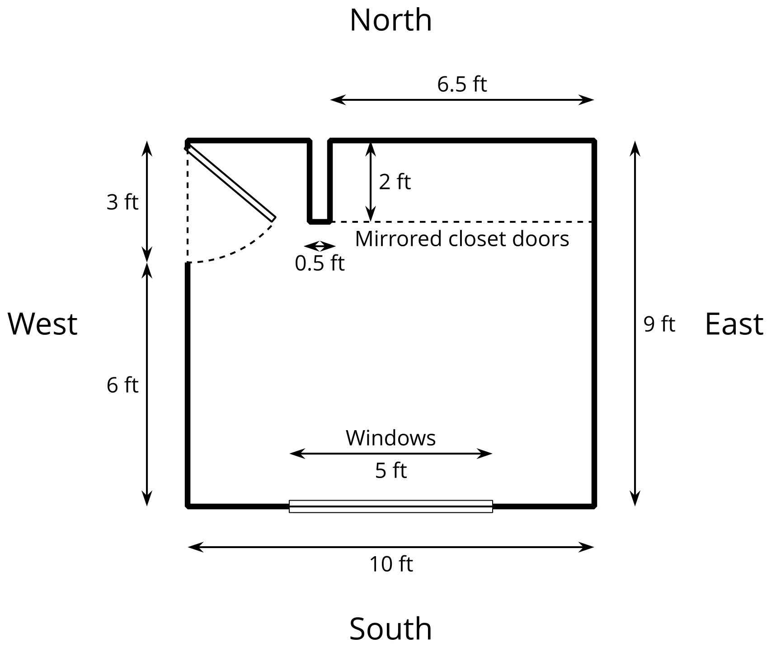
Here is some information about the room and the job:
- All the walls need to be painted, including inside the closet.
- The west wall has a door that is 3 feet wide and 7 feet tall.
- The north wall has a closet with floor-to-ceiling mirrored doors.
- The south wall has windows that are 5 feet wide by 3 feet tall.
- The doors and windows do not need to be painted.
- The short wall on one end of the closet needs to be painted on three sides.
- The ceiling in this room is 8 feet high.
- All of the corners are right angles.
How many square feet need to be covered with paint? Show your reasoning. Organize your work so that it can be followed by others.
Grade 6
Unit 3Lesson 17CC BY NC Illustrative Mathematics, based on IM 6–8 Math, CC BY Open Up Resources.

17.3Shopping for Paint
- An ad for paint reads: “Just 2 quarts covers 175 square feet!” If you need to apply two coats of paint on all the walls, how much paint do you need to buy?
- Paint can be purchased in 1-quart or 1-gallon containers. The paint chosen for the room costs $12 a quart and $38 a gallon.
  - Which container sizes and how many could you buy to have enough paint for the room? Name at least two options.
  - 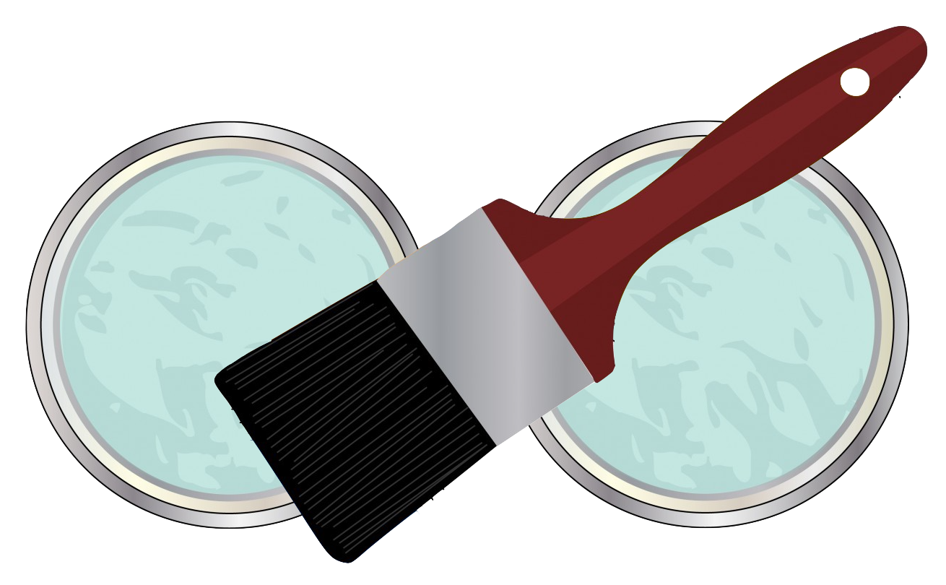
  - Which of your options would cost the least? Show your reasoning.
- Pause for a whole-class discussion.
- The hardware store is having a sale: 20% off of quart-size paint and 30% off of gallon-size paint.
  - With the sale, how much would you save with each option?
  - Would the option you chose earlier still be the cheapest? Show your reasoning.

Are you ready for more?
Check the prices for a quart and a gallon of interior paint at a local store or online. Look for discounts or deals, but also consider possible differences in quality. Some paints may be more expensive because they are of higher quality.
- When would it make sense to pay more for better paint? When would it make sense to buy the least expensive paint?
- What is the best deal you can find for putting 2 coats of paint on the walls of this bedroom?
Grade 6
Unit 3Lesson 17CC BY NC Illustrative Mathematics, based on IM 6–8 Math, CC BY Open Up Resources.

17.4Time to Paint
After buying the supplies, you start painting the east wall. It takes you 96 minutes to put two coats of paint on that wall (not including a lunch break between the two coats). A friend stops by to see how you are doing.
- Your friend comments that you are 25% finished with the painting. Are they correct? Explain your reasoning.
- Your friend offers to help you with the rest of the painting. It takes the two of you 150 more minutes of painting time to finish the entire room.
- How much time did your friend save you? Show your reasoning.

