Grade 2
Unit 2Lesson 16CC BY NC 2024 Illustrative Mathematics®
Unit 2, Lesson 16

Center Day 3
- Let’s use diagrams to make and solve our own story problems.
Grade 2
Unit 2Lesson 16CC BY NC 2024 Illustrative Mathematics®

Warm-upNumber Talk: Subtract Multiples of 10
Find the value of each expression mentally.
- $25−10$
- $35−10$
- $35−20$
- $35−19$
Grade 2
Unit 2Lesson 16CC BY NC 2024 Illustrative Mathematics®

Activity 2Centers: Choice Time
Choose a center.
Target Numbers

Capture Squares
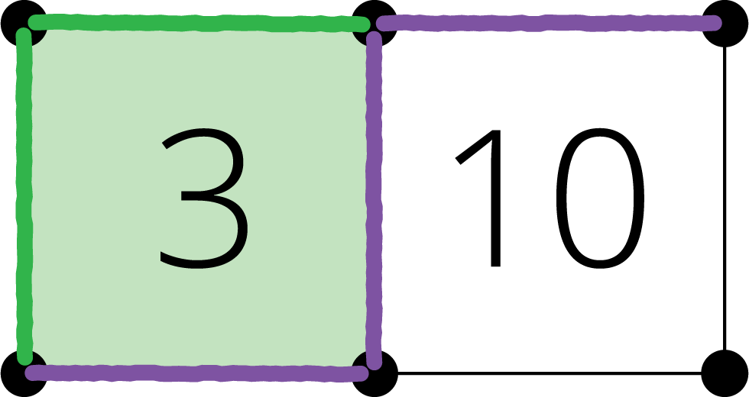
Five in a Row
