Grade 2
Unit 7Lesson 7CC BY NC 2024 Illustrative Mathematics®
Unit 7, Lesson 7

Compose a Greater Unit
- Let’s add 3-digit numbers and compose tens or hundreds.
Grade 2
Unit 7Lesson 7CC BY NC 2024 Illustrative Mathematics®

Warm-up How Many Do You See: Are They the Same?
How many do you see? How do you see them?
Unable to process <img src="/tikz_files/239649.svg">Failed: rsvg-convert --format png --dpi-x 300 --dpi-y 300 /app/tmp/svgtopng-1786381276.312377.svg --output /app/tmp/svgtopng-1786381276.312377.png Backtrace: /app/app/services/script/runner.rb:34:in `block in run_cmd' <internal:kernel>:90:in `tap' /app/app/services/script/runner.rb:32:in `run_cmd' /app/app/services/script/svg_to_png.rb:27:in `convert_svg_to_png' /app/app/services/script/svg_to_png.rb:17:in `to_png' /app/vendor/bundle/ruby/3.3.0/gems/embeddable_content-1.1.0/app/services/embeddable_content/images/image_downloader.rb:37:in `png_rendered_from_svg' /app/vendor/bundle/ruby/3.3.0/gems/embeddable_content-1.1.0/app/services/embeddable_content/images/image_downloader.rb:33:in `raw_image_data' /app/vendor/bundle/ruby/3.3.0/gems/embeddable_content-1.1.0/app/services/embeddable_content/images/image_downloader.rb:13:in `block in save' <internal:kernel>:90:in `tap' /app/vendor/bundle/ruby/3.3.0/gems/embeddable_content-1.1.0/app/services/embeddable_content/images/image_downloader.rb:13:in `save'
Unable to process <img src="/tikz_files/239650.svg">Failed: rsvg-convert --format png --dpi-x 300 --dpi-y 300 /app/tmp/svgtopng-1786381276.3726237.svg --output /app/tmp/svgtopng-1786381276.3726237.png Backtrace: /app/app/services/script/runner.rb:34:in `block in run_cmd' <internal:kernel>:90:in `tap' /app/app/services/script/runner.rb:32:in `run_cmd' /app/app/services/script/svg_to_png.rb:27:in `convert_svg_to_png' /app/app/services/script/svg_to_png.rb:17:in `to_png' /app/vendor/bundle/ruby/3.3.0/gems/embeddable_content-1.1.0/app/services/embeddable_content/images/image_downloader.rb:37:in `png_rendered_from_svg' /app/vendor/bundle/ruby/3.3.0/gems/embeddable_content-1.1.0/app/services/embeddable_content/images/image_downloader.rb:33:in `raw_image_data' /app/vendor/bundle/ruby/3.3.0/gems/embeddable_content-1.1.0/app/services/embeddable_content/images/image_downloader.rb:13:in `block in save' <internal:kernel>:90:in `tap' /app/vendor/bundle/ruby/3.3.0/gems/embeddable_content-1.1.0/app/services/embeddable_content/images/image_downloader.rb:13:in `save'
Unable to process <img src="/tikz_files/239651.svg">Failed: rsvg-convert --format png --dpi-x 300 --dpi-y 300 /app/tmp/svgtopng-1786381276.4430387.svg --output /app/tmp/svgtopng-1786381276.4430387.png Backtrace: /app/app/services/script/runner.rb:34:in `block in run_cmd' <internal:kernel>:90:in `tap' /app/app/services/script/runner.rb:32:in `run_cmd' /app/app/services/script/svg_to_png.rb:27:in `convert_svg_to_png' /app/app/services/script/svg_to_png.rb:17:in `to_png' /app/vendor/bundle/ruby/3.3.0/gems/embeddable_content-1.1.0/app/services/embeddable_content/images/image_downloader.rb:37:in `png_rendered_from_svg' /app/vendor/bundle/ruby/3.3.0/gems/embeddable_content-1.1.0/app/services/embeddable_content/images/image_downloader.rb:33:in `raw_image_data' /app/vendor/bundle/ruby/3.3.0/gems/embeddable_content-1.1.0/app/services/embeddable_content/images/image_downloader.rb:13:in `block in save' <internal:kernel>:90:in `tap' /app/vendor/bundle/ruby/3.3.0/gems/embeddable_content-1.1.0/app/services/embeddable_content/images/image_downloader.rb:13:in `save'
Grade 2
Unit 7Lesson 7CC BY NC 2024 Illustrative Mathematics®

Activity 1 Compose a Ten or a Hundred
- Find the value of each expression. Show your thinking, using objects, drawings, numbers, or words.
  - $364+28$
  - $364+82$
- Compare your thinking with your partner.
Grade 2
Unit 7Lesson 7CC BY NC 2024 Illustrative Mathematics®

Activity 2 Walk about and Add
Work with a partner.
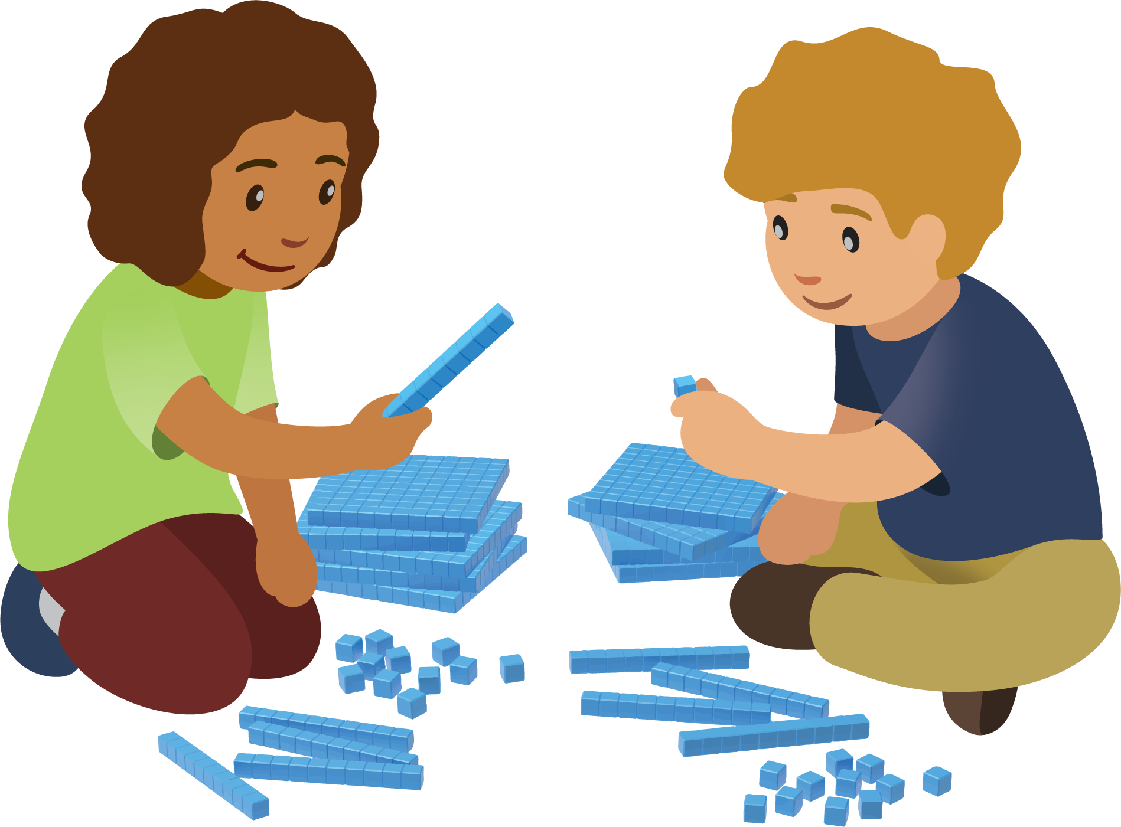

  - Record your numbers to make an expression.
  - ______________ + ______________
  - Do you need to compose a ten?
  - Yes or No
  - Do you need to compose a hundred?
  - Yes or No
  - Find the value of the sum. Show your thinking, using drawings, numbers, or words.

  - Record your numbers to make an expression.
  - ______________ + ______________
  - Do you need to compose a ten?
  - Yes or No
  - Do you need to compose a hundred?
  - Yes or No
  - Find the value of the sum. Show your thinking, using drawings, numbers, or words.

  - Record your numbers to make an expression.
  - ______________ + ______________
  - Do you need to compose a ten?
  - Yes or No
  - Do you need to compose a hundred?
  - Yes or No
  - Find the value of the sum. Show your thinking, using drawings, numbers, or words.

