Grade 2
Unit 8Lesson 6CC BY NC 2024 Illustrative Mathematics®
Unit 8, Lesson 6

Center Day 1
- Let’s skip-count and practice addition and subtraction.
Grade 2
Unit 8Lesson 6CC BY NC 2024 Illustrative Mathematics®

Warm-up Number Talk: 2 More
Find the value of each expression mentally.
- $2+2+2$
- $2+2+2+2$
- $2+2+2+2+2$
- $2+2+2+2+2+2$
Grade 2
Unit 8Lesson 6CC BY NC 2024 Illustrative Mathematics®

Activity 2 Centers: Choice Time
Choose a center.
Write Numbers

Target Numbers
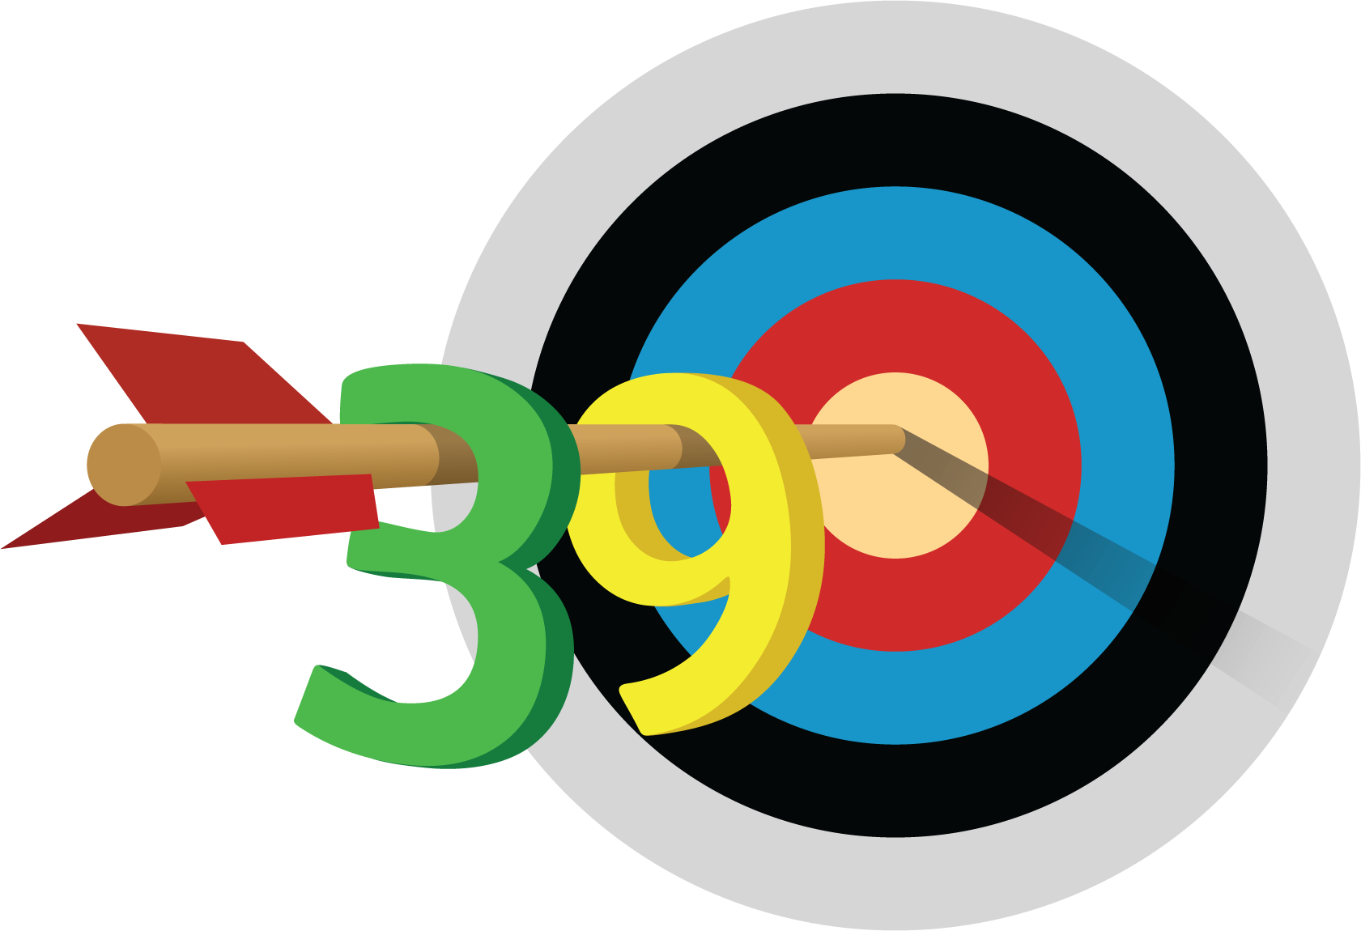
Five in a Row
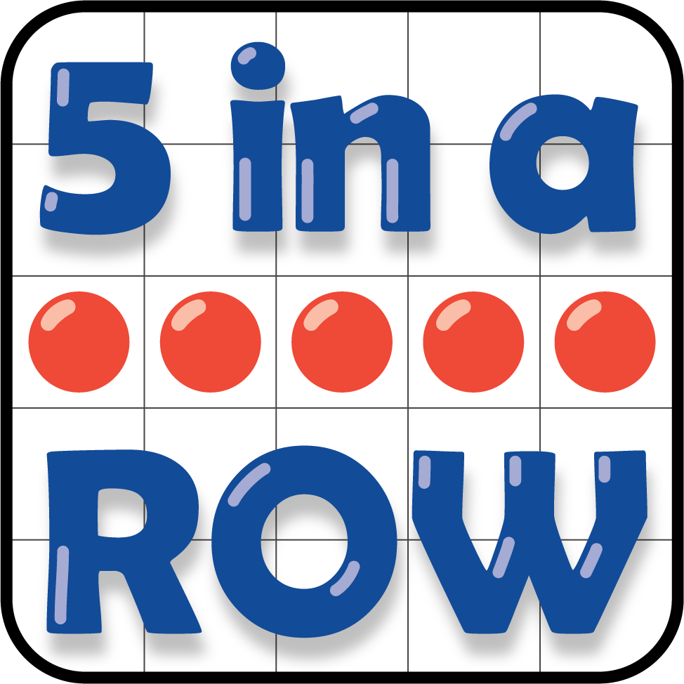
How Close
