Lesson 9 Practice Problems
- Functions $R$ and $D$ give the height, in feet, of a toy rocket and a drone, $t$ seconds after they are released.
- Here are the graphs of $R$ (for the rocket) and $D$ (for the drone).
- 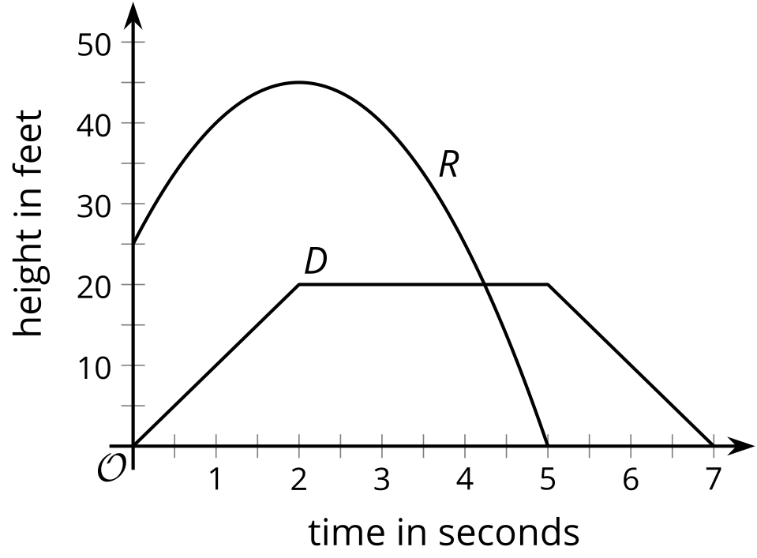
- Write each statement in function notation:
  - At 3 seconds, the toy rocket is higher than the drone.
  - At the start, the toy rocket is 25 feet above the drone.
- $A\left(t\right)$ is the average high temperature in Aspen, Colorado, $t$ months after the start of the year. $M\left(t\right)$ is the average high temperature in Minneapolis, Minnesota, $t$ months after the start of the year. Temperature is measured in degrees Fahrenheit.
- 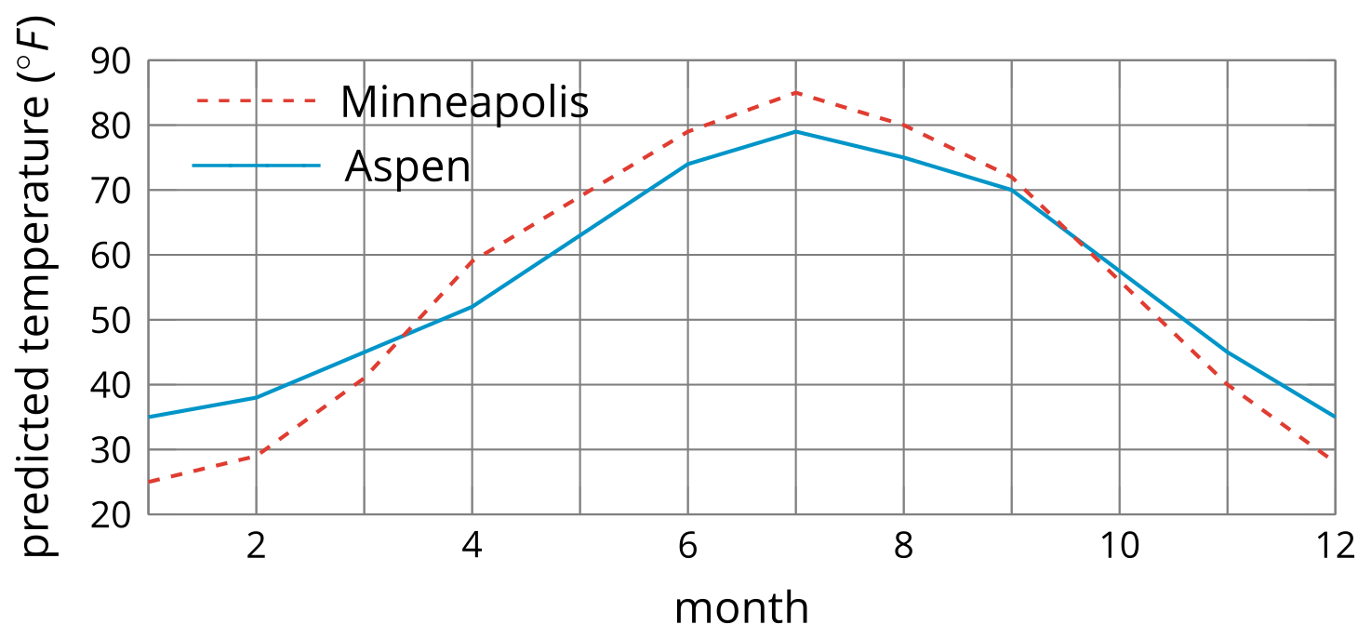
- Which function had the higher average rate of change between the beginning of January and middle of March? What does this mean about the temperature in the two cities?
- Here are two graphs representing functions $f$ and $g$.
- Select all statements that are true about functions $f$ and $g$.
- 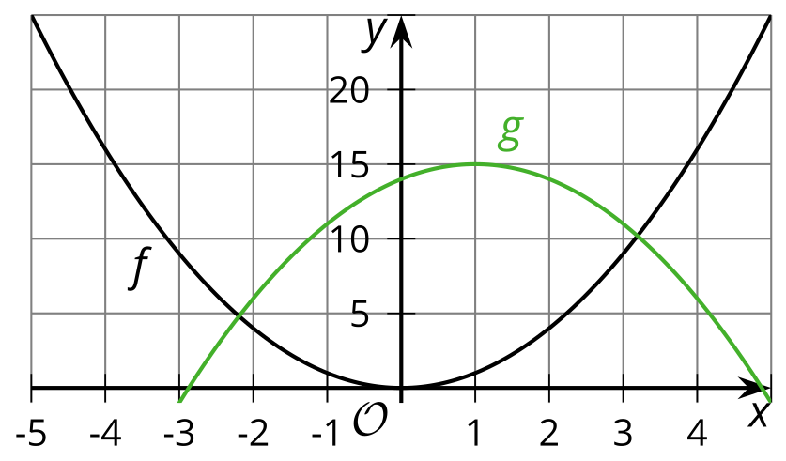
  - $f\left(0\right)>g\left(0\right)$
  - There are two values of $x$ where $f\left(x\right)=g\left(x\right)$.
  - $f\left(\text{-}1\right)<g\left(\text{-}1\right)$
  - $f\left(\text{-}3\right)>g\left(4\right)$
- The three graphs represent the progress of three runners in a 400-meter race.
- The solid line represents runner A. The dotted line represents runner B. The dashed line represents runner C.
- 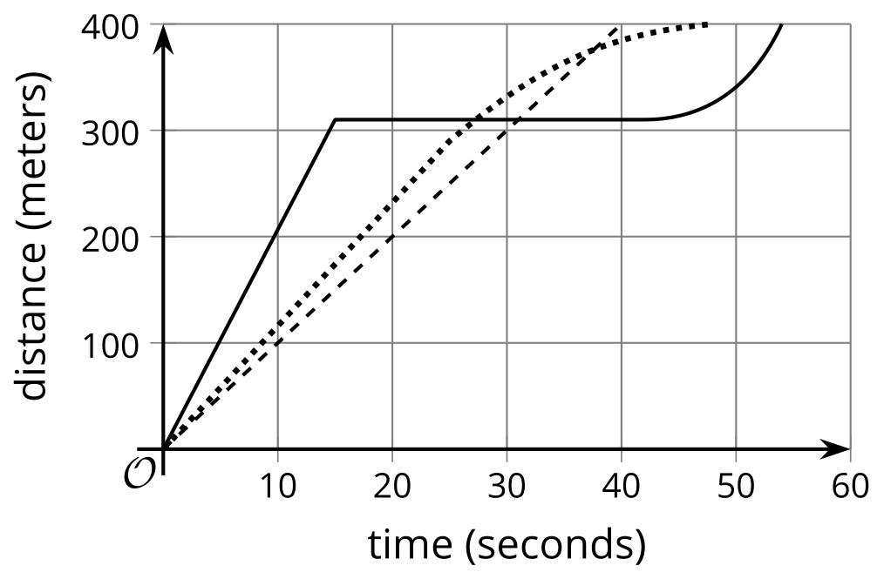
  - One runner ran at a constant rate throughout the race. Which one?
  - A second runner stopped running for a while. Which one? During which interval of time did that happen?
  - Describe the third runner's race. Be as specific as possible.
  - Who won the race? Explain how you know.
- Function $A$ gives the area, in square inches, of a square with side length $x$ inches.
  - Complete the table.
- $x$ | - 0 | - 1 | - 2 | - 3 | - 4 | - 5 | - 6
  - $A\left(x\right)$
  - Represent function $A$ using an equation.
  - Sketch a graph of function $A$.
  - 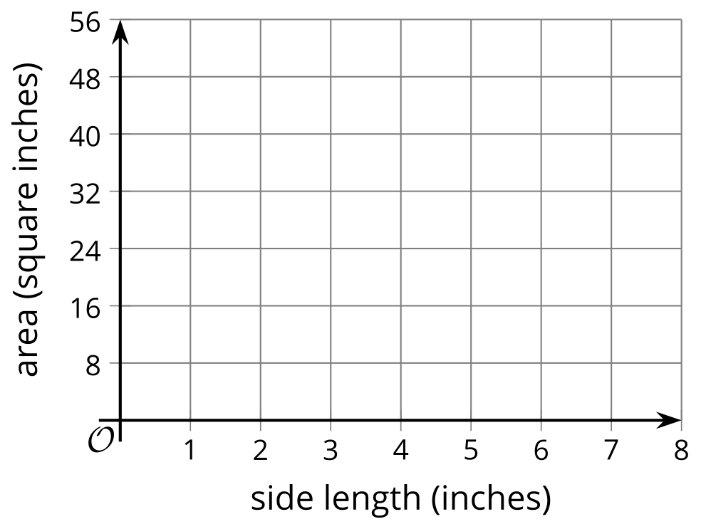
- (From Unit 4, Lesson 4.)
- Function $f$ is represented by $f\left(x\right)=5\left(x+11\right)$.
  - Find $f\left(\text{-}2\right)$.
  - Find the value of $x$ such that $f\left(x\right)=90$ is true.
- (From Unit 4, Lesson 5.)
© CC BY 2019 by Illustrative Mathematics®

