Grade 6
Unit 4Lesson 4CC BY NC Illustrative Mathematics, based on IM 6–8 Math, CC BY Open Up Resources.
Unit 4, Lesson 4

How Many Groups? (Part 1)
Let’s play with blocks and diagrams to think about division with fractions.
Grade 6
Unit 4Lesson 4CC BY NC Illustrative Mathematics, based on IM 6–8 Math, CC BY Open Up Resources.

4.1Equal-size Groups
Write a multiplication equation and a division equation for each sentence or diagram.
- Eight $5 bills are worth $40.

- 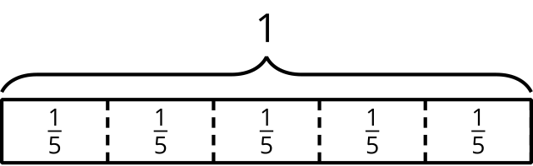
- There are 9 thirds in 3 ones.
Grade 6
Unit 4Lesson 4CC BY NC Illustrative Mathematics, based on IM 6–8 Math, CC BY Open Up Resources.

4.2Reasoning with Pattern Blocks
Your teacher will give you pattern blocks as shown here. Use them to answer the questions.
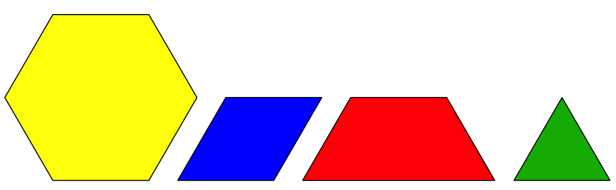
- If a hexagon represents 1 whole, what fraction does each of the following shapes represent? Be prepared to show or explain your reasoning.
  - 1 triangle
  - 1 rhombus
  - 1 trapezoid
  - 4 triangles
  - 3 rhombuses
  - 2 hexagons
  - 1 hexagon and 1 trapezoid
- Here are Elena’s diagrams for $2⋅\frac{1}{2}=1$ and $6⋅\frac{1}{3}=2$. Do you think these diagrams represent the equations? Explain or show your reasoning.
- 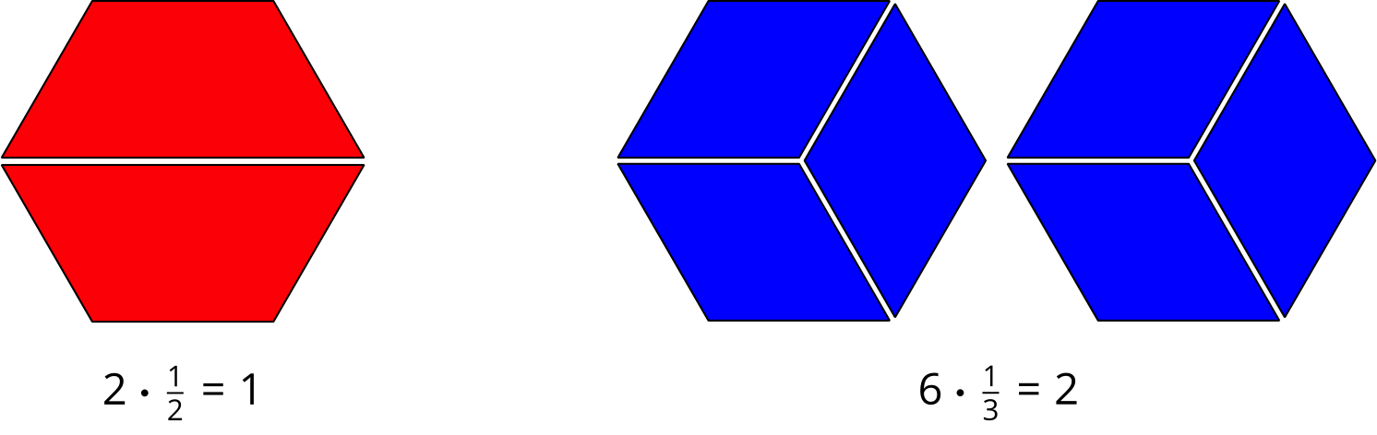
- Use pattern blocks to represent each multiplication. Sketch or trace the blocks to record your representation. Remember that a hexagon represents 1 whole.
  - $3⋅\frac{1}{6}=\frac{1}{2}$
  - $2⋅\frac{3}{2}=3$
- Answer each question. If you get stuck, consider using pattern blocks.
  - How many $\frac{1}{2}$s are in 4?
  - How many $\frac{1}{6}$s are in $1\frac{1}{2}$?
  - How many $\frac{2}{3}$s are in 2?

Lesson 4 Summary
Some problems that involve equal-size groups also involve fractions. Here is an example: “How many $\frac{1}{6}$s are in 2?” We can express this question with multiplication and division equations.
$?⋅\frac{1}{6}=2$
$2÷\frac{1}{6}=?$
Pattern-block diagrams can help us make sense of such problems. Here is a set of pattern blocks.
If the hexagon represents 1 whole, then a triangle must represent $\frac{1}{6}$, because 6 triangles make 1 hexagon. We can use the triangle to represent the $\frac{1}{6}$ in the problem.
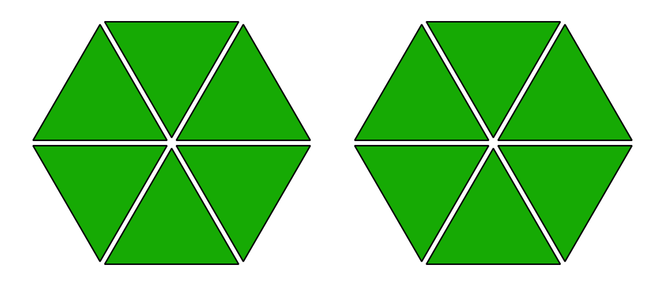
Twelve triangles make 2 hexagons, which means there are 12 groups of $\frac{1}{6}$ in 2.
If we write the 12 in the place of the “?” in the original equations, we have:
$12⋅\frac{1}{6}=2$
$2÷\frac{1}{6}=12$

