Grade 6
Unit 7Lesson 3CC BY NC Illustrative Mathematics, based on IM 6–8 Math, CC BY Open Up Resources.
Unit 7, Lesson 3

Comparing Positive and Negative Numbers
Let’s compare numbers on the number line.
Grade 6
Unit 7Lesson 3CC BY NC Illustrative Mathematics, based on IM 6–8 Math, CC BY Open Up Resources.

3.1Which Three Go Together: Inequalities
Which three go together? Why do they go together?
A
$\frac{5}{4}<2$
B
$8.5>0.95$
C
$8.5<7$
D
$10.00<100$
Grade 6
Unit 7Lesson 3CC BY NC Illustrative Mathematics, based on IM 6–8 Math, CC BY Open Up Resources.

3.2Comparing Temperatures
Here are the low temperatures, in degrees Celsius, for a week in Anchorage, Alaska.
day | Mon | Tue | Wed | Thurs | Fri | Sat | Sun
temperature | 5 | -1 | -5.5 | -2 | 3 | 4 | 0
- Plot the temperatures on a number line.
- Which day of the week had the lowest low temperature?
- On a winter day, the low temperature in Anchorage, Alaska, was -21 degrees Celsius, and the low temperature in Minneapolis, Minnesota, was -14 degrees Celsius.
- Jada said, “I know that 14 is less than 21, so -14 is also less than -21. This means that it was colder in Minneapolis than in Anchorage.”
- Do you agree? Explain your reasoning.

Are you ready for more?
Another temperature scale frequently used in science is the Kelvin scale. In this scale, 0 $\text{K}$ is the lowest possible temperature of anything in the universe, and it is -273.15 degrees in the Celsius scale. Each $1\text{ K}$ is the same as $1^{∘}\text{C}$, so $10\text{ K}$ is the same as $\text{-}{263.15}^{∘}\text{C}$.
- Water boils at ${100}^{∘}\text{C}$. What is this temperature in $\text{K}$?
- Ammonia boils at $\text{-}{35.5}^{∘}\text{C}$. What is the boiling point of ammonia in $\text{K}$?
- Explain why only positive numbers (and 0) are needed to record temperature in $\text{K}$.
Grade 6
Unit 7Lesson 3CC BY NC Illustrative Mathematics, based on IM 6–8 Math, CC BY Open Up Resources.

3.3Rational Numbers on a Number Line
- Plot the numbers -2, 4, -7, and 10 on the number line. Label each point with its numeric value.
- Decide whether each inequality statement is true or false. Be prepared to explain your reasoning.
  - $\text{-}2<4$
  - $\text{-}2<\text{-}7$
  - $4>\text{-}7$
  - $\text{-}7>10$

Lesson 3 Summary
The phrases “greater than” and “less than” can be used to compare numbers on the number line. For example, the numbers -2.7, 0.8, and -1.3, are shown on the number line.
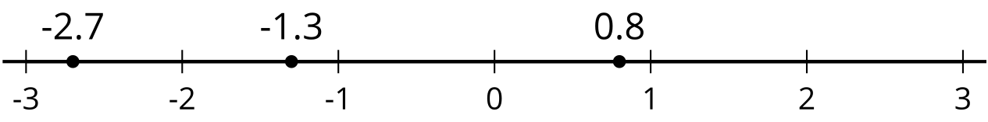
Because -2.7 is to the left of -1.3, we say that -2.7 is less than -1.3. We write:
$\text{-}2.7<\text{-}1.3$
In general, any number that is to the left of a number $n$ is less than $n$.
We can see that -1.3 is greater than -2.7 because -1.3 is to the right of -2.7. We write:
$\text{-}1.3>\text{-}2.7$
In general, any number that is to the right of a number $n$ is greater than $n$.
We can also see that $0.8>\text{-}1.3$ and $0.8>\text{-}2.7$. In general, any positive number is greater than any negative number.

