Grade 2
Unit 5Lesson 3CC BY NC 2024 Illustrative Mathematics®
Unit 5, Lesson 3

Compose 3-Digit Numbers
- Let’s compose 3-digit numbers.
Grade 2
Unit 5Lesson 3CC BY NC 2024 Illustrative Mathematics®

Warm-up Number Talk: Add Tens and Ones
Find the value of each expression mentally.
- $42+42$
- $21+63$
- $50+34$
- $48+36$
Grade 2
Unit 5Lesson 3CC BY NC 2024 Illustrative Mathematics®

Activity 1 Sort Blocks by Value
- Sort the blocks.
  - We have _________ hundreds.
  - We have _________ tens.
  - We have _________ ones.
- Represent the same value. Use the fewest number of blocks possible.
  - We have _________ hundreds.
  - We have _________ tens.
  - We have _________ ones.
- Represent the value of your blocks. Show your thinking using drawings, numbers, or words.
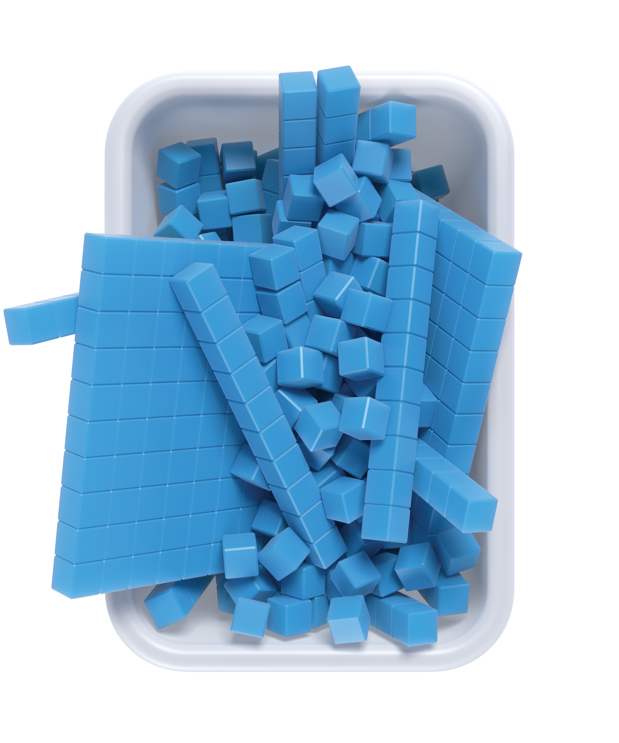
Grade 2
Unit 5Lesson 3CC BY NC 2024 Illustrative Mathematics®

Activity 2The Same But Different
Mai’s blocks
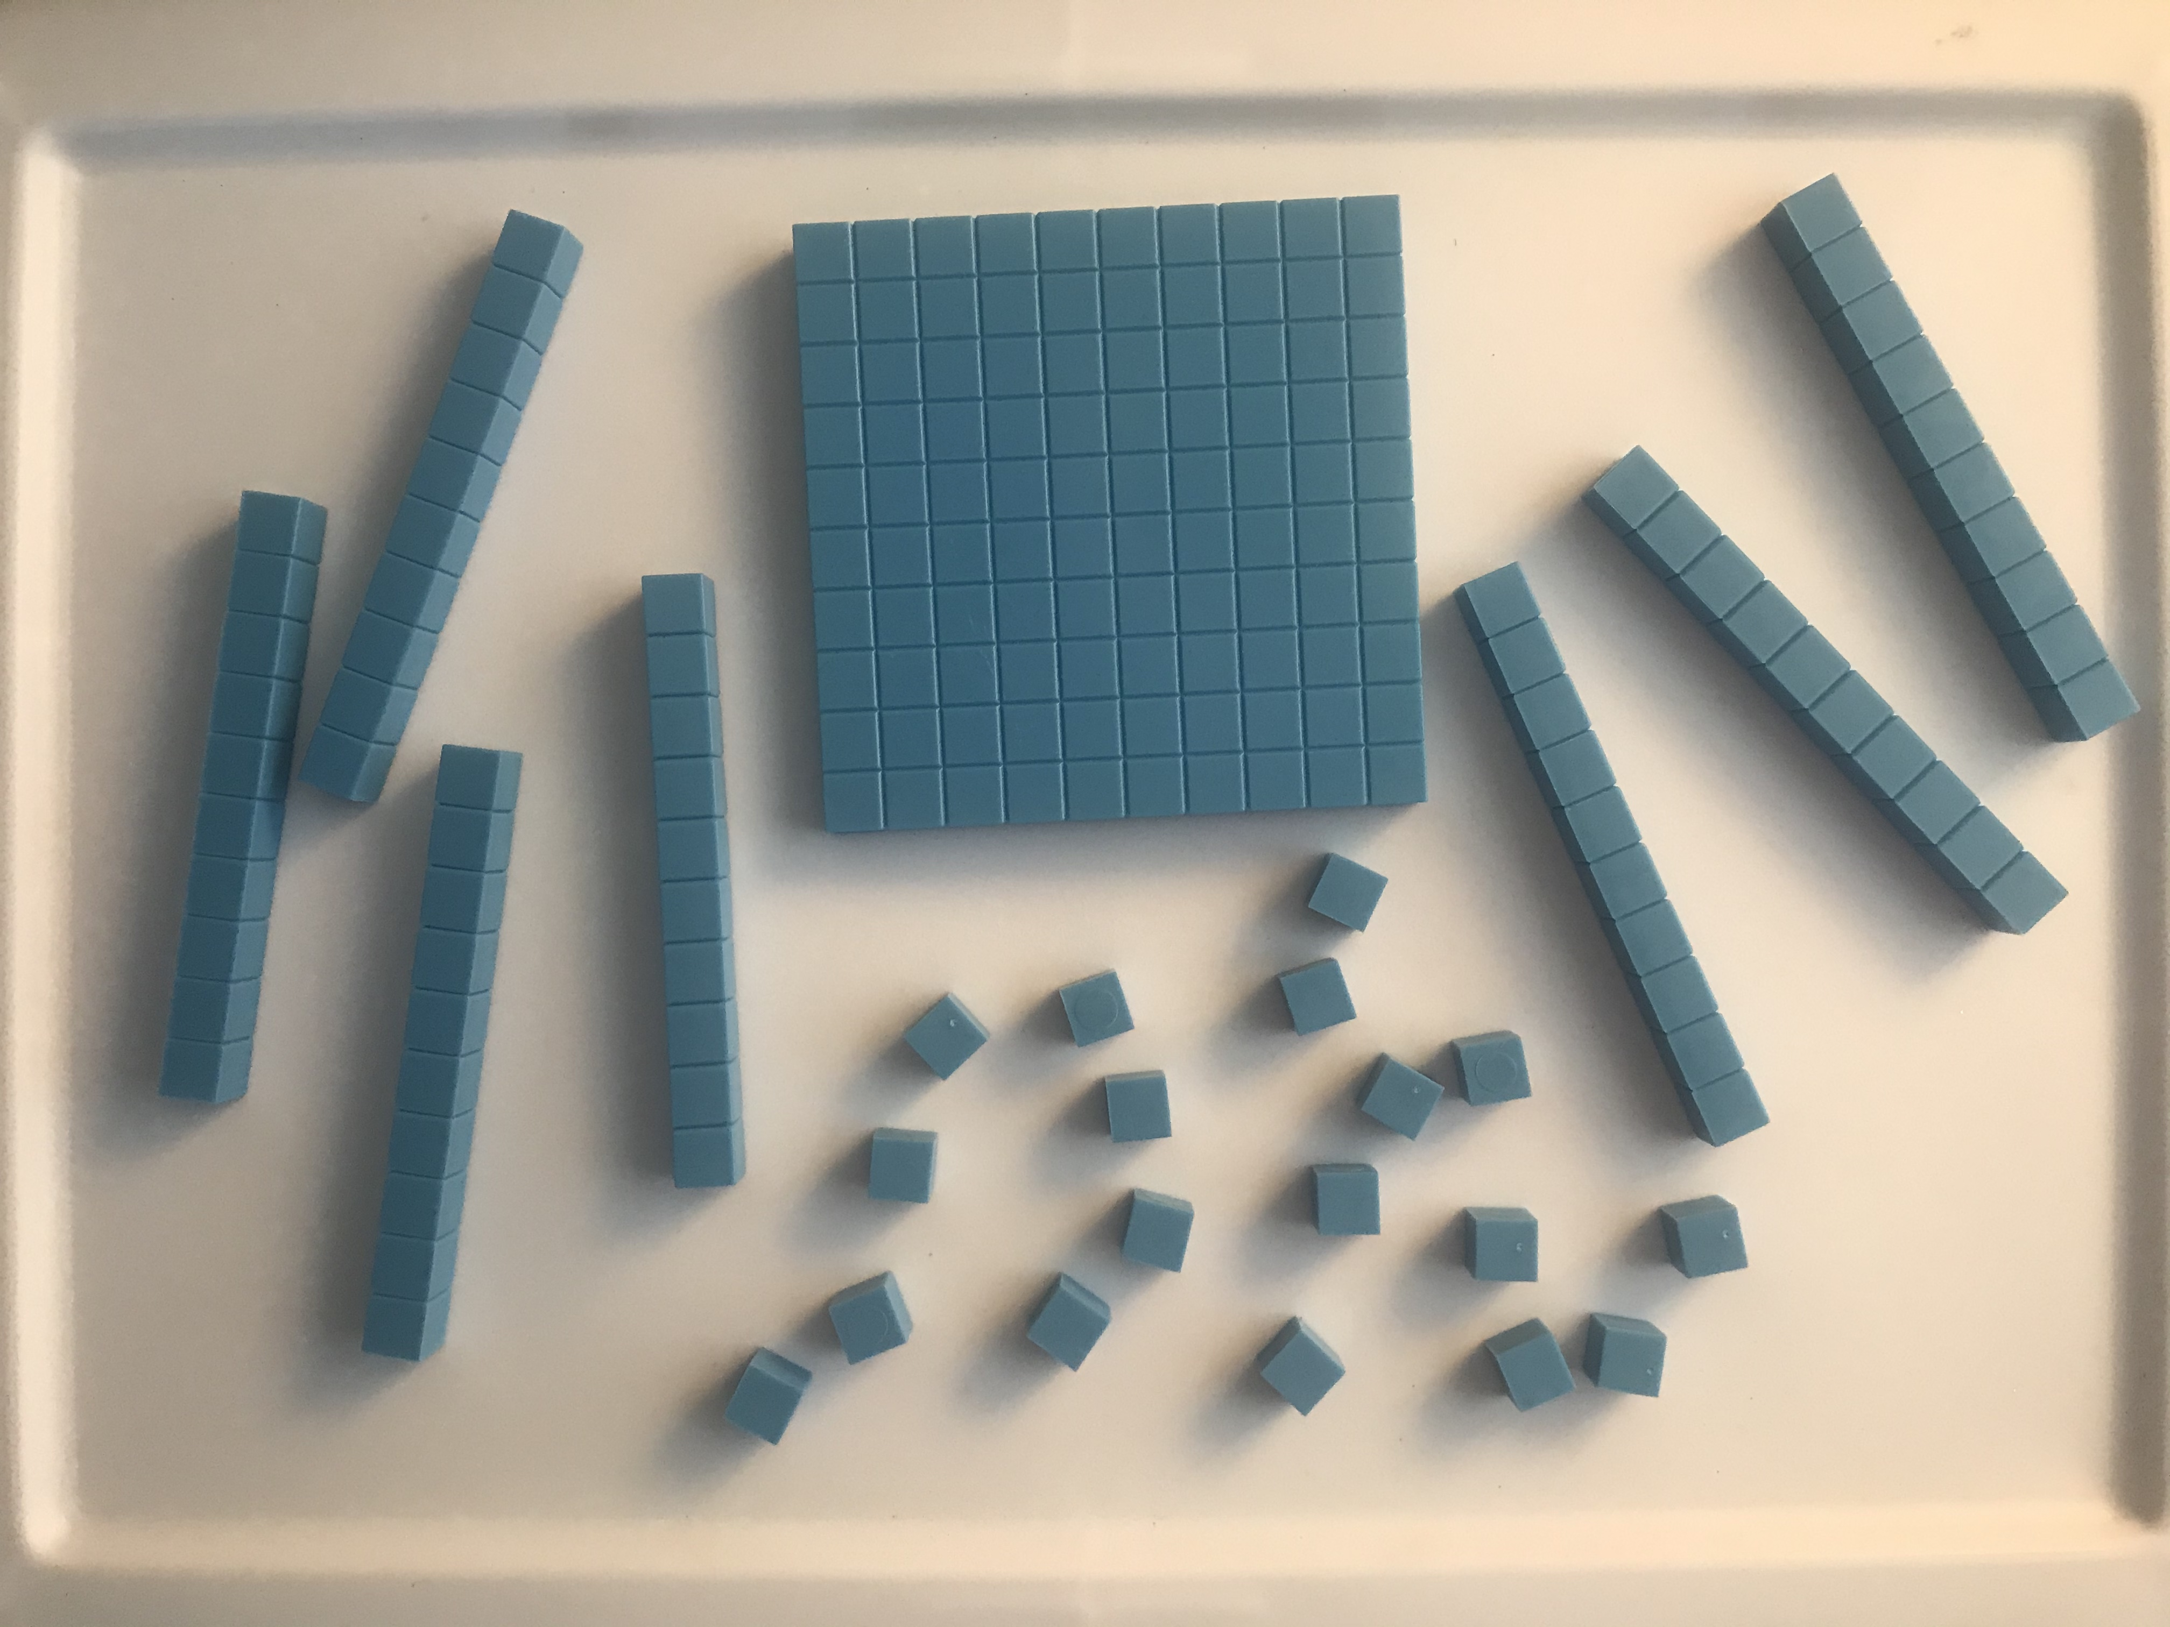
- Mai has ______ hundreds _____ tens _____ ones.
- Draw a base-ten diagram that represents the same total value. Use the fewest number of each unit.
- What is the value of Mai’s blocks?
- Diego’s blocks
- 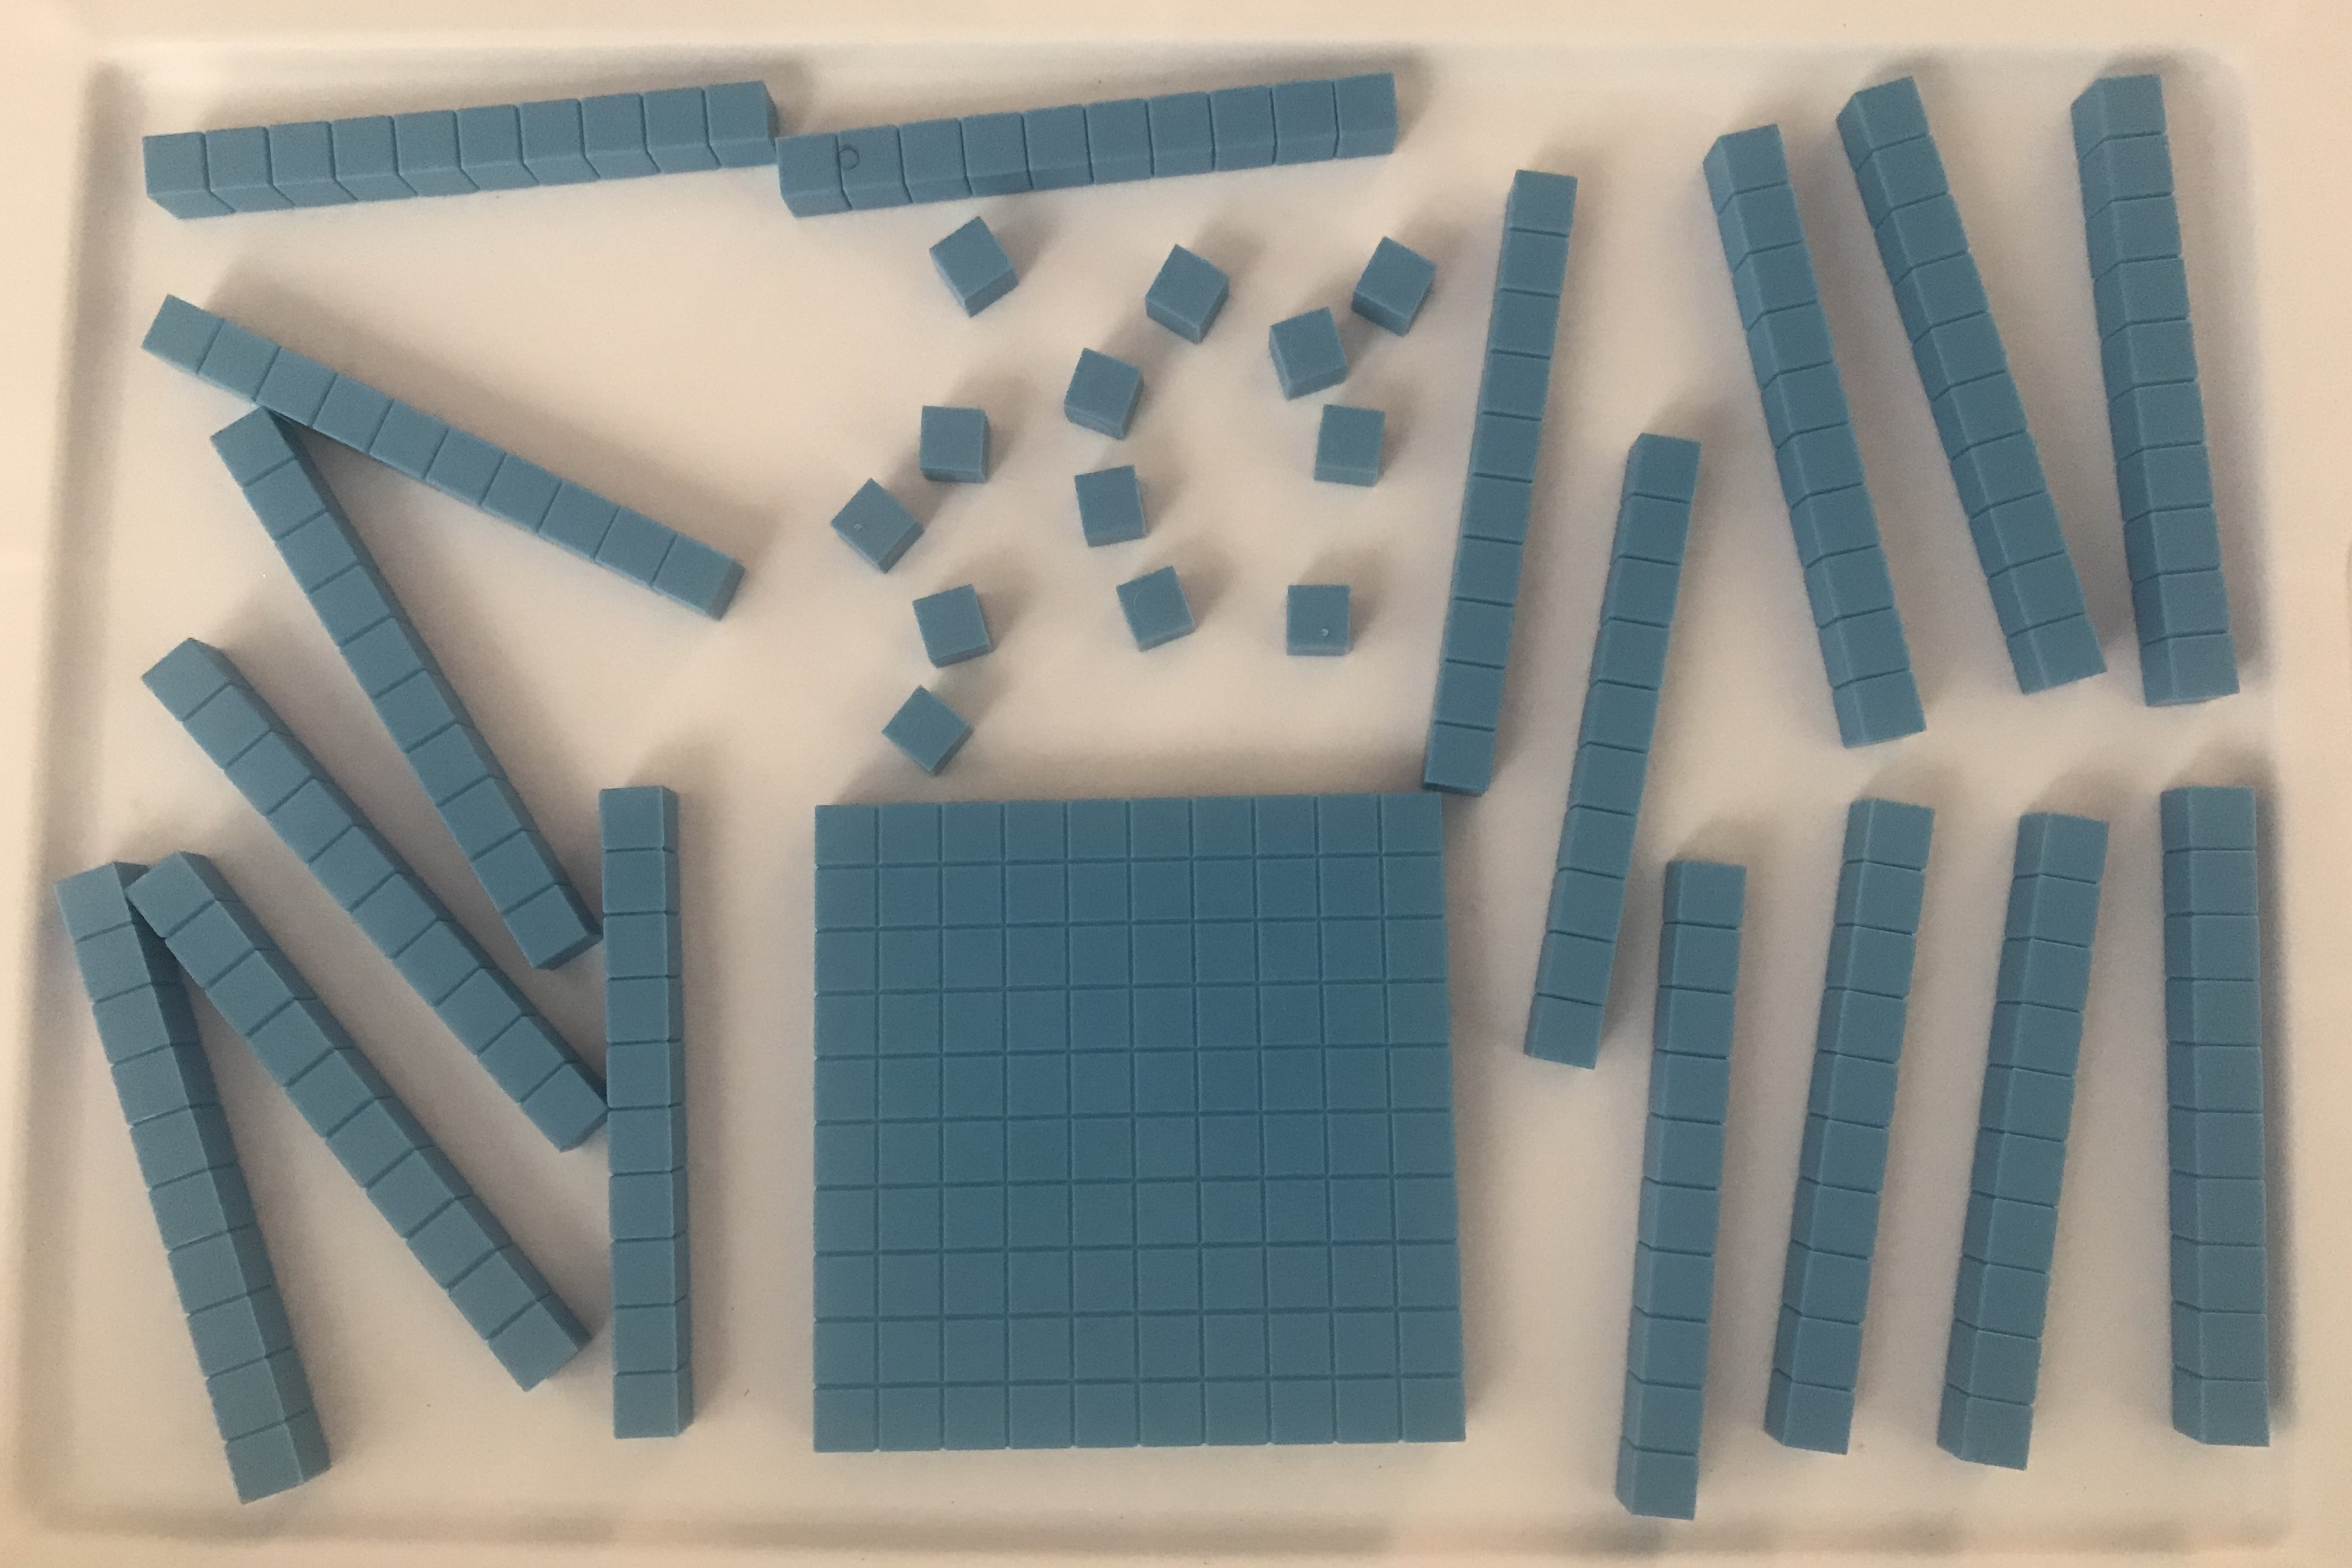
- Diego has ______ hundreds _____ tens _____ ones.
- Draw a base-ten diagram that represents the same total value. Use the fewest number of each unit.
- What is the value of Diego’s blocks?

