Grade 2
Unit 2Lesson 2CC BY NC 2024 Illustrative Mathematics®
Unit 2, Lesson 2

Find the Unknown Addend
- Let’s find values that make the equations true.
Grade 2
Unit 2Lesson 2CC BY NC 2024 Illustrative Mathematics®

Activity 1How Did You Find It?
- 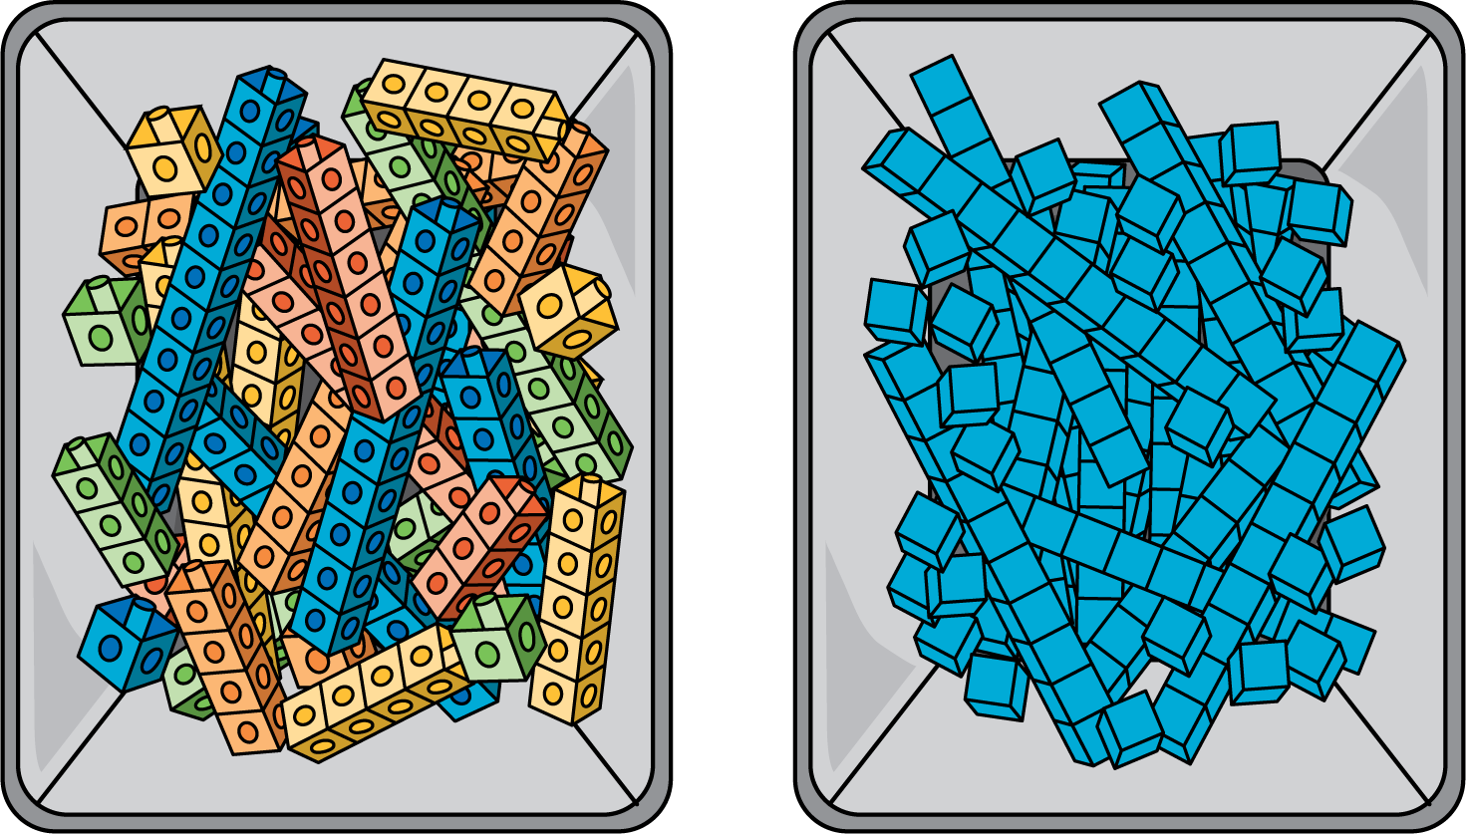
- How are the tools alike? How are they different?
- Find the number that makes the equation true. Show your thinking using drawings, numbers, or words.
- 41+ _=84
Grade 2
Unit 2Lesson 2CC BY NC 2024 Illustrative Mathematics®

Activity 2You Go This Way, I’ll Go That Way
Han and Mai use blocks to find the number that makes the equation true.
17+ _=48
- Han uses blocks to show 17. Show how to find the number that makes the equation true.
- Mai uses blocks to show 48. Show how to find the number that makes the equation true.
- Work with a partner. One partner starts with 21. The other partner starts with 96.
- 21+ _=96
- Show your partner how you found the number that makes the equation true.

