Algebra 1
Unit 4Lesson 4CC BY NC 2024 Illustrative Mathematics®
Unit 4, Lesson 4

Graphing Linear Inequalities in Two Variables (Part 1)
- Let’s find out how to use graphs to represent solutions to inequalities in two variables.
Algebra 1
Unit 4Lesson 4CC BY NC 2024 Illustrative Mathematics®

4.1Math Talk: Less Than, Equal To, or More Than 12?
Here is an expression: $2x+3y$.
Decide if the values in each ordered pair, $\left(x,y\right)$, make the value of the expression less than, greater than, or equal to 12.
- $\left(0,5\right)$
- $\left(6,0\right)$
- $\left(\text{-}1,\text{-}1\right)$
- $\left(\text{-}5,10\right)$
Algebra 1
Unit 4Lesson 4CC BY NC 2024 Illustrative Mathematics®

4.2Solutions and Not Solutions
Here are four inequalities. Study each inequality assigned to your group and work with your group to:
- Find some coordinate pairs that represent solutions to the inequality and some coordinate pairs that do not represent solutions.
- Plot both sets of points. Use either two different colors or two different symbols like X and O.
- Plot enough points until you start to see the region that contains solutions and the region that contains non-solutions. Look for a pattern describing the region where solutions are plotted.

$x≥y$
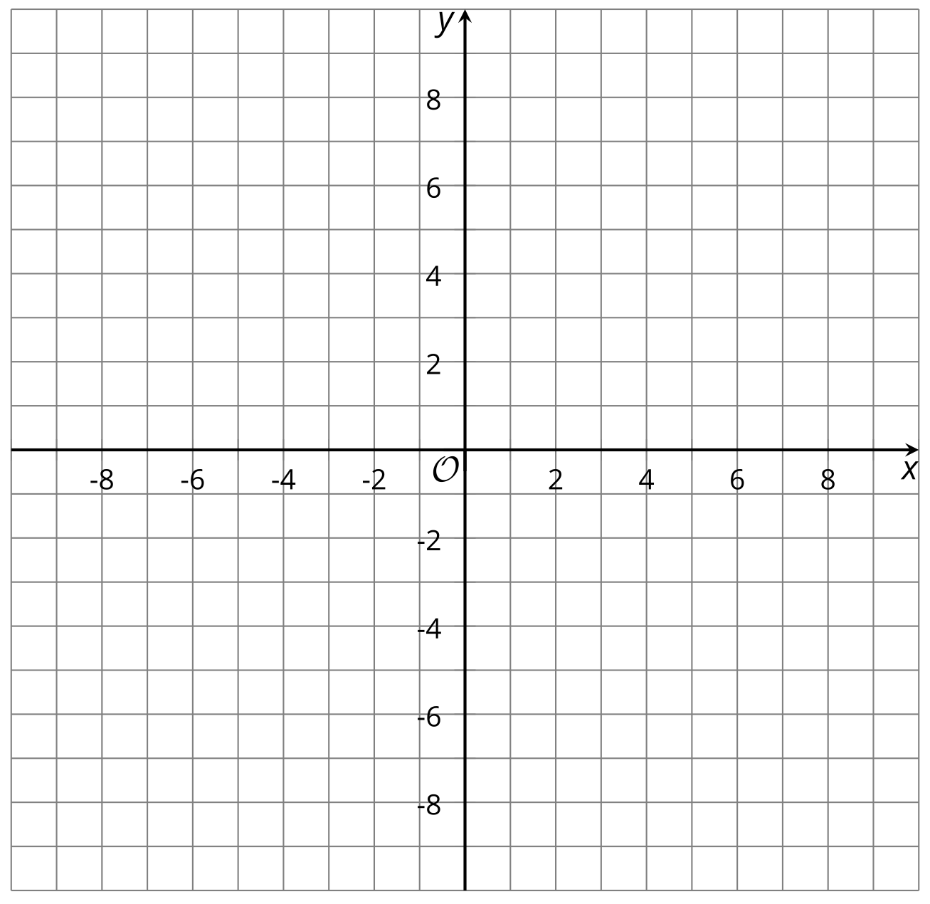

$\text{-}2y≥\text{-}4$

$3x<0$

$x+y>10$

Algebra 1
Unit 4Lesson 4CC BY NC 2024 Illustrative Mathematics®

4.3Sketching Solutions to Inequalities
- Here is a graph that represents solutions to the equation $x−y=5$.
- 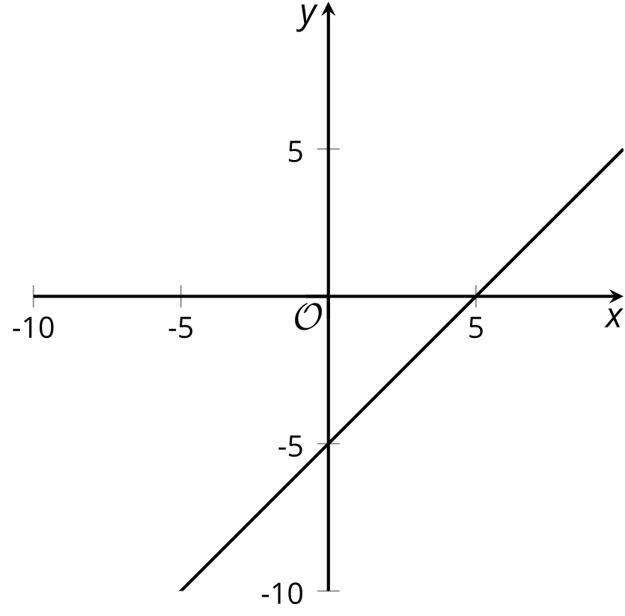
- Sketch 4 quick graphs representing the solutions to each of these inequalities:
- $x−y<5$
- 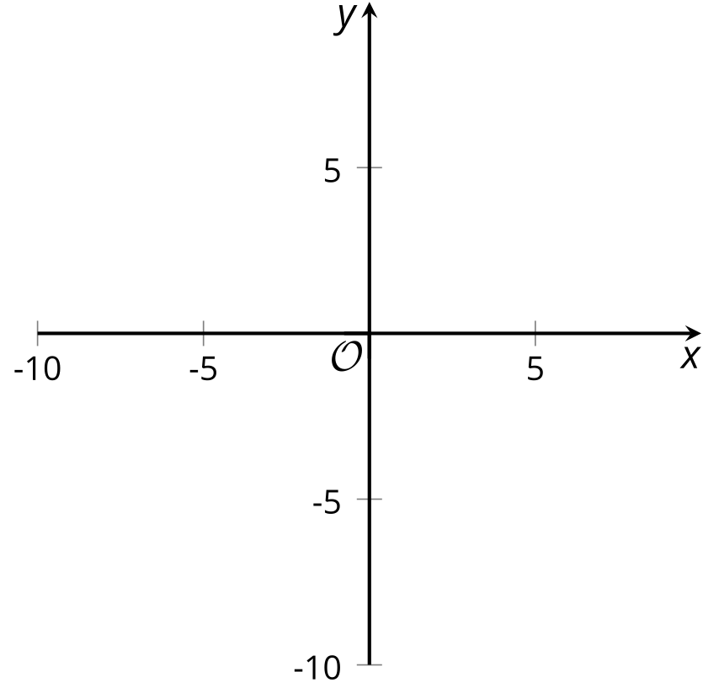
- $x−y≤5$
- $x−y>5$
- $x−y≥5$
- For each graph, write an inequality whose solutions are represented by the shaded part of the graph.

- A
- 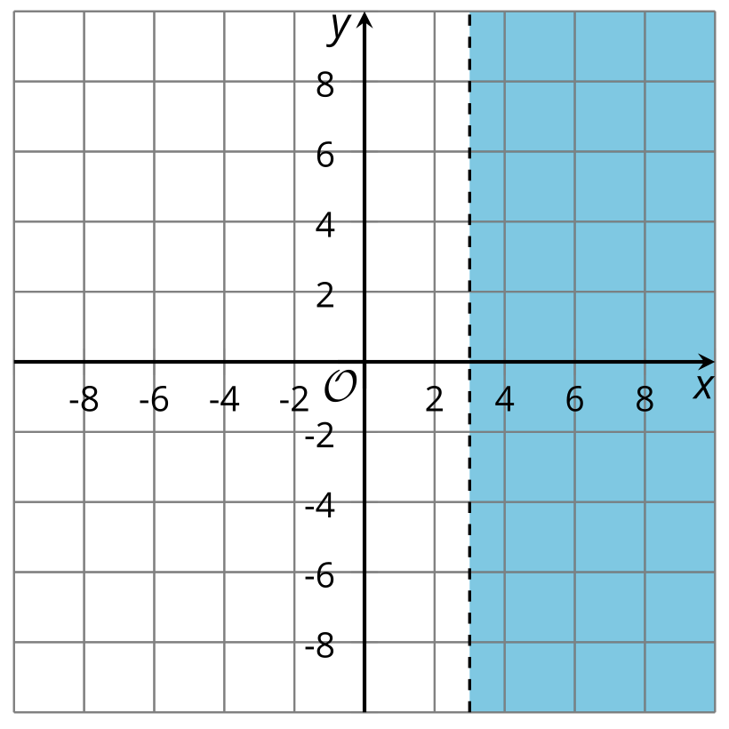

- B
- 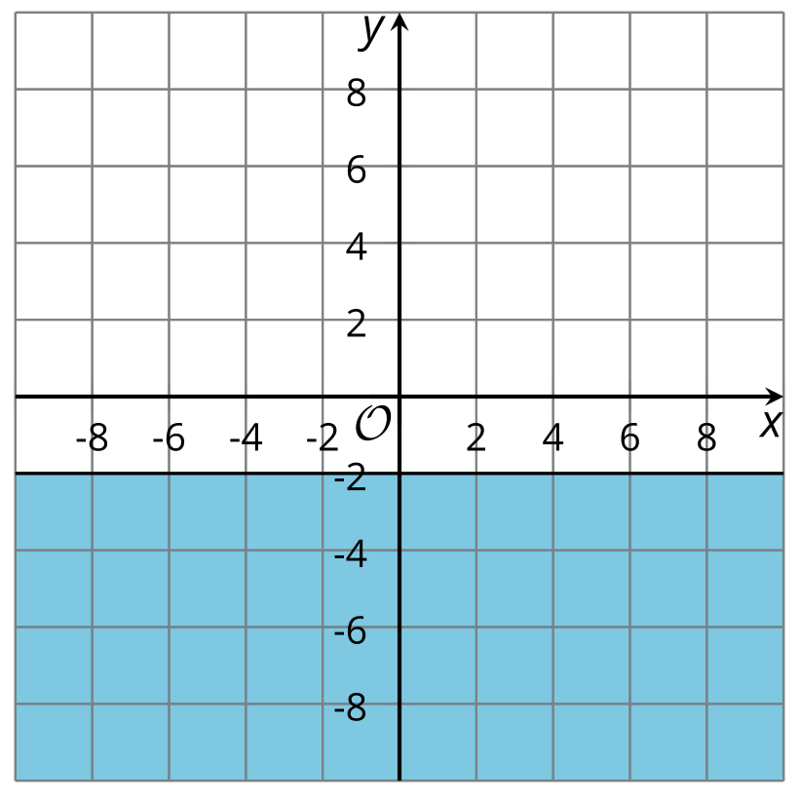

- C
- 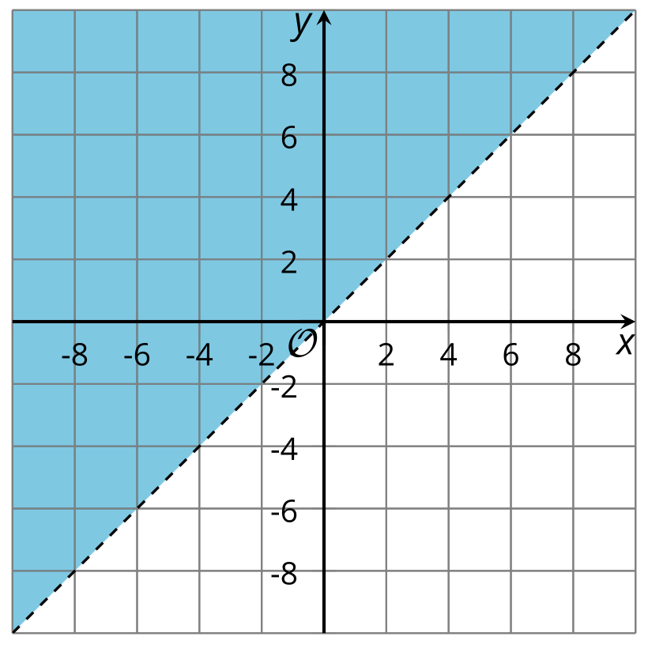

- D
- 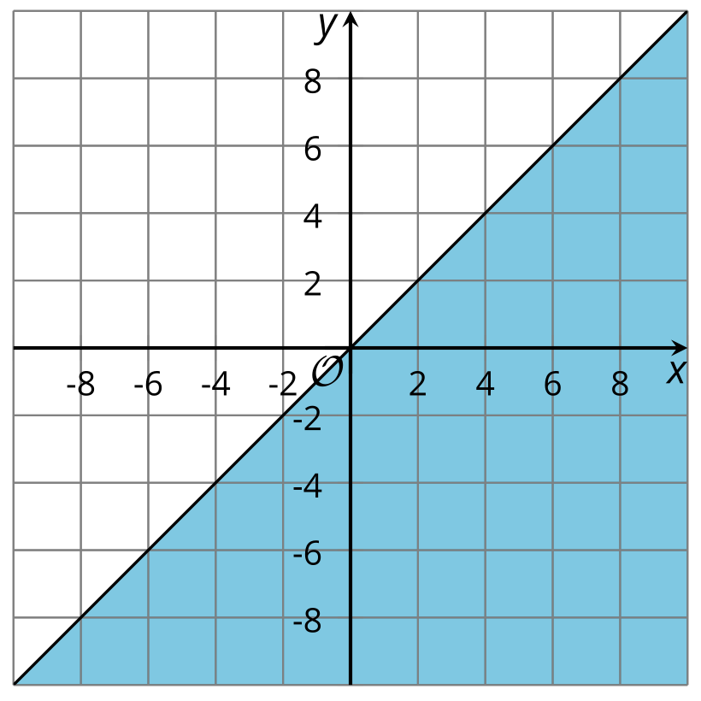

Are you ready for more?
- The points $\left(7,3\right)$ and $\left(7,5\right)$ are both in the solution region of the inequality $x−2y<3$.
  - Compute $x−2y$ for both of these points.
  - Which point comes closest to satisfying the equation $x−2y=3$? That is, for which $\left(x,y\right)$ pair is $x−2y$ closest to 3?
- 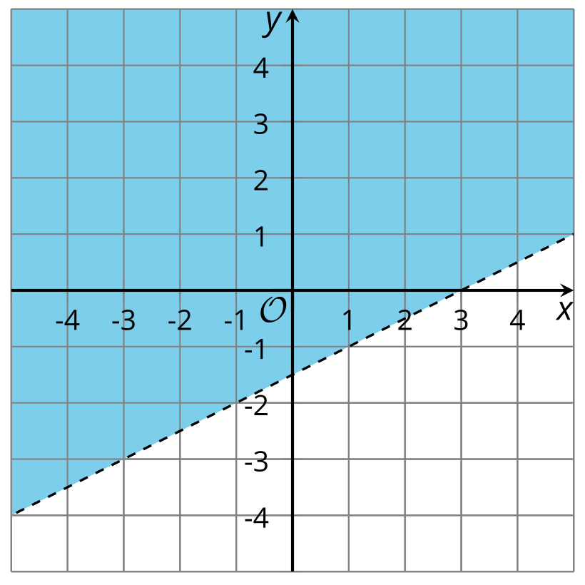
- The points $\left(3,2\right)$ and $\left(5,2\right)$ are also in the solution region. Which of these points comes closest to satisfying the equation $x−2y=3$?
- Find a point in the solution region that comes even closer to satisfying the equation $x−2y=3$. What is the value of $x−2y$?
- For the points $\left(5,2\right)$ and $\left(7,3\right)$, $x−2y=1$. Find another point in the solution region for which $x−2y=1$.
- Find $x−2y$ for the point $\left(5,3\right)$. Then find two other points that give the same answer.

Lesson 4 Summary
The equation $x+y=7$ is an equation in two variables. Its solution is any pair of $x$ and $y$ whose sum is 7. The pairs $x=0,y=7$ and $x=\text{5},y=2$ are two examples.
We can represent all the solutions to $x+y=7$ by graphing the equation on a coordinate plane.
The graph is a line. All the points on the line are solutions to $x+y=7$.
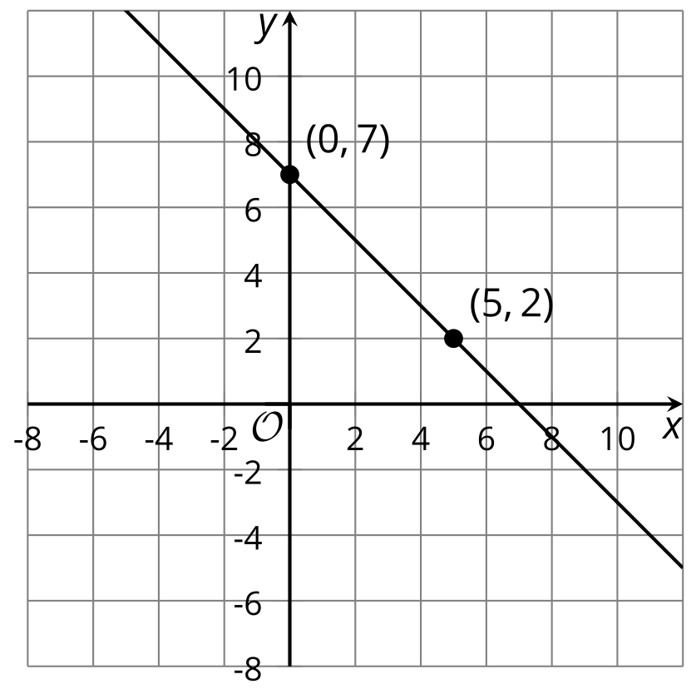
​​​​​
The inequality $x+y≤7$ is an inequality in two variables. Its solution is any pair of $x$ and $y$ whose sum is 7 or less than 7.
This means it includes all the pairs that are solutions to the equation $x+y=7$, but also many other pairs of $x$ and $y$ that add up to a value less than 7. The pairs $x=4,y=\text{-}7$ and $x=\text{-}6,y=0$ are two examples.
On a coordinate plane, the solution to $x+y≤7$ includes the line that represents $x+y=7$. If we plot a few other $\left(x,y\right)$ pairs that make the inequality true, such as $\left(4,\text{-}7\right)$ and $\left(\text{-}6,0\right)$, we see that these points fall on one side of the line. (In contrast, $\left(x,y\right)$ pairs that make the inequality false fall on the other side of the line.)
We can shade that region on one side of the line to indicate that all points in it are solutions.
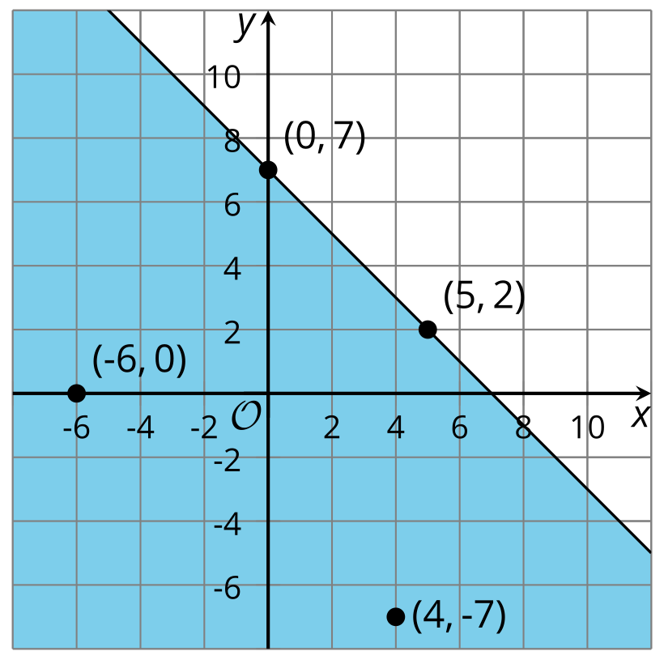
​​​​​​
What about the inequality $x+y<7$?
The solution is any pair of $x$ and $y$ whose sum is less than 7. This means pairs like $x=0,y=7$ and $x=5,y=2$ are not solutions.
On a coordinate plane, the solution does not include points on the line that represent $x+y=7$ (because those points are $x$ and $y$ pairs whose sum is 7).
To exclude points on that boundary line, we can use a dashed line.
All points below that line are $\left(x,y\right)$ pairs that make $x+y<7$ true. The region on that side of the line can be shaded to show that it contains the solutions.



