Unit 8 Lesson 1: Up to Chance

1 Which One Doesn’t Belong: Spinners (Warm up)

Student Task Statement
Which one doesn’t belong?

A
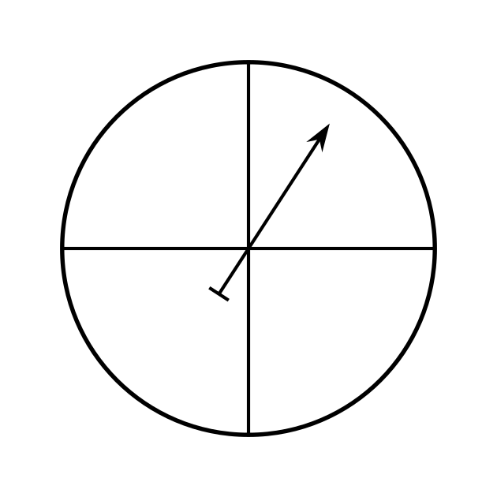

B
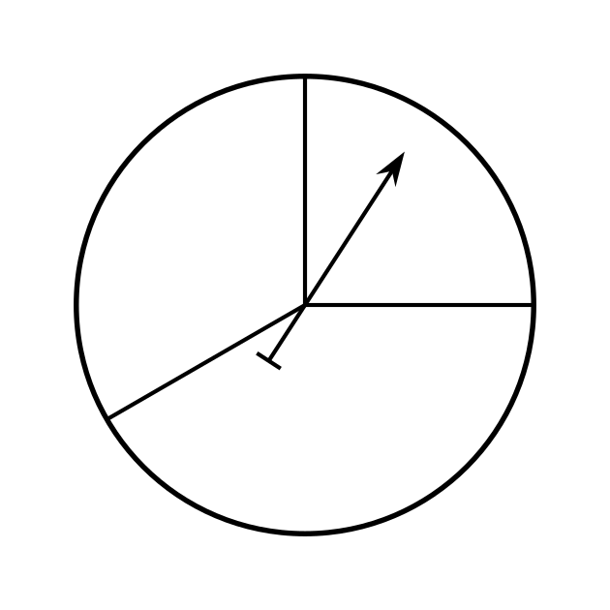

C
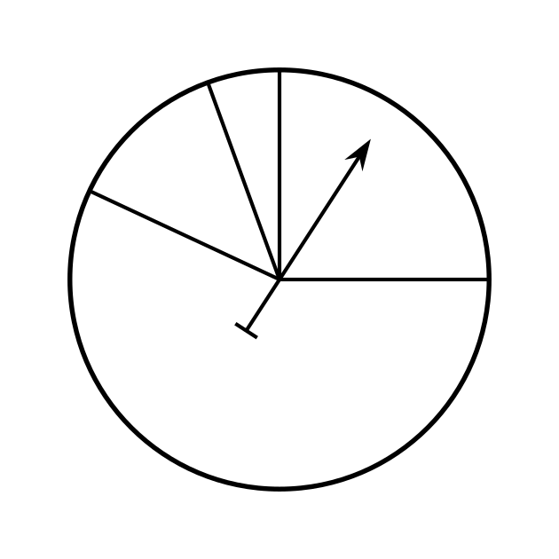

D
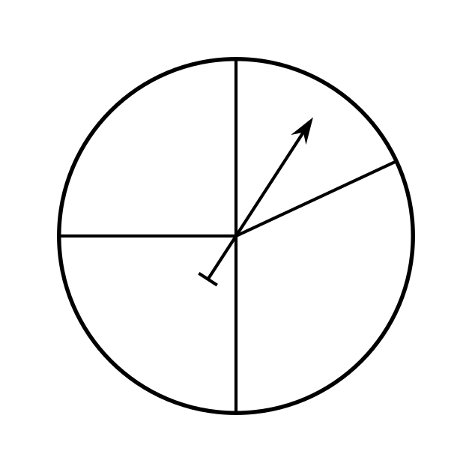

2 You’re Saying There’s a Chance? (Optional)

Student Task Statement
In Elena’s Spanish class, they have a quiz every two weeks.
- For the first quiz of the year, Elena takes time to study and understands the material very well. The quiz involves 20 multiple choice questions with possible answers A, B, C, or D. Elena tries her best to answer the questions correctly.
- For the second quiz of the year, Elena has been absent a lot and does not understand the material at all. The quiz involves 20 multiple choice questions with possible answers A, B, C, or D. Elena fills in the answer sheet without even looking at the questions.
- For the third quiz of the year, Elena is still lost in the class and has not come in for any help. The quiz involves 20 true or false questions. Again, Elena fills in the answer sheet without even looking at the questions.
- Based on the description, rank the quizzes in order from worst expected grade to best.
- For each of the 3 quizzes, explain why you think chance played a large or small role in determining Elena’s score.
- For the second and third quizzes, Elena did not look at the questions. Explain why you think she might do better on one than the other.
- What percentage of the questions do you think Elena will get right on each quiz? Explain your reasoning.
- For the second quiz, the teacher made a mistake and each of the questions had two correct answers. The teacher accepted either of the correct answers for full credit. What percentage of the questions do you think Elena will get right on the second quiz with the new scoring? Explain your reasoning.

3 A Fair Game (Optional)

Student Task Statement
Han, Clare, Mai, and Kiran are inventing a game for the county fair. Players will spin a spinner and if it points to the section labeled B, then the player will win a prize.
Han says, “I think this spinner is a good one. What do you think?”
Clare says, “I like the spinner, but I think people should be able to spin again if they don’t win the first time.”
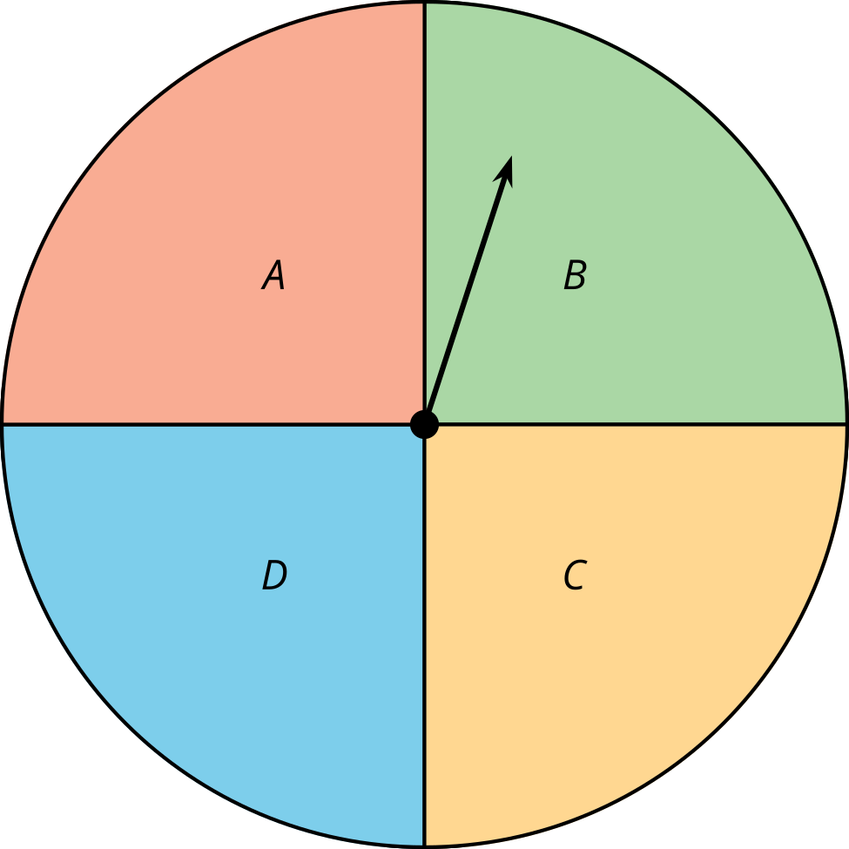
Mai says, “What if we just make 3 sections like this?”
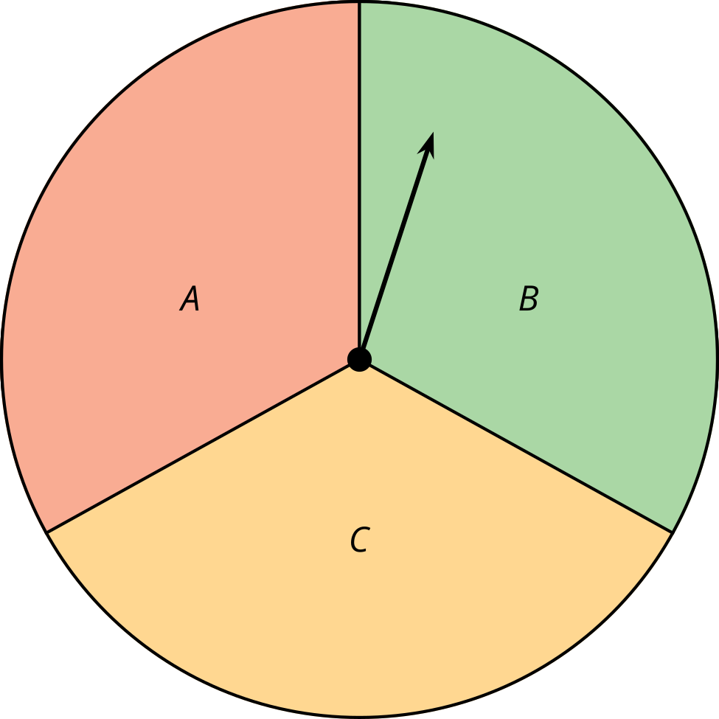
Kiran says, “I think it might make more sense if we just do two sections like this.”
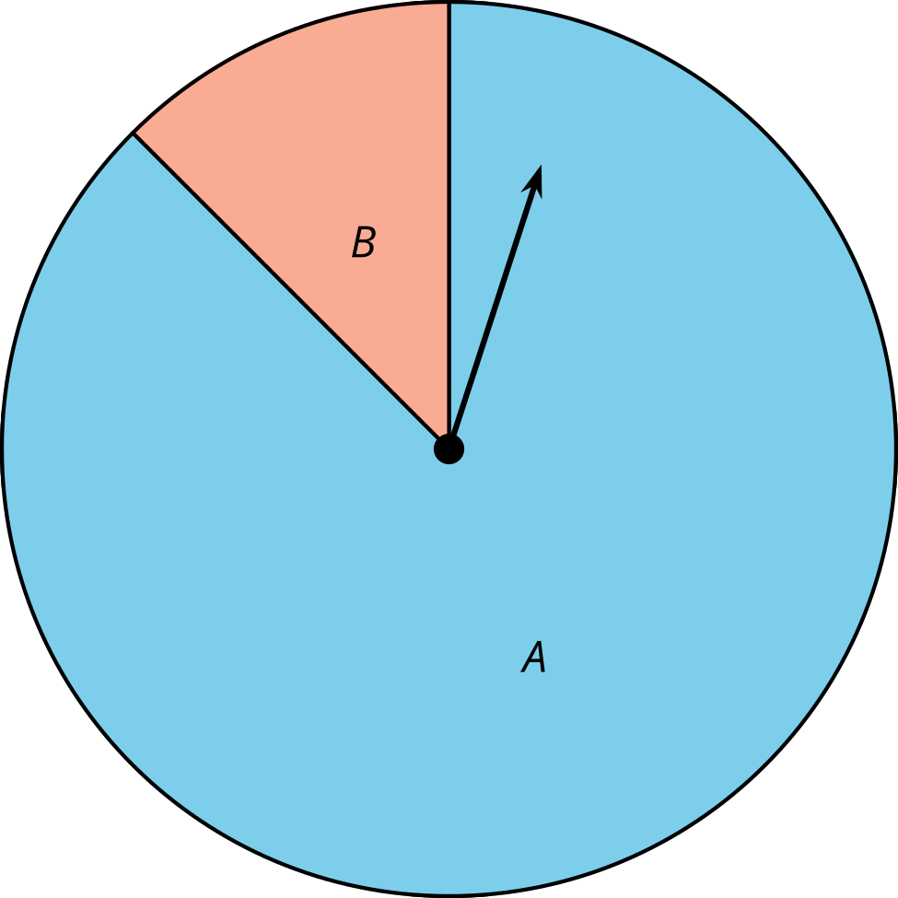
- Put the proposals in order of the probability that a player will win using that method from least to greatest. Explain your reasoning. Share your explanation with a partner.
- Each student writes a computer program to play the game using the method they suggested. The computer runs the program for a short time and reports the number of wins and losses. Use the results to estimate the probability of winning using each method.
  - Han's method: 2,513 wins; 7,516 losses.
  - Clare’s method: 876 wins; 1,127 losses.
  - Mai’s method: 2,026 wins; 3,984 losses.
  - Kiran’s method: 322 wins; 3,621 losses.
- By talking to their friends, they figure out that a good probability for winning is about $\frac{1}{5}$ since it will let enough people win to draw in customers, but not cost them too much for prizes. Which method fits this best?
- Before they settled on a spinner game, they considered other things at their booth. Which of these suggestions would be considered chance experiments?
  - A watermelon-eating contest. The fastest to eat a wedge of watermelon wins the prize.
  - Two cubes have one face labeled “Win!” If both cubes land with the “Win!” side facing up, the player wins a prize.
  - A ball is placed under one of five cups. The cups are shuffled around under a cover so the player cannot see how they are moved. The player chooses one of the cups and wins a prize if it has the ball under it.
  - Players push a button that starts lighting up different regions on a board. The game is rigged so that every fifth person wins.

Activity Synthesis
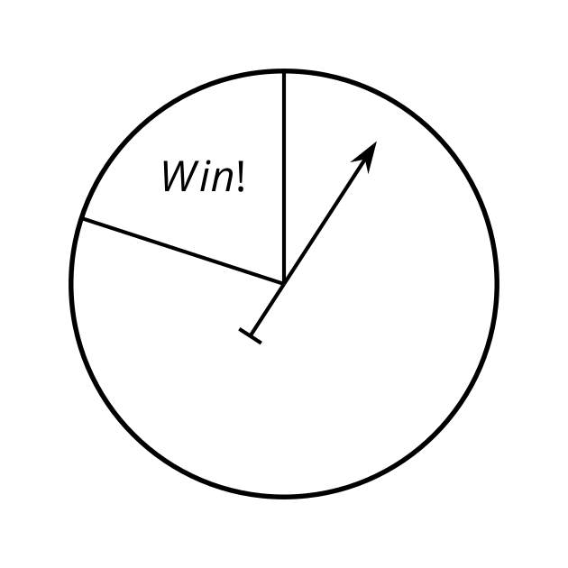
© CC BY 2019 by Illustrative Mathematics®

