## Unit 2 Lesson 14: Area Situations

### WU Number Talk: Multiply Fractions (Warm up)

#### Student Task Statement

Find the value of each expression mentally.

$3×\left(10÷2\right)$

$\frac{3}{2}×10$

$\left(\frac{14}{7}\right)×10$

$14×\frac{10}{7}$

### 1 Info Gap: Area

#### Student Task Statement

Your teacher will give you either a problem card or a data card. Do not show or read your card to your partner.

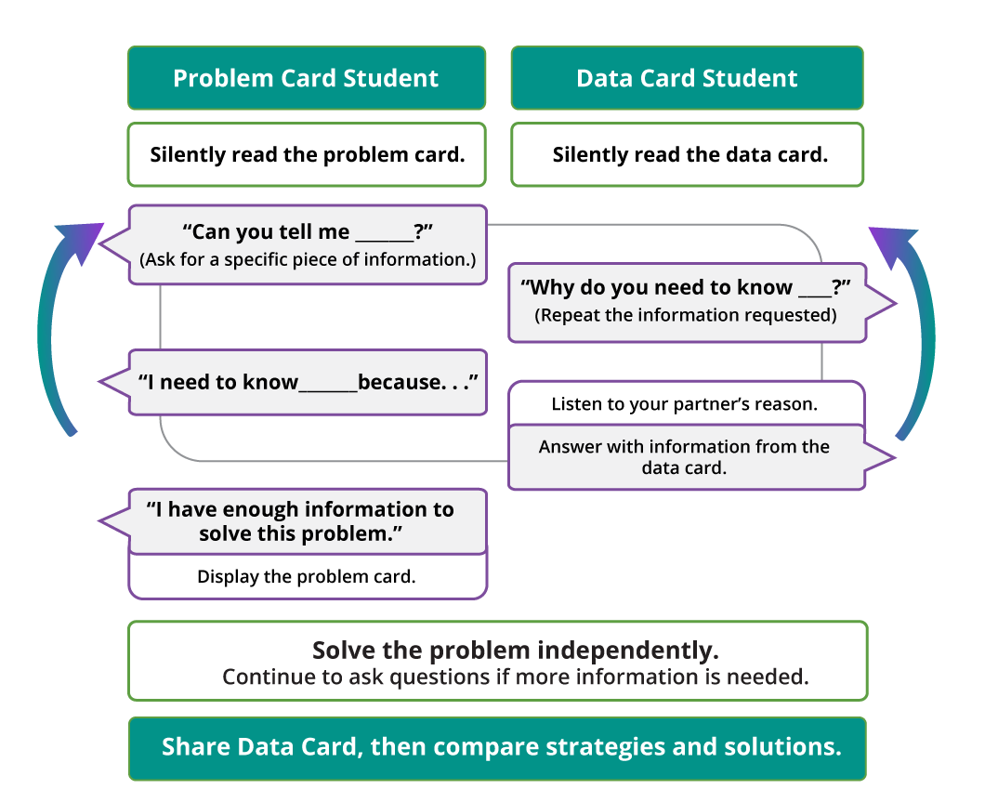

Pause here so your teacher can review your work. Ask your teacher for a new set of cards and repeat the activity, trading roles with your partner.

### 2 Fill in the Blank (Optional)

#### Student Task Statement

Fill in the blanks to make each equation true. Be prepared to explain your reasoning.



$\frac{1}{3}×18=\underset{_}{}$

$\frac{7}{9}×\underset{_}{}=\frac{21}{9}$

$\frac{1}{15}×\underset{_}{}=2$

$9×6\frac{2}{3}=\underset{_}{}$

$14\frac{99}{100}×10=\underset{_}{}$

$7\frac{3}{5}×6=\underset{_}{}$

$4×6\frac{9}{10}=\underset{_}{}$

© CC BY 2021 Illustrative Mathematics®