Lesson 16: Represent the Classroom with Shapes
- Let’s use shapes to make a model of our classroom.

16.3: Centers: Choice Time
Choose a center.
Build Shapes
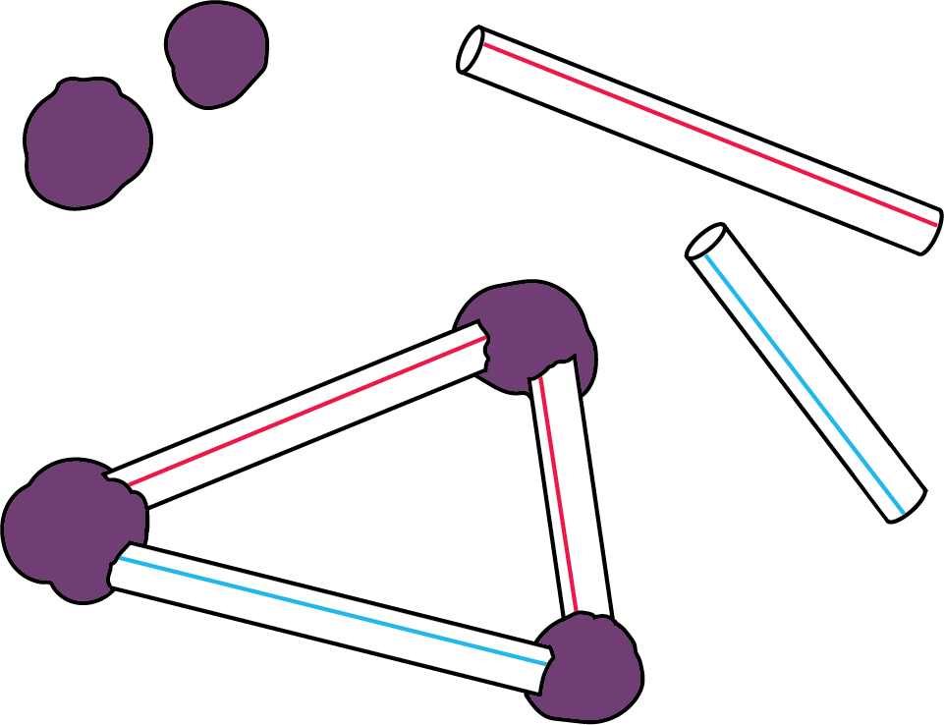
Geoblocks
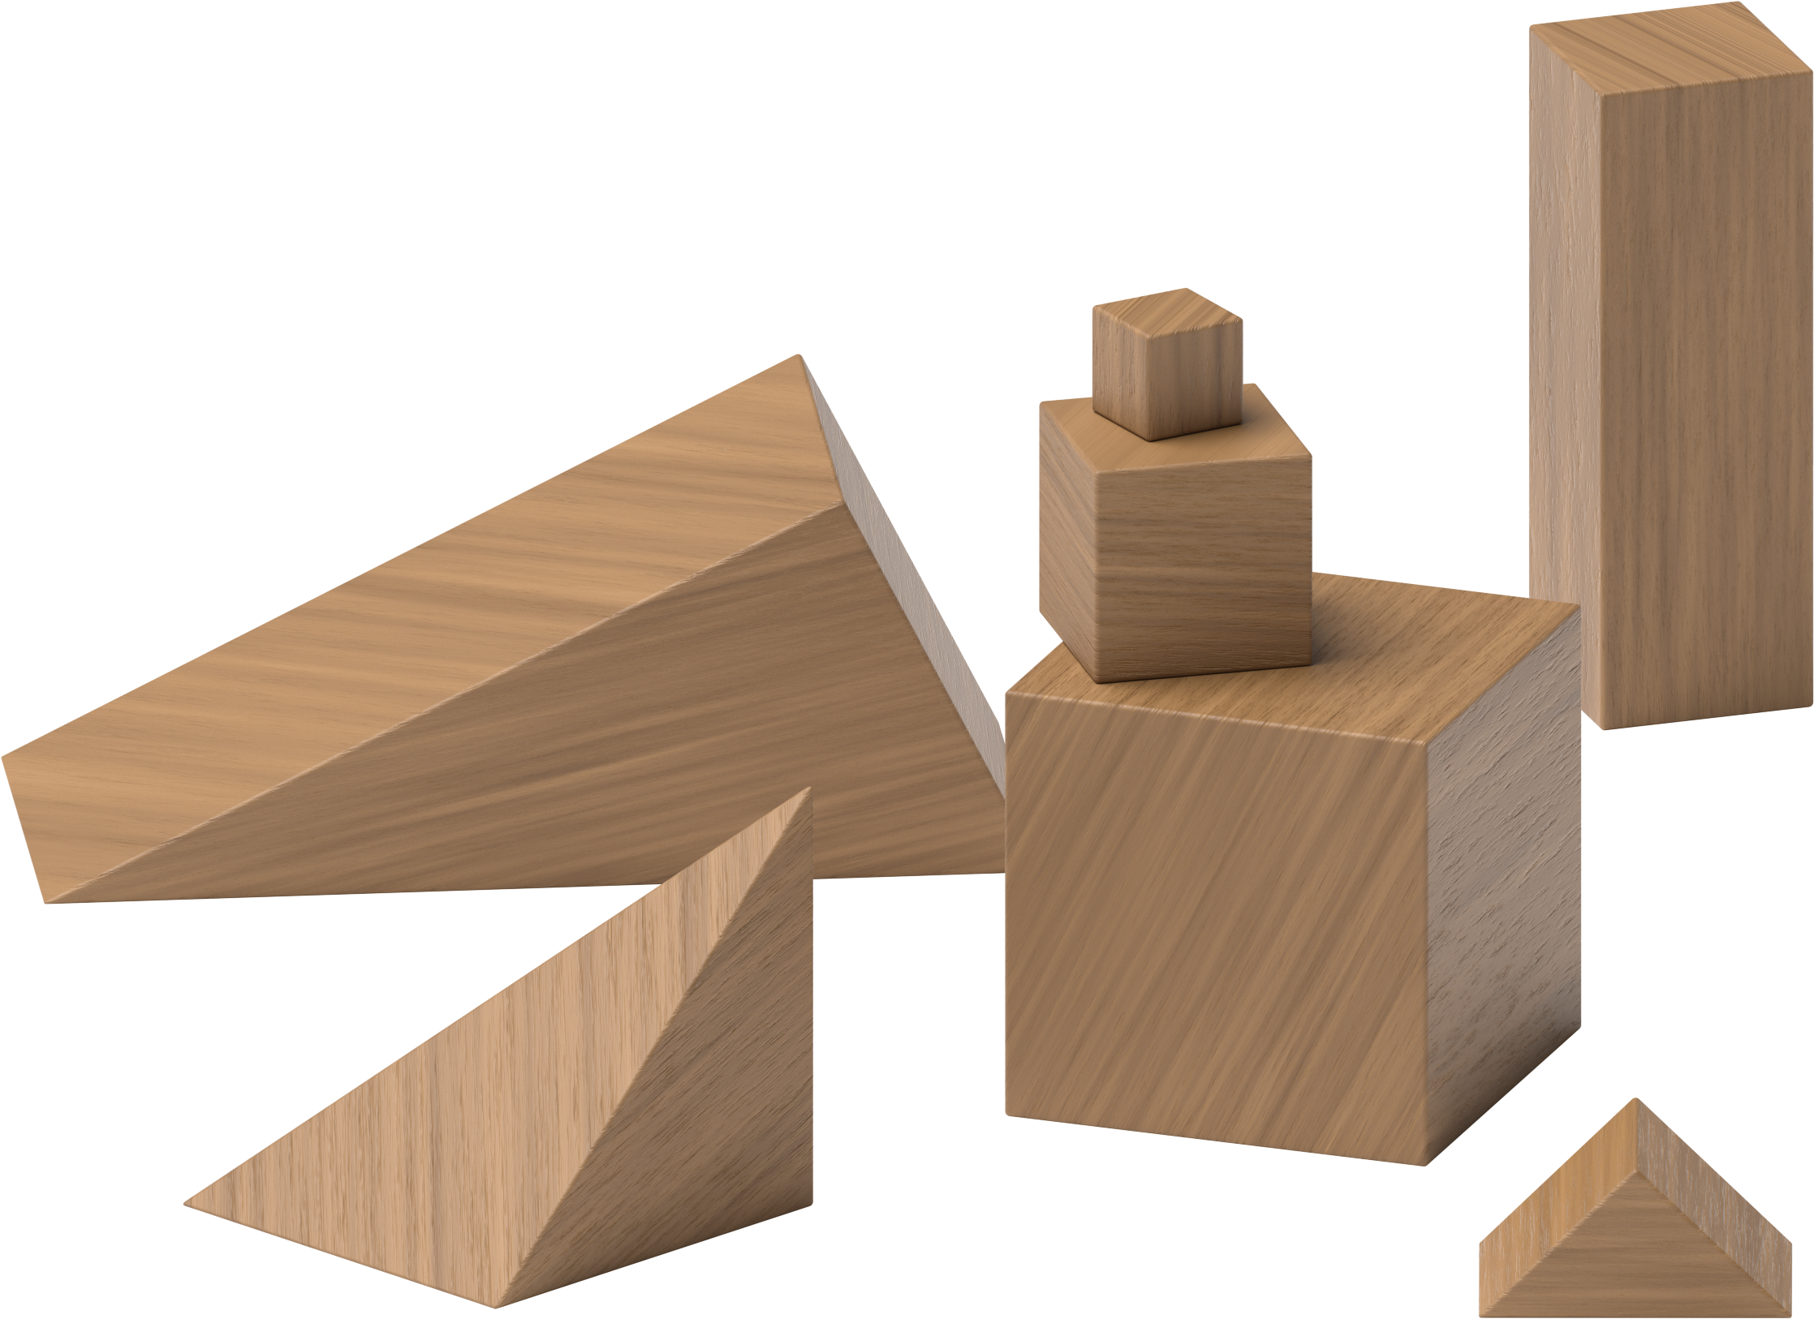
Counting Collections
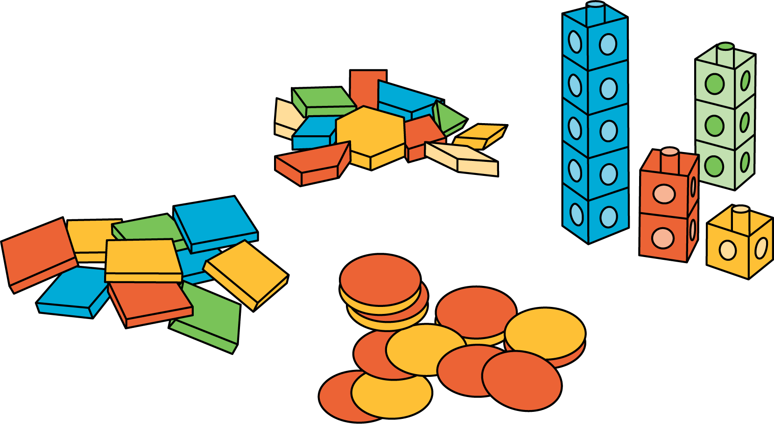
Match Mine
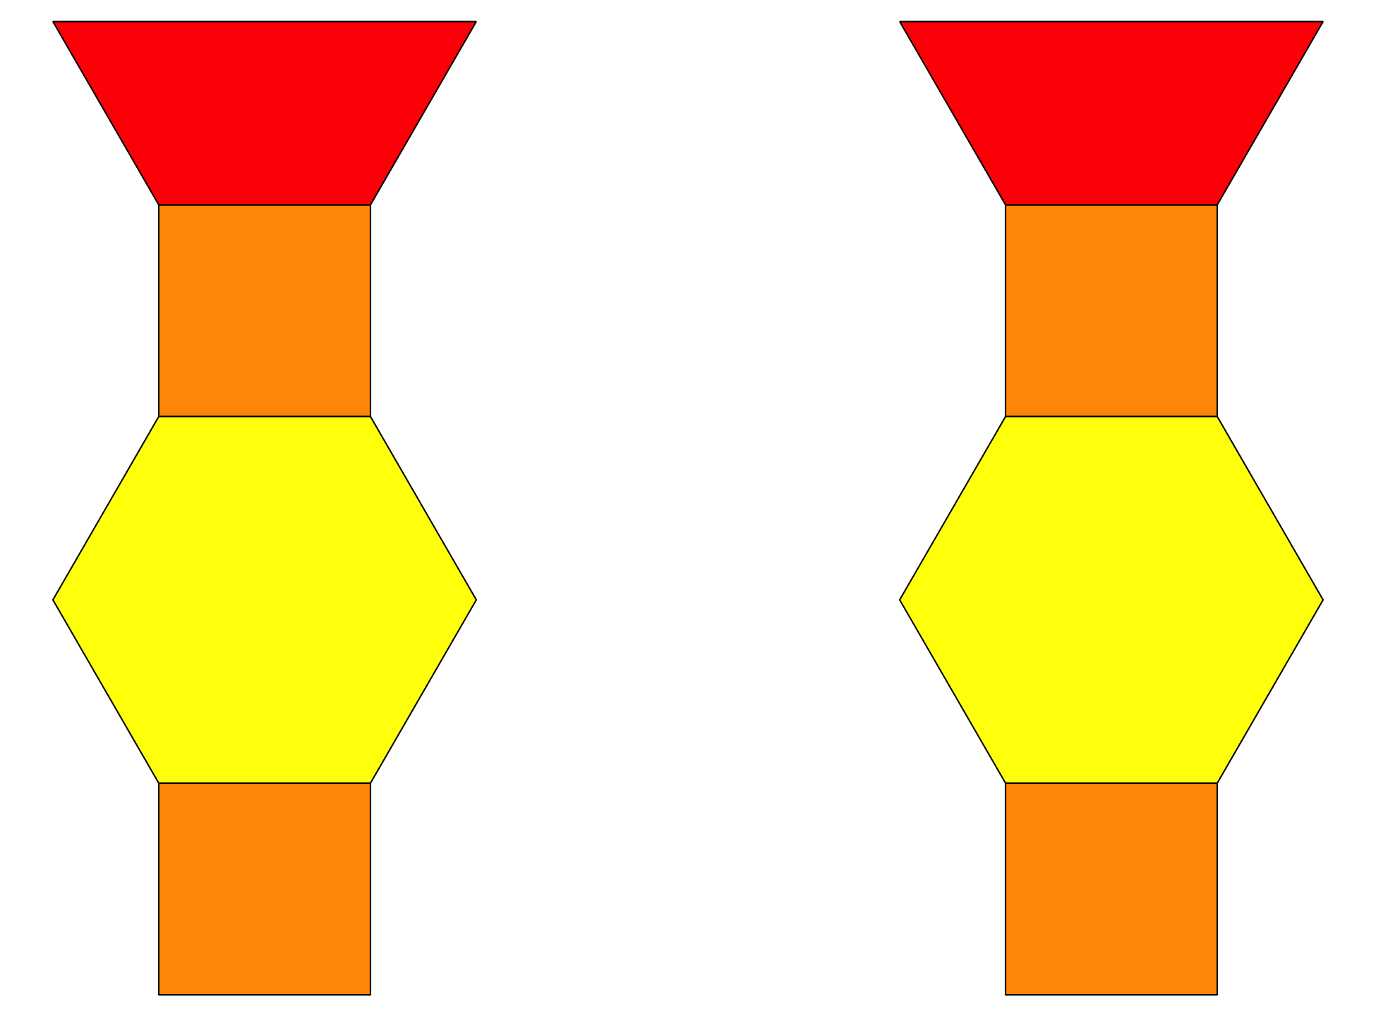
Shake and Spill


Section Summary
Section Summary
In this section, we described, compared, and created solid shapes.
cube
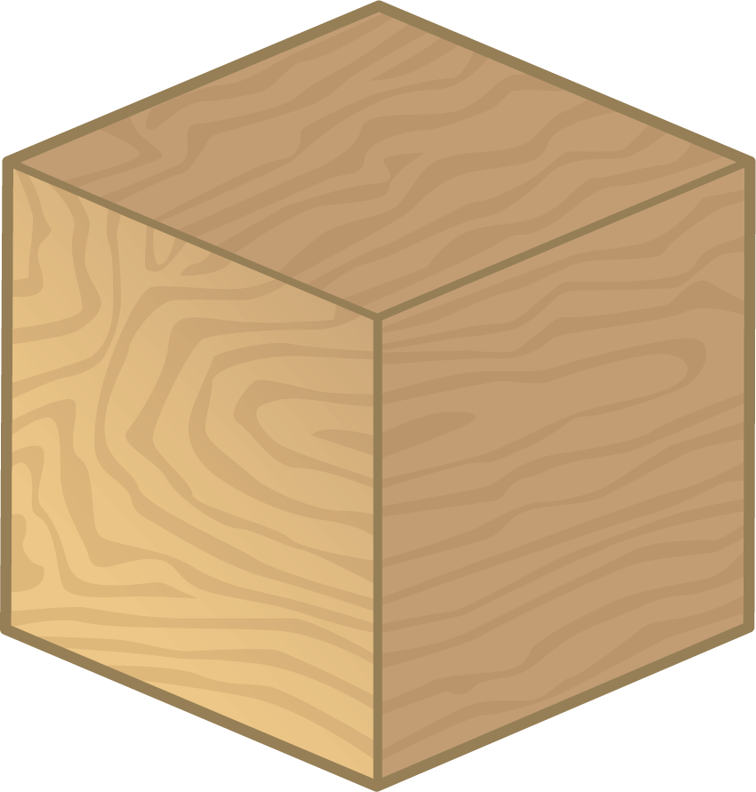
cone
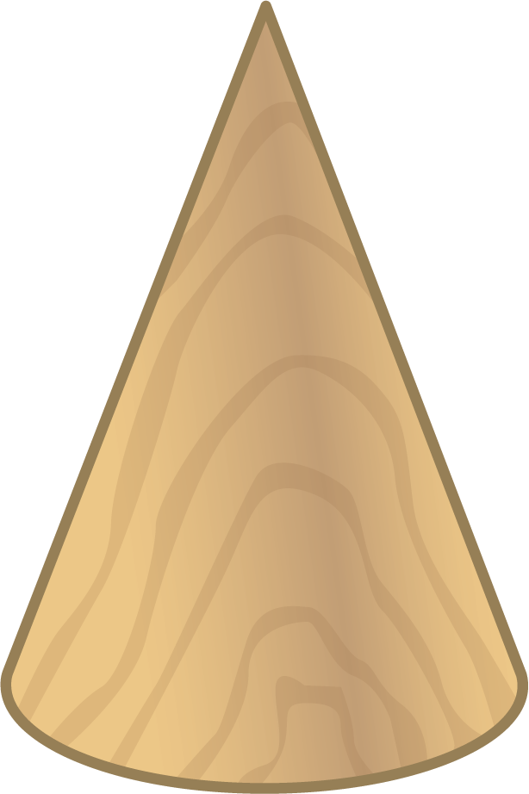
cylinder
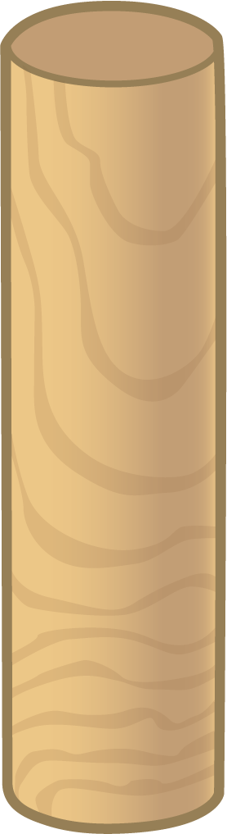
sphere
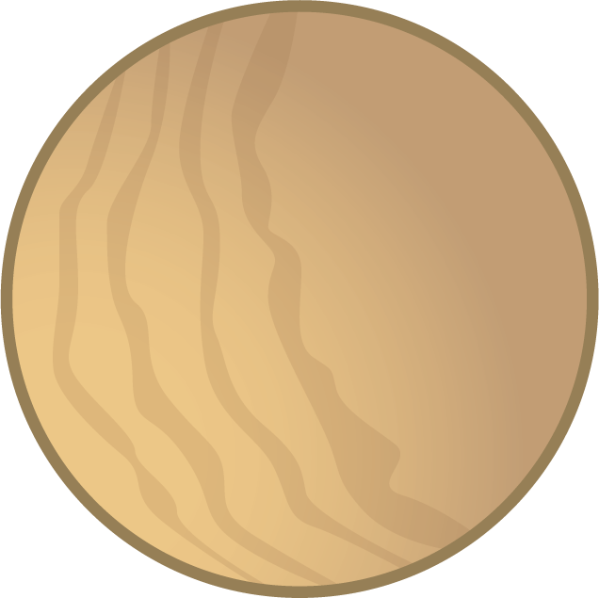
We found examples of solid shapes in our world.

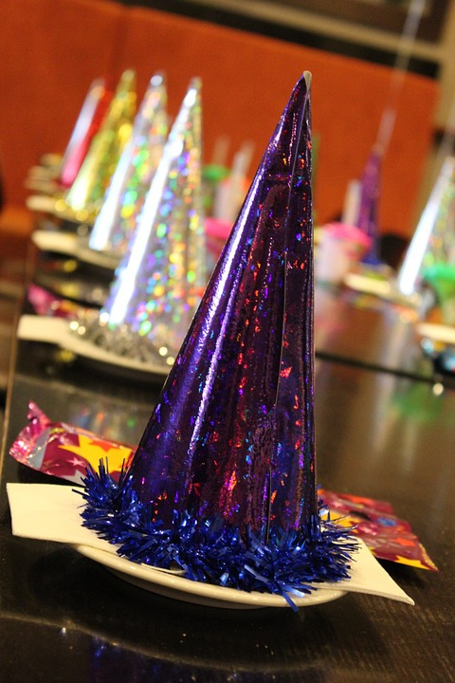
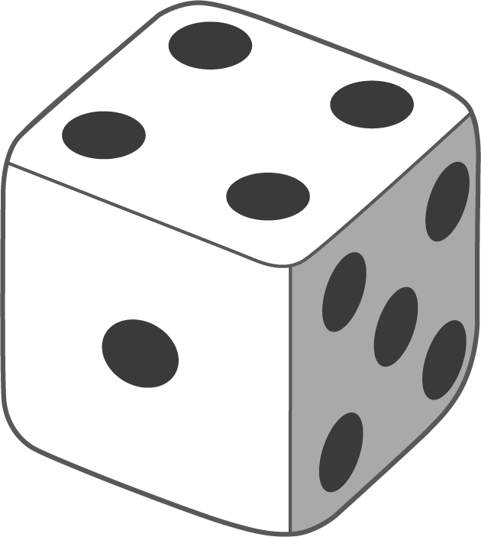
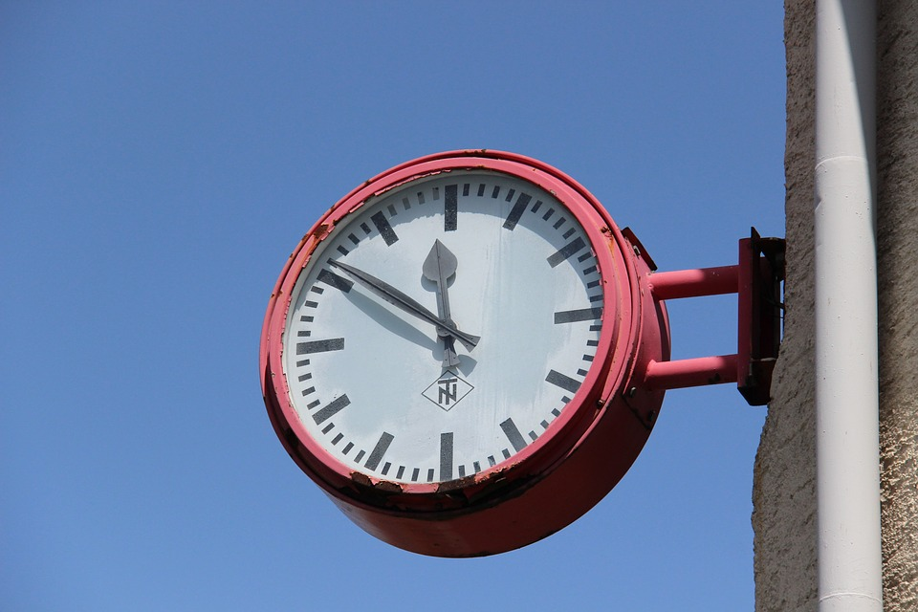
We used solid shapes to build things and described what we made.
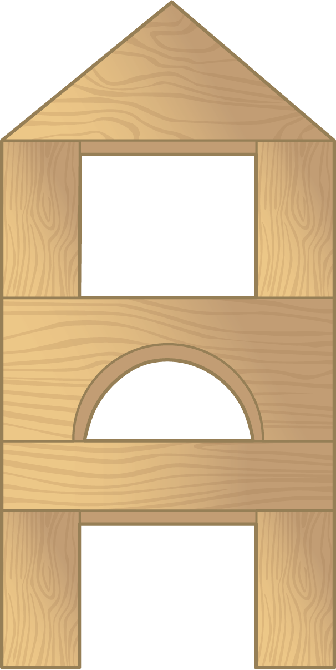
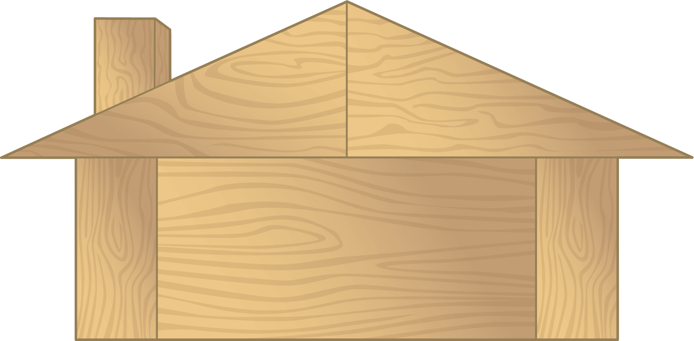
© CC BY 2021 Illustrative Mathematics®

