Unit 3 Lesson 8: Draw Shapes

WU What Do You Know About Rectangles? (Warm up)

Student Task Statement
What do you know about rectangles?

1 Connect the Dots

Student Task Statement
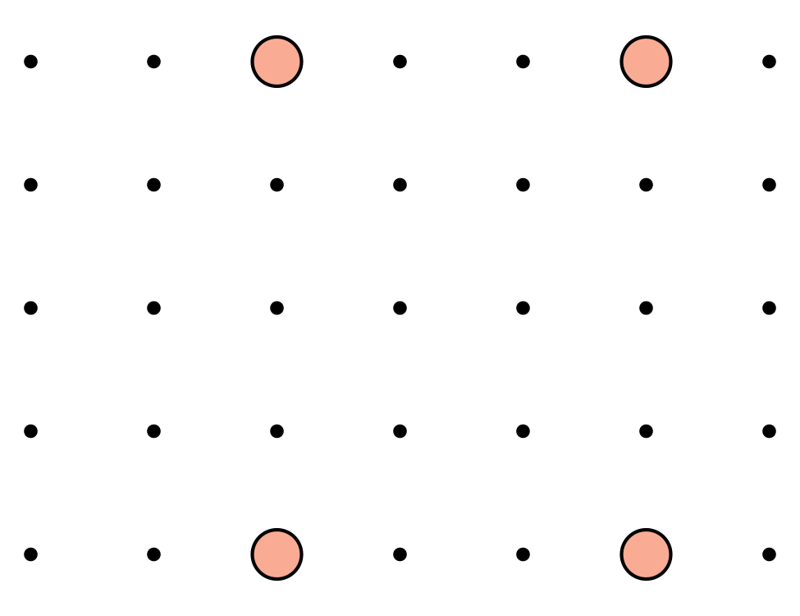

- 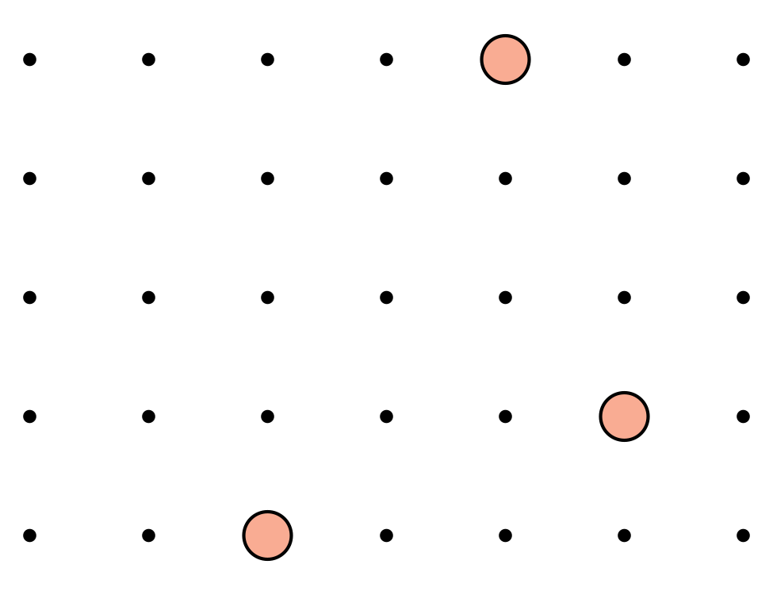

- 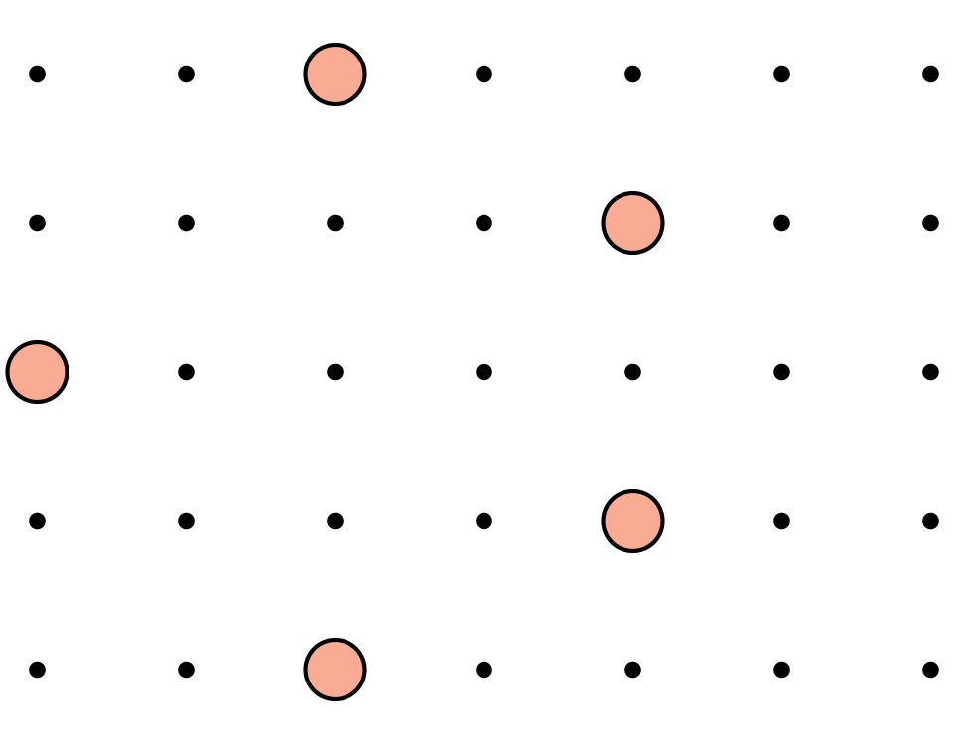

- 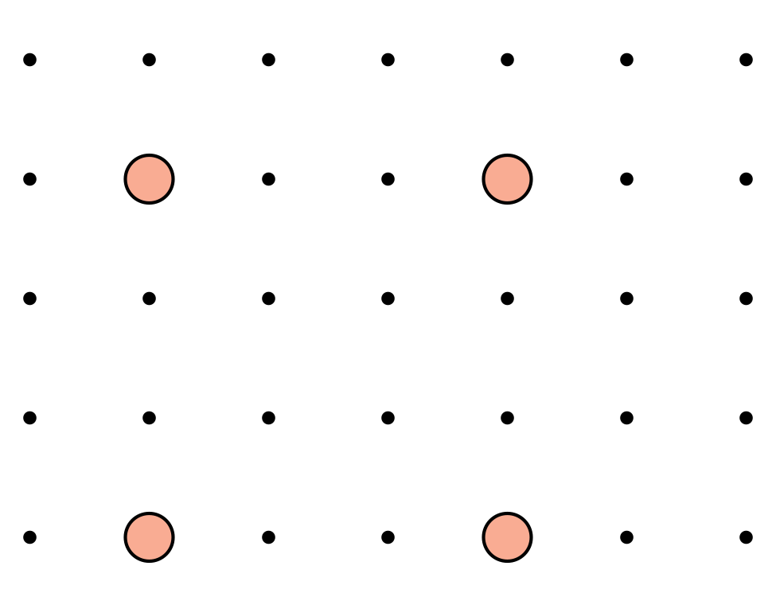

- 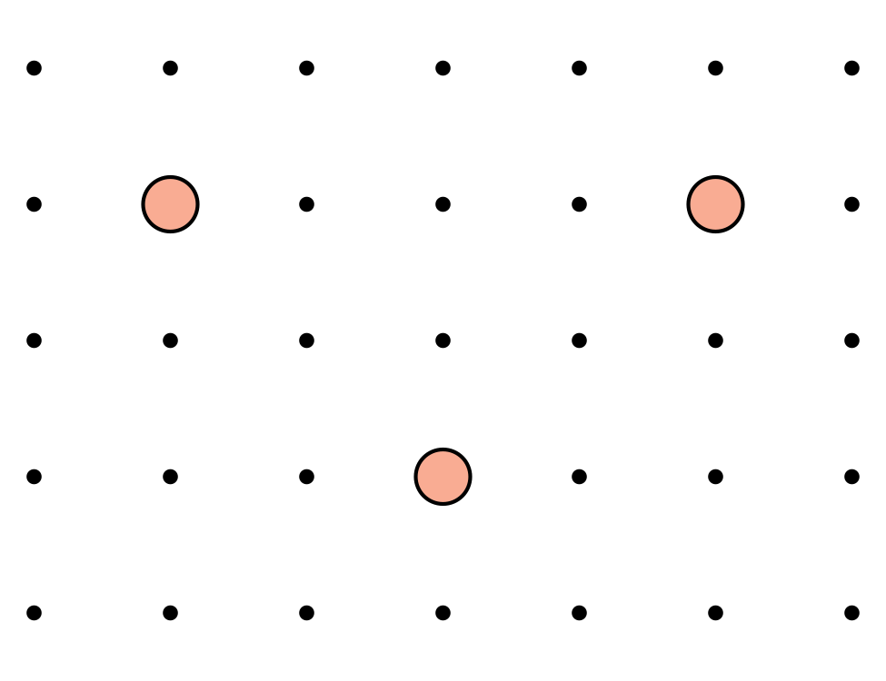

- 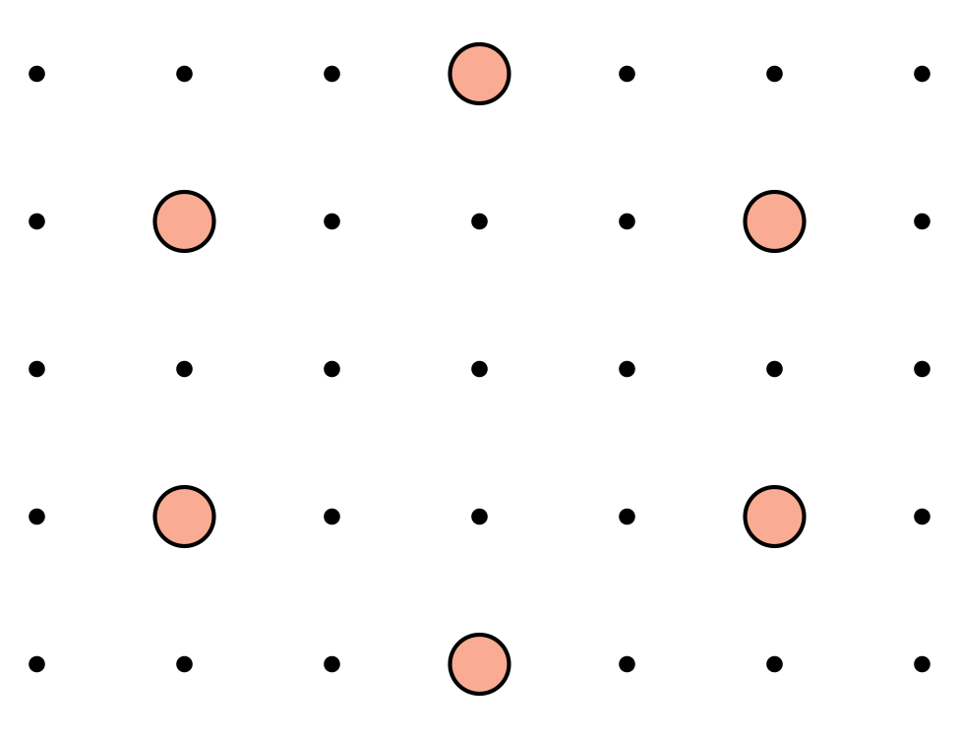
Synthesis:
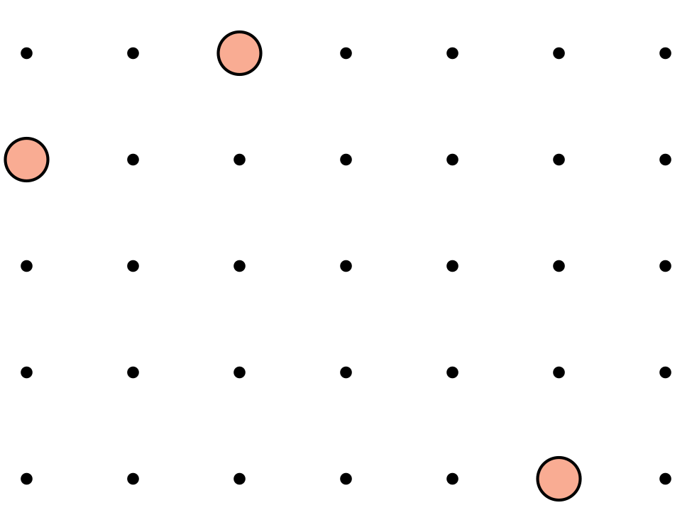

2 Describe and Draw Shapes

Images for Launch
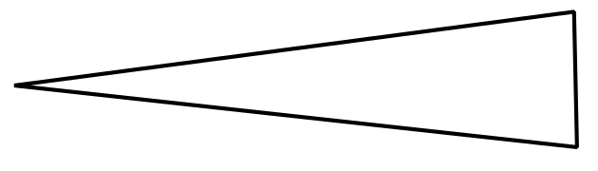

Student Task Statement
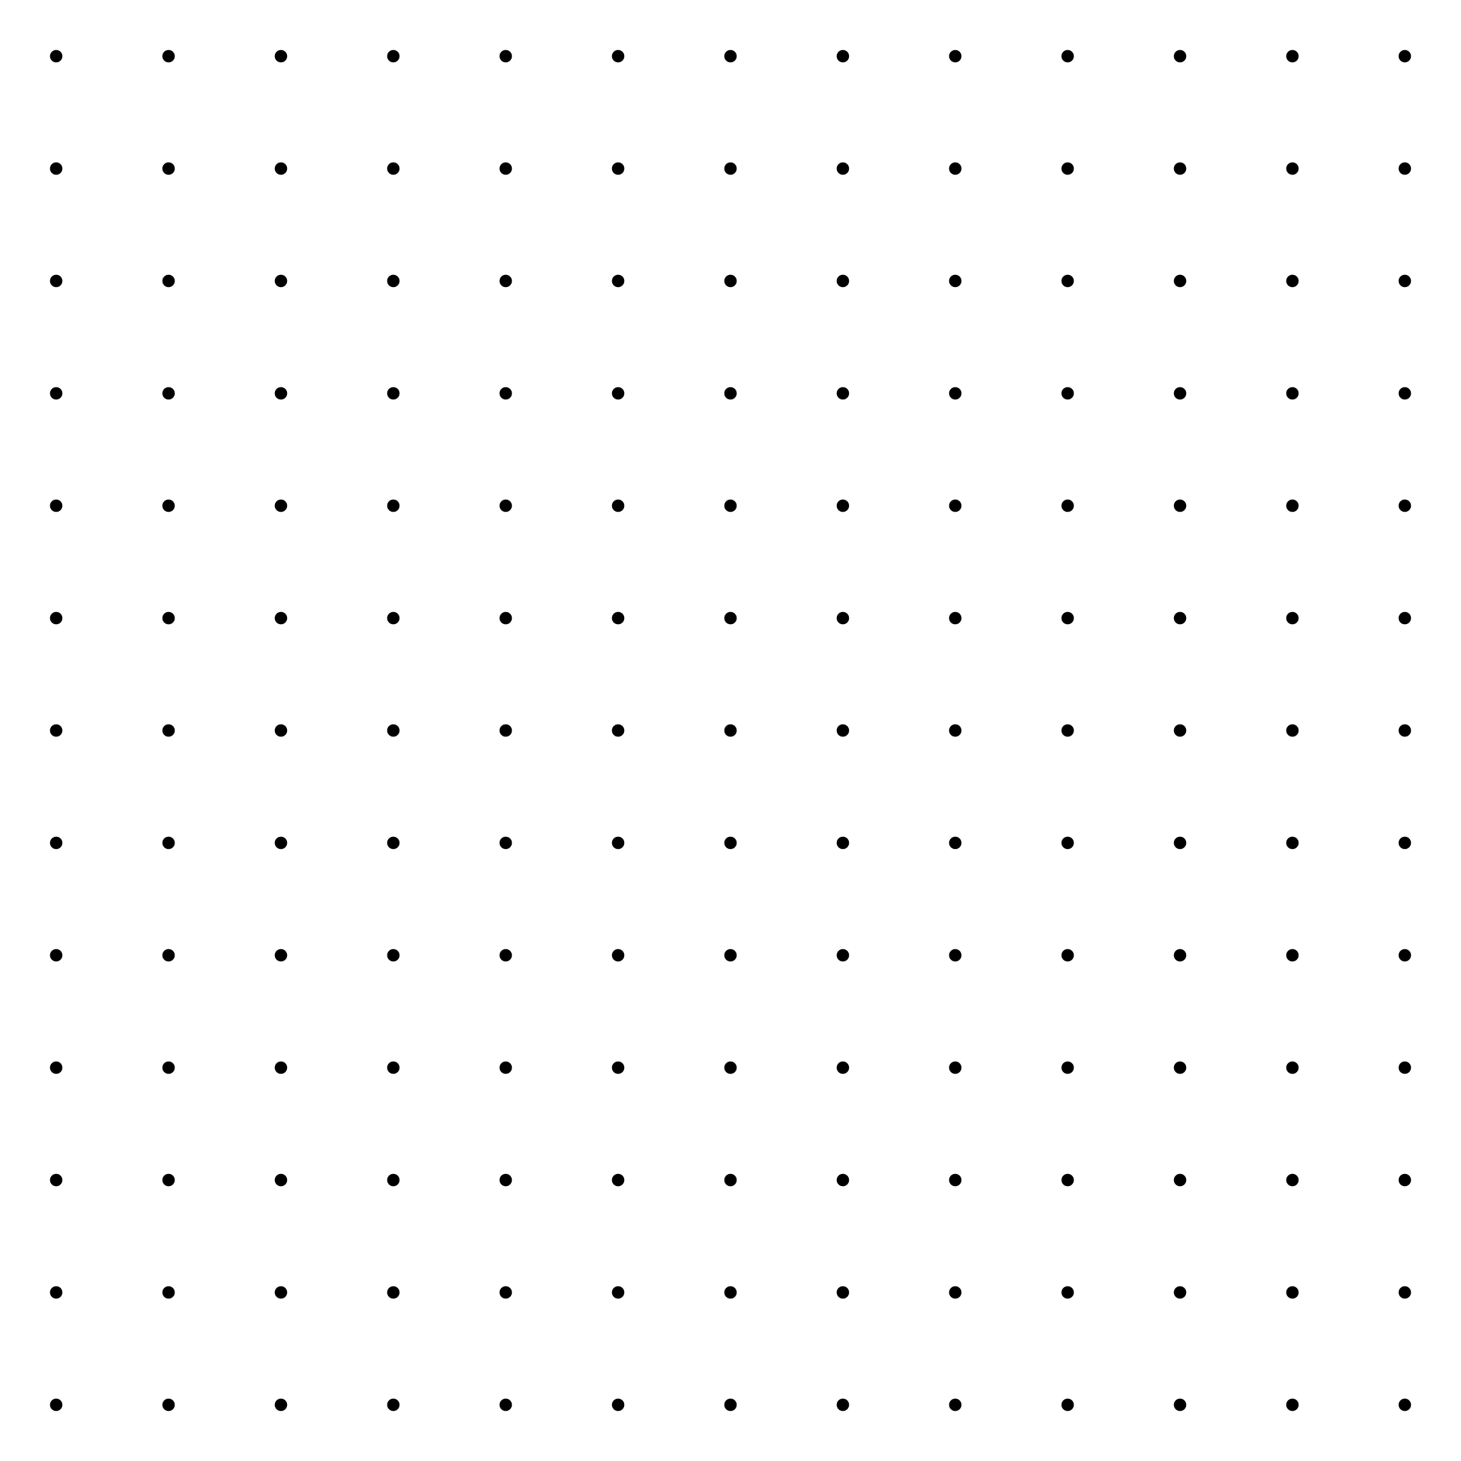
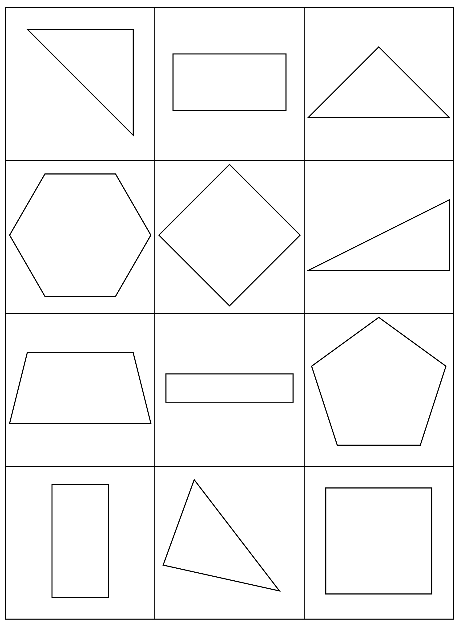

3 Introduce Build Shapes, Describe the Flat Shape

Student Task Statement
Choose a center.
Build Shapes
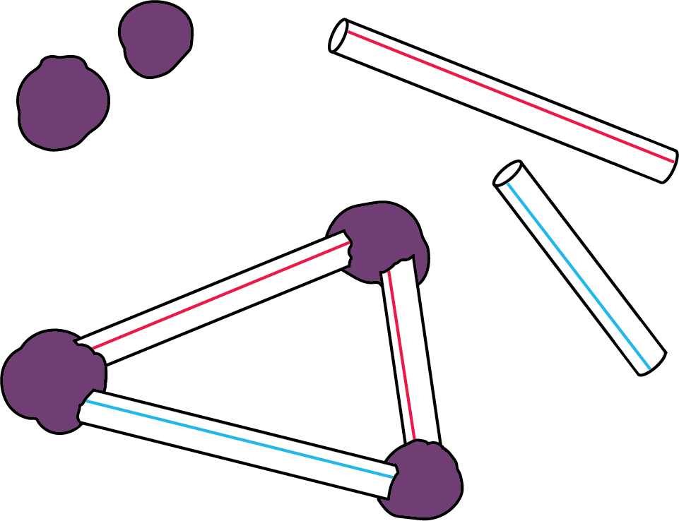
Counting Collections
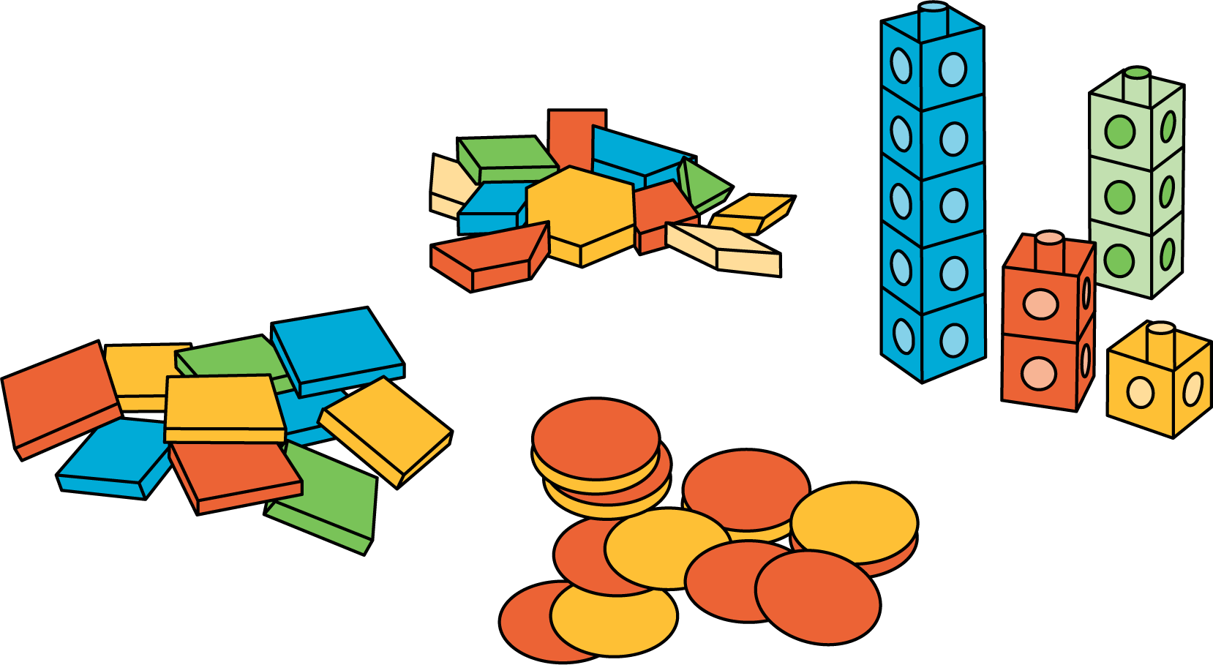
Which One
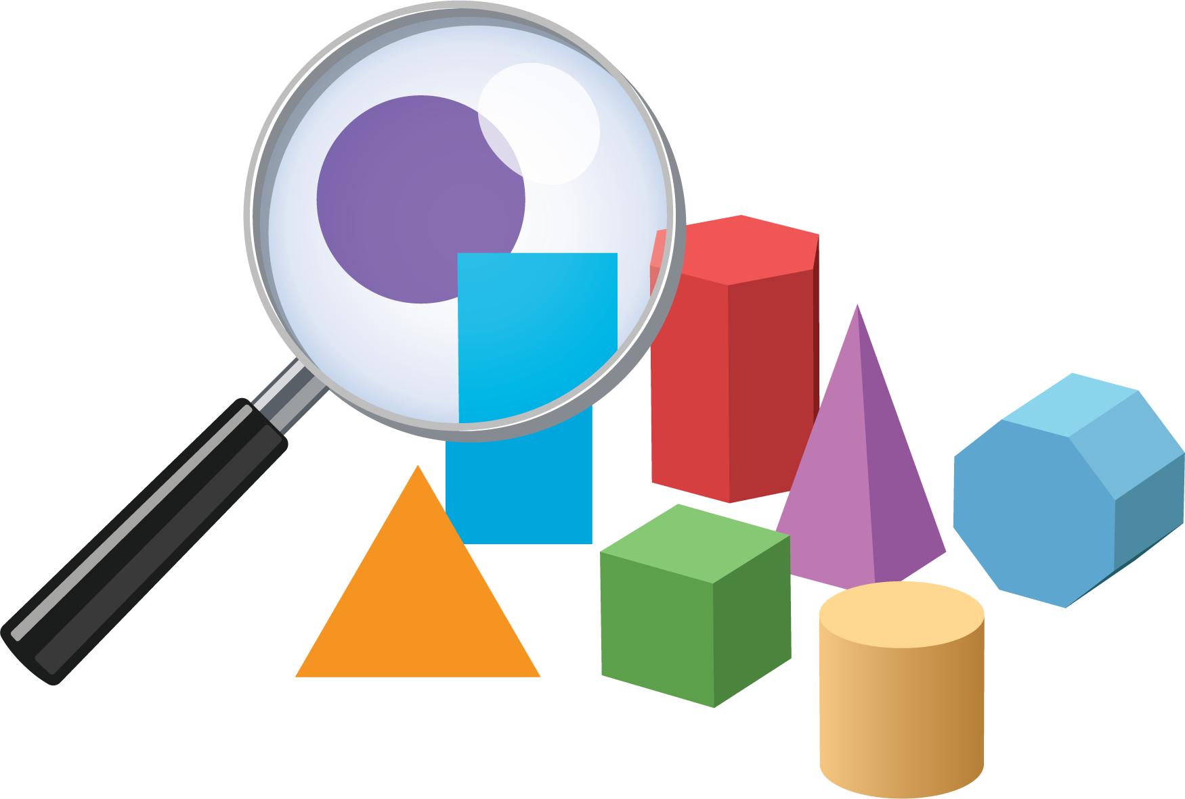
Picture Books
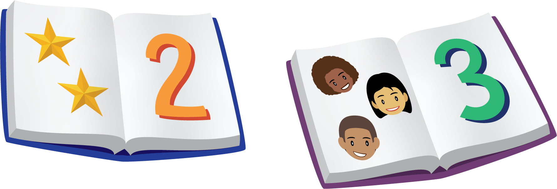
Bingo
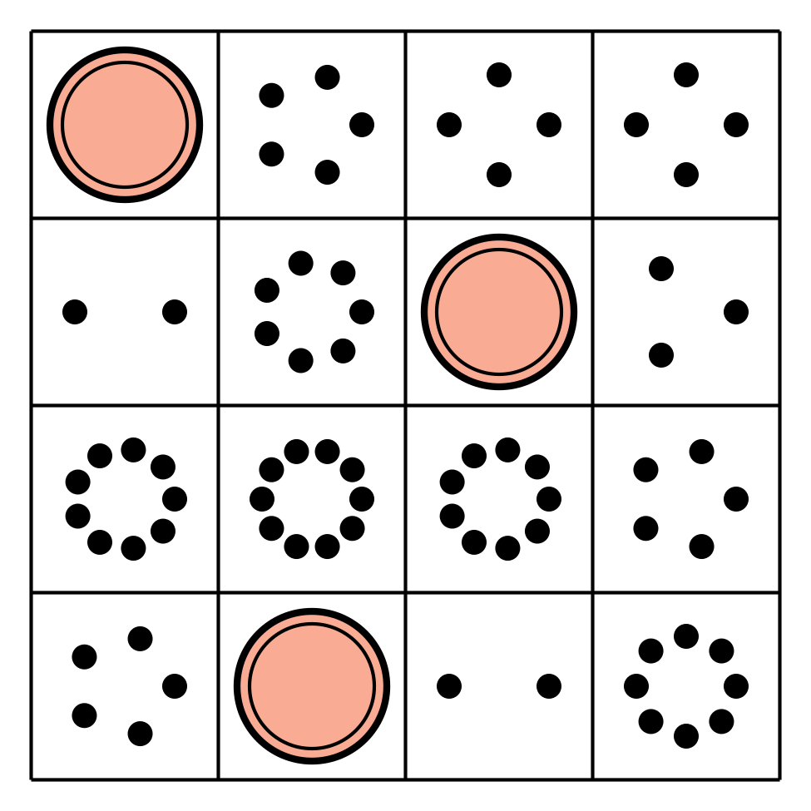
Shake and Spill


Images for Activity Synthesis
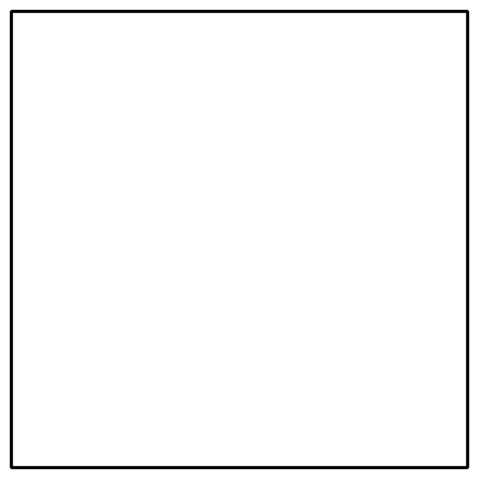
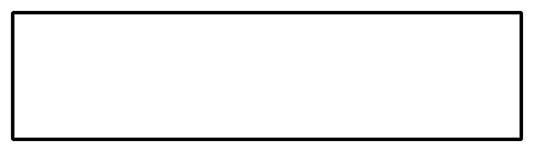
© CC BY 2021 Illustrative Mathematics®

