Lesson 5: Some Functions Have Symmetry
- Let's look at symmetry in graphs of functions

5.1: Changing Heights
The table shows Clare’s elevation on a Ferris wheel at different times, $t$. Clare got on the ride 80 seconds ago. Right now, at time 0 seconds, she is at the top of the ride. Assuming the Ferris wheel moves at a constant speed for the next 80 seconds, complete the table.

time (seconds) | height (feet)
-80 | 0
-60 | 31
-40 | 106
-20 | 181
0 | 212
20
40
60
80

5.2: Card Sort: Two Types of Graphs
Your teacher will give you a set of cards that show graphs. Sort the cards into 2 categories of your choosing. Be prepared to explain the meaning of your categories.

5.3: Card Sort: Two Types of Coordinates
Your teacher will give you a set of cards to go with the cards you already have.
- Match each table of coordinate pairs with one of the graphs from earlier.
- Describe something you notice about the coordinate pairs of even functions.
- Describe something you notice about the coordinate pairs of odd functions.

Are you ready for more?
- Can a non-zero function whose domain is all real numbers be both even and odd? Give an example if it is possible or explain why it is not possible.
- Can a non-zero function whose domain is all real numbers have a graph that is symmetrical around the $x$-axis? Give an example if it is possible or explain why it is not possible.

Lesson 5 Summary
We've learned how to transform functions in several ways. We can translate graphs of functions up and down, changing the output values while keeping the input values. We can translate graphs left and right, changing the input values while keeping the output values. We can reflect functions across an axis, swapping either input or output values for their opposites depending on which axis is reflected across.
For some functions, we can perform specific transformations and it looks like we didn't do anything at all. Consider the function $f$ whose graph is shown here:
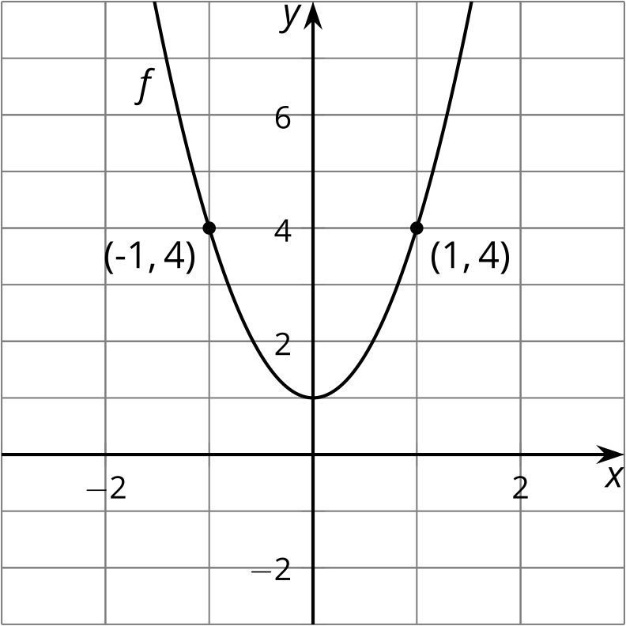
What transformation could we do to the graph of $f$ that would result in the same graph? Examining the shape of the graph, we can see a symmetry between points to the left of the $y$-axis and the points to the right of the $y$-axis. Looking at the points on the graph where $x=1$ and $x=\text{-}1$, these opposite inputs have the same outputs since $f\left(1\right)=4$ and $f\left(\text{-}1\right)=4$. This means that if we reflect the graph across the $y$-axis, it will look no different. This type of symmetry means $f$ is an even function.
Now consider the function $g$ whose graph is shown here:
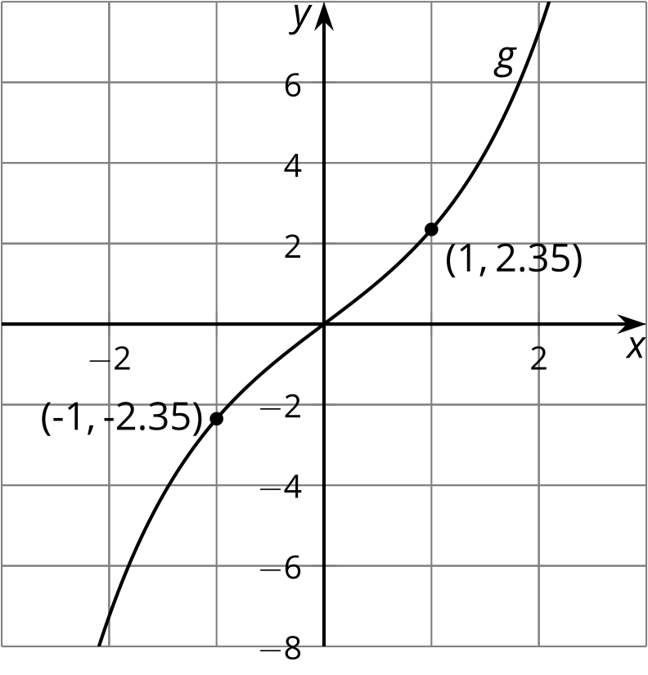
What transformation could we do to the graph of $g$ that would result in the same graph? Examining the shape of the graph, we can see that there is a symmetry between points on opposite sides of the axes. Looking at the points on the graph where $x=1$ and $x=\text{-}1$, these opposite inputs have opposite outputs since $g\left(1\right)=2.35$ and $g\left(\text{-}1\right)=\text{-}2.35$. So a transformation that takes the graph of $g$ to itself has to reflect across the $x$-axis and the $y$-axis. This type of symmetry is what makes $g$ an odd function.
© CC BY 2019 by Illustrative Mathematics®

