Grade 2
Unit 1Lesson 5CC BY NC 2024 Illustrative Mathematics®
Unit 1, Lesson 5

Add within 50
- Let’s add within 50.
Grade 2
Unit 1Lesson 5CC BY NC 2024 Illustrative Mathematics®

Warm-upNumber Talk: 2-Digit, 1-Digit
Find the value of each sum mentally.
- $16+3$
- $16+5$
- $26+5$
- $38+6$
Grade 2
Unit 1Lesson 5CC BY NC 2024 Illustrative Mathematics®

Activity 1Revisit How Close—Add To 100






Grade 2
Unit 1Lesson 5CC BY NC 2024 Illustrative Mathematics®

Activity 2Add within 50
Find the value of each sum. Show your thinking using drawings, numbers, or words.
- $37+8$
- $24+23$
- $16+30$
- $39+11$
- $27+15$

Section A Summary
We used what we know about making 10 to add and subtract. We used different ways to find an unknown number in an equation.
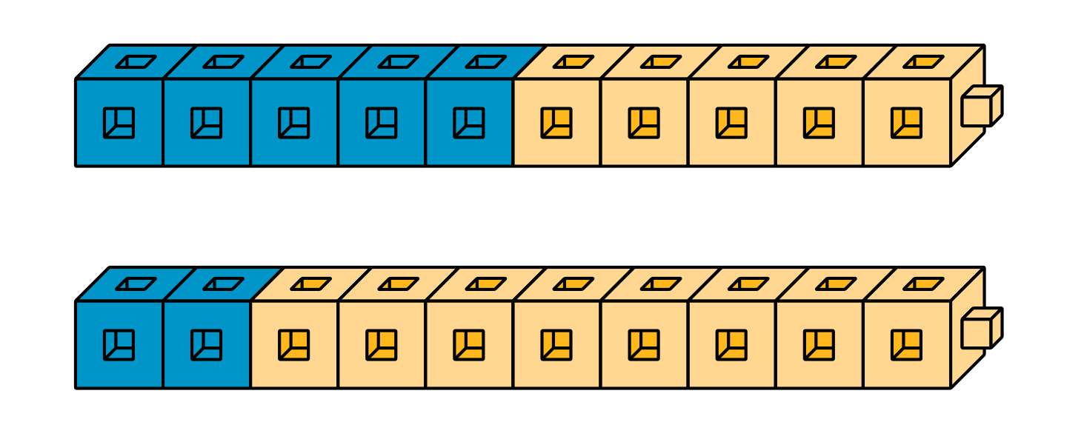
$10−5=\underset{_}{}$
$5+\underset{_}{}=10$
$2+\underset{_}{}=10$
$10−8=\underset{_}{}$

