Grade 6
Unit 7Lesson 12CC BY NC Illustrative Mathematics, based on IM 6–8 Math, CC BY Open Up Resources.
Unit 7, Lesson 12

Constructing the Coordinate Plane
Let’s investigate different ways of creating a coordinate plane.
Grade 6
Unit 7Lesson 12CC BY NC Illustrative Mathematics, based on IM 6–8 Math, CC BY Open Up Resources.

12.1English Winter
The following data were collected over one December afternoon in England.
time after noon (hours) | temperature($​^{∘}\text{C}$)
0 | 5
1 | 3
2 | 4
3 | 2
4 | 1
5 | -2
6 | -3
7 | -4
8 | -4

- Which set of axes would you choose to represent these data? Explain your reasoning.
- A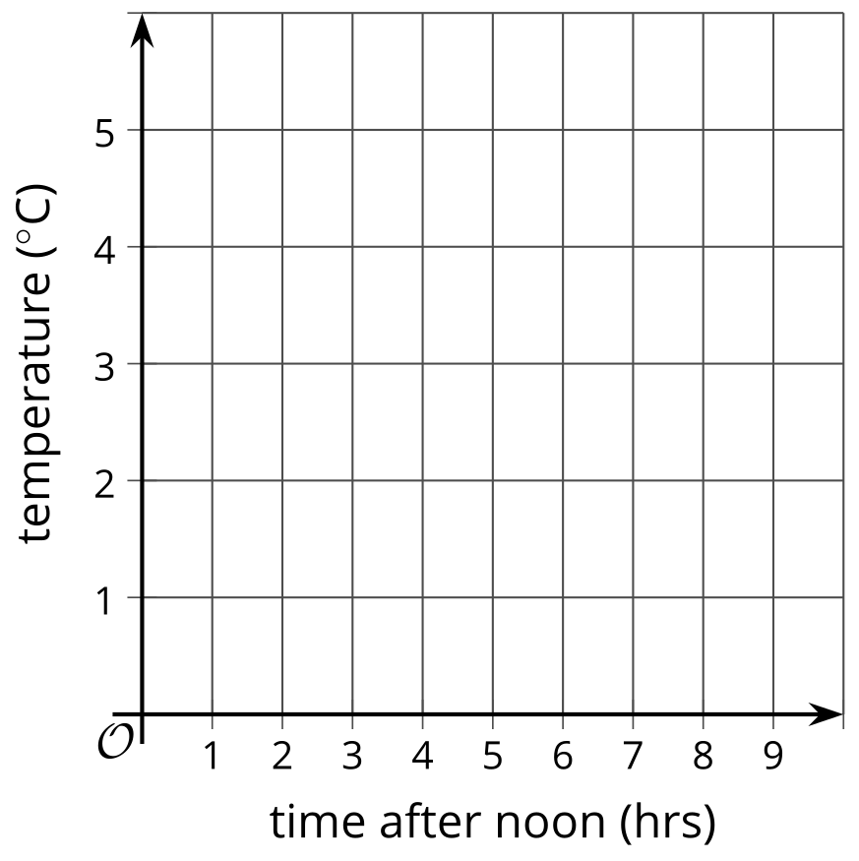
- B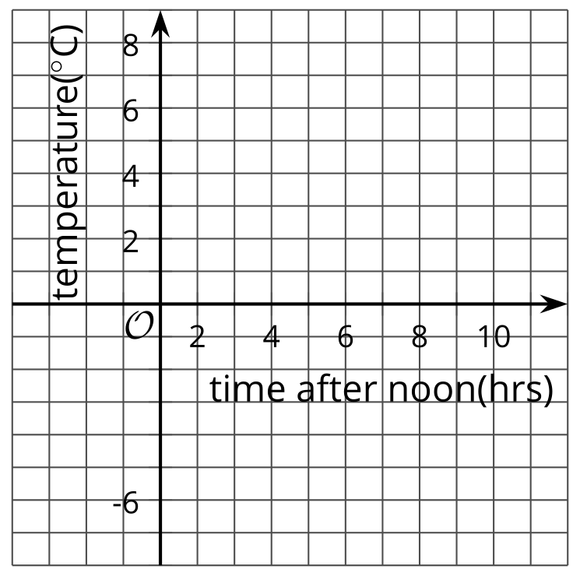
- C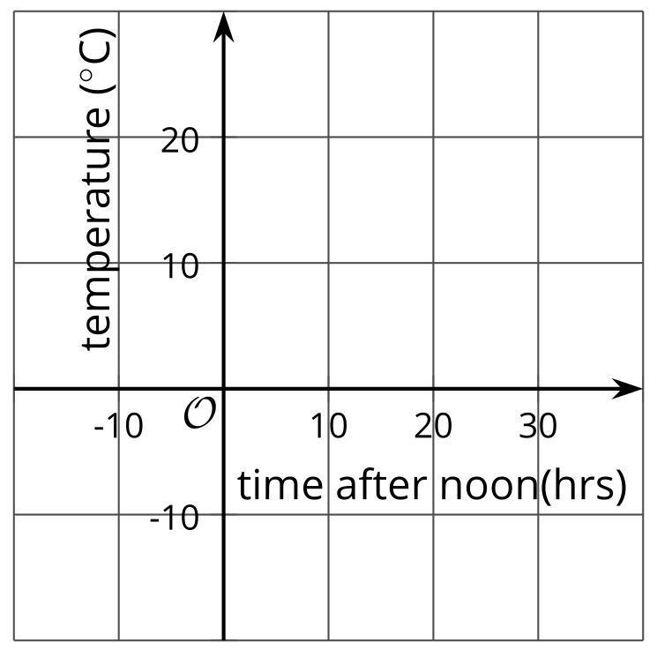
- Explain why the other two sets of axes did not seem as appropriate as the one you chose.
Grade 6
Unit 7Lesson 12CC BY NC Illustrative Mathematics, based on IM 6–8 Math, CC BY Open Up Resources.

12.2Axes Drawing Decisions
- For each set of coordinates, draw and label an appropriate pair of axes, and plot the points.
  - $\left(1,2\right),\left(3,\text{-}4\right),\left(\text{-}5,\text{-}2\right),\left(0,2.5\right)$
  - 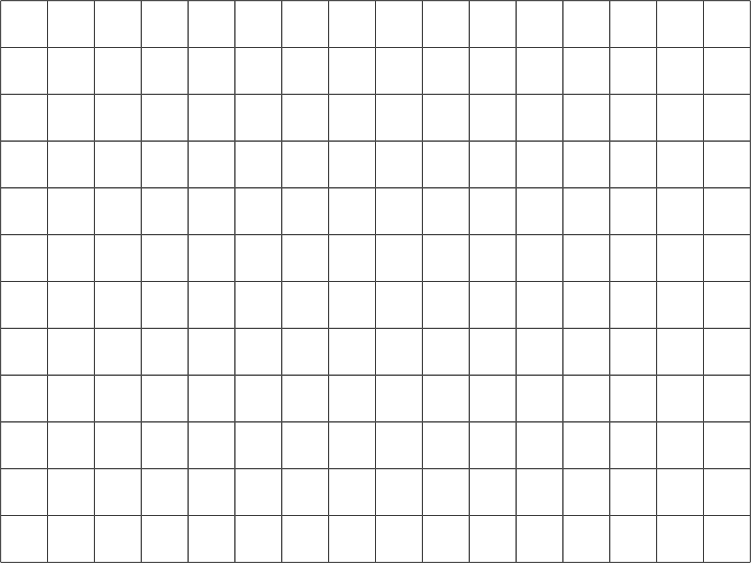
  - $\left(50,50\right),\left(0,0\right),\left(\text{-}10,\text{-}30\right),\left(\text{-}35,40\right)$
  - $\left(\frac{1}{4},\frac{3}{4}\right),\left(\frac{\text{-}5}{4},\frac{1}{2}\right),\left(\text{-}1\frac{1}{4},\frac{\text{-}3}{4}\right),\left(\frac{1}{4},\frac{\text{-}1}{2}\right)$
- Discuss with a partner:
  - How are the axes and labels of your three drawings different?
  - How did the coordinates affect the way you drew the axes and label the numbers?
Grade 6
Unit 7Lesson 12CC BY NC Illustrative Mathematics, based on IM 6–8 Math, CC BY Open Up Resources.

12.3Positively “a-MAZE-ing”
Here is a maze in a coordinate plane. The black point in the center is (0, 0). The side of each grid square is 2 units long.
The starting point of the maze is located at the top left of the maze and labeled as point $A$. Draw line segments to show your way through and out of the maze. Label each turning point with a letter. Then list all the letters, and write their coordinates.
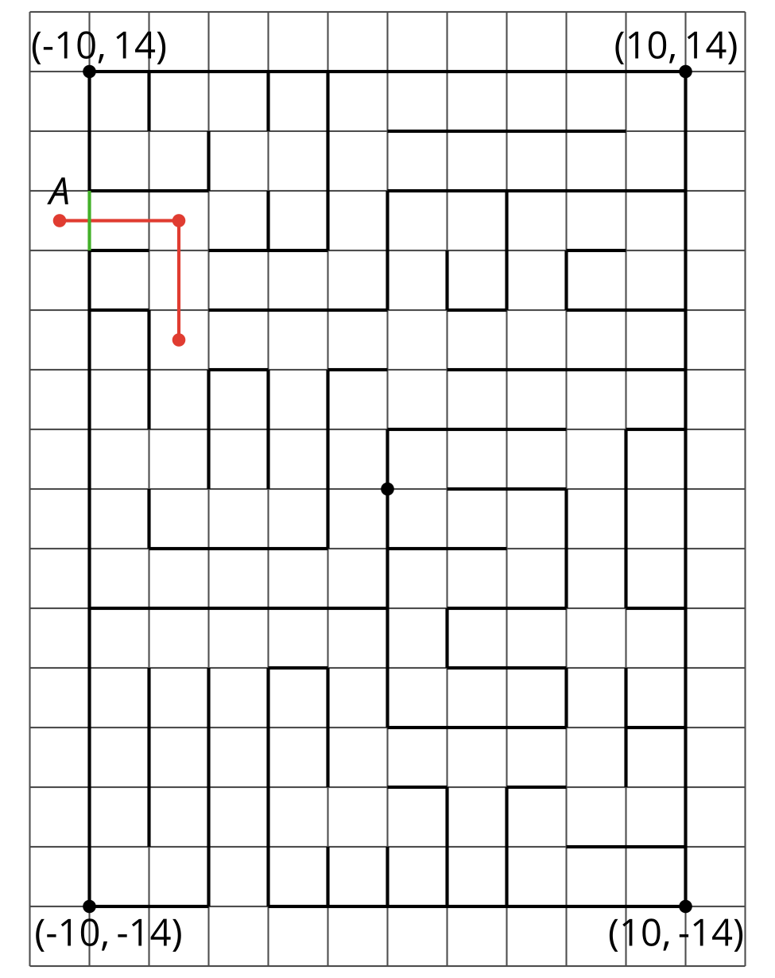
​

Are you ready for more?
To get from the point $\left(2,1\right)$ to $\left(\text{-}4,3\right)$ you can go two units up and six units to the left, for a total distance of eight units. This is called the “taxicab distance,” because a taxi driver would have to drive eight blocks to get between those two points on a map.
Find as many points as you can that have a taxicab distance of eight units away from $\left(2,1\right)$. What shape do these points make?
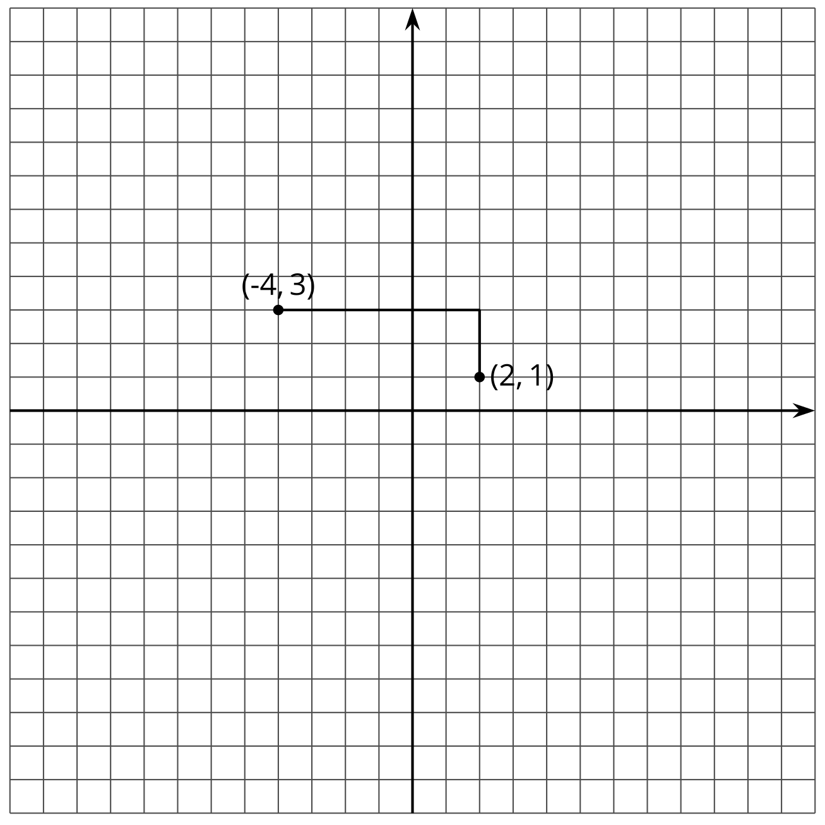

Lesson 12 Summary
The coordinate plane can be used to show information involving pairs of numbers.
When using the coordinate plane, we should pay close attention to what each axis represents and what scale each axis uses.
Suppose we want to plot the following points: $\left(\text{-}4,3\right)$, $\left(\text{-}1,\text{-}2\right)$, $\left(0,\text{-}4\right)$, and $\left(3,\text{-}8\right)$.
The data involve whole numbers, so it is appropriate that each square on the grid represents a whole number.
- To the left of the origin, the $x$-axis needs to go as far as -4 or lower. To the right, it needs to go to at least 3.
- Below the origin, the $y$-axis has to go as far as -8 or lower. Above the origin, it needs to go to at least 3.
Here is a possible graph of the data.
