Unit 4 Lesson 4: More Addition and Subtraction with Tens

WU Number Talk: Plus or Minus 10 (Warm up)

Student Task Statement
Find the value of each expression mentally.
- $30+10$
- $40+10$
- $80−10$
- $70−10$

1 How Many Are in the Bag?

Student Task Statement
- Jada is counting collections of cubes.
In Bag A there are 30 cubes.
In Bag B there are 2 towers of 10.
How many cubes are in the two bags all together?
Show your thinking using drawings, numbers, or words.
- Tyler is counting a collection of cubes.
In Bag C there are 7 towers of 10.
He takes 40 cubes out of the bag.
How many cubes does he have left in the bag?
Show your thinking using drawings, numbers, or words.

2 Add and Subtract Tens

Student Task Statement
- Add 20:
- 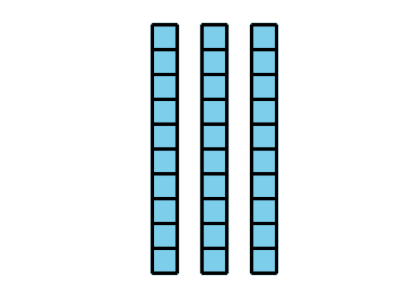
- Equation: ____________________________
- Subtract 20:
- 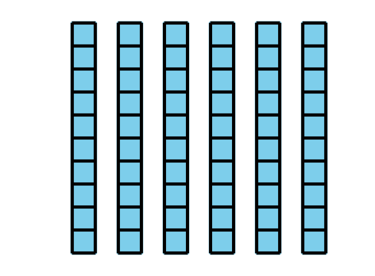
- Equation: ____________________________
- 4 tens and 5 tens is ___________
- Equation: ____________________________
- 8 tens take away 3 tens is __________
- Equation: ____________________________
- 20+60=aaaiaaai
- 70−20=aaaiaaai
- 90−70=aaaiaaai
- 40+40=aaaiaaai
© CC BY 2021 Illustrative Mathematics®

