Grade 2
Unit 4Lesson 15CC BY NC 2024 Illustrative Mathematics®
Unit 4, Lesson 15

Tall Enough to Ride
- Let’s find out what amusement park rides people are tall enough to ride.
Grade 2
Unit 4Lesson 15CC BY NC 2024 Illustrative Mathematics®

Warm-up Notice and Wonder: How Tall Are You?
What do you notice? What do you wonder?
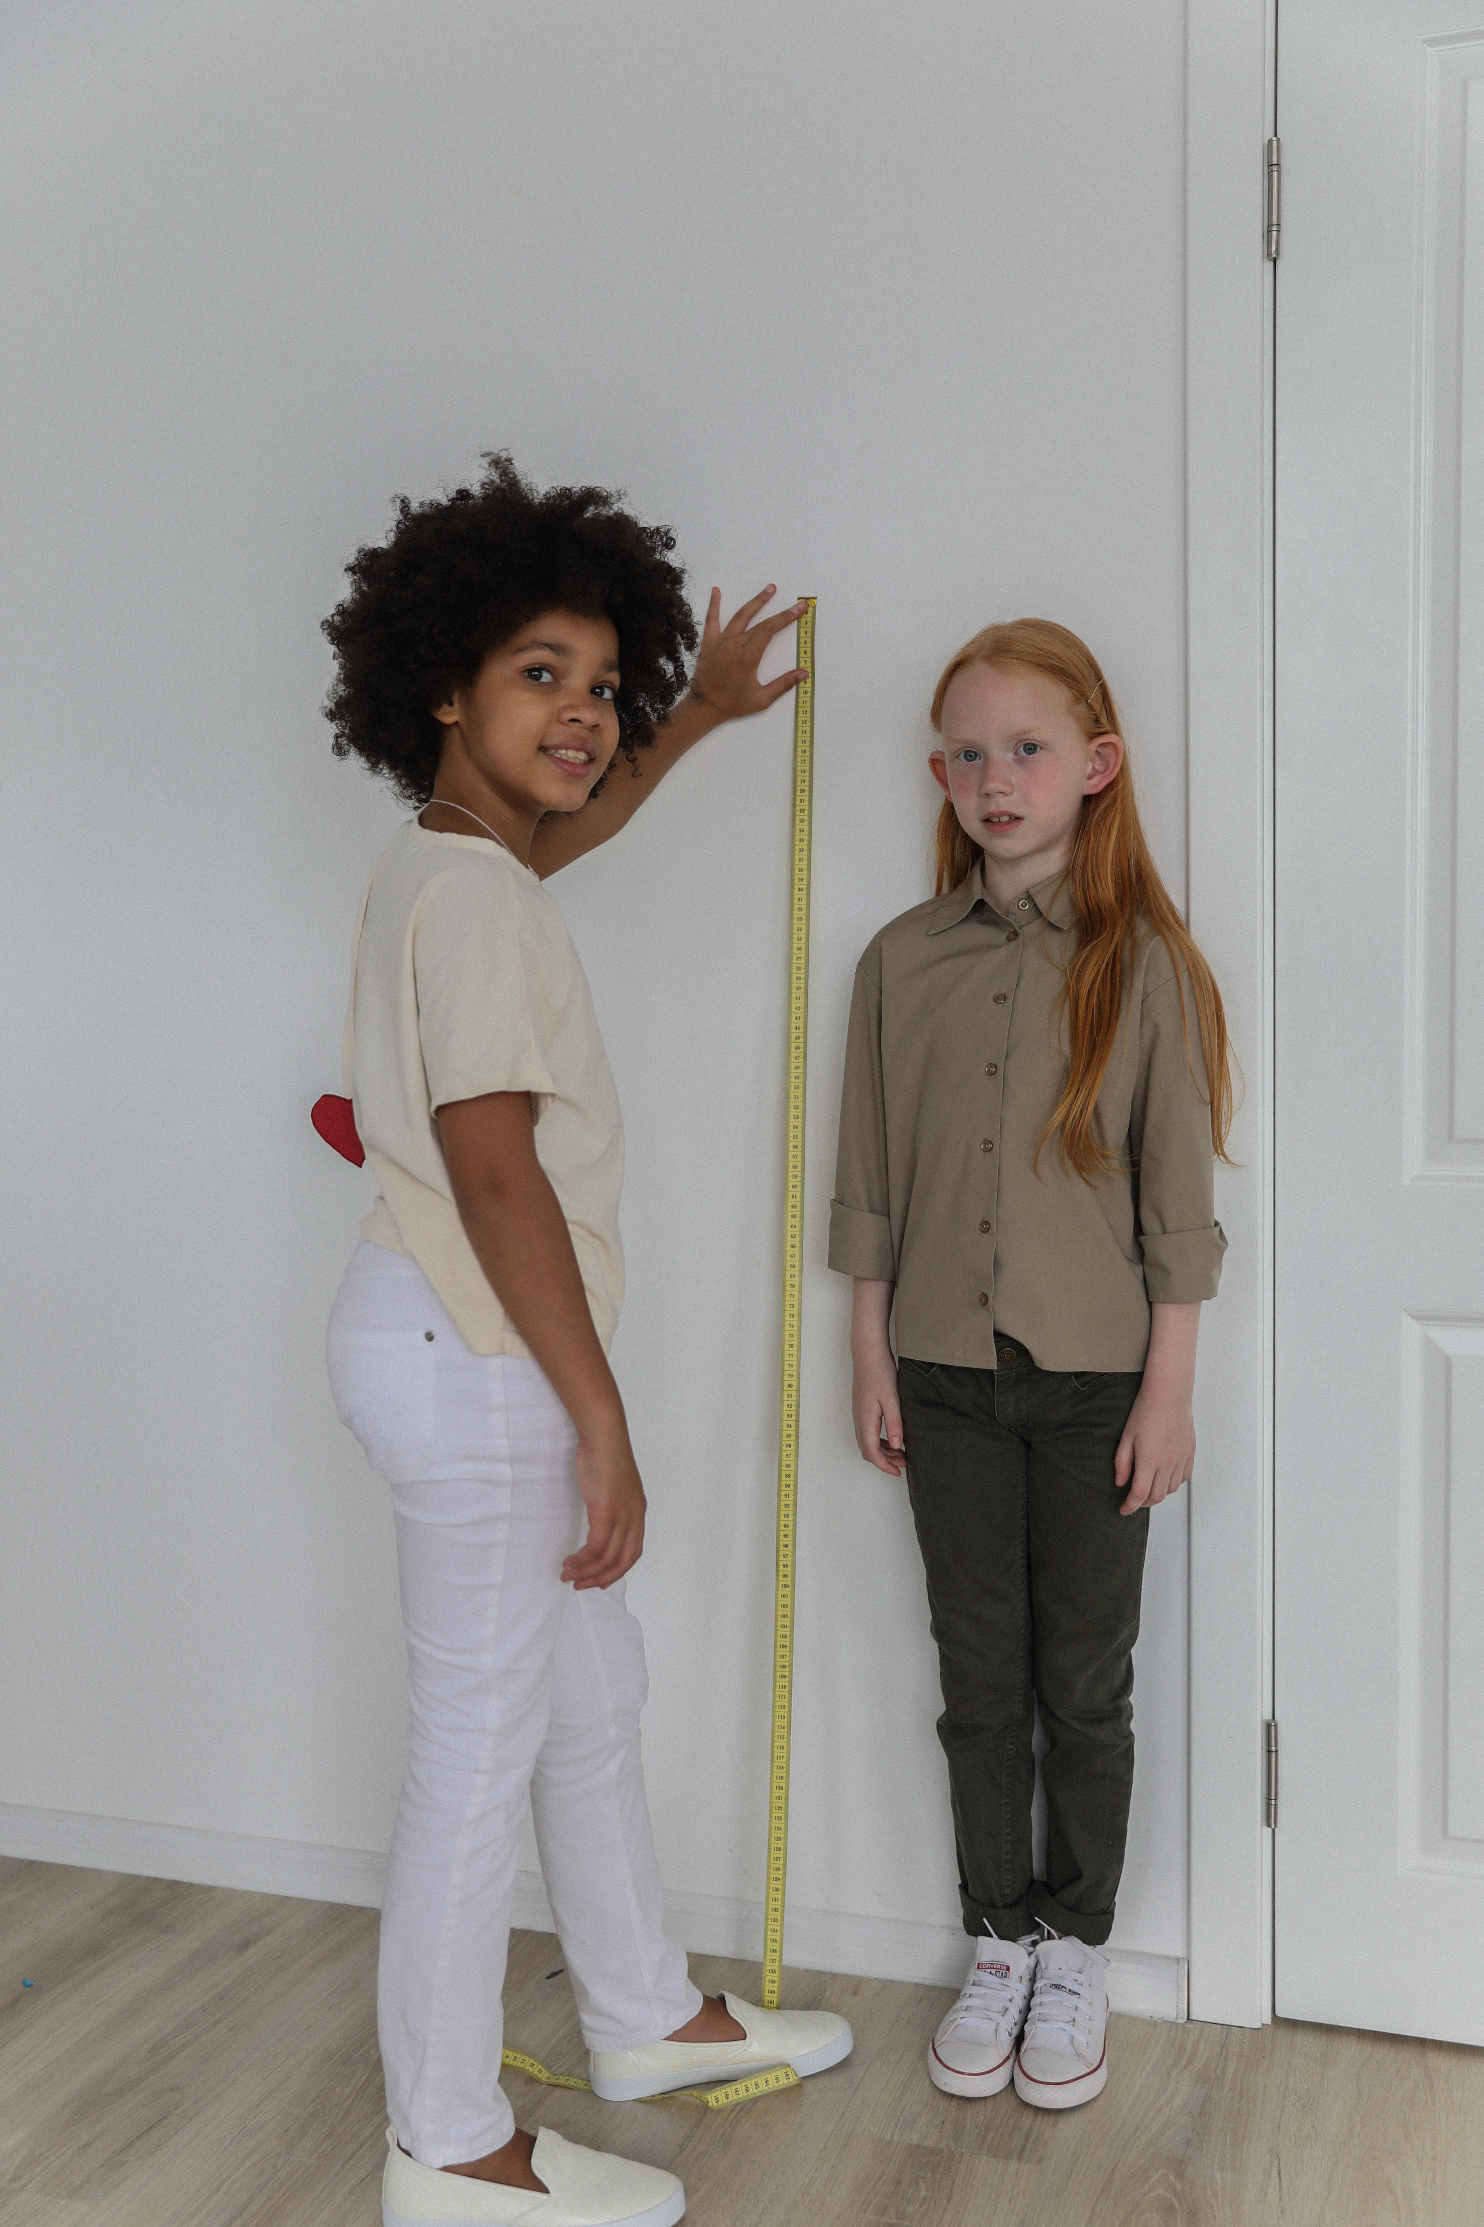
Grade 2
Unit 4Lesson 15CC BY NC 2024 Illustrative Mathematics®

Activity 1Must Be This Tall to Ride
The number line shows how tall you must be to go on some rides at an amusement park.
What do you notice?
What do you wonder?
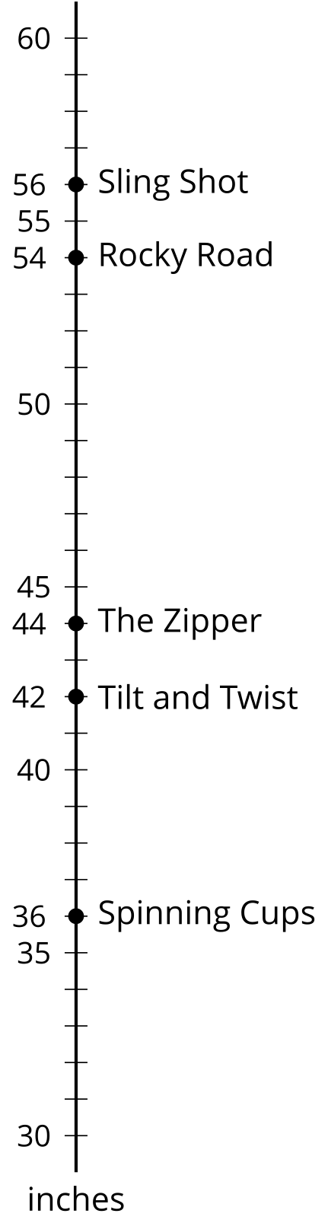
- How many of the rides could a person go on if they are:
  - 40 inches tall?
  - 43 inches tall?
  - 30 inches tall?
  - 62 inches tall?
- Show each person’s height on the number line.
  - Jada is 48 inches tall.
  - Jada's brother is 12 inches taller than her.
  - Jada's sister is 22 inches shorter than her brother.
Grade 2
Unit 4Lesson 15CC BY NC 2024 Illustrative Mathematics®

Activity 2A Day at the Park
Help Jada’s family plan their day at the amusement park. Use the following information.
- There is time for 2 activities before lunch and 1 activity after it.
- The family wants to go on at least 1 ride together.
- Jada and her sister want time to play games in the arcade.
- Jada’s sister hopes there is time to get ice cream.
- Jada’s brother wants to go on rides all day.

